

2012 ACT school students:
Where are they now?

This publication presents an overview of the 2013 destination of all students who attended an ACT school in February 2012 together with more detailed information from a survey of students in years 9 to 12 who left the ACT school system in 2012. Students who completed an ACT Year 12 Certificate or NSW Higher School Certificate at an ACT school are described as school graduates and students who left school prior to completing an ACT Year 12 Certificate or NSW Higher School Certificate are described as school leavers.

Key Findings
- The majority of students (87%) enrolled in the ACT school system in February 2012 remained in the system in 2013. Of those students who left the system, just over half had been in year 12.
- Ninety-four percent of year 12 students who graduated in 2012 were employed and/or studying in 2013, compared with 72 percent of years 9 to 12 school leavers in the survey.
- Sixty percent of year 12 students who graduated in 2012 were studying in 2013 and a further 31 percent intended to start some study in the next two years.
- Forty percent of the years 9 to 12 school leavers in the survey were studying in 2013 and a further 30 percent intended to start some study in the next two years.
- The unemployment rate for year 12 students who graduated in 2012 was 16 percent compared with 28 percent for years 9 to 12 school leavers in the survey.
- Nineteen percent of school graduates were travelling at the time of the survey in 2013, compared with six percent of school leavers.
- Overall, 96 percent of year 12 students who graduated in 2012 and 71 percent of year 12 students who left school in 2012 without obtaining a year 12 certificate found years 11 and 12 worthwhile.
- Sixty-five percent of parents of years 9 to 11 school leavers were satisfied with the school their child most recently attended.

Contents
Introduction 2
2013 destination of all students who were attending school in 2012 3
Entries and exits from the ACT school system 4
Destinations of students who left school in 2012 5
Destinations of students who left school in 2012 5
Key Outcomes 5
Study 5
Labour Force Status 7
Participation in other post school activities 8
Characteristics of students who left school in 2012 9
Enrolment in special education programs at school 9
Participation in flexible learning options at school 9
Satisfaction with School 9
Reasons for leaving school 10
Explanatory Notes 11

Introduction
This publication presents an overview of the destination of all students who attended an ACT school in 2012 together with more detailed information from a survey of students in years 9 to 12 who left the ACT school system in 2012 (School Leaver Survey).
The information in this publication has primarily been obtained from the ACT School Census and the School Leaver Survey.
- The ACT School Census is conducted in February each year and includes all public, Catholic and independent school students from preschool to year 12. In this publication, information from the 2012 School Census and the 2013 School Census have been used to determine the movement of students enrolled in the ACT school system.
- The School Leaver Survey is an annual survey of students in years 9 to 12 who left the ACT school system in the previous year. This publication includes a summary of the results of the third annual survey which was conducted in May and June 2013 and covered students who left the ACT school system in 2012. The survey excluded full fee paying students whose usual residence was overseas, school leavers who experienced a traumatic event, returned to school prior to May 2013 or moved interstate or overseas and school leavers from a small number of ACT non-government schools who chose not to participate in the survey.
In this publication students who completed an ACT Year 12 Certificate or NSW Higher School Certificate at an ACT school are described as school graduates and students who left school prior to completing an ACT Year 12 Certificate or NSW Higher School Certificate are described as school leavers. The school leavers group may include a small number of students who completed a vocational education and training (VET) qualification prior to leaving school.

2013 destination of all students who were attending school in 2012
In February 2012, there were 67,536 students attending ACT schools. There were 40,074 students (59%) attending public schools and 27,462 (41%) attending non-government schools. Figure 1 shows the 2013 destination of these students.
The majority (73%) of the 5,804 students in years 9 to 12 who exited the ACT school system between February 2012 and February 2013 were school graduates. Approximately 13 percent were school leavers, seven percent moved interstate, five percent moved overseas and two percent returned to school prior to May 2013.
Figure 1: Number of students who were enrolled in an ACT school in 2012, by 2012 year level and 2013 destination
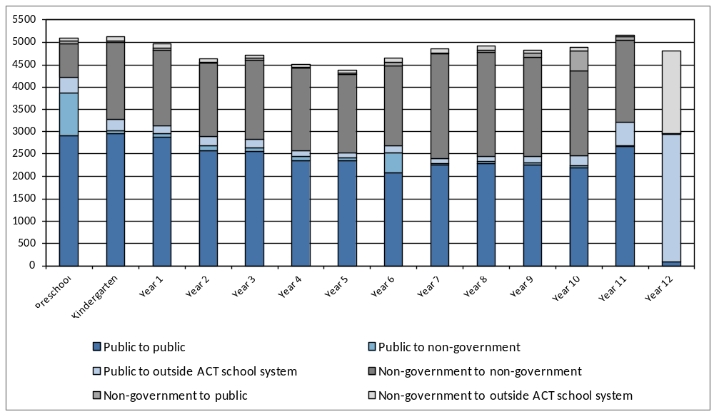
Of the 8,446 students who exited the ACT school system between February 2012 and February 2013, 56 percent were in year 12 in 2012. Movement of public school students to outside the ACT school system occurred most often for students enrolled in preschool and year 11 in 2012.
Overall, the greatest movement occurred at the traditional transition points (the end of preschool, year 6 and year 10), with substantial movement from the public to non-government sector for students at the end of preschool and year 6 in 2012, and movement from the non-government to public sector for students at the end of year 10 in 2012 (Figure 1).

Entries and exits from the ACT school system
Of the 67,536 students enrolled in ACT schools in February 2012, 8,446 left the ACT school system prior to February 2013. During the same period 9,749 students entered the ACT school system. This resulted in a slight increase in the total number of students enrolled in ACT schools between February 2012 and February 2013. Fifty percent of the new students started preschool in 2013. The number of preschool entrants (4,907) was slightly more than the number of year 12 exits (4,699).
Figure 2 details the number of students who entered and exited the ACT school system between February 2012 and February 2013. For most year levels the number of exits was similar to the number of entrants. However, between preschool and kindergarten, year 6 and year 7 and year 10 and year 11 there were more entrants than exits. Between year 11 and year 12 there were more exits than entrants. As kindergarten is the first compulsory year of schooling in the ACT it is understandable that there were more entrants than exits between preschool and kindergarten. Fifty-three percent of the entrants into year 7 and 20 percent of entrants into year 11 had a NSW home address in 2013.
Figure 2: Number of students that entered and exited the ACT school system between February 2012 and February 2013, by year level.
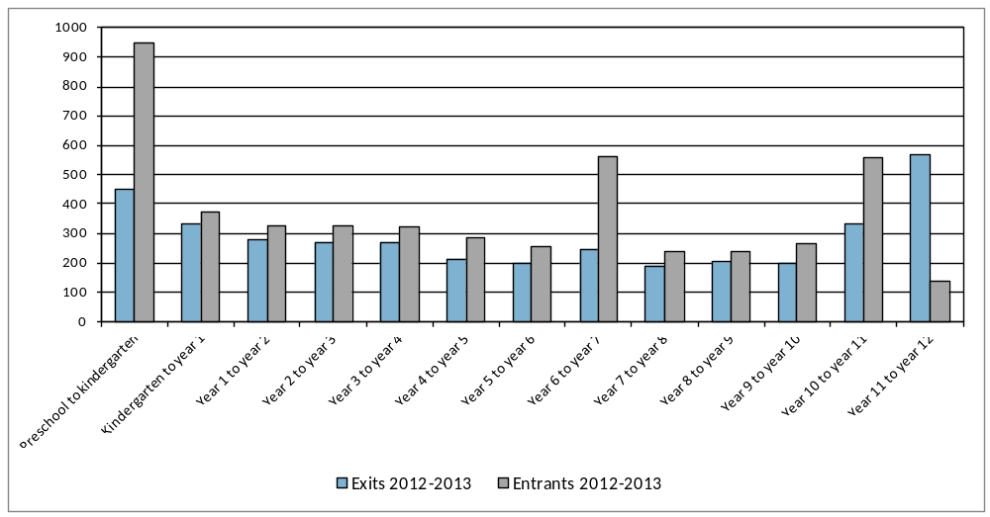

Destinations of students who left school in 2012
Key Outcomes
Table 1 details the percentage of school graduates and school leavers employed and/or studying in 2013.
Of the school graduates, 94 percent reported they were employed and/or studying in 2013. In contrast, only 72 percent of school leavers were employed and/or studying in 2013.
Table 1: Proportion of 2012 school graduates and school leavers employed and/or studying in 2013, by sex (%)
 |  | Employed | Currently Studying | Employed or Studying
School leavers |  | 60.1 | 40.1 | 72.3
 | Females | 58.7 | 42.9 | 75.2
 | Males | 60.9 | 38.2 | 70.4
School graduates |  | 73.8 | 60.2 | 93.5
 | Females | 77.0 | 60.4 | 94.8
 | Males | 70.7 | 60.0 | 92.3

Study
Table 2 shows the percentage of school graduates and school leavers studying full-time and part-time in 2013, by 2012 year level (the year the student was in when they left school). In this survey “studying” means actively undertaking some study in the year following school departure, including those attending university, technical and further education (TAFE), undertaking an apprenticeship or studying a secondary school qualification outside the traditional school environment.
Sixty percent of all school graduates indicated that they were undertaking some study in 2013, with 51 percent of graduates studying full-time. Forty percent of school leavers indicated that they were undertaking some study in 2013, with 19 percent of school leavers studying full-time. The majority of school graduates and year 12 school leavers who were studying in 2013 were studying full-time. About half of the year 9 and 10 school leavers (48%) were studying.
Table 2: Proportion of 2012 school graduates and school leavers studying in 2013, by 2012 year level (%)
 |  | Studying |  |  |  | Not studying
 |  |  | Part-time | Full-time | All
School leavers |  |  | 19.5 | 18.9 | 40.1 |  | 59.9
 | Year 9 or 10 |  | 13.9 | 28.1 | 48.0 |  | 52.0
 | Year 11 |  | 25.0 | 8.8 | 34.6 |  | 65.4
 | Year 12 |  | 15.6 | 26.6 | 43.0 |  | 57.0
School graduates |  |  | 8.5 | 51.4 | 60.2 |  | 39.8
Note: The percentages in this table do not all add to 100 percent due to rounding and a small percentage of ‘don’t know’ responses.
For school graduates the most common subjects of study related to:
- society and culture (15%). This includes fields such as political science, psychology, law, economics, sport and literature.
- management and commerce (14%). This includes fields such as accounting, business management, marketing and finance.
- health (13%). This includes fields such as medical, dental and veterinary studies, nursing, pharmacy, optical and rehabilitation therapies.
For school leavers, the most common subjects of study related to:
- food, hospitality and personal services (21%). This includes fields such as hospitality, food hygiene, cookery, beauty therapy and hairdressing.
- architecture and building (18%). This includes fields such as landscape architecture, interior design, regional planning, bricklaying, carpentry and plumbing.
- engineering and related technologies (14%). This includes fields such as panel beating, cabinet making, vehicle mechanics, refrigeration mechanics and welding, as well as engineering.
Figure 3: Proportion of 2012 school graduates and school leavers studying in 2013, by main field of study (%)
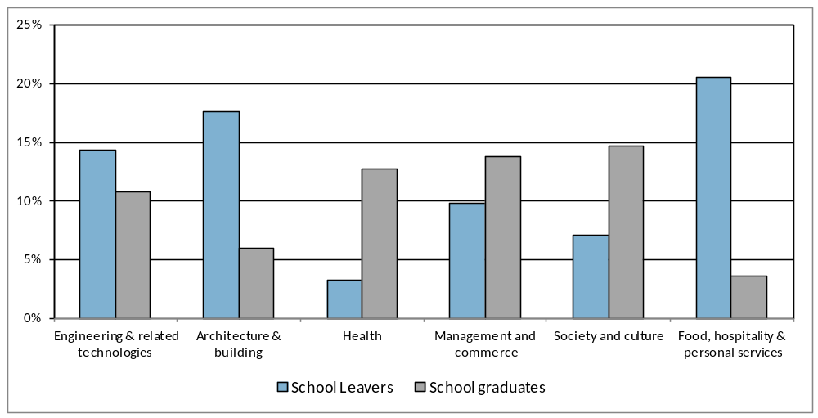

Sixty-eight percent of school graduates who were studying in 2013 reported they were studying at a Bachelor Degree level or higher. Fifteen percent of school graduates were studying at Certificate III in 2013 compared with 45 percent of the school leavers. Ten percent of school leavers who were studying were undertaking a secondary school qualification outside the traditional school environment.
Twenty-nine percent of school leavers and 10 percent of school graduates reported undertaking an apprenticeship or traineeship in 2013. Of the school leavers who were undertaking an apprenticeship most were technicians or trade workers studying engineering and related technologies or architecture and building.
Fifty-two percent of school graduates and 32 percent of school leavers who were studying in 2013 said that the main reason for choosing their course was because "it's a course that interests me". The most common main reason for not studying in 2012 was “taking a gap year” for school graduates and “got a job” for school leavers, closely followed by “family commitments”.
Seventy-seven percent of the school graduates and 51 percent of the school leavers who were not studying in 2013 intended to start some study in the next two years.
Labour Force Status
Table 3 details the 2013 labour force status of school leavers and school graduates. Seventy-four percent of school graduates reported having a paid job and sixty percent of school leavers reported having a paid job. Twenty-thee percent of school leavers said they did not have a paid job but were actively looking for work compared with 14 percent of school graduates. The unemployment rate was 28 percent for school leavers and 16 percent for school graduates.
Table 3: Proportion of 2012 school leavers and school graduates, by labour force status in 2013 (%)
 |  |  | School leavers | School graduates
 | Employed |  | 60.1 | 73.8
 |  | Full-time | 34.5 | 23.5
 |  | Part-time | 21.8 | 48.9
 |  | Don't know/Refused | 3.7 | 1.4
 | Unemployed |  | 23.2 | 13.9
 |  | Looking for full-time work | 9.0 | 2.4
 |  | Looking for part-time work | 7.5 | 9.9
 |  | Looking for full or part-time work | 6.3 | 1.6
 |  | Don't know | 0.3 | 0.0
 | Total in labour force |  | 83.2 | 87.7
Not in labour force |  |  | 16.8 | 12.3
Total |  |  | 100.0 | 100.0
Unemployment rate |  |  | 27.8 | 15.9

The majority of school leavers who were employed in 2013 were employed full-time. The opposite trend was recorded for the school graduates with the majority employed part-time.
Of the school graduates who had a paid job in 2013, the most common occupations were community and personal service workers (37%) and sales workers (29%). For school leavers, the most common occupations were technicians and trade workers (30%), community and personal service workers (25%), labourers (18%) and sales workers (17%).
Figure 4: Proportion of 2012 school graduates and school leavers employed in 2013, by occupation (%)
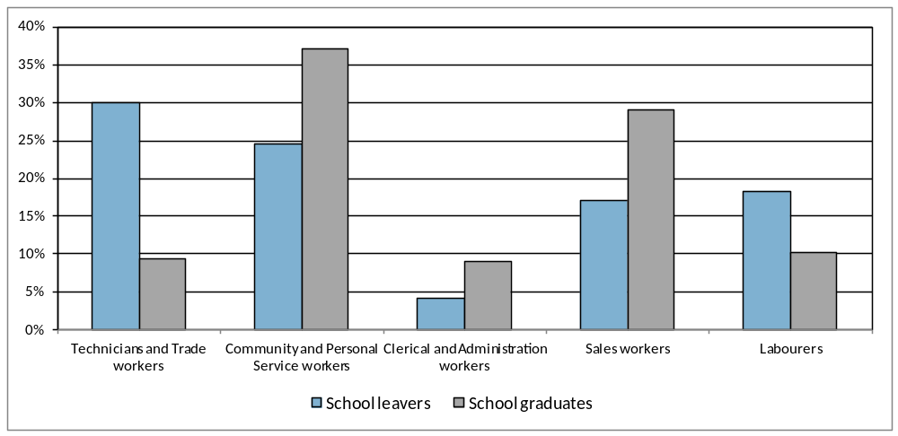

Participation in other post school activities
Table 4 shows the percentage of school graduates and school leavers who participated in various activities in the year following leaving school. School graduates were more likely to be travelling, pursuing elite sporting interests and/or undertaking volunteer work at the time of the survey in 2013 and school leavers were slightly more likely to be caring for family members.

Table 4: Proportion of 2012 school graduates and school leavers participating in various post school activities (%)
 | School leavers | School graduates
Undertaking volunteer work | 6.4 | 11.7
Caring for family members | 7.8 | 6.5
Pursuing elite sporting interests | 3.9 | 8.6
Travelling | 6.2 | 19.3

Characteristics of students who left school in 2012
Enrolment in special education programs at school
Special education programs, such as specialist schools and learning support units, are designed for students with a disability. School leavers were more likely than school graduates to have been enrolled in special education programs at school. Seventeen percent of school leavers were enrolled in special education programs at school and four percent of school graduates were enrolled in special education programs at school.

Participation in flexible learning options at school
Flexible learning options, such as connect 10 and college pathway programs, are for young people who choose to enrol in an alternative education program. School leavers were more likely than school graduates to have participated in alternative learning options at school. Twenty percent of school leavers participated in alternative learning options at school and five percent of school graduates participated in alternative learning options at school.

Satisfaction with School
Parents of years 9 to 11 school leavers were asked about their level of satisfaction with the school the student most recently attended. Sixty-five percent of parents were satisfied with the school. In contrast, the 2012 School Satisfaction Survey showed that overall 86% of parents were satisfied with the school their child attended.
Year 12 school leavers and school graduates were asked about their level of agreement with seven statements regarding their experience in years 11 and 12 in the ACT (Figure 5). Responses of strongly agree or agree were classified as “satisfied”, responses of strongly disagree or disagree as “not satisfied” and responses of neither agree nor disagree as “neutral”. Overall 71 percent of year 12 school leavers and 96 percent of school graduates found year 11 and 12 worthwhile. School graduates were generally more satisfied than year 12 school leavers.
Figure 5: Proportion of 2012 school graduates and year 12 school leavers satisfied with various aspects of their year 11 and 12 experience (%)
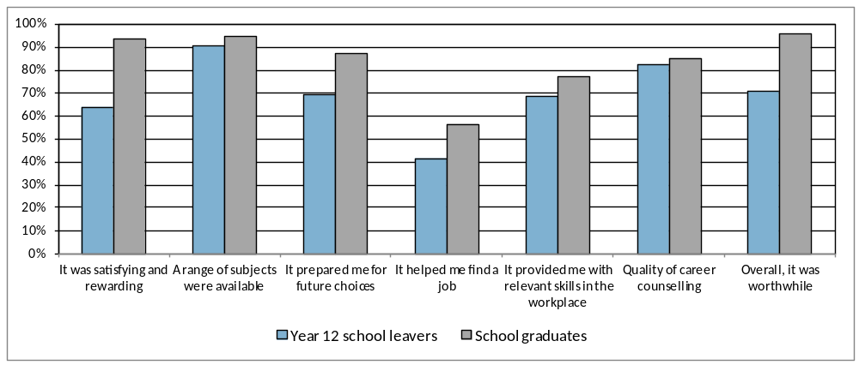
Fifty-four percent of the school graduates and 40 percent of school leavers received career counselling at school.
Reasons for leaving school
Parents of years 9 to 11 students who left school in 2012 were asked the reasons why their child decided to leave school (Table 5). The most common responses were the child was not doing very well at school (67%), the child wanted to get a job (66%), the child wanted to earn their own money (62%), and the child had a job to go to (40%).
Table 5: Most common responses parents gave regarding why their child (who was in year 9, 10 or 11 in 2012) left school
Response Categories |  | Percentage
Not doing very well at school |  | 66.6
Wanted to get a job |  | 65.8
Wanted to earn his/her own money |  | 62.4
Had a job to go to |  | 40.2
Did not get on with the teachers and/or students at school |  | 35.6
Wanted to do study or training that wasn't available at school |  | 33.5
Note: The percentages in this table do not add to 100 percent, as respondents could provide more than one response.

Explanatory Notes
Career counselling in schools may include one on one or group discussion between students and career advisors, industry experts and representatives from universities and CIT about various aspects of student pathways planning, such as course choices, work experience and developing a resume.
Currently studying refers to respondents who were actively undertaking some study in the year following school departure, including those attending university, technical and further education (TAFE), undertaking an apprenticeship or studying a secondary school qualification outside the traditional school environment.
Labour force status provides data on whether a respondent was employed (full or part-time), unemployed (looking for full or part-time work) or not in the labour force at the time of the survey. Labour force status was derived from responses to a number of questions on the survey form.
Survey Methodology. Prior to the School Leaver Survey being undertaken a primary approach letter was sent to year 12 school graduates, year 12 leavers and parents of years 9 to 11 school leavers. This provided information about its purpose and importance: the broad content of the survey, the amount of time the interview would take and confidentiality provisions. The survey was undertaken by telephone from 7 May 2012 to 2 June 2013. Of the 3,799 school graduates who were sent a primary approach letter, 2,937 completed the survey, providing a response rate of 77 percent. Of the 611 school leavers who were sent a primary approach letter, 366 completed the survey, providing a response rate of 60 percent.

© ACT Government, 2013
This publication has been produced by the ACT Government. Apart from any use permitted under the Copyright Act 1968, no part of this publication may be reproduced by any process without written permission. Requests should be made to the ACT Government. Comments and suggestions regarding this publication are welcomed and should be forwarded to the Education and Training Directorate.

Published by Education and Training Directorate | ACT Government
220 Northbourne Avenue, Canberra City ACT 2602 | GPO Box 158, CANBERRA ACT 2601
Phone: (02) 6205 9358 Web: http://www.det.act.gov.au

