

ACT POST SCHOOL DESTINATIONS AND PATHWAYS IN 2015

A summary of the 2015 results from the survey of 2014 year 12 graduates and school leavers and the longitudinal survey of 2013 year 12 graduates and school leavers.
Key Findings
- Ninety-two percent of 2014 year 12 graduates were employed and/or studying in 2015, compared with 75 percent of 2014 school leavers in the survey.
- Sixty-one percent of 2014 year 12 graduates were studying in 2015 and a further 30 percent intended to start some study in the next two years.
- Forty-four percent of 2014 school leavers were studying in 2015 and a further 34 percent intended to start some study in the next two years.
- Seventy percent of 2014 year 12 graduates were employed in 2015, compared with 59 percent of 2014 school leavers.
- The percentage of 2013 year 12 graduates studying increased from 60 percent in 2014 to 76 percent in 2015.
- Eighty-six percent of the 2013 year 12 graduates who deferred university in 2014 were attending university in 2015.
- Sixty percent of 2013 year 12 graduates and 32 percent of 2013 school leavers who were not studying in 2014, started studying in 2015

© Australian Capital Territory, Canberra, 2016
This publication has been produced by the ACT Government. Apart from any use permitted under the Copyright Act 1968, no part of this publication may be reproduced by any process without written permission from the ACT Government’s Education Directorate.

Contents
Background 4
Part 1 – 2014 Year 12 Graduates and School Leavers 4
Destination of year 12 graduates 4
Key outcomes 4
Study 6
Labour force status 9
Participation in other post-school activities 11
Destination of school leavers 11
Characteristics of students who left school in 2014 13
Satisfaction with school 13
Reasons for leaving school 14
Part 2 – 2013 Year 12 Graduates and School Leavers 15
Pathways of 2013 year 12 graduates 15
Key outcomes 15
Study 15
Labour force status 20
Pathways of 2013 school leavers 23
Scope and methodology 24
Glossary 25
References 26

Background
Australia is in a period of significant education and training reform. The current national reform agenda is impacting on all sectors of education, training and skills development. The ACT is proactive in looking to the future of education and training in our region, building on the strengths of current collaborations, relationships and partnerships within the sector, and promoting opportunities for change.
The ACT is committed to providing learning pathways for students which result in an educated and skilled workforce to meet the present and future needs of the ACT and region. Priorities focus on ensuring young people’s needs are met, providing flexible and responsive training options, engaging with industry and employers and improving retention rates. Together these strategies empower students to shape their own learning pathways while meeting industry needs.
The School Leaver Survey results provide important information which informs the ongoing planning, development and provision of appropriate education and training options for the young people of the ACT and region.
In 2015 the Directorate introduced a longitudinal survey to find out if students continue with their initial and/or intended pathways in subsequent years and to further explore issues identified in the annual survey, such as, the trend to defer further study. The longitudinal survey of 2013 year 12 graduates and school leavers is the first longitudinal survey of school leavers to be conducted in the ACT. Consenting 2013 year 12 graduates and school leavers will be surveyed three times in total; 2014 (Wave 1), 2015 (Wave 2) and 2016 (Wave 3).
In this publication students who completed an ACT Year 12 Certificate in 2014 are described as 2014 year 12 graduates. Students who were in year 9 to 12 when they left school in 2014 prior to completing an ACT Year 12 Certificate are described as 2014 school leavers. Students who completed an ACT Year 12 Certificate in 2013 are described as 2013 year 12 graduates. Students who were in year 9 to 12 when they left school in 2013 prior to completing an ACT Year 12 Certificate are described as 2013 school leavers.

Part 1 – 2014 Year 12 Graduates and School Leavers

Destination of year 12 graduates
Key outcomes
Ninety-two percent of 2014 year 12 graduates reported that they were employed and/or studying in 2015. This compares favourably with the Australian employed and/or studying rate of 88 percent for 15-24 year olds who completed year 12 prior to leaving school in 2014 (Australian Bureau of Statistics, 2015).
Table 1 provides an overview of three key outcome indicators covering employment, study and those who were employed and/or studying in the year following graduation. Data are presented for surveys conducted with 2011, 2012, 2013 and 2014 year 12 graduates. The following interesting features were identified consistently over the four years:
- female students were more likely to be employed and more likely to be employed and/or studying than male graduates. For example, 73 percent of female 2014 year 12 graduates were employed in 2015 compared to 66 percent of male graduates
- graduates who spoke a language other than English at home (LBOTE) were more likely to be studying while graduates who were not LBOTE were more likely to be employed
- graduates who did not obtain an Australian Tertiary Admission Rank (ATAR) were more likely to be employed, less likely to be studying and less likely to be employed and/or studying
- graduates who were receiving a Government pension, allowance or benefit in 2015 were more likely to be studying, less likely to be employed and less likely to be employed and/or studying.
Table 1: Proportion of year 12 graduates employed and/or studying, by selected demographics (%)
 |  | Employed |  |  |  |  | Currently studying |  |  |  |  | Employed and/or studying
Year of graduation |  | 2011 | 2012 | 2013 | 2014 |  | 2011 | 2012 | 2013 | 2014 |  | 2011 | 2012 | 2013 | 2014
Sex
 | Female | 80.3 | 77.2 | 75.2 | 72.8 |  | 55.8 | 60.4 | 61.8 | 61.7 |  | 95.5 | 94.7 | 93.7 | 93.1
 | Male | 75.7 | 71.4 | 70.8 | 66.3 |  | 59.0 | 59.3 | 56.7 | 60.7 |  | 93.0 | 92.1 | 90.1 | 90.7
LBOTE
 | No | 81.6 | 78.2 | 75.9 | 72.9 |  | 53.8 | 55.9 | 55.8 | 58.3 |  | 94.3 | 93.2 | 91.7 | 91.6
 | Yes | 58.5 | 55.1 | 57.0 | 54.3 |  | 77.2 | 79.4 | 78.0 | 75.3 |  | 94.5 | 94.5 | 93.0 | 93.8
Participated in a VET course at school
 | No | 74.9 | 74.4 | 71.5 | 67.9 |  | 60.5 | 57.6 | 57.5 | 60.4 |  | 94.3 | 93.5 | 91.1 | 91.4
 | Yes | 84.1 | 74.0 | 77.3 | 74.7 |  | 51.4 | 65.7 | 64.2 | 63.8 |  | 94.4 | 93.1 | 94.1 | 93.5
ATAR Group
 | No ATAR | 85.1 | 78.8 | 75.6 | 74.3 |  | 43.9 | 48.5 | 49.1 | 45.4 |  | 92.3 | 88.3 | 86.7 | 85.8
 | 1 - 65 | 78.9 | 75.9 | 75.3 | 69.7 |  | 57.4 | 55.5 | 57.4 | 63.3 |  | 93.5 | 93.0 | 92.8 | 93.7
 | 66 - 75 | 81.7 | 74.6 | 79.9 | 75.8 |  | 58.6 | 65.0 | 62.9 | 66.5 |  | 94.4 | 95.7 | 96.5 | 96.7
 | 76 - 85 | 76.8 | 73.1 | 74.8 | 69.8 |  | 64.3 | 66.8 | 64.4 | 68.1 |  | 96.8 | 97.7 | 93.8 | 95.2
 | 86 - 95 | 70.9 | 70.9 | 67.0 | 62.8 |  | 67.6 | 70.9 | 67.3 | 71.5 |  | 95.8 | 97.4 | 95.1 | 93.5
 | 96 - 100 | 59.6 | 59.6 | 52.5 | 51.9 |  | 75.6 | 73.3 | 74.7 | 80.8 |  | 96.2 | 95.9 | 94.9 | 96.8
Received career counselling at school
 | No | 78.2 | 74.6 | 72.5 | 68.8 |  | 56.5 | 59.1 | 60.9 | 61.4 |  | 94.7 | 92.7 | 92.0 | 91.5
 | Yes | 79.0 | 74.6 | 73.8 | 70.7 |  | 58.2 | 61.3 | 58.2 | 61.4 |  | 94.5 | 94.2 | 92.1 | 92.8
 | Don't Know | 63.2 | 62.5 | 63.5 | 57.7 |  | 49.7 | 42.8 | 52.7 | 51.7 |  | 82.6 | 89.1 | 85.5 | 76.7
Participated in work experience at school
 | No | n.a. | n.a. | 72.7 | 67.6 |  | n.a. | n.a. | 59.2 | 60.2 |  | n.a. | n.a. | 92.4 | 91.7
 | Yes | n.a. | n.a. | 73.2 | 71.3 |  | n.a. | n.a. | 59.2 | 62.2 |  | n.a. | n.a. | 91.5 | 92.1
Received a government pension, allowance or benefit in 2015
 | No | n.a. | n.a. | 75.7 | 72.9 |  | n.a. | n.a. | 57.7 | 60.0 |  | n.a. | n.a. | 92.6 | 92.8
 | Yes | n.a. | n.a. | 46.8 | 43.7 |  | n.a. | n.a. | 73.9 | 71.1 |  | n.a. | n.a. | 85.4 | 85.0
All graduates |  | 78.2 | 74.3 | 73.0 | 69.6 |  | 57.2 | 59.8 | 59.2 | 61.2 |  | 94.3 | 93.4 | 91.9 | 91.9
Note: n.a. indicates that results are not available.
Study
Table 2 shows the proportions of 2014 year 12 graduates studying in 2015 by selected demographic factors. Sixty-one percent of all graduates indicated that they were undertaking some study in 2015, with 51 percent studying full-time. This is similar to the Australian study rate of 62 percent (and 50% in full-time study) for 15-24 year olds who completed year 12 prior to leaving school in 2014 (Australian Bureau of Statistics, 2015).
2014 year 12 graduates who achieved a higher Australian Tertiary Admission Rank (ATAR) had a greater tendency to undertake further study. Eighty-one percent of the graduates with an ATAR between 96 and 100 were undertaking study in 2015, compared with 67 percent of the graduates with an ATAR between 66 and 75.
Of the 10 percent of 2014 year 12 graduates who were receiving a government pension, allowance or benefit in May 2015, 71 percent were studying in 2015, compared with 60 percent of those who were not receiving a government pension, allowance or benefit.
Table 2: Proportion of 2014 year 12 graduates studying in 2015, by selected demographics (%)
 |  | Studying |  |  | Not studying
 |  | Part-time | Full-time | All
Sex
 | Females | 9.1 | 52.2 | 61.7 | 38.3
 | Males | 10.6 | 49.8 | 60.7 | 39.3
LBOTE
 | No | 10.0 | 47.9 | 58.3 | 41.7
 | Yes | 9.1 | 66.1 | 75.3 | 24.7
Participated in a VET course at school
 | No | 8.9 | 51.2 | 60.4 | 39.6
 | Yes | 12.8 | 50.6 | 63.8 | 36.2
ATAR Group
 | No ATAR | 16.4 | 28.4 | 45.4 | 54.6
 | 1 - 65 | 13.1 | 50.2 | 63.3 | 36.7
 | 66 - 75 | 6.6 | 58.9 | 66.5 | 33.5
 | 76 - 85 | 4.6 | 63.3 | 68.1 | 31.9
 | 86 - 95 | 3.5 | 68.0 | 71.5 | 28.5
 | 96 - 100 | 4.5 | 76.4 | 80.8 | 19.2
Received career counselling at school
 | No | 10.7 | 50.4 | 61.4 | 38.6
 | Yes | 8.9 | 52.0 | 61.4 | 38.6
Participated in work experience at school
 | No | 7.5 | 52.2 | 60.2 | 39.8
 | Yes | 11.8 | 50.0 | 62.2 | 37.8
Received a government pension, allowance or benefit in 2015
 | No | 9.5 | 50.1 | 60.0 | 40.0
 | Yes | 10.7 | 60.4 | 71.1 | 28.9
All graduates |  | 9.8 | 51.0 | 61.2 | 38.8
Note: The percentages in this table do not all add to 100 percent due to rounding and a small percentage of ‘don’t know’ responses.
The Australian Standard Classification of Education (ASCED) was used to classify fields of study. The most common fields of study related to:
- society and culture (16%). This included fields such as political science, psychology, law, economics, sport and literature
- management and commerce (15%). This included fields such as accounting, business management, marketing and finance
- health (13%). This included fields such as medical, dental and veterinary studies, nursing, pharmacy, optical and rehabilitation therapies.
Sixty-three percent of 2014 year 12 graduates applied for a university place and 97 percent of these graduates were successful in gaining a place. However, only 73 percent of successful applicants accepted the place and enrolled in 2015. Twenty-four percent of successful applicants deferred and three percent rejected the offer. Graduates who were not LBOTE, graduates who received career counselling at school and graduates with a mid-range (66-85) ATAR were more likely to defer their university studies.
The ASCED was also used to classify level of study. Sixty-eight percent of 2014 year 12 graduates studying in 2015 reported that they were studying at a Bachelor Degree level or higher and 15 percent were studying at Certificate III level.
A greater proportion of females were studying at a Bachelor Degree level or higher – 73 percent of females compared with 63 percent of males. The proportion of males studying at Certificate III level was more than the proportion of females studying at that level – 21 percent of males compared with 10 percent of females (Figure 1).
Figure 1: 2014 year 12 graduates studying in 2015, by level of study and sex (%)
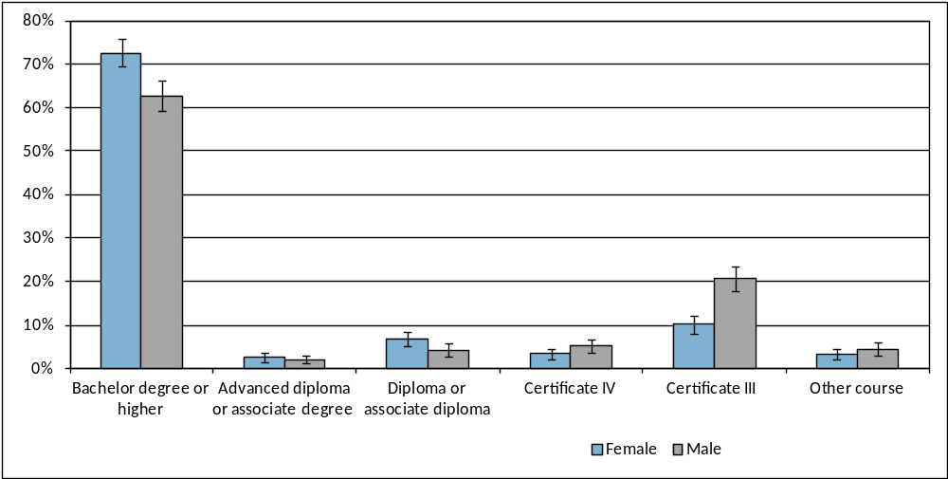
Note: The error bars reflect the 95 percent confidence intervals and no overlap indicates there is a statistical difference between the results.
Table 3 shows the main reason why 2014 year 12 graduates chose their course in 2015. Overall, 57 percent reported that they chose their course because it interested them and 30 percent chose the course because they thought it would assist with employment.
Forty-two percent of graduates who were studying in 2015 and did not gain an ATAR reported that they chose the course because they thought it would assist with employment and 40 percent chose the course because it interested them. Graduates with a higher ATAR were more likely to have chosen their course because it interested them, with 76 percent of graduates, with an ATAR between 96 and 100, reporting this as their main reason.
Table 3: 2014 year 12 graduates studying in 2015, by main reason for choosing their course and selected demographics (%)
 |  | It's a course that interests me | To get/start/help in a job/business | To help get into another course | To improve my education | Other
Sex
 | Females | 57.4 | 29.3 | 4.1 | 2.7 | 4.9
 | Males | 55.7 | 31.4 | 4.6 | 3.2 | 3.7
Participated in a VET course at school
 | No | 58.2 | 29.2 | 4.5 | 3.0 | 3.8
 | Yes | 52.0 | 33.6 | 3.9 | 2.7 | 6.0
ATAR Group
 | No ATAR | 40.2 | 42.5 | 7.7 | 3.3 | 5.0
 | 1 - 65 | 47.9 | 33.3 | 6.6 | 4.9 | 3.3
 | 66 - 75 | 61.5 | 26.9 | 2.5 | 1.6 | 5.8
 | 76 - 85 | 61.5 | 29.0 | 3.0 | 1.8 | 4.3
 | 86 - 95 | 66.7 | 23.0 | 2.3 | 2.9 | 4.3
 | 96 - 100 | 75.7 | 17.5 | 1.5 | 2.9 | 2.4
All graduates |  | 56.6 | 30.3 | 4.4 | 2.9 | 4.3
Note: The percentages in this table do not all add to 100 percent due to rounding and a small percentage of ‘don’t know’ responses.
Overall, seven percent of year 12 graduates indicated they were undertaking an apprenticeship in 2015 and three percent were doing a traineeship.

Figure 2: Proportion of 2014 year 12 graduates undertaking an apprenticeship or traineeship in 2015, by selected demographics (%)
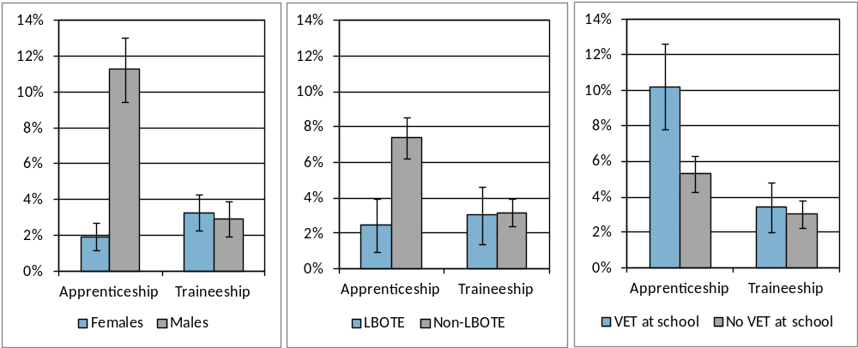
Note: The error bars reflect the 95 percent confidence intervals and no overlap indicates there is a statistical difference between the results.
The percentage of graduates undertaking an apprenticeship varied significantly for selected demographics (Figure 2):
- male graduates were much more likely to be undertaking an apprenticeship than females
- graduates who were not LBOTE were more likely to be undertaking an apprenticeship than graduates who were LBOTE
- graduates who participated in a vocational education and training (VET) course at school were more likely to be undertaking an apprenticeship than graduates who did not participate in a VET course at school.
Thirty-nine percent of 2014 year 12 graduates who were not studying in 2015 reported their main reason for not studying was to “take a gap year”, 12 percent were “not ready for study”, 11 percent indicated that they had “got a job” and seven percent were “travelling” (Table 4). Twenty percent of graduates who were not studying and did not get an ATAR reported their main reason for not studying was because they were “taking a gap year” and other common responses were “not ready for study” (17%) and “got a job” (17%).
Table 4: 2014 year 12 graduates not studying in 2015, by main reason for not studying and selected demographics (%)
 |  | Taking a gap year | Travelling | Not ready for study | Got a job | Other
Sex
 | Females | 42.9 | 9.3 | 11.6 | 7.4 | 28.8
 | Males | 34.5 | 4.2 | 13.1 | 15.1 | 33.3
Participated in a VET course at school
 | No | 38.5 | 7.9 | 12.0 | 10.2 | 31.4
 | Yes | 39.5 | 2.9 | 13.3 | 14.6 | 29.8
ATAR Group
 | No ATAR | 19.9 | 2.6 | 16.8 | 16.7 | 44.0
 | 1 - 65 | 45.5 | 6.0 | 11.6 | 10.9 | 26.0
 | 66 - 75 | 54.0 | 8.1 | 9.3 | 12.1 | 16.6
 | 76 - 85 | 53.9 | 11.5 | 8.5 | 1.5 | 24.6
 | 86 - 95 | 65.1 | 15.9 | 4.2 | 1.1 | 13.7
 | 96 - 100 | 64.0 | 12.6 | 7.9 | 4.4 | 11.0
All graduates |  | 38.7 | 6.8 | 12.3 | 11.2 | 31.0
Note: The percentages in this table do not all add to 100 percent due to rounding and a small percentage of ‘don’t know’ responses.
Of the 39 percent of 2014 year 12 graduates who were not studying in 2015, 76 percent intended to start some study in the next two years. As ATAR increased, so did intention to start some study in the next two years. The most common intended ASCED fields of study related to society and culture (21%), health (13%), management and commerce (12%) and creative arts (11%). This high rate of deferral in ACT is consistent with the general trend in Australia, with the incidence increasing from 10 percent in 1999-2000 to 24 percent in 2009-10 (Lumsden & Stanwick, 2012).

Labour force status
Table 5 details the 2015 labour force status of 2014 year 12 graduates. Seventy percent of graduates reported having a paid job. Seventeen percent of graduates reported not currently having a paid job and actively looking for work with the majority looking for part-time work.
Table 5: Number and proportion of 2014 year 12 graduates, by labour force status in 2015
 |  |  | Number | Proportion (%)
 | Employed |  | 2987 | 69.6
 |  | Full-time | 803 | 18.7
 |  | Part-time | 2170 | 50.6
 |  | Don't know/Refused | 14 | 0.3
 | Unemployed |  | 728 | 17.0
 |  | Looking for full-time work | 100 | 2.3
 |  | Looking for part-time work | 533 | 12.4
 |  | Looking for full or part-time work | 94 | 2.2
 |  | Don't know | 2 | 0.0
 | Total in labour force |  | 3715 | 86.6
Not in labour force |  |  | 576 | 13.4
Total |  |  | 4291 | 100.0
Unemployment rate |  |  |  | 19.6

The percentage of 2014 year 12 graduates who were receiving a government pension, allowance or benefit in May 2015 varied depending on their labour force status. Eighteen percent of graduates who were unemployed and 20 percent of those not in the labour force were receiving a government pension, allowance or benefit in May 2015, compared with six percent of employed graduates.
The Australian and New Zealand Standard Classification of Occupations (ANZSCO) was used to classify occupations. The most common occupations were sales workers (36%), community and personal service workers (28%), labourers (11%) and technicians and trade workers (11%).
Table 6 provides details of the labour force status of 2014 year 12 graduates studying and not studying in 2015. Seventy-four percent of graduates studying part-time were employed, with 39 percent employed part-time. Sixty-one percent of graduates studying full-time were employed, with the majority (54%) employed part-time. Seventy-nine percent of graduates who were not studying were employed and 13 percent were unemployed.
Table 6: 2014 year 12 graduates in the labour force in 2015, by study status in 2015 (%)
 |  |  | Studying |  |  | Not studying | All graduates
 |  |  | Part-time | Full-time | All
 | Employed |  | 73.6 | 61.4 | 63.5 | 79.2 | 69.6
 |  | Full-time | 33.4 | 7.6 | 11.8 | 29.7 | 18.7
 |  | Part-time | 39.3 | 53.6 | 51.5 | 49.1 | 50.6
 | Unemployed |  | 16.0 | 19.9 | 19.3 | 13.4 | 17.0
 |  | Looking for full-time work | 2.2 | 0.8 | 1.0 | 4.5 | 2.3
 |  | Looking for part-time work | 13.0 | 18.4 | 17.5 | 4.3 | 12.4
 |  | Looking for full or part-time work | 0.8 | 0.6 | 0.7 | 4.6 | 2.2
Total in labour force |  |  | 89.6 | 81.3 | 82.8 | 92.6 | 86.6
Not in labour force |  |  | 10.4 | 18.7 | 17.2 | 7.4 | 13.4
Total |  |  | 100.0 | 100.0 | 100.0 | 100.0 | 100.0
Note: The percentages in this table do not all add to 100 percent due to rounding and a small percentage of ‘don’t know’ responses.
Participation in other post-school activities
Table 7 shows the percentage of 2012, 2013 and 2014 year 12 graduates who participated in various activities in the year following leaving school. Participation has remained reasonably stable over the three years. In 2015, 18 percent of 2014 year 12 graduates were travelling at the time of the survey in May 2015, 14 percent were undertaking volunteer work, 10 percent were pursuing elite sporting interests and eight percent were caring for family members.
Table 7: Proportion of year 12 graduates participating in various post school activities (%)
Year of graduation | 2012 | 2013 | 2014
Travelling | 19.0 | 21.7 | 18.2
Undertaking volunteer work | 11.4 | 13.4 | 14.2
Pursuing elite sporting interests | 8.5 | 11.0 | 10.0
Caring for family members | 6.9 | 10.1 | 8.1

Destination of school leavers
Seventy-five percent of 2014 school leavers reported they were employed and/or studying in 2015. This compares favourably with the Australian employed and/or studying rate of 68 percent for 15-24 year olds who completed year 11 or below prior to leaving school in 2014 (Australian Bureau of Statistics, 2015).
Table 8: Proportion of 2014 school leavers employed and/or studying, by selected demographics (%)
 |  | Employed |  |  |  |  | Currently studying |  |  |  |  | Employed and/or studying
Year left school |  | 2011 | 2012 | 2013 | 2014 |  | 2011 | 2012 | 2013 | 2014 |  | 2011 | 2012 | 2013 | 2014
Sex
 | Females | 61.0 | 58.7 | 57.6 | 53.9 |  | 34.3 | 42.9 | 38.5 | 46.5 |  | 81.4 | 75.2 | 72.3 | 70.5
 | Males | 74.6 | 60.6 | 54.2 | 61.8 |  | 40.8 | 44.7 | 49.5 | 43.3 |  | 87.8 | 75.9 | 75.1 | 77.4
Year level
 | Year 9 to 11 | 69.0 | 59.5 | 58.1 | 57.5 |  | 42.9 | 38.1 | 45.6 | 42.7 |  | 84.2 | 68.8 | 72.7 | 68.7
 | Year 12 | 70.8 | 60.8 | 52.4 | 60.7 |  | 31.9 | 50.8 | 46.0 | 45.6 |  | 87.5 | 84.2 | 75.7 | 80.3
LBOTE
 | No | 70.1 | 60.3 | 55.3 | 61.3 |  | 38.3 | 44.4 | 45.2 | 44.7 |  | 82.3 | 75.7 | 73.5 | 76.5
 | Yes | 63.4 | 56.6 | 54.6 | 44.8 |  | 42.3 | 42.2 | 51.5 | 42.0 |  | 90.2 | 74.4 | 81.9 | 66.3
Received career counselling at school
 | No | 66.3 | 58.8 | 46.0 | 56.4 |  | 29.0 | 38.5 | 42.8 | 37.0 |  | 83.0 | 70.7 | 65.6 | 69.4
 | Yes | 77.9 | 61.2 | 62.1 | 63.8 |  | 32.6 | 50.9 | 49.2 | 51.2 |  | 91.8 | 81.0 | 81.5 | 82.2
Participated in work experience at school¹
 | No | n.a. | n.a. | 50.3 | 52.7 |  | n.a. | n.a. | 46.8 | 41.0 |  | n.a. | n.a. | 73.1 | 70.1
 | Yes | n.a. | n.a. | 63.7 | 65.3 |  | n.a. | n.a. | 47.5 | 47.3 |  | n.a. | n.a. | 79.4 | 79.9
Receiving a government pension, allowance or benefit in 2014¹
 | No | n.a. | n.a. | 61.2 | 64.4 |  | n.a. | n.a. | 46.3 | 44.9 |  | n.a. | n.a. | 78.5 | 78.9
 | Yes | n.a. | n.a. | 12.7 | 23.7 |  | n.a. | n.a. | 42.5 | 42.8 |  | n.a. | n.a. | 42.5 | 49.2
All school leavers |  | 69.7 | 60.0 | 55.3 | 59.3 |  | 38.5 | 44.1 | 45.8 | 44.3 |  | 85.3 | 75.6 | 74.1 | 75.2
Note: n.a. indicates that results are not available. ¹ 2013 school leavers who attended specialist school were not included in this item.
Table 8 details the percentage of school leavers employed and/or studying in the year after leaving school. Data are presented for surveys conducted with 2011, 2012, 2013 and 2014 school leavers. The following interesting features were identified over the four years:
- male school leavers were more likely to be employed and/or studying than female school leavers. For example, 77 percent of male 2014 year 12 school leavers were employed and/or studying in 2015 compared to 71 percent of female school leavers
- school leavers who were LBOTE were less likely to be employed than those who were not LBOTE
- school leavers who received career counselling at school were more likely to be employed, studying and employed and/or studying than those that did not receive career counselling
- school leavers who participated in work experience were more likely to be employed, studying and employed and/or studying than those that did not participate in work experience
- school leavers who were receiving a Government pension, allowance or benefit in 2015 were less likely to be employed and less likely to be employed and/or studying.
Forty-four percent of 2014 school leavers indicated that they were undertaking some study in 2015, with 25 percent studying full-time. This is similar to the Australian study rate of 44 percent for 15-24 year olds who completed year 11 or below prior to leaving school in 2014 (Australian Bureau of Statistics, 2015).
For 2014 school leavers, the most common ASCED subjects of study related to:
- management and commerce (14%). This included fields such as accounting, business management, marketing and finance
- mixed field program (14%). This included study aimed at developing basic literacy and numeracy skills and general skills needed for employment and personal wellbeing.
Twenty-one percent of 2014 school leavers reported undertaking an apprenticeship or traineeship in 2015. Of the school leavers who were undertaking an apprenticeship most were technicians or trade workers (ANZSCO) studying architecture and building, food, hospitality and personal services or engineering and related technologies (ASCED).
Sixty-two percent of the 2014 school leavers who were not studying in 2015 intended to start some study in the next two years.
Fifty-nine percent of 2014 school leavers reported having a paid job in 2015. Twenty-one percent of school leavers said they did not have a paid job but were actively looking for work. Twenty percent of 2014 school leavers were not in the labour force. The unemployment rate was 26 percent for school leavers. Of the school leavers who had a paid job in 2015, the most common ANZSCO occupations were community and personal service workers (27%), technicians and trade workers (26%), sales workers (21%) and labourers (17%).
At the time of the survey, some 2014 school leavers were participating in other post-school activities, either instead of or as well as study and/or employment. Twelve percent were travelling, 10 percent were pursuing elite sporting interests, nine percent were undertaking volunteer work and eight percent were caring for family members.

Characteristics of students who left school in 2014
Table 9 details the characteristics of 2014 year 12 graduates and school leavers. An equal proportion of males and female graduates completed the survey; however for school leavers the majority (68%) percent were male. Just over half (57%) of the 2014 school leavers who completed the survey were in year 12 when they left school. Eighteen percent of graduates spoke a language other than English at home, whilst 12 percent of school leavers spoke a language other than English at home. School leavers were more likely to have participated in engagement programs at school.
Table 9: Proportion of 2014 school leavers and year 12 graduates, by selected demographics (%)
Selected Demographics | School leavers | Year 12 Graduates
Year 9 to 11 | 43.4 | 0.0
Year 12 | 56.6 | 100.0
Females | 31.7 | 51.0
Males | 68.3 | 49.0
LBOTE | 12.2 | 17.5
Participated in a VET course at school | n.a. | 24.8
Received career counselling at school | 50.4 | 53.0
Participated in work experience at school | 52.5 | 53.9
Received a government pension, allowance or benefit in 2014 | 11.5 | 10.2
Participated in engagement programs whilst at school | 13.4 | 6.0
Participated in support programs for students with disability at school | 9.2 | 6.5
Aboriginal and Torres Strait Islanders | 5.8 | 1.1
Note: n.a. indicates that results are not available.
Specific survey results for students with disabilities and Aboriginal and Torres Strait Islanders have not been included in this publication due to concerns regarding the small number who participated in the survey. The majority of young people who participated in school support programs for students with disability, and graduated or left school in 2014, were employed and/or studying in 2015. Although most attended a regular school, a small proportion attended a specialist school for students with disabilities and the majority of these students were participating in community support programs for people with disabilities at the time of the survey in 2015. Around three quarters of Aboriginal and Torres Strait Islander young people who graduated or left school in 2014 were employed and/or studying in 2015.

Satisfaction with school
Parents of 2014 years 9 to 11 school leavers were asked about their level of satisfaction with the school the student most recently attended. Sixty-eight percent of parents were satisfied with the school. In contrast, the 2014 School Satisfaction Survey showed that overall 85 percent of parents and carers were satisfied with the school their child attended.
2014 Year 12 school leavers and year 12 graduates were asked about their level of agreement with seven statements regarding their experience in years 11 and 12 in the ACT (Figure 3). Responses of strongly agree or agree were classified as “satisfied”, responses of strongly disagree or disagree as “not satisfied” and responses of neither agree nor disagree as “neutral”. Overall 85 percent of year 12 school leavers and 96 percent of year 12 graduates found year 11 and 12 worthwhile. Year 12 graduates were generally more satisfied than year 12 school leavers.
Figure 3: Proportion of 2014 year 12 graduates and year 12 school leavers satisfied with various aspects of their year 11 and 12 experience (%)
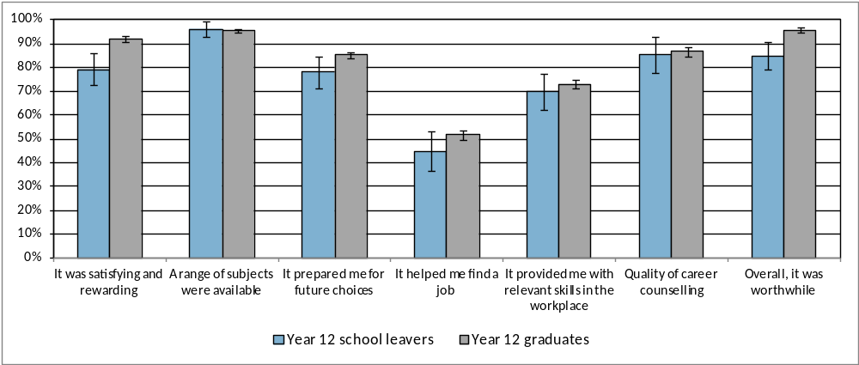
Note: The error bars reflect the 95 percent confidence intervals and no overlap indicates there is a statistical difference between the results.

Reasons for leaving school
Parents of years 9 to 11 students who left school in 2014 were asked the reasons why their child decided to leave school (Table 10). The most common responses were the child wanted to get a job (61%), the child wanted to earn their own money (61%) and the child was not doing very well at school (53%).
Table 10: Most common responses parents gave regarding why their child (who was in year 9, 10 or 11 in 2014) left school
Response Categories | Proportion (%)
Wanted to get a job | 61.1
Wanted to earn his/her own money | 61.1
Not doing very well at school | 52.7
Had a job to go to | 38.3
Didn't get on with the teachers and/or students at school | 36.8
Wanted to do study or training that wasn't available at school | 34.0
Had an illness, disability or caring responsibilities | 27.7
Note: The percentages in this table do not add to 100 percent, as respondents could provide more than one response.

Part 2 – 2013 Year 12 Graduates and School Leavers

Pathways of 2013 year 12 graduates
Key outcomes
Ninety-six percent of 2013 year 12 graduates reported that they were employed and/or studying in 2015. Seventy-eight percent of graduates were employed and 76 percent of all year 12 graduates were studying in 2015. Overall, 2013 year 12 graduate participation in study increased substantially from 2014 to 2015 and there was a slight increase in the percentage employed and employed and/or studying over the same period. These results are consistent with employment and/or study results reported in similar interstate longitudinal surveys with different year cohorts (Queensland Department of Education, Training and Employment, 2013; Victorian Department of Education and Early Childhood Development, 2010). However, the percentage increase in participation in study was much larger in ACT which may be due to the more recent reporting period in this publication and/or the greater percentage of graduates who deferred study in the first year after leaving school and commenced study in the following year in the ACT.
Table 11 provides the 2015 main employment and study destinations by employment and study destination in 2014 for 2013 year 12 graduates. Eighty-eight percent of the graduates who were employed in 2014 remained employed in 2015, 86 percent of those studying in 2014 were still studying in 2015 and 97 percent of those employed and/or studying in 2014 were still employed and/or studying in 2015. Of the 2013 year 12 graduates who were not employed or studying in 2014, 55 percent had gained employment in 2015 and 52 percent had commenced study in 2015. Twenty-one percent of the 2013 year 12 graduates who were not employed or studying in 2014 remained in this category in 2015.
Table 11: Proportion of 2013 year 12 graduates employed and/or studying in 2015, by employed and/or studying in 2014 (%)
 | 2015 |  |  | Distribution in 2014
2014 | Employed | Studying | Employed and/or Studying
Employed | 88.2 | 75.3 | 97.5 | 75.2
Studying | 77.2 | 86.4 | 97.1 | 59.7
Employed and/or Studying | 79.5 | 77.6 | 96.7 | 93.1
Not employed or studying | 55.2 | 52.1 | 79.1 | 6.9
Distribution in 2015 | 77.8 | 75.9 | 95.5 | 100.0

Study
Most (86%) of the 2013 year 12 graduates who were studying in 2014 were still studying in 2015. The ASCED was used to classify level of study, with responses of advanced diploma, associate degree and bachelor degree or higher being more broadly classified as the higher education level and responses of Certificate I-IV and diploma being described as the Vocational Education and Training (VET) level in this publication.
Ninety-two percent of those studying at a higher education level continued with study at this level in 2015 and 60 percent of those studying at a vocational education and training level continued with study at this level in 2015 (Table 12). Twenty-eight percent of the year 12 graduates who were studying at the vocational education and training level in 2014 were not studying in 2015, with the majority (66%) of these graduates completing the qualification prior to the survey in 2015. Over half (60%) of the graduates who were not studying in 2014, commenced study in 2015. Forty-four percent of 2013 year 12 graduates not studying in 2014 commenced study at the higher education level in 2015, with the majority (79%) of these students having formally deferred university in 2014.
Table 12: Level of study in 2015 by level of study in 2014 for 2013 Year 12 graduates (%)
 |  | 2015
 |  | Studying |  |  |  | Not studying | Total
2014 |  | Higher education | VET course | Other | All
Studying |  | 65.4 | 18.9 | 2.1 | 86.4 | 13.6 | 100.0
 | Higher education | 91.8 | 1.5 | 0.0 | 93.4 | 6.6 | 100.0
 | VET course | 11.1 | 59.8 | 1.6 | 72.4 | 27.6 | 100.0
 | Other | 20.1 | 9.9 | 42.4 | 72.4 | 27.6 | 100.0
Not Studying |  | 44.2 | 14.7 | 1.4 | 60.2 | 39.8 | 100.0
Distribution in 2015 |  | 55.8 | 5.2 | 1.7 | 75.9 | 24.1 | 100.0
Note: The percentages in this table do not all add to 100 percent due to rounding and a small percentage of ‘don’t know’ responses. Diploma includes associate degree or diploma.
Forty percent of 2013 year 12 graduates were studying at the higher education level in 2014. Figure 4 provides details of the 2015 main destination for 2013 year 12 graduates studying at the higher education level in 2014. The majority (78%) of 2013 year 12 graduates, who were studying at the higher education level in 2014, were still undertaking the same study in 2015. Thirteen percent of 2013 year 12 graduates who were studying at the higher education level in 2014 made a change to their study field, qualification and/or study load in 2015. Seven percent did not continue to study in 2015, with five percent employed and two percent unemployed or not in the labour force.
Figure 4: 2015 main destination for 2013 Year 12 graduates who were studying at the higher education level in 2014
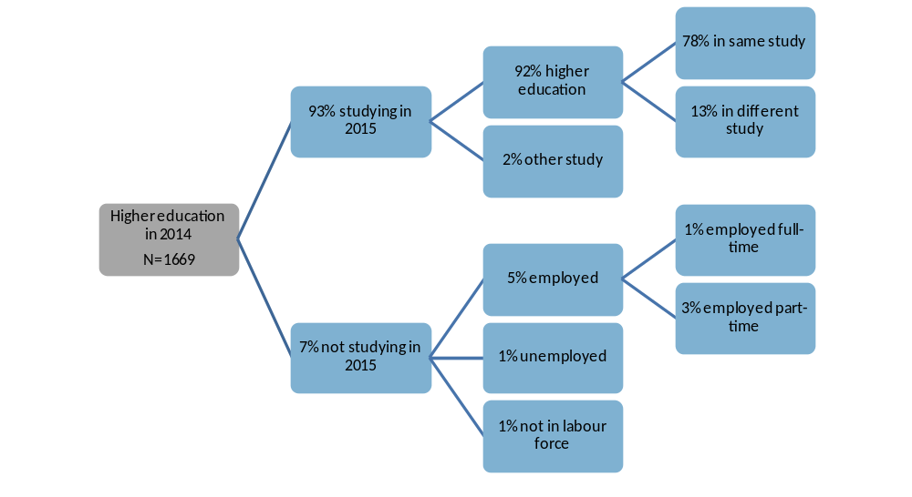
Note: The percentages in this figure do not all add to 100 percent due to rounding and a small percentage of ‘don’t know’ responses.
Eighteen percent of 2013 year 12 graduates were studying at the VET level in 2014. Figure 5 provides details of the 2015 main destination for 2013 year 12 graduates studying at the VET level in 2014. Forty-six percent of 2013 year 12 graduates who were studying at the VET level in 2014, were still undertaking the same study in 2015. Thirteen percent of 2013 year 12 graduates who were studying at the VET level in 2014 made a change to their study field, qualification and/or study load in 2015. Twenty-eight percent did not continue to study in 2015, with 23 percent employed and four percent unemployed or not in the labour force.
Figure 5: 2015 main destination for 2013 Year 12 graduates who were studying at the VET level in 2014
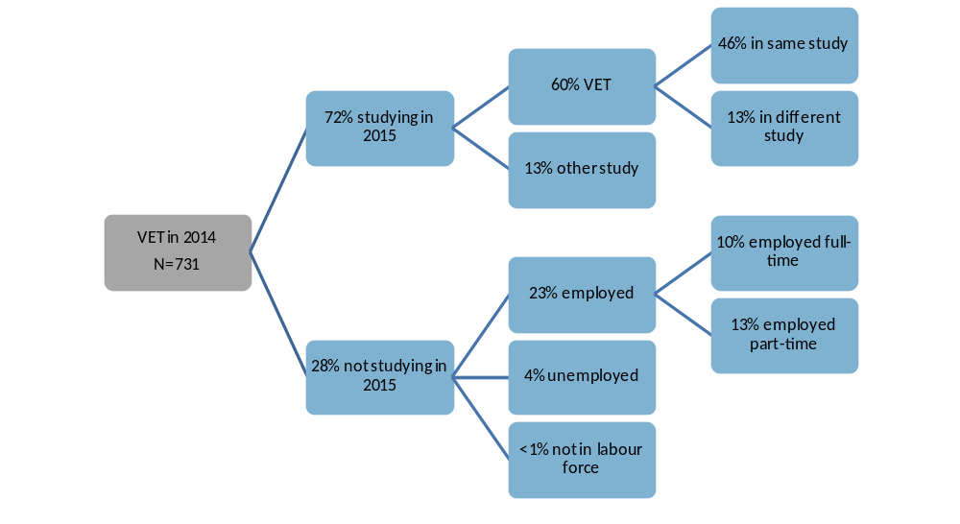
Note: The percentages in this figure do not all add to 100 percent due to rounding and a small percentage of ‘don’t know’ responses.
Seven percent of 2013 year 12 graduates were undertaking an Australian Apprenticeship (had signed a national training contract) in 2014. Figure 6 provides details of the 2015 main destination for 2013 year 12 graduates who were undertaking an Australian Apprenticeship in 2014. Over half (62%) of 2013 year 12 graduates, who were undertaking an Australian Apprenticeship in 2014, were still undertaking the same apprenticeship or traineeship in 2015. Four percent of 2013 year 12 graduates continued to undertake an Australian Apprenticeship in 2015 but made a change to their study field and/or study load in 2015. Twenty-one percent of the 2013 year 12 graduates, who were undertaking an Australian Apprenticeship in 2014, continued to study in 2015 but not as an apprentice or trainee. Thirteen percent did not continue to study in 2015, with 12 percent employed and one percent unemployed or not in the labour force.

Figure 6: 2015 main destination for 2013 Year 12 graduates who were undertaking an Australian Apprenticeship in 2014
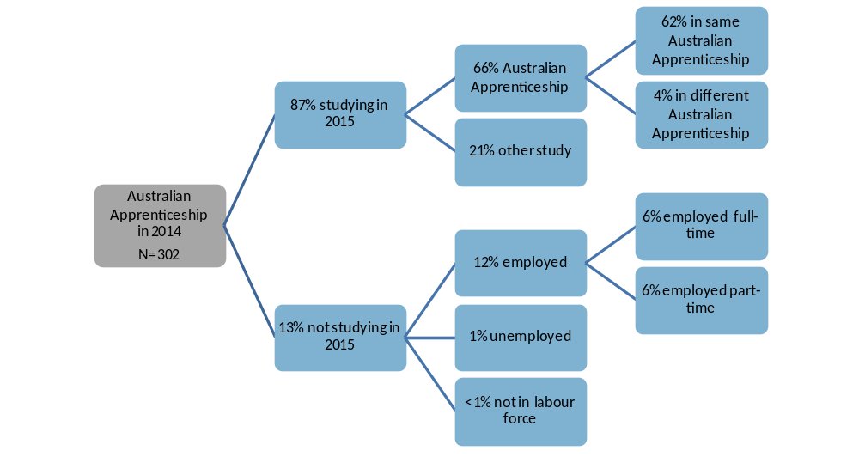
Note: The percentages in this figure do not all add to 100 percent due to rounding and a small percentage of ‘don’t know’ responses.
Eight percent of 2013 year 12 graduates were studying in 2014 but not in 2015, and about half (51%) of these graduates said they successfully completed the course and/or qualification they were undertaking.
Ten percent of graduates were not studying in 2014 or 2015 but indicated that they were planning to study in 2015 or 2016 at the time of the survey in 2014. Twenty-nine percent of these graduates said their main reason for not studying was because they got a job.
Thirty-two percent of 2013 year 12 graduates intended to start some study in the next two years at the time of the survey in 2014, with about half (51%) of these graduates formally deferring a university offer. Figure 7 details the 2015 study destination for these graduates and graduates with an informal intention to study (intended to study but did not formally defer university) in the next two years. Eighty-six percent of 2013 year 12 graduates that deferred university in 2014 were attending university in 2015, three percent were studying elsewhere, seven percent were not currently studying but intending to start study in 2016 and two percent no longer had an intention to study in 2016. Of the 2013 year 12 graduates who in 2014 reported an informal intention to study in 2015 or 2016, 22 percent were attending university in 2015, 25 percent were undertaking other study, 26 percent were not studying in 2015 but still had an intention to study in 2016 and 20 percent were not studying in 2015 and no longer had an intention to study in 2016.
Figure 7: 2015 study destination for 2013 Year 12 graduates who in 2014 reported an intention to study
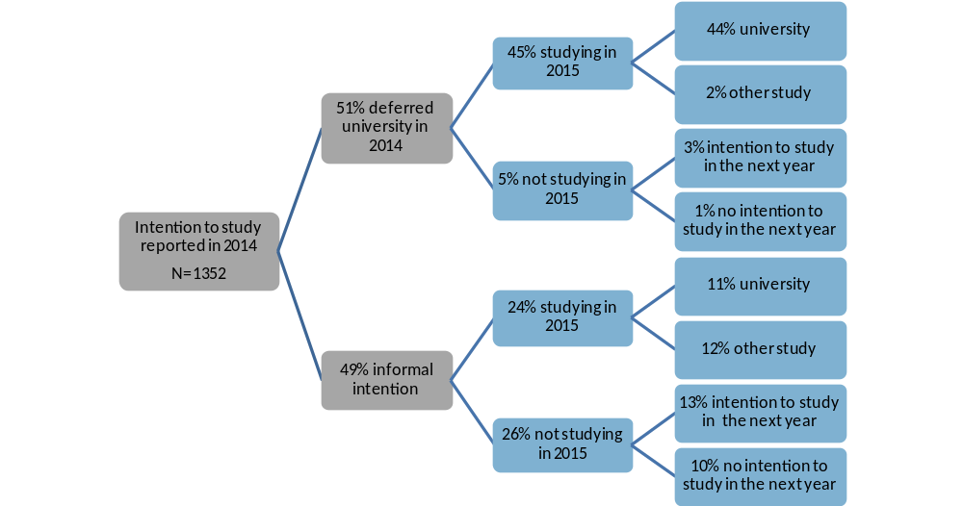
Note: The percentages in this figure do not all add to 100 percent due to rounding and a small percentage of ‘don’t know’ responses.
These results are consistent with findings from the Longitudinal Surveys of Australian Youth which track young people as they move from school (starting at 15 years of age) into further study, work and other destinations (Lumsden & Stanwick, 2012). Almost three quarters of Australian young people (in the year 2003 cohort) who intended to attend university did so by the age of 23, including about 10 percent who took a break between school and university (Curtis, Mlotkowski & Lumsden, 2012). Of most interest is that there does not appear to be any significant differences, in course outcomes, between those that started university straight after finishing school and those that had a break (Curtis, Mlotkowski & Lumsden, 2012).
Table 13: 2015 field of study by 2014 intended field of study for 2013 Year 12 graduates (%)
 | Field of study in 2015
Intended field of study in 2014 | Natural and physical sciences | Health | Management and commerce | Society and culture | Creative arts | Other | Total
Natural and physical sciences | 60.1 | 11.4 | 5.7 | 7.6 | 0.0 | 15.2 | 100.0
Health | 17.9 | 58.5 | 1.4 | 8.9 | 0.0 | 11.9 | 100.0
Management and commerce | 2.1 | 1.9 | 60.1 | 25.8 | 0.0 | 10.2 | 100.0
Society and culture | 11.1 | 2.5 | 6.5 | 58.2 | 7.2 | 14.5 | 100.0
Creative arts | 0.0 | 3.9 | 9.4 | 9.4 | 58.4 | 19.0 | 100.0
Other | 6.2 | 3.6 | 7.2 | 5.5 | 4.6 | 72.8 | 100.0
Note: The percentages in this table do not all add to 100 percent due to rounding and a small percentage of ‘don’t know’ responses.
Twenty-two percent of 2013 year 12 graduates were intending to study in the next two years at the time of the survey in 2014 and were studying in 2015, with 54 percent of these graduates studying in their intended ASCED field of study. Table 13 highlights the most common fields of study in 2015 for each of the most common intended fields of study in 2014. Twenty-six percent of 2013 year 12 graduates who intended to study in the field of management and commerce commenced study in the field of society and culture in 2015 and 18 percent of graduates who intended to study in the field of health commenced study in the field of natural and physical sciences in 2015.
Twenty-four percent of 2013 year 12 graduates started studying in 2015, with 61 percent of these graduates deferring university, 32 percent reported having an informal intention to study in the next two years and eight percent had no intention to study at the time of the survey in 2014. Table 14 details the main reason for starting study in 2015 for each type of study intention in 2014. Of the graduates who deferred university, 53 percent chose a course because it interested them and 34 percent chose the course because they thought it would assist with employment.
Assisting with employment was the most common main reason 2013 year 12 graduates, with an informal intention to study (47%) and those with no intention to study (64%), decided to commence study in 2015.
Table 14: Main reason for starting study in 2015 by study intention in 2014 for 2013 Year 12 graduates (%)
 | Reason for starting study in 2015
Not studying in 2014 | It's a course that interests me | To get/start/help in a job/business | To help get into another course | To improve my education | Other | Total
Deferred University | 53.2 | 33.8 | 3.2 | 3.7 | 4.7 | 100.0
Informal intention to study | 38.3 | 47.3 | 4.1 | 4.9 | 4.8 | 100.0
No intention to study | 24.4 | 63.6 | 0.0 | 4.8 | 2.4 | 100.0
Note: The percentages in this table do not all add to 100 percent due to rounding and a small percentage of ‘don’t know’ responses.
Labour force status
Overall, part-time employment was the most common labour force status for 2013 year 12 graduates in 2014 and 2015. Most (88%) of the 2013 year 12 graduates who were employed in 2014 were still employed in 2015, with most continuing in either full-time or part-time employment (Table 15). Of those who were unemployed in 2014, 59 percent gained employment in 2015 and 26 percent remained unemployed. Almost half (49%) of those that were not in the labour force in 2014, joined the labour force in 2015, with 32 percent in employment and 17 percent unemployed.
Table 15: 2015 labour force status in 2015 by 2014 labour force status for 2013 Year 12 graduates (%)
 |  |  | 2015
 |  |  | Employed |  |  | Unemployed | Not in labour force | Total
2014 |  |  | Part-time | Full-time | Total |  | Not in labour force | Total
Employed |  |  | 59.6 | 27.4 | 88.2 | 6.6 | 5.2 | 100.0
 | Part-time |  | 78.3 | 9.4 | 88.0 | 7.0 | 5.0 | 100.0
 | Full-time |  | 13.8 | 75.2 | 89.3 | 4.9 | 5.9 | 100.0
Unemployed |  |  | 46.6 | 12.1 | 59.1 | 25.8 | 15.2 | 100.0
Not in labour force |  |  | 27.0 | 3.9 | 31.7 | 16.8 | 51.5 | 100.0
Distribution in 2015 |  |  | 54.1 | 22.7 | 77.8 | 10.3 | 11.9 | 100.0
Note: The percentages in this table do not all add to 100 percent due to rounding and a small percentage of ‘don’t know’ responses.
Seventy-five percent of 2013 year 12 graduates were employed in 2014, and 56 percent of these graduates were studying in 2014. Figure 8 details the 2015 labour force destination for these graduates and graduates who were employed but not studying in 2014. Of those that were employed in 2014, 36 percent were studying in 2014 and employed in the same job in 2015 and 20 percent were not studying in 2014 and employed in the same job in 2015.
Figure 8: 2015 labour force status for 2013 Year 12 graduates employed in 2014, by 2014 study status
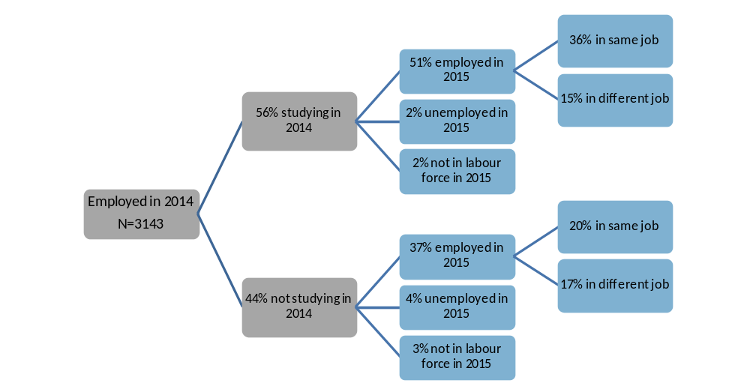
Note: The percentages in this figure do not all add to 100 percent due to rounding and a small percentage of ‘don’t know’ responses.
Thirteen percent of 2013 year 12 graduates were unemployed in 2014, and 65 percent of these graduates were studying in 2014. Figure 9 details the 2015 labour force destination for these graduates and graduates who were unemployed and not studying in 2014. Of those that were unemployed in 2014, 40 percent were studying in 2014 and employed in 2015 and 19 percent were not studying in 2014 and employed in 2015.
Figure 9: 2015 labour force status for 2013 Year 12 graduates unemployed in 2014, by 2014 study status
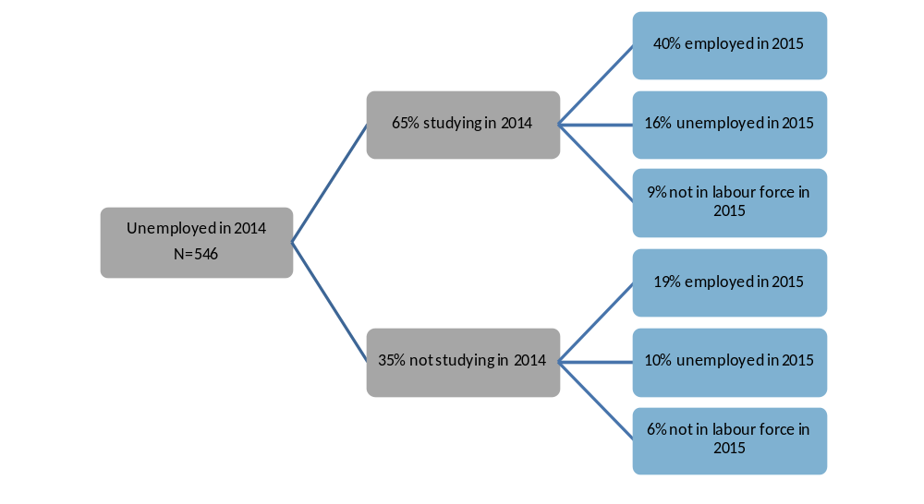
Note: The percentages in this figure do not all add to 100 percent due to rounding and a small percentage of ‘don’t know’ responses.
Twelve percent of 2013 year 12 graduates were not in the labour force in 2014, and 80 percent of these graduates were studying in 2014. Figure 10 details the 2015 labour force destination for these graduates and graduates who were not in the labour force and not studying in 2014. Of those that were not in the labour force in 2014, 20 percent were studying in 2014 and employed in 2015 and 11 percent were not studying in 2014 and employed in 2015.
Figure 10: 2015 labour force status for 2013 Year 12 graduates not in the labour force in 2014, by 2014 study status
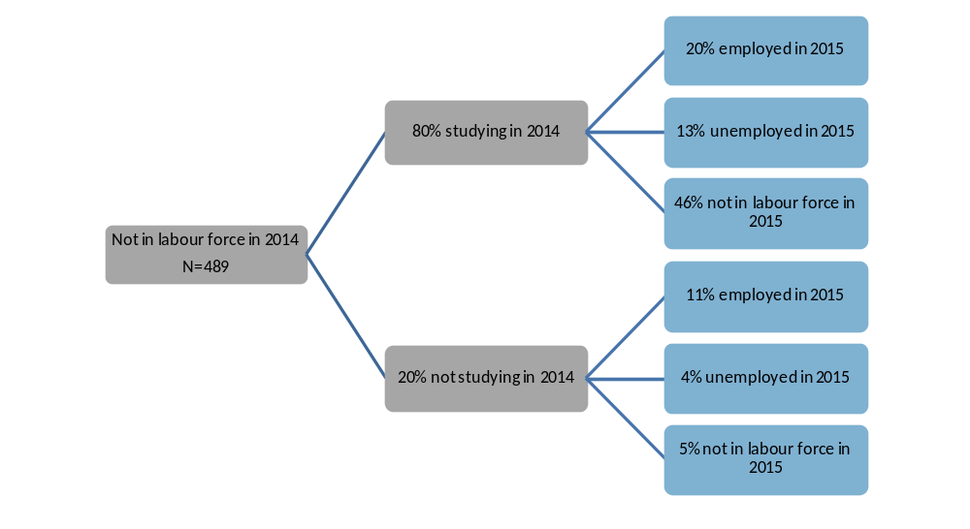
Note: The percentages in this figure do not all add to 100 percent due to rounding and a small percentage of ‘don’t know’ responses.
Table 16: 2015 labour force status by 2014 labour force status for 2013 Year 12 graduates studying in 2014 (%)
 |  |  | 2015
 |  |  |  | Employed |  |  | Unemployed | Not in labour force | Total
Studying in 2014 |  |  |  | Part-time | Full-time | Total |  | Not in labour force | Total
Employed |  |  |  | 66.8 | 23.7 | 91.9 | 4.4 | 3.7 | 100.0
 | Part-time |  |  | 84.5 | 6.7 | 91.2 | 4.7 | 4.1 | 100.0
 | Full-time |  |  | 6.5 | 88.8 | 95.8 | 1.6 | 2.6 | 100.0
Unemployed |  |  |  | 55.2 | 6.3 | 61.5 | 24.5 | 14.0 | 100.0
Not in labour force |  |  |  | 22.4 | 2.9 | 25.3 | 16.3 | 58.4 | 100.0
Distribution in 2015 |  |  |  | 58.3 | 18.0 | 77.2 | 9.1 | 13.7 | 100.0
Note: The percentages in this table do not all add to 100 percent due to rounding and a small percentage of ‘don’t know’ responses.
Sixty percent of the 2013 year 12 graduates were studying in 2014. Part-time employment was the most common labour force status for these graduates in 2014 and 2015. Most (92%) of the 2013 year 12 graduates studying and employed in 2014 were still employed in 2015, with most continuing in either full-time or part-time employment (Table 16). Of those who were studying and unemployed in 2014, 61 percent gained employment in 2015 and 24 percent remained unemployed. Forty-two percent of 2013 year 12 graduates that were studying and not in the labour force in 2014 entered the labour force in 2015.

Pathways of 2013 school leavers
Eighty-three percent of 2013 school leavers reported that they were employed and/or studying in 2015. Sixty-seven percent of school leavers were employed and 55 percent were studying in 2015. Overall, 2013 school leaver participation in study, employment and employment and/or study increased from 2014 to 2015.
Table 17 provides the 2015 employment and study destinations by employment and study destination in 2014 for 2013 school leavers. Eighty-six percent of the school leavers who were employed in 2014 remained employed in 2015, 77 percent of those studying in 2014 were still studying in 2015 and 93 percent of those employed and/or studying in 2014 were still employed and/or studying in 2015. Of the 2013 school leavers who were not employed or studying in 2014, 26 percent had gained employment in 2015 and 28 percent had commenced study in 2015. Fifty-five percent of the school leavers who were not employed or studying in 2014 remained in this category in 2015.
Table 17: Proportion of 2013 school leavers employed and/or studying in 2015, by employed and/or studying in 2014 (%)
 | 2015 |  |  | Distribution in 2014
2014 | Employed | Studying | Employed and/or Studying | Distribution in 2014
Employed | 85.9 | 58.7 | 95.3 | 60.4
Studying | 77.4 | 77.1 | 91.6 | 51.6
Employed and/or Studying | 78.3 | 62.6 | 93.2 | 78.4
Not employed or studying | 26.0 | 28.5 | 45.2 | 21.6
Distribution in 2015 | 67.0 | 55.2 | 82.9 | 100.0

Most (77%) of the 2013 school leavers who were studying in 2014 were still studying in 2015. Sixty-nine percent of the 2013 school leavers who were studying at the VET level in 2014 continued to study in 2015, with 61 percent continuing at the VET level in 2015. Thirty-two percent of the school leavers who were not studying in 2014 commenced study in 2015.
Full-time employment was the most common labour force status for 2013 school leavers in 2014 and 2015. Most (86%) of the 2013 school leavers who were employed in 2014 were still employed in 2015, with most continuing in either full-time or part-time employment. Of those who were unemployed in 2014, 51 percent gained employment in 2015 and 39 percent remained unemployed. Fifty-two percent of those that were not in the labour force in 2014 joined the labour force in 2015, with 29 percent in employment and 23 percent unemployed.
Scope and methodology
The annual School Leaver Survey is a survey of students in years 9 to 12 who left the ACT school system or were awarded an ACT Year 12 Certificate in the preceding year. This publication includes a summary of the results of the fifth annual survey, conducted in 2015.
The survey frame was drawn from administrative records held within the Directorate, non-government schools and the Board of Senior Secondary Studies (BSSS). 2014 year 12 graduates included those that were awarded an ACT Year 12 Certificate from an ACT college, school or the Canberra Institute of Technology (CIT) in 2014. 2014 school leavers included year 9 to 12 ACT students who were listed as attending an ACT school in the 2014 February school census but not in the 2015 census (and did not obtain an ACT Year 12 Certificate). The survey excluded full fee paying students whose usual residence was overseas, school leavers who experienced a traumatic event, returned to school prior to May 2015 or moved interstate or overseas and school leavers from a small number of ACT non-government schools who chose not to participate in the survey.
Prior to the annual School Leaver Survey being undertaken a primary approach letter was sent to year 12 graduates and year 12 school leavers and parents of years 9 to 11 school leavers. This provided information about its purpose and importance: the broad content of the survey, the amount of time the interview would take and confidentiality provisions. The survey was undertaken by telephone from 4 May 2015 to 2 June 2015. Of the 3,701 graduates sent a primary approach letter, 2,541 completed the survey, providing a response rate of 69 percent. Of the 654 school leavers sent a primary approach letter, 384 completed the survey, providing a response rate of 59 percent. The figures reported in this publication are estimates based on weighting the survey responses to reflect the total number of 4,291 graduates and 823 school leavers.
The 2015 longitudinal survey of 2013 year 12 graduates and school leavers surveyed young people who participated in the annual school leaver survey in 2014 and agreed to be recontacted in 2015. The vast majority (98%) agreed to be recontacted in 2015 and provided updated contact details when they completed the survey in 2014. This publication includes a summary of the post-school pathways from wave 1 (conducted in 2014) to Wave 2 (conducted in 2015).
Prior to the survey being undertaken an email was sent to a sample of 2013 year 12 graduates and all 2013 school leavers that agreed to participate in 2015 and provided a valid email address when surveyed in 2014. The email provided information about the purpose, importance and content of the survey, the amount of time the interview would take and confidentiality provisions. The 2015 survey of 2013 year 12 graduates, year 11 and 12 school leavers and parents of year 9 and 10 school leavers, was undertaken by telephone from 4 May 2015 to 2 June 2015. Of the 2,247 graduates identified for the survey, 1,750 completed the survey, providing a response rate of 78 percent. Of the 352 school leavers identified for the survey, 229 completed the survey, providing a response rate of 65 percent. The figures reported in this publication are estimates based on weighting the survey responses for 2015 (and corresponding 2014 responses) to reflect the total number of 4,178 graduates and 824 school leavers. Please note, the 2014 figures reported in this publication are in some cases slightly different to the figures reported in the 2013 ACT year 12 graduates and school leavers: Where were they in 2014? publication because they are based on only those students who completed both the 2014 and 2015 surveys.

Glossary
ANZSCO - Australian and New Zealand Standard Classification of Occupations is a standard used in Australia and New Zealand to classify all occupations and jobs and is designed facilitate the organisation and comparability of occupation statistics.
ASCED - Australian Standard Classification of Education is a standard used in Australia to classify all education levels and fields of education. It is designed facilitate the organisation and comparability of education statistics.
ATAR - Australian Tertiary Admission Rank is a percentile ranking used by universities to assist in the selection of school leavers for entry into undergraduate courses. It is used as an indication of a student’s suitability for study at university level, and to allow universities to select appropriate numbers of students for each course.
Career counselling in schools may include one on one or group discussion between students and career advisors, industry experts and representatives from universities and CIT about various aspects of student pathways planning, such as course choices, work experience and developing a resume.
Currently studying refers to respondents who were actively undertaking some study at the time of the survey, including those attending university, technical and further education (TAFE), undertaking an Australian apprenticeship or repeating year 12.
Engagement programs are school based programs, such as Big Picture, Connect 10 and Canberra College Cares.
Labour force status provides data on whether a graduate was employed (full or part-time), unemployed (looking for full or part-time work) or not in the labour force at the time of the survey. Labour force status was derived from responses to a number of questions in the survey.
LBOTE is used in this publication to describe graduates who speak a language other than English at home. Please note, this is slightly different from Language Background other than English (also known as LBOTE) which is used when a language other than English is spoken at home by the individual and/or one or both of their parents.
Government pensions, allowances and benefits include Austudy or ABSTUDY, Carer Allowance or Carer Payment, Disability Support Pension, Newstart Allowance, Parenting Payment, Sickness Allowance, Special Benefit and Youth Allowance.
VET - Vocational Education and Training courses are accredited vocational courses provided by a Registered Training Organisation. Successful completion usually leads to the award of a Vocational Certificate.
References
Australian Bureau of Statistics (2015). Education and Work, Australia, May 2015. Cat. No. 6227.0. Canberra, Australia: Australian Bureau of Statistics.
Curtis, D., Mlotkowski, P. & Lumsden, M. (2012). Bridging the gap: Who takes a gap year and why? Longitudinal Surveys of Australian Youth Research Report. Adelaide, South Australia: National Centre for Vocational Education and Research Ltd.
Queensland Department of Education, Training and Employment (2013). Next step longitudinal study 2012: A report on the post-school transitions of Queensland’s Year 12 completers from 2010. Queensland: State of Queensland.
Lumsden, M. & Stanwick, J. (2012). Who takes a gap year and why? Longitudinal Surveys of Australian Youth Briefing Paper 28. Adelaide, South Australia: National Centre for Vocational Education and Research Ltd.
Victorian Department of Education and Early Childhood Development (2010). The On Track Survey 2009 Longitudinal report: The 2007 cohort 2 years on. Victoria: State of Victoria.

Published by Education Directorate | ACT Government
220 Northbourne Avenue, Canberra City ACT 2602 | GPO Box 158, CANBERRA ACT 2601
Phone: (02) 6207 5111 Web: http://www.det.act.gov.au

