ACT POST SCHOOL DESTINATIONS AND PATHWAYS IN 2017

A summary of the 2017 results from the survey of 2016 year 12 graduates and school leavers and the longitudinal survey of 2015 year 12 graduates and school leavers.

Key Findings
- Ninety-three percent of 2016 year 12 graduates were employed and/or studying in 2017, compared with 78 percent of 2016 school leavers in the survey.
- Fifty-nine percent of 2016 year 12 graduates were studying in 2017 and a further 31 percent intended to start some study in the next two years.
- Forty five percent of 2016 school leavers were studying in 2017 and a further 28 percent intended to start some study in the next two years.
- Seventy-five percent of 2016 year 12 graduates were employed in 2017, compared with 66 percent of 2016 school leavers.
- The percentage of 2015 year 12 graduates studying increased from 58 percent in 2016 to 72 percent in 2017.
- Eighty percent of the 2015 year 12 graduates who deferred university in 2016 were attending university in 2017.
- Fifty-four percent of 2015 year 12 graduates and 23 percent of 2015 school leavers who were not studying in 2016, started studying in 2017

© Australian Capital Territory, Canberra, 2017
This publication has been produced by the ACT Government. Apart from any use permitted under the Copyright Act 1968, no part of this publication may be reproduced by any process without written permission from the ACT Government’s Education Directorate.
Contents

Executive Summary 4
Background 6
Part 1 – 2016 Year 12 Graduates and School Leavers 6
Destination of 2016 year 12 graduates 6
Key outcomes 6
Study 8
Labour force status 11
Participation in other post-school activities 13
Destination of 2016 school leavers 13
Characteristics of students who left school in 2016 16
Satisfaction with school 17
Reasons for leaving school 18
Part 2 – 2015 Year 12 Graduates and School Leavers 19
Pathways of 2015 year 12 graduates 19
Key outcomes 19
Study 20
Labour force status 24
Pathways of 2015 school leavers 27
Satisfaction with life 28
Scope and methodology 29
Glossary 30
References 31

Executive Summary
The ACT Government believes every student in the ACT should have access to the opportunities provided through quality education. The Education Directorate 2014-17 Strategic Plan sets out an ambitious agenda to ensure progress for all students and an increase in the qualification levels of the ACT, with every Canberran set for life through access to quality further education and training.

In its commitment to an educated and skilled workforce to meet the present and future needs of the ACT, the Education Directorate has prioritised learning pathways designed to meet the needs of young people through flexible training options and engagement with industry and employers.

In May 2017 the Education Directorate conducted two post school destination surveys.
- The annual survey of 2016 ACT year 12 graduates (those who completed an ACT Senior Secondary Certificate in 2016) and year 9 to 12 school leavers (those who were in year 9 to 12 when they left school in 2016 prior to completing an ACT Senior Secondary Certificate). A total of 2374 graduates and 356 school leavers completed the survey.
- A longitudinal survey of 2015 ACT year 12 graduates and school leavers (approximately 1.5 years after leaving school). This longitudinal survey was the second wave of the three-year longitudinal study of 2015 ACT year 12 graduates and school leavers (conducted in 2016, 2017 & 2018). A total of 1803 graduates and 195 school leavers completed the survey.

Part 1 of the ACT Post School Destinations and Pathways in 2017 report presents information about the 2017 destinations of 2016 ACT year 12 graduates and school leavers and part 2 presents information about the pathways 2015 year 12 graduates and school leavers have taken from 2016 to 2017.
The vast majority (93%) of 2016 ACT year 12 graduates, were employed and/or studying in 2017, with the report highlighting that females, those who gained an ATAR and/or did not receive a pension, were more likely to be employed and/or studying than their peers.

Survey results for 2016 school leavers showed that 78 percent were employed and/or studying in 2017. The report highlights that males, those who spoke a language other than English at home received career guidance and/or did not receive a pension were more likely to be employed and/or studying than their peers.

The report shows that 31 percent of 2016 year 12 graduates and school leavers were not studying in 2017, but were intending to study in the next two years. A similar trend has been observed in previous years. The results from the longitudinal survey found that over half of the 2015 graduates who indicated their intention to study in 2017 or 2018, when surveyed in 2016, did start studying in 2017. Figure 1 shows the overall increase in the percentage of 2015 year 12 graduates and school leavers commencing study in 2017. 2015 year 12 graduates who formally deferred university in 2016 were more likely to start study in 2017 than those who had an informal intention to study.
Figure 1: 2015 year 12 graduates and school leavers by study status in 2016 and 2017 (%)
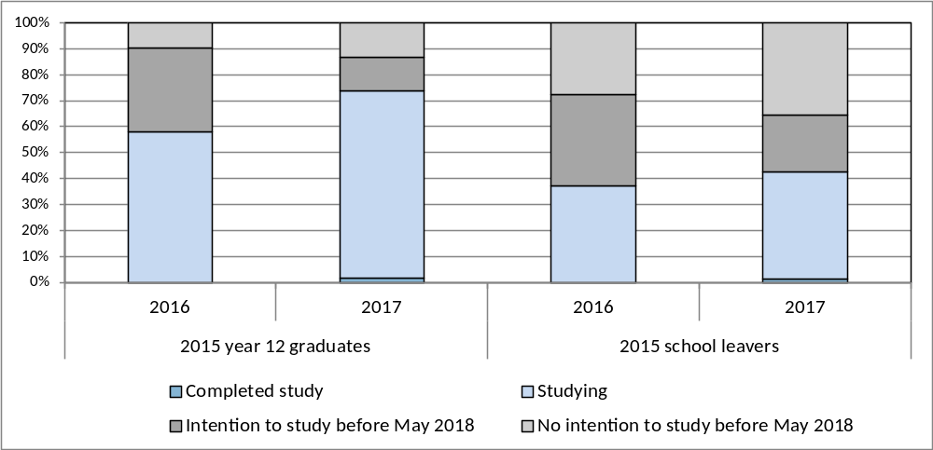

Overall, the report presents a positive picture of the pathways from school to further study and employment for young people both graduating from and leaving ACT schools. However, the report clearly shows that those young people who complete an ACT Senior Secondary Certificate are advantaged both in terms of employment and further study outcomes, six months after leaving school, when compared with their peers who leave school before completing an ACT Senior Secondary Certificate (see Figure 2 below).

Figure 2: 2016 year 12 graduates and school leavers by main destination in 2017 (%)
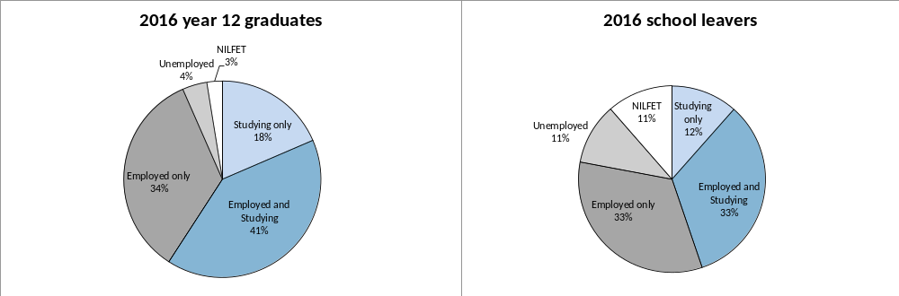
Note: NILFET means ‘not in labour force, education or training’.
The School Leaver Survey results provide important information that informs planning, development and provision of education and training choices for the young people of the ACT. The Directorate works closely with school staff in ACT public and non-government schools to ensure the survey results are disseminated and used for curriculum planning and to assist students with study and career choices at school and beyond.

Background
Australia is in a period of significant education and training reform. The current national reform agenda is impacting on all sectors of education, training and skills development. The ACT is proactive in looking to the future of education and training in our region, building on the strengths of current collaborations, relationships and partnerships within the sector, and promoting opportunities for change.
The ACT is committed to providing learning pathways for students which result in an educated and skilled workforce to meet the present and future needs of the ACT and region. The focus is on ensuring young people’s needs are met, providing flexible and responsive training options, engaging with industry and employers and improving retention rates. Together these strategies empower students to shape their own learning pathways while meeting industry needs.
Results from the School Leaver Surveys provide important information that informs planning, development and provision of education and training choices for the young people of the ACT.
In addition to the annual School Leaver Survey, the Education Directorate recently introduced a longitudinal survey to find out if students continue with their initial and/or intended pathways in subsequent years and to further explore issues identified in the annual survey, such as the trend to defer further study. The longitudinal survey of 2015 year 12 graduates and school leavers will survey consenting 2015 year 12 graduates and school leavers three times in total; 2016 (Wave 1), 2017 (Wave 2) and 2018 (Wave 3). In 2017, the Directorate completed Wave 2.
In this publication students who completed an ACT Senior Secondary Certificate in 2016 are described as 2016 year 12 graduates. Students who were in year 9 to 12 when they left school in 2016 prior to completing an ACT Senior Secondary Certificate are described as 2016 school leavers. Students who completed an ACT Senior Secondary Certificate in 2015 are described as 2015 year 12 graduates. Students who were in year 9 to 12 when they left school in 2015 prior to completing an ACT Senior Secondary Certificate are described as 2015 school leavers.

Part 1 – 2016 Year 12 Graduates and School Leavers

Destination of 2016 year 12 graduates
Key outcomes
Ninety-three percent of 2016 year 12 graduates reported that they were employed and/or studying in 2017. This is similar to the Australian employed and/or studying rate in 2016 of 92 percent for 15-24 year olds who completed year 12 prior to leaving school in 2015 (Australian Bureau of Statistics, 2016).
Table 1 provides an overview of the percentage of year 12 graduates employed, studying and employed and/or studying in the year following graduation. Data are presented for surveys conducted with 2013, 2014, 2015 and 2016 year 12 graduates. The following points were consistently noted over the four years:
- female students were more likely to be employed and more likely to be employed and/or studying than male graduates. For example, 78 percent of female 2016 year 12 graduates were employed in 2017 compared to 72 percent of male graduates
- graduates who spoke a language other than English at home (LBOTE) were more likely to be studying and less likely to be employed than graduates who were not LBOTE
- graduates who did not obtain an Australian Tertiary Admission Rank (ATAR) were less likely to be studying and less likely to be employed and/or studying
- graduates who were receiving a Government pension, allowance or benefit were more likely to be studying, less likely to be employed and less likely to be employed and/or studying.
Table 1: Year 12 graduates employed and/or studying, by selected demographics (%)
 |  | Employed |  |  |  |  | Currently studying |  |  |  |  | Employed and/or studying
Year of graduation |  | 2013 | 2014 | 2015 | 2016 |  | 2013 | 2014 | 2015 | 2016 |  | 2013 | 2014 | 2015 | 2016
Gender
 | Female | 75.2 | 72.8 | 75.7 | 77.5 |  | 61.8 | 61.7 | 59.3 | 59.8 |  | 93.7 | 93.1 | 94.5 | 94.8
 | Male | 70.8 | 66.3 | 68.9 | 72.2 |  | 56.7 | 60.7 | 58.0 | 58.5 |  | 90.1 | 90.7 | 90.4 | 92.0
LBOTE
 | No | 75.9 | 72.9 | 76.2 | 78.5 |  | 55.8 | 58.3 | 54.5 | 55.9 |  | 91.7 | 91.6 | 92.2 | 93.5
 | Yes | 57.0 | 54.3 | 56.4 | 58.0 |  | 78.0 | 75.3 | 76.1 | 74.3 |  | 93.0 | 93.8 | 93.4 | 93.0
Participated in a VET course at school
 | No | 71.5 | 67.9 | 70.5 | 74.6 |  | 57.5 | 60.4 | 57.8 | 58.5 |  | 91.1 | 91.4 | 91.8 | 93.3
 | Yes | 77.3 | 74.7 | 77.7 | 76.0 |  | 64.2 | 63.8 | 61.3 | 61.3 |  | 94.1 | 93.5 | 94.5 | 94.0
ATAR Group
 | No ATAR | 75.6 | 74.3 | 75.7 | 76.7 |  | 49.1 | 45.4 | 45.2 | 44.7 |  | 86.7 | 85.8 | 87.8 | 89.1
 | 1 - 65 | 75.3 | 69.7 | 72.6 | 79.7 |  | 57.4 | 63.3 | 57.0 | 55.6 |  | 92.8 | 93.7 | 91.8 | 93.2
 | 66 - 75 | 79.9 | 75.8 | 74.7 | 77.2 |  | 62.9 | 66.5 | 62.9 | 64.3 |  | 96.5 | 96.7 | 94.8 | 95.8
 | 76 - 85 | 74.8 | 69.8 | 72.9 | 77.8 |  | 64.4 | 68.1 | 68.6 | 66.8 |  | 93.8 | 95.2 | 97.3 | 96.8
 | 86 - 95 | 67.0 | 62.8 | 70.1 | 70.1 |  | 67.3 | 71.5 | 70.6 | 76.0 |  | 95.1 | 93.5 | 96.3 | 97.4
 | 96 - 100 | 52.5 | 51.9 | 52.0 | 53.2 |  | 74.7 | 80.8 | 79.6 | 74.7 |  | 94.9 | 96.8 | 96.1 | 94.2
Received career counselling/career guidance at school¹
 | No | 72.5 | 68.8 | 71.0 | 71.5 |  | 60.9 | 61.4 | 57.0 | 60.4 |  | 92.0 | 91.5 | 91.0 | 93.4
 | Yes | 73.8 | 70.7 | 73.5 | 76.1 |  | 58.2 | 61.4 | 60.5 | 59.4 |  | 92.1 | 92.8 | 93.9 | 93.9
 | Don't Know | 63.5 | 57.7 | 58.1 | 63.4 |  | 52.7 | 51.7 | 27.0 | 26.9 |  | 85.5 | 76.7 | 71.4 | 70.8
Participated in work experience/workplace learning whilst at school²
 | No | 72.7 | 67.6 | 70.4 | 73.3 |  | 59.2 | 60.2 | 58.0 | 58.0 |  | 92.4 | 91.7 | 92.2 | 93.0
 | Yes | 73.2 | 71.3 | 74.0 | 76.7 |  | 59.2 | 62.2 | 59.2 | 60.4 |  | 91.5 | 92.1 | 92.7 | 93.9
Received a government pension, allowance or benefit at the time of the survey
 | No | 75.7 | 72.9 | 75.7 | 77.5 |  | 57.7 | 60.0 | 56.8 | 57.3 |  | 92.6 | 92.8 | 93.0 | 93.9
 | Yes | 46.8 | 43.7 | 43.5 | 49.9 |  | 73.9 | 71.1 | 75.9 | 78.9 |  | 85.4 | 85.0 | 87.7 | 90.3
All graduates |  | 73.0 | 69.6 | 72.3 | 74.9 |  | 59.2 | 61.2 | 58.7 | 59.1 |  | 91.9 | 91.9 | 92.5 | 93.4
¹ In 2016 career guidance replaced career counselling. ² In 2016 workplace learning replaced work experience.
Study
Fifty-nine percent of all 2016 year 12 graduates indicated that they were undertaking some study in 2017, with 50 percent studying full-time (see Table 2 below). This is slightly lower than the Australian study rate in 2016 of 63 percent (and 54% in full-time study) for 15-24 year olds who completed year 12 prior to leaving school in 2015 (Australian Bureau of Statistics, 2016).
In general, 2016 year 12 graduates who achieved a higher Australian Tertiary Admission Rank (ATAR) had a greater tendency to be undertaking further study in the year after leaving school. Seventy-five percent of the graduates with an ATAR between 96 and 100 were undertaking study in 2016, compared with 64 percent of the graduates with an ATAR between 66 and 75.
Of the nine percent of 2016 year 12 graduates who were receiving a government pension, allowance or benefit in May 2017, 79 percent were studying in 2017, compared with 57 percent of those who were not receiving a government pension, allowance or benefit.
Table 2: 2016 year 12 graduates studying in 2017, by selected demographics (%)
 |  | Studying |  |  | Not studying
 |  | Part-time | Full-time | All
Gender
 | Females | 8.0 | 51.6 | 59.8 | 40.2
 | Males | 8.9 | 48.8 | 58.5 | 41.5
LBOTE
 | No | 9.0 | 46.3 | 55.9 | 44.1
 | Yes | 6.0 | 68.3 | 74.3 | 25.7
Participated in a VET course at school
 | No | 7.8 | 50.3 | 58.5 | 41.5
 | Yes | 10.4 | 50.0 | 61.3 | 38.7
ATAR Group
 | No ATAR | 14.1 | 29.5 | 44.7 | 55.3
 | 1 - 65 | 8.0 | 47.4 | 55.6 | 44.4
 | 66 - 75 | 9.5 | 54.8 | 64.3 | 35.7
 | 76 - 85 | 2.7 | 63.5 | 66.8 | 33.2
 | 86 - 95 | 4.8 | 71.0 | 76.0 | 24.0
 | 96 - 100 | 0.0 | 74.7 | 74.7 | 25.3
Received career counselling/career guidance at school¹
 | No | 8.6 | 51.4 | 60.4 | 39.6
 | Yes | 8.4 | 50.5 | 59.4 | 40.6
Participated in work experience/workplace learning whilst at school²
 | No | 7.1 | 50.8 | 58.0 | 42.0
 | Yes | 9.9 | 49.5 | 60.4 | 39.6
Received a government pension, allowance or benefit at the time of the survey
 | No | 8.3 | 48.5 | 57.3 | 42.7
 | Yes | 9.7 | 68.7 | 78.9 | 21.1
All graduates |  | 8.4 | 50.2 | 59.1 | 40.9
Note: The percentages in this table do not all add to 100 percent due to rounding and a small percentage of ‘don’t know’ responses. ¹ In 2016 career guidance replaced career counselling. ² In 2016 workplace learning replaced work experience.

The Australian Standard Classification of Education (ASCED) was used to classify fields of study. The most common fields of study related to:
- society and culture (17%). This included fields such as political science, psychology, law, economics, sport and literature
- health (15%). This included fields such as medical, dental and veterinary studies, nursing, pharmacy, optical and rehabilitation therapies
- management and commerce (13%). This included fields such as accounting, business management, marketing and finance

Sixty percent of 2016 year 12 graduates applied for a university place and 98 percent of these graduates were successful in gaining a place. Of the successful applicants:
- 72 percent accepted the place and enrolled in 2017
- 25 percent of successful applicants deferred
- two percent rejected the offer.
Graduates who were not LBOTE, females and those that received career guidance and/or had a lower (66-75) ATAR were more likely to defer their university studies.
The ASCED was also used to classify level of study. Responses of:
- advanced diploma, associate degree and bachelor degree or higher were more broadly classified as the higher education level
- responses of Certificate I-IV and diploma were classified as the Vocational Education and Training (VET) level in this publication.
Sixty-nine percent of 2016 year 12 graduates studying in 2017 reported that they were studying at the higher education level and 28 percent were studying at the VET level. A greater proportion of females were studying at the higher education level – 75 percent of females compared with 62 percent of males. The proportion of males studying at the VET level was higher than the proportion of females studying at that level (see Figure 3 below).
Figure 3: 2016 year 12 graduates studying in 2017, by level of study and gender (%)
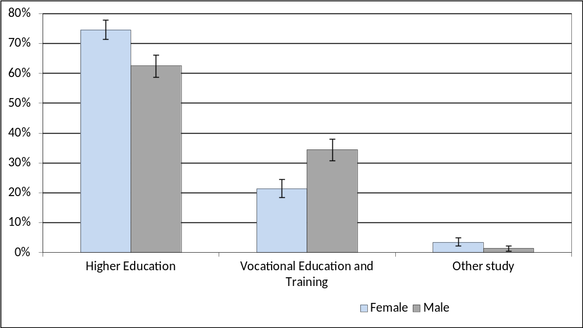
Note: The error bars reflect the 95 percent confidence intervals and no overlap indicates there is a statistical difference between the results.
Of the 2016 year 12 graduates who were studying in 2017, 55 percent reported that they chose their course because it interested them and 29 percent chose the course because they thought it would assist with employment (see Table 3 below).
Forty-four percent of graduates who were studying in 2017 and did not gain an ATAR reported that they chose the course because it interested them and 34 percent chose the course because they thought it would assist with employment. Graduates with a higher ATAR were more likely to have chosen their course because it interested them, with 68 percent of graduates with an ATAR between 96 and 100 reporting this as their main reason.
Table 3: 2016 year 12 graduates studying in 2017, by main reason for choosing their course and selected demographics (%)
 |  | It's a course that interests me | To get/start/help in a job/business | To help get into another course | To improve my education | Other
Gender
 | Females | 57.2 | 28.4 | 4.8 | 2.4 | 6.6
 | Males | 53.4 | 29.6 | 5.0 | 2.3 | 8.6
Participated in a VET course at school
 | No | 56.3 | 28.0 | 4.7 | 2.4 | 7.8
 | Yes | 52.0 | 32.1 | 5.6 | 2.2 | 7.1
ATAR Group
 | No ATAR | 44.1 | 34.2 | 8.5 | 2.4 | 10.3
 | 1 - 65 | 52.2 | 27.4 | 8.5 | 2.0 | 8.7
 | 66 - 75 | 57.9 | 30.0 | 0.8 | 3.7 | 7.2
 | 76 - 85 | 60.3 | 26.0 | 3.3 | 2.5 | 6.6
 | 86 - 95 | 60.7 | 26.5 | 3.4 | 2.0 | 6.4
 | 96 - 100 | 68.1 | 26.5 | 0.8 | 1.5 | 3.2
All graduates |  | 55.3 | 29.0 | 4.9 | 2.4 | 7.9
Note: The percentages in this table do not all add to 100 percent due to rounding and a small percentage of ‘don’t know’ responses.
Figure 4: 2016 year 12 graduates undertaking an apprenticeship or traineeship in 2017, by selected demographics (%)
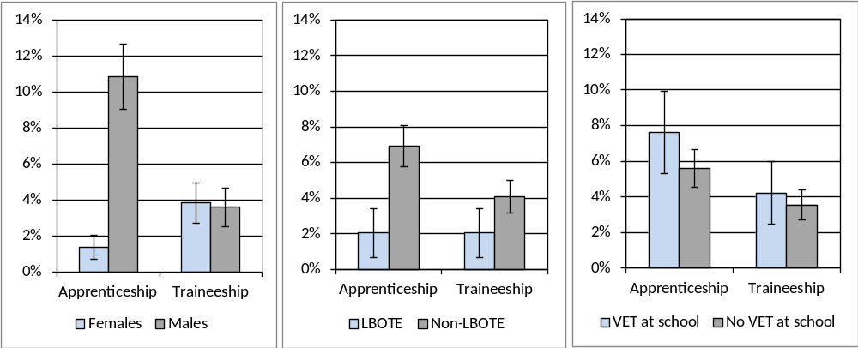
Note: The error bars reflect the 95 percent confidence intervals and no overlap indicates there is a statistical difference between the results.
Overall, six percent of 2016 year 12 graduates indicated they were undertaking an apprenticeship in 2017 and four percent were doing a traineeship. The percentage of graduates undertaking an apprenticeship varied significantly for selected demographics (see Figure 4 above):
- male graduates were much more likely to be undertaking an apprenticeship than females
- graduates who were not LBOTE were more likely to be undertaking an apprenticeship than graduates who were LBOTE.

Thirty three percent of 2016 year 12 graduates who were not studying in 2017 reported their main reason for not studying was to “take a gap year”, 11 percent “wanted to earn money”, 10 percent indicated that they had “got a job” and 10 percent were “not sure what to study” (see Table 4 below). Fifty four percent of graduates who were not studying and had an ATAR over 95 reported their main reason for not studying was because they were “taking a gap year” and 24 percent were travelling.
Table 4: 2016 year 12 graduates not studying in 2017, by main reason for not studying and selected demographics (%)
 |  | Taking a gap year | Wanted to earn money | Not sure what to study | Got a job | Travelling | Not ready for study | Other
Gender
 | Females | 36.7 | 9.2 | 10.4 | 7.3 | 11.4 | 7.8 | 16.6
 | Males | 29.5 | 11.8 | 10.3 | 12.3 | 6.1 | 5.2 | 24.3
Participated in a VET course at school
 | No | 33.2 | 10.2 | 10.5 | 8.6 | 9.1 | 6.6 | 21.5
 | Yes | 32.7 | 11.7 | 9.8 | 14.3 | 7.8 | 6.1 | 16.5
ATAR Group
 | No ATAR | 20.0 | 11.6 | 14.5 | 16.7 | 4.2 | 6.2 | 25.8
 | 1 - 65 | 38.0 | 10.9 | 11.5 | 6.2 | 5.7 | 6.5 | 20.9
 | 66 - 75 | 36.0 | 12.6 | 7.6 | 4.3 | 10.2 | 8.5 | 20.8
 | 76 - 85 | 51.1 | 6.7 | 2.7 | 1.7 | 20.4 | 7.3 | 10.3
 | 86 - 95 | 51.5 | 9.7 | 2.5 | 5.9 | 14.4 | 4.9 | 11.2
 | 96 - 100 | 53.6 | 4.1 | 6.4 | 0.0 | 24.0 | 5.5 | 6.4
All graduates |  | 33.1 | 10.5 | 10.3 | 9.8 | 8.8 | 6.5 | 20.5
Note: The percentages in this table do not all add to 100 percent due to rounding and a small percentage of ‘don’t know’ responses.
Of the 41 percent of 2016 year 12 graduates who were not studying in 2017, 76 percent intended to start some study in the next two years. In general, as ATAR increased, so did intention to start some study in the next two years. The most common intended ASCED fields of study related to:
- society and culture (18%)
- health (15%)
- creative arts (13%).

This high rate of deferral in ACT is consistent with the general trend in Australia, with the incidence increasing from 10 percent in 1999-2000 to 24 percent in 2009-10 (Lumsden & Stanwick, 2012).

Labour force status
Seventy-five percent of 2016 year 12 graduates reported having a paid job in 2017 (see Table 5 below). Fourteen percent of graduates reported not currently having a paid job and actively looking for work with the majority looking for part-time work.
Table 5: Number and proportion of 2016 year 12 graduates, by labour force status in 2017
 |  |  | Number | Proportion (%)
 | Employed |  | 3283 | 74.9
 |  | Full-time | 887 | 20.2
 |  | Part-time | 2371 | 54.1
 |  | Don't know/Refused | 26 | 0.6
 | Unemployed |  | 621 | 14.2
 |  | Looking for full-time work | 64 | 1.5
 |  | Looking for part-time work | 474 | 10.8
 |  | Looking for full or part-time work | 80 | 1.8
 |  | Don't know | 3 | 0.1
 | Total in labour force |  | 3904 | 89.1
Not in labour force |  |  | 479 | 10.9
Total |  |  | 4383 | 100.0
Unemployment rate |  |  |  | 15.9

The percentage of 2016 year 12 graduates who were receiving a government pension, allowance or benefit in May 2017 varied depending on their labour force status. Sixteen percent of graduates who were unemployed and 19 percent of those not in the labour force were receiving a government pension, allowance or benefit in May 2017, compared with six percent of employed graduates.
The Australian and New Zealand Standard Classification of Occupations (ANZSCO) was used to classify occupations. The most common occupations were:
- community and personal service workers (38%)
- sales workers (30%)
- technicians and trade workers (10%)
- labourers (10%).
Seventy-seven percent of 2016 year 12 graduates studying part-time in 2017 were employed, with 44 percent employed part-time (see Table 6 below). Sixty-seven percent of graduates studying full-time were employed, with the majority (56%) employed part-time. Eighty-four percent of graduates who were not studying were employed and 10 percent were unemployed.
Table 6: 2016 year 12 graduates in the labour force in 2017, by study status in 2017 (%)
 |  |  | Studying |  |  | Not studying | All graduates
 |  |  | Part-time | Full-time | Total
 | Employed |  | 77.5 | 67.1 | 68.7 | 83.9 | 74.9
 |  | Full-time | 32.8 | 10.8 | 14.3 | 28.9 | 20.2
 |  | Part-time | 44.1 | 55.8 | 54.0 | 54.2 | 54.1
 | Unemployed |  | 17.4 | 17.1 | 17.1 | 9.9 | 14.2
 |  | Looking for full-time work | 1.0 | 0.4 | 0.6 | 2.8 | 1.5
 |  | Looking for part-time work | 11.8 | 15.9 | 15.2 | 4.5 | 10.8
 |  | Looking for full or part-time work | 4.5 | 0.6 | 1.2 | 2.7 | 1.8
Total in labour force |  |  | 94.8 | 84.2 | 85.8 | 93.8 | 89.1
Not in labour force |  |  | 5.2 | 15.8 | 14.2 | 6.2 | 10.9
Total |  |  | 100.0 | 100.0 | 100.0 | 100.0 | 100.0
Note: The percentages in this table do not all add to 100 percent due to rounding and a small percentage of ‘don’t know’ responses.
Participation in other post-school activities
The percentage of 2013, 2014, 2015 and 2016 year 12 graduates who participated in various activities in the year following leaving school is shown in Table 7. Participation has remained reasonably stable over the four years. At the time of the survey in May 2017:
- 22 percent of 2016 year 12 graduates were travelling
- 14 percent were undertaking volunteer work
- 11 percent were pursuing elite sporting interests
- nine percent were caring for family members.
Table 7: Year 12 graduates participating in various post school activities (%)
Year of graduation | 2013 | 2014 | 2015 | 2016
Travelling | 21.7 | 18.2 | 18.1 | 21.8
Undertaking volunteer work | 13.4 | 14.2 | 12.3 | 14.0
Pursuing elite sporting interests | 11.0 | 10.0 | 11.1 | 10.7
Caring for family members | 10.1 | 8.1 | 11.0 | 8.9

Destination of 2016 school leavers
Seventy-eight percent of 2016 school leavers reported they were employed and/or studying in 2017. This compares favourably with the Australian employed and/or studying rate in 2016 of 64 percent for 15-24 year olds who completed year 11 or below prior to leaving school in 2015 (Australian Bureau of Statistics, 2016).
Table 8: School leavers employed and/or studying, by selected demographics (%)
 |  | Employed |  |  |  |  | Currently studying |  |  |  |  | Employed and/or studying
Year left school |  | 2013 | 2014 | 2015 | 2016 |  | 2013 | 2014 | 2015 | 2016 |  | 2013 | 2014 | 2015 | 2016
Gender
 | Females | 57.6 | 53.9 | 63.9 | 66.0 |  | 38.5 | 46.5 | 32.2 | 39.6 |  | 72.3 | 70.5 | 74.3 | 72.7
 | Males | 54.2 | 61.8 | 58.6 | 66.6 |  | 49.5 | 43.3 | 41.9 | 47.1 |  | 75.1 | 77.4 | 73.8 | 80.4
Year level
 | Year 9 to 11 | 58.1 | 57.5 | 65.6 | 69.8 |  | 45.6 | 42.7 | 39.0 | 42.8 |  | 72.7 | 68.7 | 68.8 | 77.7
 | Year 12 | 52.4 | 60.7 | 56.4 | 64.0 |  | 46.0 | 45.6 | 38.2 | 46.2 |  | 75.7 | 80.3 | 78.1 | 78.2
LBOTE
 | No | 55.3 | 61.3 | 62.3 | 68.2 |  | 45.2 | 44.7 | 38.2 | 43.9 |  | 73.5 | 76.5 | 74.1 | 77.3
 | Yes | 54.6 | 44.8 | 39.8 | 47.6 |  | 51.5 | 42.0 | 41.7 | 54.0 |  | 81.9 | 66.3 | 73.4 | 84.7
Received career counselling/career guidance at school¹
 | No | 46.0 | 56.4 | 52.4 | 48.5 |  | 42.8 | 37.0 | 29.7 | 43.4 |  | 65.6 | 69.4 | 61.9 | 63.9
 | Yes | 62.1 | 63.8 | 66.8 | 75.5 |  | 49.2 | 51.2 | 45.4 | 50.4 |  | 81.5 | 82.2 | 83.8 | 86.6
Participated in work experience/workplace learning whilst at school²
 | No | 50.3 | 52.7 | 51.0 | 64.7 |  | 46.8 | 41.0 | 37.0 | 43.3 |  | 73.1 | 70.1 | 67.8 | 77.5
 | Yes | 63.7 | 65.3 | 70.6 | 68.7 |  | 47.5 | 47.3 | 40.2 | 46.8 |  | 79.4 | 79.9 | 80.6 | 78.6
Receiving a government pension, allowance or benefit at the time of the survey³
 | No | 61.2 | 64.4 | 65.9 | 72.8 |  | 46.3 | 44.9 | 41.0 | 47.2 |  | 78.5 | 78.9 | 79.2 | 84.5
 | Yes | 12.7 | 23.7 | 30.5 | 33.3 |  | 42.5 | 42.8 | 26.1 | 32.2 |  | 42.5 | 49.2 | 46.6 | 44.6
All school leavers |  | 55.3 | 59.3 | 60.5 | 66.5 |  | 45.8 | 44.3 | 38.5 | 44.8 |  | 74.1 | 75.2 | 74.0 | 78.0
¹ In 2016 career guidance replaced career counselling. ² In 2016 workplace learning replaced work experience. ³ 2013 school leavers who attended specialist school were not included in this item.
The percentage of school leavers employed and/or studying in the year after leaving school is detailed in Table 8. Data are presented for surveys conducted with 2013, 2014, 2015 and 2016 school leavers. The following points were consistently noted over the four years:
- school leavers who were LBOTE were less likely to be employed than those who were not LBOTE
- school leavers who received career counselling/guidance at school were more likely to be employed, studying and employed and/or studying than those that did not receive career counselling
- males were more likely to be studying and employed and/or studying than females
- school leavers who were receiving a Government pension, allowance or benefit in 2017 were less likely to be employed, studying and employed and/or studying than those not receiving this assistance.
Forty-five percent of 2016 school leavers indicated that they were undertaking some study in 2017, with 27 percent studying full-time (see Table 9 below). This is higher than the Australian study rate in 2016 of 39 percent for 15-24 year olds who completed year 11 or below prior to leaving school in 2015 (Australian Bureau of Statistics, 2016).
Table 9: 2016 school leavers studying in 2017, by selected demographics (%)
 |  | Studying |  |  | Not studying
 |  | Part-time | Full-time | All
Gender
 | Females | 19.8 | 18.7 | 39.6 | 60.4
 | Males | 14.0 | 31.0 | 47.1 | 52.9
Year level
 | Year 9 to 11 | 24.2 | 15.4 | 42.8 | 57.2
 | Year 12 | 9.7 | 35.8 | 46.2 | 53.8
LBOTE
 | No | 16.6 | 25.9 | 43.9 | 56.1
 | Yes | 8.4 | 40.3 | 54.0 | 46.0
Received career counselling/career guidance at school¹
 | No | 19.6 | 21.6 | 43.4 | 56.6
 | Yes | 15.7 | 32.8 | 50.4 | 49.6
Participated in work experience/workplace learning whilst at school²
 | No | 13.5 | 29.1 | 43.3 | 56.7
 | Yes | 19.0 | 24.4 | 46.8 | 53.2
Receiving a government pension, allowance or benefit at the time of the survey
 | No | 15.9 | 29.5 | 47.2 | 52.8
 | Yes | 16.6 | 15.6 | 32.2 | 67.8
All school leavers |  | 15.9 | 27.1 | 44.8 | 55.2
Note: The percentages in this table do not all add to 100 percent due to rounding and a small percentage of ‘don’t know’ responses. ¹ In 2016 career guidance replaced career counselling. ² In 2016 workplace learning replaced work experience.
The main reason why 2016 school leavers chose their course of study in 2017 was because they thought it would assist with employment (37%) and 35 percent chose it because it interested them.
For 2016 school leavers, the most common ASCED subjects of study related to:
- architecture and building (17%). This included fields such as landscape architecture, interior design, regional planning, bricklaying, carpentry and plumbing
- society and culture (16%). This included fields such as political science, psychology, law, economics, sport and literature
- engineering and related technologies (16%). This includes fields such as panel beating, cabinet making, vehicle mechanics, refrigeration mechanics and welding, as well as engineering.

Twenty-five percent of 2016 school leavers reported undertaking an apprenticeship or traineeship in 2017. The percentage of year 9 to 11 school leavers undertaking an apprenticeship was significantly greater than the percentage of year 12 leavers undertaking an apprenticeship (see Figure 5 below). Of the school leavers who were undertaking an apprenticeship about half (53%) were technicians or trade workers (ANZSCO) studying architecture and building or engineering and related technologies (ASCED).
Figure 5: 2016 school leavers undertaking an apprenticeship or traineeship in 2017, by selected demographics (%)
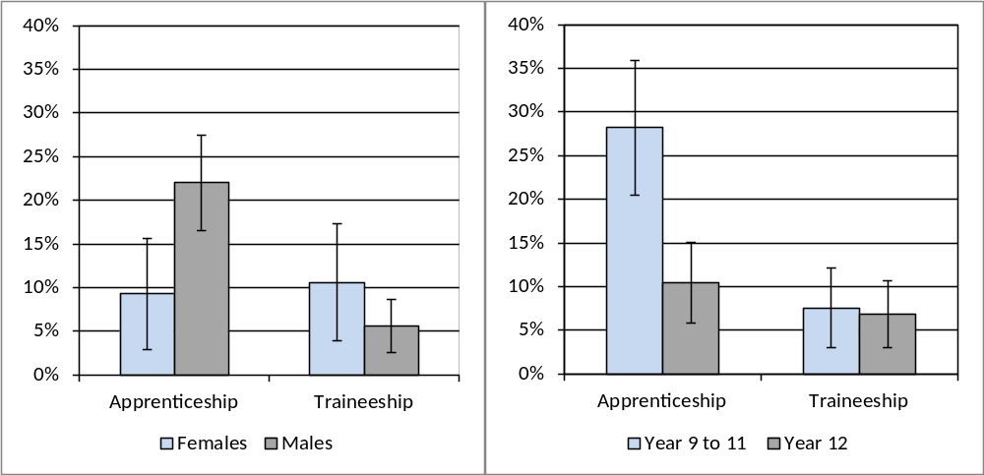
Note: The error bars reflect the 95 percent confidence intervals and no overlap indicates there is a statistical difference between the results.
Fifty-one percent of the 2016 school leavers who were not studying in 2017 intended to start some study in the next two years. Sixteen percent of 2016 school leavers who were not studying in 2017 reported their main reason for not studying as family commitments, illness or disability and 14 percent got a job.
Sixty-six percent of 2016 school leavers reported having a paid job in 2017 (see Table 10 below). Sixteen percent of school leavers said they did not have a paid job but were actively looking for work. Seventeen percent of 2016 school leavers were not in the labour force in 2017. The unemployment rate was 20 percent for school leavers.
Of the 2016 school leavers who had a paid job in 2017, the most common ANZSCO occupations were:
- technicians and trade workers (26%)
- community and personal service workers (26%)
- labourers (21%)
- sales workers (16%).

Table 10: Number and proportion of 2016 school leavers, by labour force status in 2017
 |  |  | Number | Proportion (%)
 | Employed |  | 545 | 66.5
 |  | Full-time | 264 | 32.2
 |  | Part-time | 264 | 32.2
 |  | Don't know/Refused | 17 | 2.0
 | Unemployed |  | 133 | 16.2
 |  | Looking for full-time work | 36 | 4.4
 |  | Looking for part-time work | 65 | 7.9
 |  | Looking for full or part-time work | 32 | 3.9
 |  | Don't know | 0 | 0.0
 | Total in labour force |  | 678 | 82.6
Not in labour force |  |  | 142 | 17.4
Total |  |  | 820 | 100.0
Unemployment rate |  |  |  | 19.6

At the time of the survey in 2017, some 2016 school leavers were participating in other post-school activities, either instead of or as well as study and/or employment:
- 11 percent were travelling
- nine percent were undertaking volunteer work
- seven percent were caring for family members
- six percent were pursuing elite sporting interests.

Characteristics of students who left school in 2016
Table 11 details the characteristics of 2016 year 12 graduates and school leavers. An equal proportion of males and female graduates completed the survey; however for school leavers the majority (69%) percent were male. Fifty-eight percent of the 2016 school leavers who completed the survey were in year 12 when they left school. Eighteen percent of graduates spoke a language other than English at home, whilst nine percent of school leavers spoke a language other than English at home. When compared with graduates, school leavers were twice as likely to have participated in school-based engagement programs. Graduates were more likely to have received career guidance at school.

Table 11: 2016 school leavers and year 12 graduates, by selected demographics (%)
Selected Demographics | School leavers | Year 12 Graduates
Year 9 to 11 | 42.5 | 0.0
Year 12 | 57.5 | 100.0
Females | 31.4 | 50.5
Males | 68.6 | 49.5
LBOTE | 8.6 | 17.6
Participated in a VET course at school | n.a. | 22.8
Received career guidance at school | 58.7 | 76.2
Participated in workplace learning whilst at school | 42.9 | 48.1
Received a government pension, allowance or benefit at the time of the survey | 16.8 | 8.6
Participated in engagement programs whilst at school | 9.1 | 4.5
Participated in support programs for students with disability at school | 10.4 | 8.2
Aboriginal and Torres Strait Islanders | 4.6 | 1.7
Note: n.a. indicates that results are not available.
Specific survey results for students with disability and Aboriginal and Torres Strait Islander students have not been included in this publication due to concerns regarding the small number who participated in the survey. The majority of young people with disability who graduated or left school in 2016 were employed and/or studying in 2017. Although most attended a mainstream school, a small proportion attended a specialist school for students with disability and the majority of these students were participating in community support programs at the time of the survey in 2017. Eighty-five percent of Aboriginal and Torres Strait Islander young people who graduated or left school in 2016 were employed and/or studying in 2017.

Satisfaction with school
Parents of 2016 year 9 to 11 school leavers were asked about their level of satisfaction with the school the student most recently attended and 72 percent of parents were satisfied with the school. In contrast, the 2016 School Satisfaction Survey showed that overall 86 percent of parents and carers were satisfied with the school their child attended.
2016 Year 12 school leavers and year 12 graduates were asked about their level of agreement with seven statements regarding their experience in years 11 and 12 in the ACT (see Figure 6 below). Responses of strongly agree or agree were classified as “satisfied”, responses of strongly disagree or disagree as “not satisfied” and responses of neither agree nor disagree as “neutral”. Overall 73 percent of year 12 school leavers and 94 percent of year 12 graduates found year 11 and 12 worthwhile. Year 12 graduates were generally more satisfied than year 12 school leavers.
Figure 6: 2016 year 12 graduates and year 12 school leavers satisfied with various aspects of their year 11 and 12 experience (%)
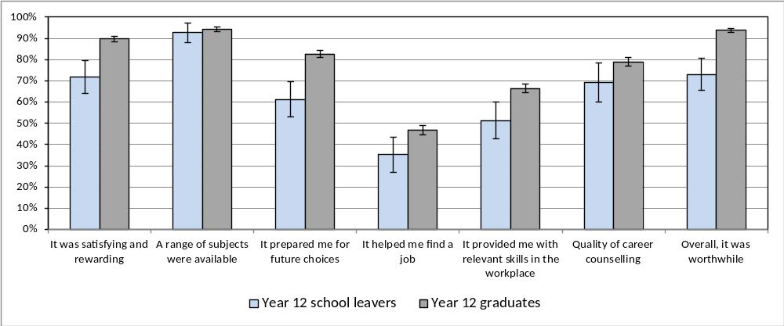
Note: The error bars reflect the 95 percent confidence intervals and no overlap indicates there is a statistical difference between the results.
2016 year 12 graduates and year 12 school leavers were also asked about their level of satisfaction with their life as a whole at the time of the survey in May 2017. A similar pattern was observed with 86 percent of graduates and 78 percent of year 12 leavers being satisfied or very satisfied. Of particular interest is that year 12 graduates and year 12 school leavers who received career guidance at school were more satisfied with their life than those who did not receive career guidance at school. For example, 88 percent of 2016 year 12 graduates who received career guidance at school were satisfied with their life compared with 79 percent of those who did not receive career guidance at school. Whilst the level of satisfaction with life was similar for male and female graduates, for year 12 school leavers, males tended to be more satisfied.

Reasons for leaving school
Parents of year 9 to 11 students who left school in 2016 were asked the reasons why their child decided to leave school (see Table 12 below). The most common responses were:
- the child was not doing very well at school (64%)
- the child wanted to earn their own money (60%)
- the child wanted to get a job (56%).
Table 12: Most common responses parents gave regarding why their child (who was in year 9, 10 or 11 in 2016) left school
Response Categories | Proportion (%)
Wanted to get a job | 55.7
Wanted to earn his/her own money | 59.9
Not doing very well at school | 63.5
Had a job to go to | 45.6
Didn't get on with the teachers and/or students at school | 30.6
Wanted to do study or training that wasn't available at school | 27.9
Had an illness, disability or caring responsibilities | 25.2
Note: The percentages in this table do not add to 100 percent, as respondents could provide more than one response.
Part 2 – 2015 Year 12 Graduates and School Leavers

Pathways of 2015 year 12 graduates
Key outcomes
Ninety-six percent of 2015 year 12 graduates reported that they were employed and/or studying in 2017. Eighty-one percent of graduates were employed and 72 percent of all year 12 graduates were studying in 2017. Participation in both study and employment increased from 2016 to 2017. Overall there was a slight increase in the percentage employed and/or studying over the same period (see Table 13 below).
This general increase in participation in study is consistent with results reported in similar interstate longitudinal surveys with different year cohorts (Queensland Department of Education, Training and Employment, 2013; Victorian Department of Education and Early Childhood Development, 2010). However, the percentage increase in participation in study was larger in ACT which may be due to the more recent reporting period in this publication and/or the greater percentage of graduates who deferred study in the first year after leaving school and commenced study in the following year in the ACT.
Table 13: 2015 year 12 graduates employed and/or studying in 2016 and 2017 by selected demographics (%)
 |  | Employed |  |  | Currently studying |  |  | Employed and/or studying
Year of survey |  | 2016 | 2017 |  | 2016 | 2017 |  | 2016 | 2017
Gender
 | Female | 75.8 | 80.9 |  | 57.8 | 73.7 |  | 94.8 | 97.0
 | Male | 68.6 | 81.1 |  | 58.6 | 71.2 |  | 90.5 | 95.7
Participated in a VET course at school
 | No | 70.9 | 80.3 |  | 56.7 | 72.4 |  | 92.0 | 95.8
 | Yes | 76.8 | 83.1 |  | 62.7 | 72.8 |  | 95.1 | 98.1
Received career counselling at school
 | No | 72.1 | 80.4 |  | 56.4 | 68.2 |  | 91.5 | 95.7
 | Yes | 72.5 | 81.2 |  | 60.3 | 75.3 |  | 94.0 | 96.8
Participated in work experience at school
 | No | 71.2 | 79.4 |  | 57.3 | 72.2 |  | 93.1 | 96.4
 | Yes | 73.2 | 82.3 |  | 58.9 | 72.7 |  | 92.5 | 96.3
All graduates |  | 72.3 | 81.0 |  | 58.2 | 72.5 |  | 92.8 | 96.4

The 2017 main employment and study destinations for 2015 year 12 graduates by employment and study destination in 2016 is shown in Table 14. Ninety-one percent of the graduates who were employed in 2016 were also employed in 2017, 86 percent of those studying in 2016 were also studying in 2017 and 98 percent of those employed and/or studying in 2016 were also employed and/or studying in 2017. Of the 2015 year 12 graduates who were not employed or studying in 2016, 62 percent were employed in 2017 and 47 percent were studying in 2017. Twenty-one percent of the 2015 year 12 graduates who were not employed or studying in 2016 were also in this category in 2017.
Table 14: 2015 year 12 graduates employed and/or studying in 2017, by employed and/or studying in 2016 (%)
 | 2017 |  |  | Distribution in 2016
2016 | Employed | Studying | Employed and/or Studying
Employed | 90.9 | 70.9 | 98.2 | 72.3
Studying | 79.6 | 85.8 | 98.0 | 58.2
Employed and/or Studying | 82.4 | 74.4 | 97.7 | 92.8
Not employed or studying | 62.3 | 47.0 | 79.1 | 7.2
Distribution in 2017 | 81.0 | 72.5 | 96.4 | 100.0

Study
Most (86%) of the 2015 year 12 graduates who were studying in 2016 were also studying in 2017. Ninety-two percent of those studying at the higher education level were also studying at this level in 2017 and 55 percent of those studying at the VET level were also studying at this level in 2017 (see Table 15 below). Thirty percent of the year 12 graduates who were studying at the VET level in 2016 were not studying in 2017, with the majority (62%) of these graduates completing the qualification prior to the survey in 2017. Over half (54%) of the graduates who were not studying in 2016 were studying in 2017. Thirty-six percent of 2015 year 12 graduates not studying in 2016 were studying at the higher education level in 2017, with the majority (74%) of these students having formally deferred university in 2016.
Table 15: Level of study in 2017 by level of study in 2016 for 2015 Year 12 graduates(%)
 |  | 2017
 |  | Studying |  |  |  | Not studying | Total
2016 |  | Higher education | VET course | Other | Total
Studying |  | 66.4 | 17.6 | 1.8 | 85.8 | 14.2 | 100.0
 | Higher education | 91.5 | 1.6 | 0.3 | 93.4 | 6.6 | 100.0
 | VET | 12.5 | 55.5 | 1.6 | 69.5 | 30.5 | 100.0
 | Other | 31.5 | 10.9 | 33.9 | 76.2 | 23.8 | 100.0
Not Studying |  | 35.6 | 16.0 | 2.2 | 53.9 | 46.1 | 100.0
Distribution in 2017 |  | 53.5 | 16.9 | 2.0 | 72.5 | 27.5 | 101.0
Note: The percentages in this table do not all add to 100 percent due to rounding and a small percentage of ‘don’t know’ responses.
Thirty-nine percent of 2015 year 12 graduates were studying at the higher education level in 2016. Figure 7 provides details of the 2017 main destination for 2015 year 12 graduates studying at the higher education level in 2016. Of those that were studying at the higher education level in 2016:
- the majority (92%) were also studying at the higher education level in 2017 with 79 percent found to be undertaking the same study in 2017 and 12 percent making a change to their study field, qualification and/or study load in 2017
- seven percent did not continue to study in 2017, with six percent employed and less than one percent unemployed or not in the labour force.
Figure 7: 2017 main destination for 2015 Year 12 graduates who were studying at the higher education level in 2016
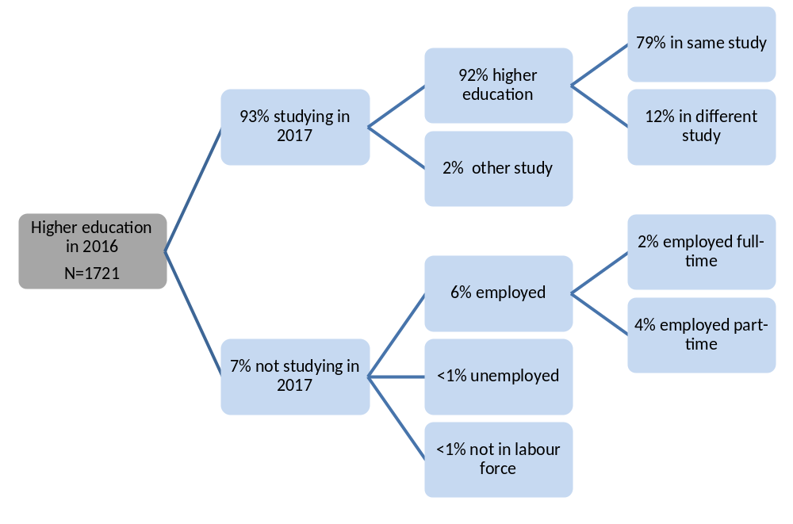
Note: The percentages in this figure do not all add to 100 percent due to rounding and a small percentage of ‘don’t know’ responses.
Seventeen percent of 2015 year 12 graduates were studying at the VET level in 2016. Figure 8 provides details of the 2017 main destination for 2015 year 12 graduates studying at the VET level in 2016. Of those that were studying at the VET level in 2016, 55 percent were also studying at the VET level in 2017 with 40 percent found to be undertaking the same study in 2017 and 16 percent making a change to their study field, qualification and/or study load in 2017.

Figure 8: 2017 main destination for 2015 Year 12 graduates who were studying at the VET level in 2016
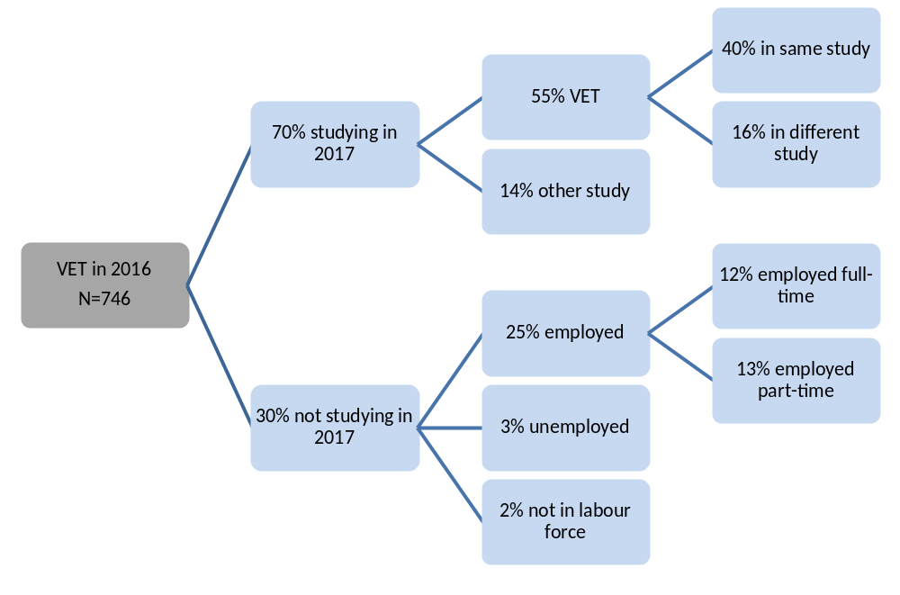
Note: The percentages in this figure do not all add to 100 percent due to rounding and a small percentage of ‘don’t know’ responses.
Seven percent of 2015 year 12 graduates were undertaking an Australian Apprenticeship (had signed a national training contract) in 2016. Figure 9 provides details of the 2017 main destination for 2015 year 12 graduates who were undertaking an Australian Apprenticeship in 2016. Of those who were undertaking an Australian Apprenticeship in 2016:
- over half (61%) were also undertaking an apprenticeship or traineeship in 2017, with 51 percent in the same apprenticeship or traineeship
- nineteen percent were studying in 2017 but not as an apprentice or trainee
- twenty-one percent were not studying in 2017, with 20 percent employed.

Figure 9: 2017 main destination for 2015 Year 12 graduates who were undertaking an Australian Apprenticeship in 2016
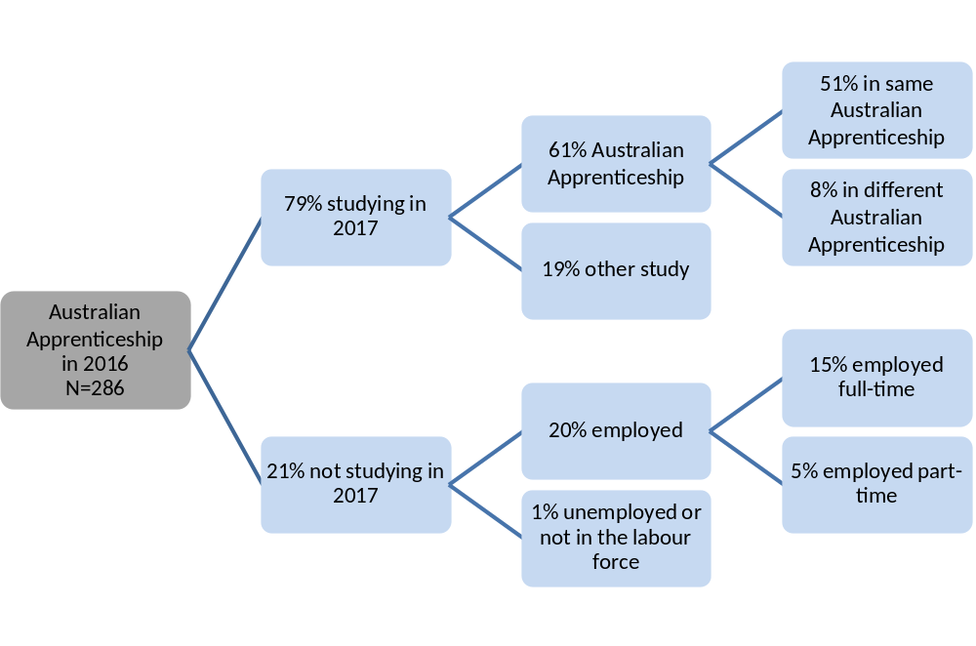
Note: The percentages in this figure do not all add to 100 percent due to rounding and a small percentage of ‘don’t know’ responses.
Eight percent of 2015 year 12 graduates were studying in 2016 but not in 2017, and (48%) of these graduates said they successfully completed the course and/or qualification they were undertaking.
Thirteen percent of graduates were not studying in 2016 or 2017 but indicated that they were planning to study in 2017 or 2018 at the time of the survey in 2016. Twenty-six percent of these graduates said their main reason for not studying was because they got a job.
Thirty-two percent of 2015 year 12 graduates intended to start some study in the next two years at the time of the survey in 2016, with 44 percent of these graduates formally deferring a university offer. Figure 10 details the 2017 study destination for these graduates and graduates with an informal intention to study (intended to study but did not formally defer university) in the next two years.

Of those who deferred university in 2016:
- eighty percent were attending university
- four percent were studying elsewhere
- sixteen percent were not studying in 2017.
Of those with an informal intention to study in 2016:
- fifty-seven percent were not studying
- twenty-one percent were attending university
- twenty-two percent were studying elsewhere in 2017.

Figure 10: 2017 study destination for 2015 Year 12 graduates who in 2016 reported an intention to study

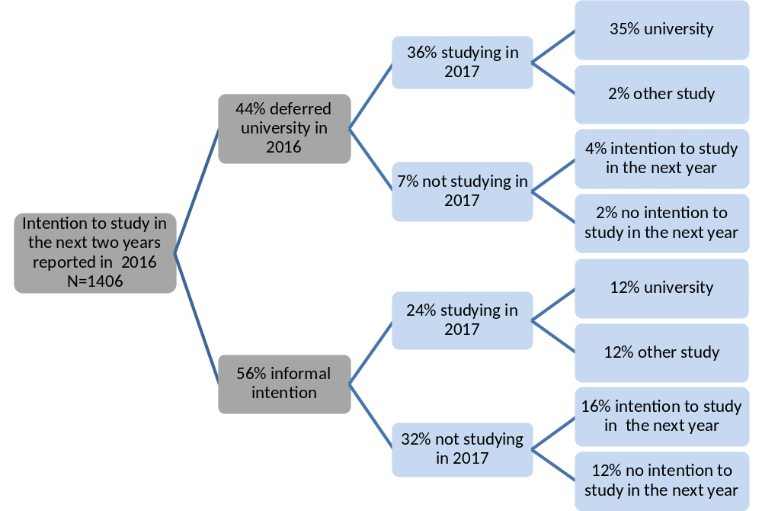
Note: The percentages in this figure do not all add to 100 percent due to rounding and a small percentage of ‘don’t know’ responses.
Nineteen percent of 2015 year 12 graduates were intending to study in the next two years at the time of the survey in 2016 and were studying in 2017, with 55 percent of these graduates studying in their intended ASCED field of study. Table 16 highlights the most common fields of study in 2017 for each of the most common intended fields of study in 2016. Twenty-four percent of 2015 year 12 graduates who intended to study in the field of management and commerce commenced study in the field of society and culture in 2017.
Table 16: 2017 field of study by 2016 intended field of study for 2015 Year 12 graduates (%)
 | Field of study in 2017
Intended field of study in 2016 | Natural and physical sciences | Health | Management and commerce | Society and culture | Creative arts | Other | Total
Natural and physical sciences | 41.1 | 16.7 | 8.8 | 9.1 | 0.0 | 24.2 | 100.0
Health | 11.1 | 60.6 | 10.5 | 7.5 | 0.0 | 10.3 | 100.0
Management and commerce | 12.5 | 3.3 | 51.7 | 23.6 | 0.0 | 8.9 | 100.0
Society and culture | 3.6 | 7.5 | 10.1 | 62.5 | 10.6 | 5.6 | 100.0
Creative arts | 0.0 | 2.6 | 2.5 | 15.2 | 63.6 | 16.1 | 100.0
Other | 4.9 | 4.1 | 11.4 | 7.5 | 4.5 | 67.6 | 100.0
2016 no intention to study | 0.0 | 6.5 | 14.8 | 9.7 | 7.9 | 61.1 | 100.0
Distribution in 2017 | 8.3 | 11.9 | 13.5 | 21.2 | 10.1 | 35.1 | 100.0
Note: The percentages in this table do not all add to 100 percent due to rounding and a small percentage of ‘don’t know’ responses.
Twenty-three percent of 2015 year 12 graduates started studying in 2017, with 52 percent of these graduates deferring university, 35 percent reported having an informal intention to study in the next two years and 14 percent had no intention to study at the time of the survey in 2016. Table 17 details the main reason for starting study in 2017 for each type of study intention in 2016. Of the graduates who deferred university, 56 percent chose a course because it interested them and 31 percent chose the course because they thought it would assist with employment.

Assisting with employment was the most common main reason 2015 year 12 graduates, with an informal intention to study (48%) and those with no intention to study (65%), decided to commence study in 2017.
Table 17: Main reason for starting study in 2017 by study intention in 2016 for 2015 Year 12 graduates (%)
 | Reason for starting study in 2017
Not studying in 2016 | It's a course that interests me | To get/start/help in a job/business | To help get into another course | To improve my education | Other | Total
Deferred University | 56.5 | 30.9 | 3.6 | 3.6 | 5.4 | 100.0
Informal intention to study | 38.8 | 48.1 | 8.5 | 0.7 | 3.1 | 100.0
No intention to study | 29.7 | 64.7 | 1.8 | 0.0 | 3.8 | 100.0
Note: The percentages in this table do not all add to 100 percent due to rounding and a small percentage of ‘don’t know’ responses.
Labour force status
Overall, part-time employment was the most common labour force status for 2015 year 12 graduates in 2016 and 2017. Most (91%) of the 2015 year 12 graduates who were employed in 2016 were also employed in 2017, with most continuing in either full-time or part-time employment (see Table 18 below). Of those who were unemployed in 2016, 68 percent were employed in 2017 and 20 percent were unemployed. More than half (58%) of those that were not in the labour force in 2016, joined the labour force in 2017, with 43 percent in employment and 15 percent unemployed.
Table 18: 2017 labour force status in 2017 by 2016 labour force status for 2015 Year 12 graduates (%)
 |  |  | 2017
 |  |  | Employed |  |  | Unemployed | Not in labour force | Total
2016 |  |  | Part-time | Full-time | Total |  | Not in labour force | Total
Employed |  |  | 57.6 | 32.6 | 90.9 | 4.5 | 4.6 | 100.0
 | Part-time |  | 77.6 | 12.2 | 90.1 | 5.2 | 4.7 | 100.0
 | Full-time |  | 18.0 | 74.7 | 92.7 | 3.4 | 3.9 | 100.0
Unemployed |  |  | 55.8 | 11.7 | 67.5 | 20.1 | 12.4 | 100.0
Not in labour force |  |  | 36.7 | 6.3 | 43.0 | 14.6 | 42.4 | 100.0
Distribution in 2017 |  |  | 54.4 | 26.1 | 81.0 | 8.1 | 10.9 | 100.0
Note: The percentages in this table do not all add to 100 percent due to rounding and a small percentage of ‘don’t know’ responses.
Seventy-two percent of 2015 year 12 graduates were employed in 2016, and 52 percent of these graduates were studying in 2016. Figure 11 details the 2017 labour force destination for these graduates and graduates who were employed but not studying in 2016. Of those that were employed in 2016:
- thirty-one percent were studying in 2016 and employed in the same job in 2017
- twenty-one percent were not studying in 2016 and employed in a different job in 2017.
Figure 11: 2017 labour force status for 2015 Year 12 graduates employed in 2016, by 2016 study status

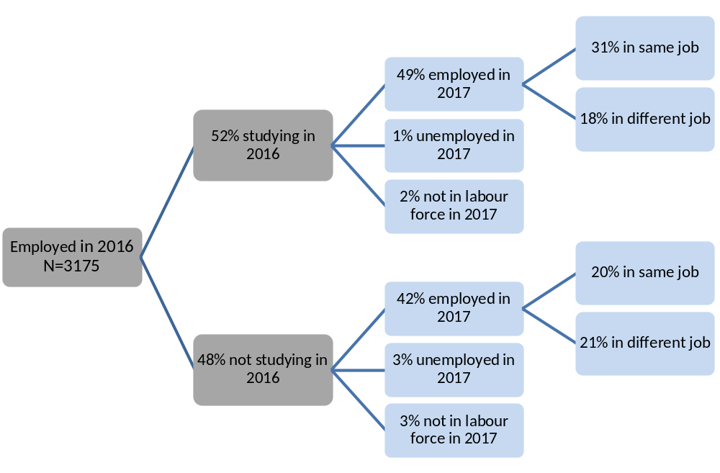
Note: The percentages in this figure do not all add to 100 percent due to rounding and a small percentage of ‘don’t know’ responses.
Fourteen percent of 2015 year 12 graduates were unemployed in 2016, and 68 percent of these graduates were studying in 2016. Figure 12 details the 2017 labour force destination for these graduates and graduates who were unemployed and not studying in 2016. Of those that were unemployed in 2016, 47 percent were studying in 2016 and employed in 2017 and 20 percent were not studying in 2016 and employed in 2017.
Figure 12: 2017 labour force status for 2015 Year 12 graduates unemployed in 2016, by 2016 study status
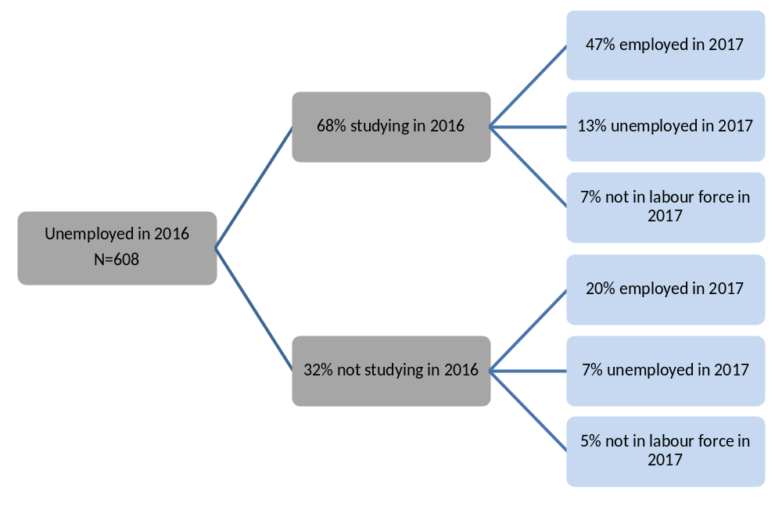
Note: The percentages in this figure do not all add to 100 percent due to rounding and a small percentage of ‘don’t know’ responses.
Fourteen percent of 2015 year 12 graduates were not in the labour force in 2016, and 80 percent of these graduates were studying in 2016. Figure 13 details the 2017 labour force destination for these graduates and graduates who were not in the labour force and not studying in 2016. Of those that were not in the labour force in 2016, 31 percent were studying in 2016 and employed in 2017 and 12 percent were not studying in 2016 and employed in 2017.
Figure 13: 2017 labour force status for 2015 Year 12 graduates not in the labour force in 2016, by 2016 study status
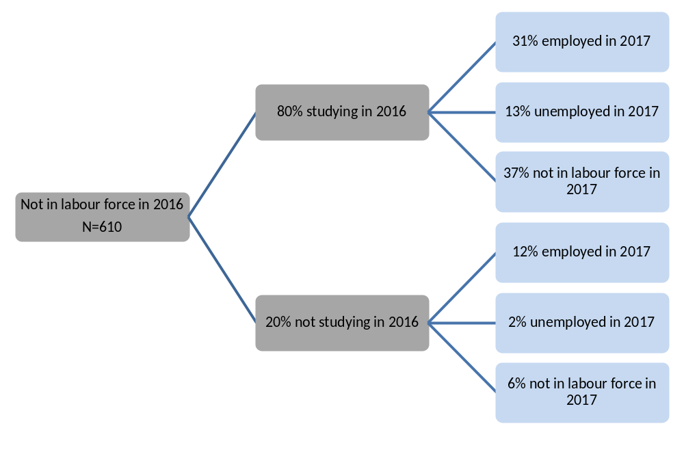
Note: The percentages in this figure do not all add to 100 percent due to rounding and a small percentage of ‘don’t know’ responses.
Fifty-eight percent of the 2015 year 12 graduates were studying in 2016. Part-time employment was the most common labour force status for these graduates in 2016 and 2017. Most (94%) of the 2015 year 12 graduates studying and employed in 2016 were also employed in 2017, with most continuing in either full-time or part-time employment (see Table 19 below). Of those who were studying and unemployed in 2016, 70 percent were employed in 2017 and 19 percent were unemployed. Fifty-four percent of 2015 year 12 graduates that were studying and not in the labour force in 2016 were in the labour force in 2017.
Table 19: 2017 labour force status by 2016 labour force status for 2015 Year 12 graduates studying in 2016(%)
 |  |  | 2017
 |  |  | Employed |  |  | Unemployed | Not in labour force | Total
2016 |  |  | Part-time | Full-time | Total |  | Not in labour force | Total
Employed |  |  | 68.0 | 26.0 | 94.2 | 2.7 | 3.0 | 100.0
 | Part-time |  | 85.9 | 8.3 | 94.2 | 3.0 | 2.8 | 100.0
 | Full-time |  | 7.4 | 87.9 | 95.3 | 2.0 | 2.7 | 100.0
Unemployed |  |  | 61.1 | 8.6 | 69.7 | 19.3 | 11.0 | 100.0
Not in labour force |  |  | 36.2 | 2.2 | 38.4 | 15.7 | 45.9 | 100.0
Distribution in 2017 |  |  | 60.8 | 18.7 | 79.6 | 7.9 | 12.5 | 100.0
Note: The percentages in this table do not all add to 100 percent due to rounding and a small percentage of ‘don’t know’ responses.

Pathways of 2015 school leavers
Eighty-four percent of 2015 school leavers reported that they were employed and/or studying in 2017. Seventy-three percent of school leavers were employed and 41 percent were studying in 2017. Overall, 2015 school leaver participation in study, employment and employment and/or study increased from 2016 to 2017 (see Table 20 below).
Table 20: 2015 school leavers employed and/or studying in 2016 and 2017 by selected demographics (%)
 |  | Employed |  |  | Currently studying |  |  | Employed and/or studying
Year of survey |  | 2016 | 2017 |  | 2016 | 2017 |  | 2016 | 2017
Gender
 | Female | 65.3 | 68.8 |  | 31.5 | 33.4 |  | 74.8 | 78.6
 | Male | 62.2 | 75.2 |  | 40.3 | 45.8 |  | 76.9 | 86.6
Year level
 | Year 9 to 11 | 70.5 | 66.7 |  | 40.1 | 40.0 |  | 75.6 | 77.6
 | Year 12 | 57.7 | 77.9 |  | 34.8 | 42.3 |  | 76.6 | 88.6
Received career counselling at school
 | No | 56.8 | 72.2 |  | 25.7 | 25.7 |  | 65.4 | 78.5
 | Yes | 69.8 | 75.4 |  | 43.5 | 51.1 |  | 85.5 | 88.2
Participated in work experience at school
 | No | 51.9 | 68.7 |  | 37.6 | 39.4 |  | 68.8 | 80.7
 | Yes | 75.4 | 77.3 |  | 36.7 | 43.3 |  | 83.8 | 86.9
All graduates |  | 63.3 | 72.9 |  | 37.1 | 41.3 |  | 76.1 | 83.7

The 2017 employment and study destinations for 2015 school leavers by their employment and study destinations in 2016 is detailed in Table 21. Eighty-three percent of the school leavers who were employed in 2016 were also employed in 2017, 73 percent of those studying in 2016 were also studying in 2017 and 93 percent of those employed and/or studying in 2016 were also employed and/or studying in 2017. Of the 2015 school leavers who were not employed or studying in 2016, 51 percent were employed in 2017 and 15 percent were studying in 2017. Forty-six percent of the school leavers who were not employed or studying in 2016 were also in this category in 2017.
Table 21: Proportion of 2015 school leavers employed and/or studying in 2017, by employed and/or studying in 2016 (%)
 | 2017 |  |  | Distribution in 2016
2016 | Employed | Studying | Employed and/or Studying
Employed | 82.8 | 42.9 | 91.7 | 63.3
Studying | 77.8 | 73.1 | 97.3 | 37.1
Employed and/or Studying | 79.9 | 49.5 | 93.1 | 76.1
Not employed or studying | 50.7 | 15.3 | 53.9 | 23.9
Distribution in 2017 | 72.9 | 41.3 | 83.7 | 100.0

Most (73%) of the 2015 school leavers who were studying in 2016 were also studying in 2017. Sixty-five percent of the 2015 school leavers who were studying at the VET level in 2016 were also studying in 2017, with 58 percent studying at the VET level in 2017. Twenty-three percent of the school leavers who were not studying in 2016 were studying in 2017.
In relation to the labour force status of 2015 school leavers:
- eighty-three percent who were employed in 2016 were also employed in 2017, with most continuing in either full-time or part-time employment
- sixty-four percent who were unemployed in 2016 were employed in 2017 and 11 percent were unemployed in 2017
- sixty-four percent of those that were not in the labour force in 2016 were in the labour force in 2017, with 48 percent in employment and 16 percent unemployed.

Satisfaction with life
In 2017, 2015 school leavers and year 12 graduates were asked about their anticipated satisfaction with life in five years (2022). Overall satisfaction levels were quite high when compared with current satisfaction with life reported by 2016 graduates and school leavers (on page 18 of this report). In addition, there was less difference between the level of satisfaction for graduates compared to school leavers. 2015 year 12 graduates and school leavers who were studying and those who were employed in 2017 were on average more likely to think they would be satisfied with their life in five years. Male school leavers seem to be more optimistic about the future than female school leavers (see Table 22 below).

Table 22: Proportion of 2015 school leavers and year 12 graduates that think they will be satisfied with their life as a whole in five years (2022) by gender and employment and study status.
 |  | School leavers | Year 12 Graduates
Gender
 | Female | 77.3 | 91.5
 | Male | 92.1 | 89.5
Study Status in 2017
 | Higher education | 98.5 | 92.1
 | VET course | 92.0 | 92.6
 | Not Studying | 79.0 | 86.3
Employed in 2017
 | No | 83.7 | 86.7
 | Yes | 88.0 | 91.4
All |  | 87.1 | 90.5

Scope and methodology
The annual School Leaver Survey is a survey of students in years 9 to 12 who left the ACT school system or were awarded an ACT Senior Secondary Certificate in the preceding year. This publication includes a summary of the results of the annual survey conducted in 2017.
The survey frame was drawn from administrative records held within the Directorate, Catholic Education Archdiocese of Canberra and Goulburn, independent schools and the Board of Senior Secondary Studies (BSSS). 2016 year 12 graduates included those that were awarded an ACT Senior Secondary Certificate from an ACT college, school or the Canberra Institute of Technology (CIT) in 2016. 2016 school leavers included year 9 to year 12 ACT students who were listed as attending an ACT school in the 2016 February school census but not in the 2017 census (and did not obtain an ACT Senior Secondary Certificate). The survey scope excluded full fee paying students whose usual residence was overseas and school leavers who returned to school or moved interstate or overseas prior to May 2017. The Directorate was unable to approach some school leavers due to insufficient contact details or family circumstances.
Prior to the annual School Leaver Survey being undertaken a primary approach letter was sent to year 12 graduates and year 12 school leavers and parents of years 9 to 11 school leavers. This provided information about its purpose and importance: the broad content of the survey, the amount of time the interview would take and confidentiality provisions. The survey was undertaken by telephone from 1 May to 30 May 2017. Of the 3,915 graduates sent a primary approach letter, 2,374 completed the survey, providing a response rate of 61 percent. Of the 726 school leavers sent a primary approach letter, 356 completed the survey, providing a response rate of 49 percent. The figures reported in this publication are estimates based on weighting the survey responses to reflect the total number of 4,383 graduates and 820 school leavers.
The 2017 longitudinal survey of 2015 year 12 graduates and school leavers surveyed young people who participated in the annual school leaver survey in 2016 and agreed to be recontacted in 2017. The vast majority (98%) agreed to be recontacted in 2017 and provided updated contact details when they completed the survey in 2016. This publication includes a summary of the post-school pathways from wave 1 (conducted in 2016) to wave 2 (conducted in 2017).
Prior to the survey being undertaken an email was sent to the 2015 year 12 graduates and school leavers who agreed to participate in 2017 and who provided a valid email address when surveyed in 2016. The email provided information about the purpose, importance and content of the survey, the amount of time the interview would take and confidentiality provisions. The 2017 survey of 2015 year 12 graduates, year 11 and 12 school leavers and parents of year 9 and 10 school leavers, was undertaken by telephone from 1 May to 30 May 2017. Of the 2,559 graduates identified for the survey, 1,803 completed the survey, providing a response rate of 70 percent. Of the 330 school leavers identified for the survey, 195 completed the survey, providing a response rate of 59 percent. The figures reported in this publication are estimates based on weighting the survey responses for 2017 (and corresponding 2016 responses) to reflect the total number of 4,393 graduates and 888 school leavers. Please note, the 2016 figures reported in this publication are in some cases slightly different to the figures reported in previous reports as the figures in this report are based on only those students who completed both the 2016 and 2017 surveys.

Glossary
ANZSCO - Australian and New Zealand Standard Classification of Occupations is a standard used in Australia and New Zealand to classify all occupations and jobs and is designed to facilitate the organisation and comparability of occupation statistics.
ASCED - Australian Standard Classification of Education is a standard used in Australia to classify all education levels and fields of education. It is designed to facilitate the organisation and comparability of education statistics.
ATAR - Australian Tertiary Admission Rank is a percentile ranking used by universities to assist in the selection of school leavers for entry into undergraduate courses. It is used as an indication of a student’s suitability for study at university level, and to allow universities to select appropriate numbers of students for each course.
Career guidance in schools may include one on one or group discussion between students and career advisors, industry experts and representatives from universities and CIT about various aspects of student pathways planning, such as course choices, work experience and developing a resume. Prior to the 2017 survey, the term ‘career counselling’ was used to describe this set of activities.
Currently studying refers to respondents who were actively undertaking some study at the time of the survey, including those attending university, technical and further education (TAFE), undertaking an Australian apprenticeship or repeating year 12.
Engagement programs are school based programs, such as Big Picture, Connect 10 and Canberra College Cares.
Labour force status provides data on whether a graduate was employed (paid work for one hour or more over a two week period), unemployed (actively looking for paid work) or not in the labour force at the time of the survey. Labour force status was derived from responses to a number of questions in the survey.
LBOTE is used in this publication to describe graduates who speak a language other than English at home. Please note, this is slightly different from Language Background other than English (also known as LBOTE) which is used when a language other than English is spoken at home by the individual and/or one or both of their parents.
Government pensions, allowances and benefits include Austudy or ABSTUDY, Carer Allowance or Carer Payment, Disability Support Pension, Newstart Allowance, Parenting Payment, Sickness Allowance, Special Benefit and Youth Allowance.
VET - Vocational Education and Training courses are accredited vocational courses provided by a Registered Training Organisation. Successful completion usually leads to the award of a Vocational Certificate.

Workplace learning includes work experience, structured workplace learning, Australian School Based Apprenticeships and flexible learning options. Flexible learning options are short term vocational education and training programs that are provided by the Education Directorate and are delivered by a registered training organisation (RTO).
References
Australian Bureau of Statistics (2016). Education and Work, Australia, May 2016. Cat. No. 6227.0. Canberra, Australia: Australian Bureau of Statistics.
Curtis, D., Mlotkowski, P. & Lumsden, M. (2012). Bridging the gap: Who takes a gap year and why? Longitudinal Surveys of Australian Youth Research Report. Adelaide, South Australia: National Centre for Vocational Education and Research Ltd.
Queensland Department of Education, Training and Employment (2013). Next step longitudinal study 2012: A report on the post-school transitions of Queensland’s Year 12 completers from 2010. Queensland: State of Queensland.
Lumsden, M. & Stanwick, J. (2012). Who takes a gap year and why? Longitudinal Surveys of Australian Youth Briefing Paper 28. Adelaide, South Australia: National Centre for Vocational Education and Research Ltd.
Victorian Department of Education and Early Childhood Development (2010). The On Track Survey 2009 Longitudinal report: The 2007 cohort 2 years on. Victoria: State of Victoria.

Published by Education Directorate | ACT Government
220 Northbourne Avenue, Canberra City ACT 2602 | GPO Box 158, CANBERRA ACT 2601
Phone: (02) 6207 5111 Web: http://www.det.act.gov.au

