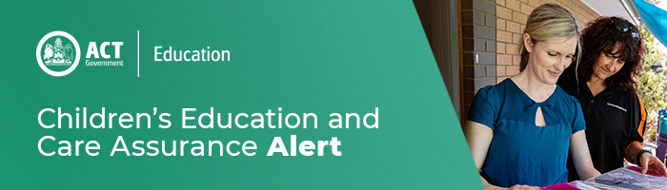

22 April 2020

Out of School Hours Care in Term 2
The Minister for Education and Early Childhood Development has provided further information on how the Safe and Supportive Schools will operate throughout term 2, the website will be updated shortly.

Providers involved in the Outside School Hours Care (OSHC) operation at the Safe and Supportive Schools have been working with the Education Directorate to support its operation.

The Education Directorate can confirm that all ACT Government school sites will remain accessible to OSHC providers to deliver OSHC during Term 2. Providers offering OSHC at an ACT Government school sites should direct any requests for changes to hours directly to EDUStrategicProcurement@act.gov.au

Any providers considering closure should contact CECA on the number below.

For enquires in relation to this notification please call CECA on (02) 6207 1114 or email CECA@act.gov.au
This email has been authorised by the ACT Regulatory Authority (CECA). CECA are responsible for administering the National Quality Framework within the ACT

