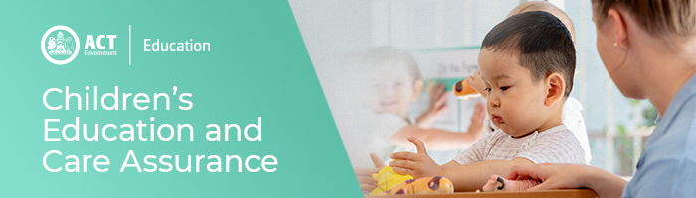

16 December 2020
Easing of COVID Restrictions in the ACT

On 2 December the ACT Government eased COVID restrictions in the ACT. This now means that for gatherings such as education and care services’ Christmas parties, the one person per two square metres of usable space rule in both indoor and outdoor spaces can be applied provided you use the Check In CBR app to collect visitors contact details.

Services will have until Wednesday 16 December to register with Check In CBR to meet this requirement. If Services are not using the Check In CBR app, they must continue to apply the rule of one person per four square metres of usable space indoors and one person per two square metres of usable space outdoors for any gatherings. For Services to be exempt from this requirement, you will need to submit a request via the COVID exemptions event email clearly explaining why Check in CBR app should not be mandated. Any gatherings over 500 will also require an exemption.

Information about Novel Coronavirus (COVID-19) for Education and Care Services is available on Education website

Additional information is available on ACT Government’s COVID-19 webpage. For further assistance contact the ACT’s COVID-19 Helpline on (02) 6207 7244 between 8am and 8pm daily.

For enquires in relation to this notification please call CECA on (02) 6207 1114 or email CECA@act.gov.au

This email has been authorised by the ACT Regulatory Authority (CECA).
CECA are responsible for administering the National Quality Framework within the ACT.

