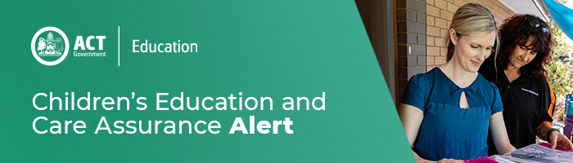

21 September 2020
Potential thunderstorms for the ACT

There is a potential for thunderstorms for the ACT this afternoon. Storms will likely bring strong winds, large hailstones and heavy rainfall that may lead to localised flash flooding.
The ACT State Emergency Service (ACTSES) encourages the community to:

-Secure or remove loose items that could blow around in strong winds
-Move your car undercover as well as avoid parking under trees
For information and tips on how you can Be Storm Ready, visit https://esa.act.gov.au/cbr-be-emergency-ready/storms

If you need assistance during a storm, call the ACTSES on 132 500. For life-threatening emergencies always call Triple Zero (000).

For enquires in relation to this notification please call CECA on (02) 6207 1114 or email CECA@act.gov.au
This email has been authorised by the ACT Regulatory Authority (CECA). CECA are responsible for administering the National Quality Framework within the ACT

