[CC BY symbol](http://creativecommons.org/licenses/by/4.0/)Arts ACT-cover background.jpg

© Australian Capital Territory 2023. This work is licensed under a [Creative Commons Attribution 4.0 licence](http://creativecommons.org/licenses/by/4.0) and subject to the terms of the license including crediting the Australian Capital Territory Government as author and indicating if changes were made.

**Student Movement register procedure**

for INDEPENDENT Schools

**Document No. 00115/1 Published 17/03/2023**

STUDENT MOVEMENT REGISTER PROCEDURE FOR INDEPENDENT SCHOOLS

This procedure must be read in conjunction with the Student Movement Register Policy.

**Table of Contents**

1. Overview 2

2. Rationale 2

3. Procedures 3

4. Contact 7

5. Feedback 7

6. References 7

Appendix 1 – Student Data Import Format 10

Appendix 2 – Student Exit Reasons 14

Appendix 3 – Exit reasons, Destination and Name of New School 15

Appendix 4 – Valid Student Previous School Selections 17

Appendix 5 – ACT Government School Names 18

Appendix 6 – ACT Non-Gov School Names 19

1. Overview
   1. This procedure provides instructions for Independent Schools in the ACT to upload data to the Student Movement Register for student movement events in their schools, including enrolments and unenrolments. The Student Movement Register Procedure: Independent Schools relates to the *Student Movement Register Policy* (Policy number 00115).
2. Rationale
   1. Following the instructions in this procedure will meet the principal’s legal obligation to report a student movement event and comply with the procedures under the *Education Act 2004*.[1]
   2. Submission of movement event information must be done within 5 calendar days (or if the fifth calendar day is not a working day, the following working day).
   3. This procedure is the independent schools component of the procedures that the Director-General must establish for schools to report student movements under section 10AB(1) of the *Education Act 2004*.
3. Procedures - Instructions
   1. All independent schools in the ACT are required to upload data or complete the web form on the Student Movement Register website within 5 calendar days of a student movement event.
   2. If the fifth calendar day is not a working day, data can be submitted on the following working day.[2] For example, if the student is enrolled on a Tuesday the school can upload the data on the following Monday (if the information is not uploaded before the weekend). This is because the fifth calendar day is a Sunday (a non-work day) and the law allows it to be done on the next day that is a work day.
   3. The Student Movement Register website can be accessed at: <https://studentmovementregister.ed.act.edu.au/>.
   4. Independent schools must login to the Student Movement Register website to submit the data or complete the webform. Each independent school has one login. Note, this is the same login from the old student transfer register.
   5. If you have forgotten the login details for your school, then please send an email to [ServiceDesk@act.gov.au](mailto:ServiceDesk@act.gov.au) attention Education ICT. Someone from the relevant team will contact you to arrange resetting the password for your school. You will need to inform other relevant people in your school.
   6. The two key types of student movement events are enrolments and unenrolments.
   7. The enrolment of a student for the purposes of the Student Movement Register occurs on the day when the student has been put on a class roll at the school and been marked as having attended that class or had an explained absence from that class.
   8. The different types of unenrolment (called exit reasons) are listed in Appendix 2 – Student Exit Reasons on page 12 of this procedure. More detail is also provided in the Student Movement Register policy about each type of student movement event and when it occurs.
   9. Non-government schools can provide the data using two different methods:
      1. Completing a web form on the Student Movement Register website for each student movement; or
      2. Through uploading an excel spreadsheet or a comma separated values (CSV) file;

***Web form method***

* 1. The web form is available on the Student Movement Register website when you select the “Upload Single Student to Movement Register” under the “Upload Student Data” tab at the top of the page.
  2. A screenshot of the webform is provided on the next page so that you know what you are looking for. The webform will adjust the fields so that you can only submit valid information.

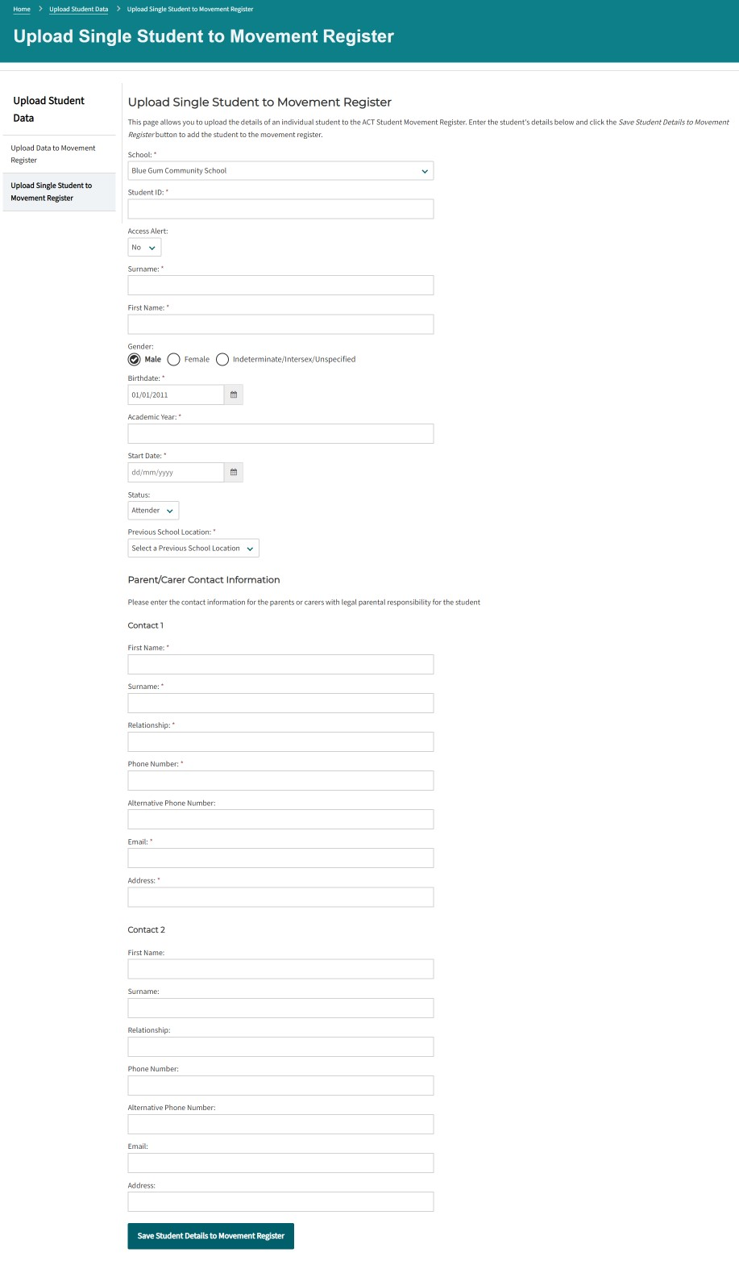

***Spreadsheet (CSV File) method***

* 1. For bulk uploads the Student Movement Register system expects a comma separated values (CSV) file of student details in a specific format. To facilitate this, a CSV student upload template is available for download from the Student Movement Register website. The data should be provided one row per student.
  2. The student upload template defines the expected fields for the sheet. The following are the instructions for preparing your data and uploading it to the Student Movement Register.
  3. Please note that you do not have to use the CSV student upload template to prepare the data for uploading to the Student Movement Register. For example, you may like to prepare a report from your school’s student administration system to generate the export file in the correct file format and use this to upload into the Student Movement Register (refer to Appendix 1 below for details of the format of the file that is expected by the register).

***Downloading the Student Upload Template***

* 1. Click the *Download template* link found on the Student Movement Register website. You will be prompted to select a path to save the file to.

***Preparing your data***

* 1. Open the student upload template. It should open with Microsoft Excel. If it does not, then please open Microsoft Excel and then open the template manually from where you have saved it. Note it could be in the downloads folder on your computer.
  2. Enter your data into the fields provided.
  3. Enter as much information as possible under the fields provided. (NB - the below fields are **mandatory fields in the system** so you cannot leave these blank. Data can also be copied into the spreadsheet providing the fields are in the correct order).
* STUDENT_ID
* ACCESS_ALERT
* SURNAME
* FIRST_NAME
* GENDER
* BIRTHDATE
* ACADEMIC_YR
* START_DATE
* STATUS
* FIRST_PARENT_CARER_CONTACT_SURNAME
* FIRST_PARENT_CARER_CONTACT_FIRSTNAME
* FIRST_PARENT_CARER_CONTACT_RELATIONSHIP_TO_STUDENT
* FIRST_PARENT_CARER_CONTACT_PHONE
* FIRST_PARENT_CARER_CONTACT_EMAIL
* FIRST_PARENT_CARER_CONTACT_ADDRESS
  1. Parent/carer contact details must be provided under the Education Regulation 2005.
  2. If your student administration system has more than two contacts for the student, then please make sure that you provide the name and contact details of the **legal parents or carers of the student**.
  3. It is important to ensure that students have the correct STUDENT ID recorded against them. You can check the Student ID through the Student Movement Register website.
  4. Actively enrolled students should have a status of ATTD for attender (students with the attending status do not need to have the exit date and reasons fields completed).
  5. Leavers should have a status of LEFT and an exit date and exit reason entered (the list of valid exit reasons can be found below in Appendix 2 of this document) as well as the destination (geographic) and name of the new school (if known).
  6. **Where there are multiple possible exit reasons for the same circumstances** you must use one code that is relevant in the following order of preference:
     1. Exclusion from Catholic System
     2. Expulsion from Non Gov School
     3. Contract terminated
     4. Unenrolled from the school
     5. Enrolled at another school or education provider
  7. For example, where a non-government school has terminated the contract of a student at the school and the parent has enrolled the student at another school, then please use “contract terminated” as the exit reason for that student being entered on the register.
  8. For the “Access Alert” field for non-government schools please put an ‘N’. This is currently only used by government schools to indicate whether there is a flag in their student administration system about the student such as a personal protection order or similar.
  9. ***Once a student’s details have been uploaded to the register it is not necessary to upload their data again unless you have been asked by the School Attendance team to provide further information about where they are moving to, you receive new contact information or their attendance status changes at your school.***
  10. Save the template file with the student details you have entered.

***Uploading the File***

* 1. Log onto the Student Movement Register web site and click the *Upload Student Data > Upload Data to Movement Register* link from the top menu.
  2. Press the *Choose file* button to locate the comma delimited text file of student data you have created to be uploaded.

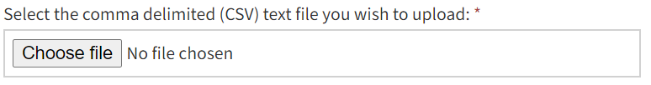

* 1. The *File contains field names* check box should be left checked as default unless you have created the comma delimited import file yourself without the aid of the Microsoft Excel template and the file does not contain field names in the first row.



* 1. Click the *Upload your Student Data to the Movement Register* button to commence the upload process.
  2. You will be directed to a data validation page. The page will generate a log of any problems that were encountered during the importing of the student data. An example of an unsuccessful import of the data appears below.
  3. **If there are any problems with the import file you will need to correct all the errors in the original file and upload the file again.**

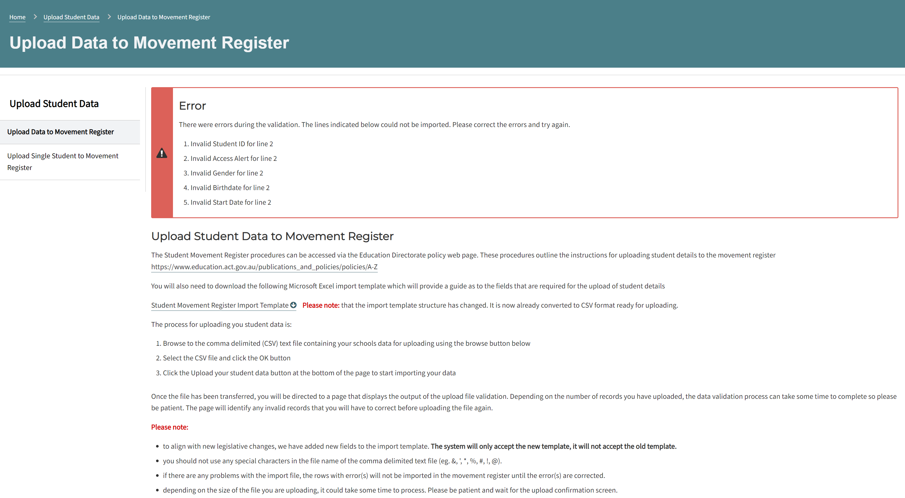

* 1. The validation summary provides a detailed explanation of the error that was encountered during the import. The summary above indicates all the errors encountered with the file. All of these errors must be corrected, and the file uploaded again.

1. Contact
   1. For support with this procedure contact the Education Directorate Attendance Team via email [attendanceteam@act.gov.au](mailto:attendanceteam@act.gov.au).
2. Feedback
   1. Any feedback about this procedure should be raised with the procedure owner. Refer to Contact information above.
3. References
   1. Definitions

* ***ACT Public School*** means an ACT Government public school established under section 20 of the *Education Act 2004*.
* ***Catholic Systemic School*** means a school who has the proprietor as the Trustees of the Roman Catholic Church for the Archdiocese of Canberra and Goulburn registered as a Non-Government School in the ACT under Part 4.3 of the *Education Act 2004*.
* ***Contact details*** include the person’s home address, postal address (if different from the home address), email address and telephone number.[3]
* ***Enrolled***means the child appears on the class roll, and the child has attended the class or been marked absent for an explained reason. Note this occurs after the parent or carer has applied for and accepted the offer of a place in a school.
* ***Excluded*** means the decision to exclude has taken effect under Chapter 2A of the *Education Act 2004*. Exclusion is the decision by the Director-General or the Director of Catholic Education to exclude a student from enrolling at any school in their system of schools. It occurs on the day the decision takes effect to exclude a student as written in the exclusion notice.
* ***Expelled*** means the decision has taken effect to expel a student under Chapter 2A of the *Education Act 2004*. A student can only be expelled from a Non-Government School. The decision is made by the director of Catholic Education or the principal of an independent school to expel a student from that school because the student has engaged in unsafe or noncompliant behaviour and the school has exhausted all reasonable alternatives to expelling the student. Expulsion occurs on the day the decision takes effect as written in the expulsion notice.[4]
* ***Five days*** means five (5) calendar days. The *Legislation Act 2001* allows an action to be done on the following working day, if otherwise it would be required to be done on a non-working day. The ACT Public School student administration system automatically syncs daily with the Student Movement Register.
* ***Independent School*** means a school that is registered in the ACT under part 4.3 of the *Education Act 2004*. Independent schools are not an ACT Public School or a Catholic Systemic School.
* ***Non-Government School*** means a school in the ACT that is not a ACT Public School. They are registered under part 4.3 of the *Education Act 2004*. This includes Catholic Systemic Schools and Independent Schools.
* ***Parent*** for the purpose of this policy, associated procedures and the Act, a ‘parent’ includes a carer and means a person having parental responsibility for the child under the *Children and Young People Act 2008 (ACT)*.[5]
* ***Registered*** ***for home education*** means registered for home education under section 131 of the *Education Act 2004* or corresponding law in another jurisdiction.
* ***Registration* *for home education ends*** means that the period in the certificate of registration for home education has ended or a cancellation of registration for home education has taken effect under section 135(6) of the *Education Act 2004*.
* ***Terminate*** the enrolment contract means that a non-government school has given notice to terminate the enrolment contract for a student and the termination has taken effect.
* ***Transfer*** means the compulsory transfer between ACT Public Schools because of a decision of the Director-General under chapter 2A of the *Education Act 2004*. These transfers occur because the student has engaged in unsafe or noncompliant behaviour and the school has exhausted all reasonable alternatives to transferring the student. Note that movements between schools also occur voluntarily and those movements are registered in the Student Movement Register as a student unenrolling in one school and/or enrolling in another school.
* ***Unenrolled*** means the school has departed the student from their student administration system because the parent or carer has specified in a form to unenroll their child from the school. Note this lawfully occurs on the later of the first school day after the parent or carer has submitted the form or the date specified by the parent or carer in the form.
  1. **Related Policies and Documents**
* 00115 Student Movement Register Policy

# Appendix 1 – Student Data Import Format

The following is the specification for the comma separated values (CSV) file that the Student Movement Register is expecting during an upload. A template CSV file is available to download from the Student Movement Register website.

You may generate this file from any text editor or software application that can produce CSV files. It might also be possible to generate this file from a report or extract from your student administration system.

Please note that **all fields need to be present in the file** whether they have data in them or not. Where fields are left blank then you can leave them blank as long as there is still a comma separator (i.e. the Student Movement Register is expecting 30 fields to come across).

### File Structure

| **Field Name** | **Type** | **Size** | **Description** | **Mandatory** |
| --- | --- | --- | --- | --- |
| STUDENT_ID | Number | 7 | The student's unique 7 digit identification number. | Y |
| ACCESS_ALERT | Text | 1 | For Non-Government Schools –Please put an ‘N’ in this field as it is not currently used when following up non-government school students.  For government schools this field indicates whether there is a flag in the student administration system about the student such as a protection order.  The valid values for this field are Y or N. | Y |
| SURNAME | Text | 30 | The student’s legal surname. | Y |
| FIRST_NAME | Text | 20 | The student’s legal first or given name. | Y |
| GENDER | Text | 1 | The student's gender. The valid values for this field are F, M or X. | Y |
| BIRTHDATE | Date/Time | 11 | The date of birth of the student. This date should be provided in the format dd-mmm-yyyy (eg 01-Jan-2003) **NB – the month needs to be displayed in this format to avoid problems with the interpretation of dates.** | Y |
| ACADEM_YR | Text | 3 | The student's academic year. | Y |
| START_DATE | Date/Time | 11 | The date of student enrolment. This date should be provided in the format dd-mmm-yyyy (eg 01-Jan-2003) **NB – the month needs to be displayed in this format to avoid problems with the interpretation of dates.** | Y |
| STATUS | Text | 4 | The student's enrolment status at the school. The valid values for this field are ATTD for actively attending students and LEFT for students that have left the school. | Y |
| EXIT_DATE | Date/Time | 11 | The final date a student’s enrolment at the school. This date should be provided in the format dd-mmm-yyyy (eg 01-Jan-2003) **NB – the month needs to be displayed in this format to avoid problems with the interpretation of dates.** | Y when the student status is LEFT. |
| EXIT_REASON | Text | 100 | The reason that the student left the school. Leave blank if the student is actively enrolled in the school.  The reason codes are set out in Appendix 2 and Appendix 3 of this document. | Y when an exit date is specified. |
| DESTINATION | Text | 40 | The geographic location that the student is moving to.  The valid options for destination are set out in Appendix 3 of this document. They must match a valid exit reason. | Y for some Exit Reasons. |
| NAME_NEW_SCHOOL | Text | 60 | The name of the school the student is expected to attend once they have left the school that is reporting. | Y when specific Exit Reasons are specified. |
| PREVIOUS_SCHOOL_LOCATION | Text | 40 | The location and type of schooling the student attended previously. The valid options are set out in Appendix 4 of this document. | Y when status is ATTD (enrolers) |
| NAME_OF_PREVIOUS_SCHOOL | Text | 60 | The name of the school the student attended previously. See Appendix 4 for further details. | N |
| SCHOOL_CODE | Text | 4 | The 4 digit school code for the reporting school.  For Independent Schools this can be left blank.  The register will automatically use the default school code associated with your login. | N |
| FIRST_PARENT_CARER_CONTACT_SURNAME | Text | 30 | The surname of the legal parent or carer of the student. | Y |
| FIRST_PARENT_CARER_CONTACT_FIRSTNAME | Text | 20 | The first name of the legal parent or carer of the student | Y |
| FIRST_PARENT_CARER_CONTACT_RELATIONSHIP_TO_STUDENT | Text | 15 | The relationship of the parent or carer to the student.  Eg Father, Mother, Parent, Guardian. | Y |
| FIRST_PARENT_CARER_CONTACT_PHONE | Number | 15 | The current phone number of the student’s parent or carer. | Y |
| FIRST_PARENT_CARER_CONTACT_ALTERNATIVE_PHONE | Number | 15 | The alternative phone number of the student’s parent or carer. | N |
| FIRST_PARENT_CARER_CONTACT_EMAIL | Text | 255 | The current email address of the student’s parent or carer.  Must contain an ‘@’ symbol. | Y |
| FIRST_PARENT_CARER_CONTACT_ADDRESS | Text | 255 | The address of the student’s parent/carer.  **Please make sure this is the current address if the parent has moved.** | Y |
| SECOND_PARENT_CARER_CONTACT_SURNAME | Text | 30 | The surname of the student’s second legal parent or carer. | N |
| SECOND_PARENT_CARER_CONTACT_FIRSTNAME | Text | 20 | The first name of the student’s second legal parent or carer. | N |
| SECOND_PARENT_CARER_CONTACT_ RELATIONSHIP_TO_STUDENT | Text | 15 | The relationship of the second parent carer to the student.  Eg Father, Mother, Parent, Guardian. | N |
| SECOND_PARENT_CARER_CONTACT_PHONE | Number | 15 | The phone number of the student’s second parent or carer. | N |
| SECOND_PARENT_CARER_CONTACT_ ALTERNATIVE_PHONE | Number | 15 | The alternative phone number of the student’s second parent or carer. | N |
| SECOND_PARENT_CARER_CONTACT_EMAIL | Text | 255 | The email address of the student’s second parent or carer. | N |
| SECOND_PARENT_CARER_CONTACT_ADDRESS | Text | 255 | The address of the student’s second parent or carer. | N |

# Appendix 2 – Student Exit Reasons

The following is a list of the valid exit reasons. They are listed in the order of how commonly they occur. Make sure that you select the correct reason based on the meaning provided. Copy and paste into CSV file if using that method. The Destination and Name New School values that go with these exit reasons are available in Appendix 3.

|  |  |
| --- | --- |
| **Exit Reasons** | **Meaning** |
| Unenrolled from the school | The parent or carer has signed a form that they are unenrolling their student from the school. This should be entered on the day that the parent or carer specifies in the form or the first school day after the school receives the form, whichever is later.  This would include where the student is no longer of compulsory school age and are leaving the education system.  This would also include where the student has a fulltime exemption certificate (under sections 12A(3)(a) of the Education Act) or an approval statement (under section 13D of the Education Act). |
| Enrolled at another school or education provider | The school has received confirmation from another school or education provider that the student has been enrolled there by a legal parent or guardian. This would include students enrolled with CIT. |
| Registered for home education | The student has been registered for home education. |
|  |  |
| Contract terminated | The non government school has terminated the enrolment contract for the student. For example, this may be where the parents have stopped paying fees. This is initiated by the school. |
| Expulsion from Non Gov School | The student has been expelled from a Catholic system school or an independent school under section 17U of the Act. This expulsion is for unsafe or noncompliant behaviour and the school has exhausted all reasonable alternatives to expelling the student (among other legal requirements). This is initiated by the school. |
| Exclusion from Catholic System | The student has been excluded from the Catholic system of schools by the director of Catholic education under section 17ZF of the Act. This is exclusion for unsafe or noncompliant behaviour and the school has exhausted all reasonable alternatives to excluding the student (among other legal requirements). This is initiated by the school and the Director, Catholic Education. |
|  |  |
| Deceased | The school has been informed that the student enrolled at the school has died. |

The first three exit reasons above are initiated by the parent or carer. The second three are initiated by the school or system of schools.

As mentioned above in the body of the procedure **where there are multiple possible exit reasons for the same circumstances of a student** you must use one code that is relevant in the following order of preference:

* + 1. Exclusion from Catholic System
    2. Expulsion from Non Gov School
    3. Contract terminated
    4. Unenrolled from the school
    5. Enrolled at another school or education provider (if old school has been notified by the new school)

# Appendix 3 – Exit reasons, Destination and Name of New School

|  |  |  |
| --- | --- | --- |
| **Exit Reason** | **Destination (location)** | **Name_New_School** |
| Enrolled at another school or education provider | ACT Government School | *Name of ACT Government school (copy from list below in Appendix 5)* |
| ACT non-Government School | *Name of ACT non-Government school (copy from list below in Appendix 6)* |
| New South Wales | *Name of school or other education provider* |
| Victoria | *Name of school or other education provider* |
| Queensland | *Name of school or other education provider* |
| South Australia | *Name of school or other education provider* |
| Northern Territory | *Name of school or other education provider* |
| Western Australia | *Name of school or other education provider* |
| Tasmania | *Name of school or other education provider* |
| Overseas | *Destination country and name of school or other education provider if known* |
| ACT other education provider | *Name of alternative education provider e.g., CIT/TAFE/VET* |
| Unenrolled from the school | ACT Government School | *Name of ACT Government school* |
| ACT non-Government School | *Name of ACT non-Government school* |
| New South Wales | *Name of school or other education provider* |
| Victoria | *Name of school or other education provider* |
| Queensland | *Name of school or other education provider* |
| South Australia | *Name of school or other education provider* |
| Northern Territory | *Name of school or other education provider* |
| Western Australia | *Name of school or other education provider* |
| Tasmania | *Name of school or other education provider* |
| Overseas | *Destination country and name of school if known* |
| ACT other education provider | *Name of alternative education provider e.g., CIT/TAFE/VET* |
| Approval statement | *Leave blank* |
| Fulltime Exemption certificate | *Leave blank* |
| Non-compulsory preschool student | *Leave blank* |
| Non-compulsory age 17+ | *Description of student destination e.g., Full time employment/already certified* |
| Distance education | *Name of distance education provider* |
| Unknown | *Leave blank* |
| Registered for home education | Australian Capital Territory | *Leave blank* |
| New South Wales | *Leave blank* |
| Victoria | *Leave blank* |
| Queensland | *Leave blank* |
| South Australia | *Leave blank* |
| Northern Territory | *Leave blank* |
| Western Australia | *Leave blank* |
| Tasmania | *Leave blank* |
| Overseas | *Destination country and state if known* |
| Contract terminated | ACT Government school | *Name of school or other education provider* |
| ACT non-Government school | *Name of school or other education provider* |
| New South Wales | *Name of school or other education provider* |
| Victoria | *Name of school or other education provider* |
| Queensland | *Name of school or other education provider* |
| South Australia | *Name of school or other education provider* |
| Northern Territory | *Name of school or other education provider* |
| Western Australia | *Name of school or other education provider* |
| Tasmania | *Name of school or other education provider* |
| Overseas | *Destination country if known* |
| Unknown | *Leave blank* |
| Expulsion from  non-Government school | ACT Government school | *Name of school or other education provider* |
| ACT non-Government school | *Name of school or other education provider* |
| New South Wales | *Name of school or other education provider* |
| Victoria | *Name of school or other education provider* |
| Queensland | *Name of school or other education provider* |
| South Australia | *Name of school or other education provider* |
| Northern Territory | *Name of school or other education provider* |
| Western Australia | *Name of school or other education provider* |
| Tasmania | *Name of school or other education provider* |
| Overseas | *Destination country if known* |
| Unknown | *Leave blank* |
| Exclusion from Catholic System | ACT Government school | *Name of school or other education provider* |
| ACT non-Government school | *Name of school or other education provider* |
| New South Wales | *Name of school or other education provider* |
| Victoria | *Name of school or other education provider* |
| Queensland | *Name of school or other education provider* |
| South Australia | *Name of school or other education provider* |
| Northern Territory | *Name of school or other education provider* |
| Western Australia | *Name of school or other education provider* |
| Tasmania | *Name of school or other education provider* |
| Overseas | *Destination country if known* |
| Unknown | *Leave blank* |
| Deceased | *Leave blank* | *Leave blank* |

# Appendix 4 – Valid Student Previous School Selections

The following is a list of accepted previous school selections for a student with status of attender.

|  |  |
| --- | --- |
| **Previous_School_Location** | **Previous School Description** |
| ACT Government school | *Name of ACT Government school (copy from list below in Appendix 5)* |
| ACT non-Government school | *Name of ACT non-Government school (copy from list below in Appendix 6)* |
| Interstate | *Name of school or other education provider and state or territory* |
| Other | *Name of school or other education provider* |
| Overseas | *Destination country if known* |
| Home education | *State/Territory/Country where registered* |
| Unknown | *Leave blank. Unknown should also be used where there was no previous school* |
| No previous school | *The student has never been enrolled in a school.* |

# Appendix 5 – ACT Government School Names

Please copy the exact name from this alphabetical list of ACT Public Schools.

|  |  |
| --- | --- |
| Ainslie School | Kaleen Primary School |
| Alfred Deakin High School | Kingsford Smith School |
| Amaroo School | Lake Tuggeranong College |
| Aranda Primary School | Lanyon High School |
| Arawang Primary School | Latham Primary School |
| Belconnen High School | Lyneham High School |
| Black Mountain School | Lyneham Primary School |
| Bonython Primary School | Lyons Early Childhood School |
| Calwell High School | Macgregor Primary School |
| Calwell Primary School | Macquarie Primary School |
| Campbell High School | Majura Primary School |
| Campbell Primary School | Malkara School |
| Canberra College | Margaret Hendry School |
| Canberra High School | Maribyrnong Primary School |
| Canberra Institute of Technology | Mawson Primary School |
| Caroline Chisholm School | Melba Copland Secondary School |
| Chapman Primary School | Melrose High School |
| Charles Conder Primary School | Miles Franklin Primary School |
| Charles Weston School | Monash Primary School |
| Charnwood-Dunlop School | Mount Rogers Primary School |
| Cranleigh School | Mount Stromlo High School |
| Curtin Primary School | Namadgi School |
| Dickson College | Narrabundah College |
| Duffy Primary School | Narrabundah Early Childhood School |
| Erindale College | Neville Bonner Primary School |
| Evatt Primary School | Ngunnawal Primary School |
| Evelyn Scott School | North Ainslie Primary School |
| Fadden Primary School | O'Connor Cooperative School |
| Farrer Primary School | Palmerston District Primary School |
| Florey Primary School | Red Hill Primary School |
| Forrest Primary School | Richardson Primary School |
| Franklin School | Southern Cross Early Childhood School |
| Fraser Primary School | Taylor Primary School |
| Garran Primary School | Telopea Park School |
| Gilmore Primary School | The Woden School |
| Giralang Primary School | Theodore Primary School |
| Gold Creek School | Throsby School |
| Gordon Primary School | Torrens Primary School |
| Gowrie Primary School | Turner School |
| Gungahlin College | UC High School Kaleen |
| Harrison School | UC Senior Secondary College Lake Ginninderra |
| Hawker College | Wanniassa Hills Primary School |
| Hawker Primary School | Wanniassa School |
| Hughes Primary School | Weetangera Primary School |
| Isabella Plains Early Childhood School | Yarralumla Primary School |
| Jervis Bay School |  |

# Appendix 6 – ACT Non-Gov School Names

Please copy the exact name from this list of non-government schools in the ACT.

|  |  |  |
| --- | --- | --- |
| Blue Gum Community School | St Thomas the Apostle Primary School | |
| Brindabella Christian College | St Vincent's Primary School | |
| Burgmann Anglican School | Sts Peter and Paul Primary School | |
| Canberra Christian School | Taqwa School | |
| Canberra Girls Grammar School | Trinity Christian School | |
| Canberra Grammar School | St Thomas the Apostle Primary School | |
| Canberra Montessori School | St Vincent's Primary School | |
| Communities@Work Galilee School | Sts Peter and Paul Primary School | |
| Covenant Christian School | Taqwa School | |
| Daramalan College | Trinity Christian School | |
| Emmaus Christian School |  |
| Good Shepherd Primary School |  |
| Holy Family Primary School |  |
| Holy Spirit Primary School |  |
| Holy Trinity Primary School |  |
| Islamic School Of Canberra |  |
| Marist College Canberra |  |
| Merici College |  |
| Mother Teresa School |  |
| Orana Steiner School |  |
| Radford College |  |
| Rosary Primary School |  |
| Sacred Heart Primary School |  |
| St Anthony's Parish Primary School |  |
| St Bede's Primary School |  |
| St Benedict's Primary School |  |
| St Clare of Assisi Primary School |  |
| St Clare's College |  |
| St Edmund's College |  |
| St Francis of Assisi Primary School |  |
| St Francis Xavier College |  |
| St John Paul II College |  |
| St John the Apostle Primary School |  |
| St John Vianney's Primary School |  |
| St Joseph's Primary School |  |
| St Jude's Primary School |  |
| St Mary MacKillop College |  |
| St Matthew's Primary School |  |
| St Michael's Primary School |  |
| St Monica's Primary School |  |
| St Thomas Aquinas Primary School |  |
| St Thomas More's Primary School |  |

1. *Education Act 2004*, sections 10AA(2) and 10AB(2).
2. *Legislation Act 2001*, section 151A.
3. *Education Act 2004*, section 3: The dictionary at the end of the Act is part of the Act.
4. *Education Act 2004* (ACT), s17V(a)(ii).
5. *Education Act 2004*, section 6: a parentincludes a carer; a parent is a person having parental responsibility for the child under the *Children and Young People Act 2008*, division 1.3.2. (3); and a carer is a person who is an out-of-home carer under the *Children and Young People Act 2008*, section 508 (Who is an out of home carer?).