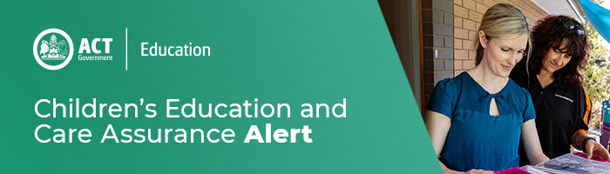
13 March 2020
Updated COVID-19 information for ACT education and care services
On 12 March 2020 the ACT Health Directorate confirmed the first case of COVID-19 in the ACT.
The ACT Health Directorate has well established processes and procedures in place for the management of infectious diseases in the ACT. The ACT Health Directorate is working in partnership with the Australian Government Department of Health and our state and territory counterparts to monitor and respond to the situation.
The ACT Health Directorate is taking a highly precautionary approach to managing the spread of COVID-19, which is in line with the latest national health advice.
As of 11 March 2020, anyone who has returned to Australia from mainland China, Iran, Italy and South Korea, including transit through these countries, must self-quarantine at home for 14 days from the date they left the country and closely monitor for symptoms of COVID-19.
The list of high-risk countries is regularly reviewed and updated.
If individuals have been in close contact with a person who has been confirmed with COVID-19, they must self-isolate themselves for 14 days after the last contact with that person.
Signs and symptoms to look out for include:
- fever
- coughing and sore throat
- difficulty breathing

Providers, services, and educators can:
- Maintaining good hygiene standards is an important way to reduce the risk of acquiring and spreading respiratory infections.

- Education and care services are reminded to provide appropriate handwashing facilities as handwashing is the single most effective way to reduce the spread of germs that cause respiratory disease.

- As always, children or staff who are unwell and reasonably suspected to have a communicable disease should be excluded from your service until they are cleared by a doctor to return.

- Keep up to date with the latest information and advice from ACT Health by following the ACT Health web page, Facebook and Twitter.

- Do not use advice or resources from unreliable sources, for example marketing providers.

- Contact the Coronavirus Health Information Line on 1800 020 080 for further information on COVID-19. The line operates 24 hours a day, seven days a week.
Infectious diseases and reporting responsibilities

Given the evolving nature of COVID-19 education and care providers and services are encouraged to review their obligations of responding to infectious diseases.

Regulation 88 of the Education and Care Services National Regulations requires providers and services to:

- Ensure that reasonable steps are taken to prevent the spread of the infectious disease at the service.
- In an event of an infectious disease at a service the approved provider must ensure that a parent or an authorised emergency contact of each child being educated and cared for is notified of the occurrence as soon as practicable.

Any infectious disease should be notifiable to Children’s Education and Care Assurance (CECA) and ACT Health’s Communicable Disease Control Unit telephone 02 5124 9213.

Providers and services should submit a notification to CECA using the National Quality Agenda IT System (NQAITS) to meet notification requirements.

All approved providers and services are required to have updated contact details recorded in NQAITS. Please note that under Section 174 of the Education and Care Services National Law (ACT), it is an offence to fail to notify information in respect of prescribed matters. It is essential that CECA have the means to directly contact services and providers on an urgent basis. CECA require all providers and service leaders to review (and, if necessary, update) all service and provider level phone numbers, emergency mobile phone numbers and email addresses by close of business on 16 March 2020.

For enquires in relation to this notification please call CECA on (02) 6207 1114 or email CECA@act.gov.au
This email has been authorised by the ACT Regulatory Authority (CECA). CECA are responsible for administering the National Quality Framework within the ACT

