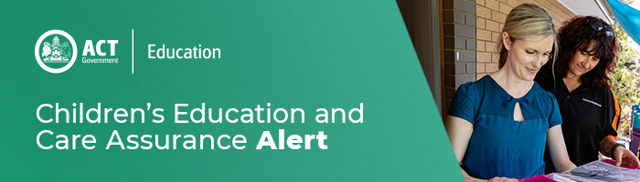
2 February 2021
Updated COVID-19 Information for Education and Care Services
New Public Health Direction for those who have been in Western Australia since 25 January 2021

A new Public Health Direction came into effect on 1 February declaring the Perth metropolitan area, and the Peel and South West regions of Western Australia (WA) as COVID-19 affected areas. Anyone in the ACT who has been in these areas since 25 January 2021 must immediately quarantine and get tested for COVID-19. In addition, people should remain in quarantine until at least 9pm (ACT time) on 5 February 2021, even if they receive a negative result. ACT residents

Individuals who have returned to the ACT from one of the WA COVID-19 affected areas, must immediately enter quarantine until at least 9pm (ACT time) on Friday 5 February, get tested for COVID-19, and complete this online declaration form (https://actredcap.act.gov.au/redcap/surveys/?s=ENA34MC3TR) before 2pm Tuesday 2 February.

Individuals who have been in the Perth metropolitan area or the Peel and South West regions of WA since 25 January 2021, should self-quarantine and get tested for COVID-19.
In line with the lockdown in WA, individuals who have been in Perth at this time should stay in self-quarantine until 9pm on Friday 5 February, even if a negative test result is received.

Update on travel restrictions from COVID-19 affected areas of NSW

As of 3.00pm Friday 29 January 2021, there will no longer be travel restrictions in place for the Cumberland Local Government Area (LGA), with the Chief Health Officer revoking the ACT Public Health Direction for COVID-19 affected areas of New South Wales.

This means people currently in quarantine in the ACT from the Cumberland LGA will no longer be required to quarantine. The Northern Beaches LGA and Canterbury-Bankstown LGA will also be removed from the current list of geographical areas of risk for high risk settings, such as hospitals and other healthcare facilities and residential aged care. This will see only two LGAs – the Cumberland LGA and Blacktown LGA – remaining as geographical areas of risk for these high-risk settings. This means that anyone who has visited these two NSW LGAs should not visit or work in a high risk setting for 14 days after leaving the area. Visit https://www.covid19.act.gov.au/ to keep up to date with the latest travel restrictions.

COVID-19 viral fragments detected in Belconnen wastewater

ACT Health is urging the community to get tested for COVID-19 if they have even the mildest of symptoms, with fragments of the virus detected in the ACT’s wastewater (sewage) for the first time. The positive detection was found in a sewage sample collected on 27 January 2021 from the Belconnen wastewater testing location. The Belconnen testing site covers wastewater from Aranda, Belconnen, Bruce, Charnwood, Cook, Dunlop, Evatt, Florey, Flynn, Fraser, Giralang, Hall, Hawker, Higgins, Holt, Kaleen, Latham, Lawson, Macgregor, Macquarie, McKellar, Melba, Page, Scullin, Spence, Strathnairn and Weetangera.

All other locations in the ACT had negative sample results on 27 January 2021. Anyone who lives in, works in, or has recently visited the Belconnen area, is urged to get tested for COVID-19 if they are experiencing even the mildest of symptoms, and to self-isolate until they receive a negative result. This is particularly important for anyone who has recently travelled outside the ACT. Common symptoms of COVID-19 include fever, sore throat, cough, shortness of breath, and loss of smell or taste, while less commons symptoms include runny or blocked nose, muscle pain, joint pain, diarrhoea, nausea, vomiting and loss of appetite. ACT Health is continuing to investigate, and further wastewater testing will be conducted next week as part of the ongoing Wastewater surveillance program in the ACT. For information, including FAQs on the ACT Wastewater Surveillance Program, visit www.covid19.act.gov.au/news-articles/wastewater

For enquires in relation to this notification please call CECA on (02) 6207 1114 or email CECA@act.gov.au
This email has been authorised by the ACT Regulatory Authority (CECA). CECA are responsible for administering the National Quality Framework within the ACT

