

Fraud and Corruption Reporting Procedure

ACT Education Directorate
Insert Directorate

Document Information
Procedure Identifier: 00120/1
Date endorsed: May 2026
Endorsed by: COO (Tier 2)
Review date: May 2031
It is the responsibility of the user to verify that this is the current and complete version of the document, available on the Directorate’s website at http://www.education.act.gov.au/publications_and_policies/policy_a-z.

Contents
Document Information 2
1. Overview 2
2. Rationale 3
3. Procedures 3
4. Contact 7
5. Feedback 7
6. References 7


© Australian Capital Territory 2026
This work, Fraud and Corruption Reporting Procedure, is licensed under a Creative Commons Attribution 4.0 licence. You are free to re-use the work under that licence, on the condition that you credit the Australian Capital Territory Government as author, indicate if changes were made and comply with the other licence terms.
The licence does not apply to the ACT Government logo.
This procedure must be read in conjunction with Fraud and Corruption Reporting Policy.

Overview
  - This procedure relates to the Fraud and Corruption Reporting Policy. It covers procedures for staff to report suspected fraudulent and corrupt activity, including mandatory reporting requirements under the Integrity Commission Act 2018.

Rationale
  - Consistent with the Directorate’s zero-tolerance of fraud and corruption, the purpose of these procedures is to provide clear instructions to staff on how to report suspected fraud and corruption and information on how these reports are managed.

Procedures
  - The Directorate’s Fraud and Corruption Control framework
    - The Directorate’s Senior Executive Responsible for Business Integrity Risk (the SERBIR) is responsible for implementation and monitoring of the Directorate’s fraud and corruption control framework which is aligned to the Australian Standard AS8001-2021. Fraud and Corruption Control and can be categorised into three elements:
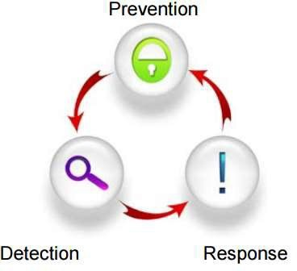

    - Prevention: As required under Part 2.3 of the Public Sector Management Standards 2006, the Directorate has a Fraud and Corruption Prevention Plan. This plan is updated annually and captures a range of actions to prevent fraud and corruption based on an assessment of risk. Examples include prevention systems (e.g., auditing of HR and payroll systems), regular reminders to all staff from senior executives that reinforce a strong integrity message and engagement with education and guidance provided by external agencies such as the ACT Integrity Commission.
    - Detection: The Directorate implements systems aimed at detecting fraud and corrupt activity.
    - Response: Section 3.3. of these procedures outlines the Directorate’s approach to responding to reports of suspected fraud and corruption.
  - How to report suspected fraud and corruption
    - All staff must report suspected fraud and corruption in accordance with the following procedures:
      - Confidentiality
People who report evidence or suspicions of fraud or corruption can be confident that their identity and information will be treated in the strictest confidence.
      - Note observations
It is important that you do not jump to conclusions. Carefully observe and note (but do not investigate) the suspected conduct. Capture your notes and actions at the time of the event or as close to this time as possible, store them securely along with any other relevant documents and do not to keep these notes and any documents as possible evidence and do not alter them
      - Report concerns
Report concerns to your supervisor, the SERBIR or a Senior Executive in the Education Directorate as soon as you have suspicions. This process is detailed in the flowchart at Attachment A.
The sooner you report suspected or actual fraud or corruption, the sooner it can be actioned and dealt with. A delay in reporting can affect the ease with which a matter is investigated and dealt with. The SERBIR can be contacted through the eduserbir@act.gov.au email address.
Persons reporting suspected fraud or corruption may be protected under the provisions of the Public Interest Disclosure Act 2012 and the Integrity Commission Act 2018. Further information on Public Interest Disclosure (sometimes referred to as ‘whistleblowing’) is available in the EDU Public Interest Disclosure Factsheet.
Note: Any person can report wrongdoing by a person or organisation that is covered by the Integrity Commission Act 2018 or the Public Interest Disclosure Act 2012 directly to the ACT Integrity Commission.
      - Recording fraud and corruption matters
The SERBIR is responsible for maintaining an appropriate recording and tracking system for the Directorate to ensure all instances of fraud and corruption are satisfactorily investigated, resolved, and decisions are recorded. This system facilitates the extraction of statistical data for monitoring the effectiveness of the Directorate’s fraud and corruption prevention activities and provides information required to meet annual reporting and other obligations. Accurate and detailed records are to be kept of all reported suspected fraud and corruption.
  - How the Directorate manages reports of suspected fraud and corruption
    - Preliminary case handling
Initial enquiries into all instances of suspected fraud or corruption will be made by the SERBIR, who will determine whether there is any basis for further action. The SERBIR may appoint an authorised officer within the organisation to undertake enquiries, utilise People and Performance (for example to conduct a preliminary assessment) or may acquire the services of external experts to assist in the conduct of any inquiry.
Conversely, the People and Performance Branch may identify suspected fraud or corruption during a preliminary assessment and will notify the SERBIR.
    - Investigation (Internal and External)
      - All allegations of fraud or corruption, whether raised by staff or individuals external to the ACTPS, are assessed and where appropriate, investigated with the aim of proving or disproving the allegations made. The SERBIR is guided by a number of potential criteria when determining referrals of suspected fraud or corruption for investigation. These are based on the following:
- Guidance Advice - ACTPS Decision Maker’s Handbook
- Integrity Commission Act 2018
- Public Interest Disclosure Act 2012
- Relevant staff Enterprise Agreements
      - Where appropriate, the SERBIR may determine the need to refer matters to the Public Sector Standards Commissioner, through an officer of the Professional Standards Unit, or to the ACT Integrity Commission or the Australian Federal Police.
      - Following the discovery of fraud or corruption, the SERBIR will assess the adequacy of internal controls and determine if improvements need to be implemented.
    - Reporting
Reporting mechanisms undertaken within the Directorate adhere to the requirements of the ACTPS Integrity Governance Policy and the Integrity Commission Act 2018 include:
- Inclusion of information in the annual report on prevention processes, detection of and resolved instances of fraud and corruption and in accordance with the Annual Report Directions;
- SERBIR reports regularly to the Executive Governance Committee (EGC) and Audit Committee; and
- If, in the opinion of the SERBIR, there is an occurrence or suspected occurrence of serious or systemic corrupt conduct then there is a mandated obligation to report this conduct to the ACT Integrity Commissioner.
  - Mandated reporting obligations to the ACT Integrity Commission
    - There is a duty on mandated reporters to carefully consider all information or material that comes to their attention about serious or systemic corrupt conduct. Under the Integrity Commission Directions 2019 (No 2) a mandated reporter is defined as, the head of a public sector entity, a Senior Executive Service level office (Band 1, 2 or 3 Senior Executive Service), a member of the Legislative Assembly, and a chief of staff of a minister (including the Chief Minister) and must notify the Commission about any matter that the member suspects on reasonable grounds involves serious corrupt conduct or systemic corrupt conduct.
    - In the Education Directorate mandated reporters are Executive Branch Managers, Executive Group Managers, Deputy Directors-General and the Director-General.
    - A mandated reporter must notify the SERBIR of matters reported to the ACT Integrity Commissioner that relate to Directorate business. This will ensure that the SERBIR has visibility of the matter and can assist the Commission with the provision of any relevant information they may seek.
Note: this reporting obligation is in addition to the requirement under the Public Sector Management Act 1994 to report any maladministration or corrupt or fraudulent conduct by a public servant to the Head of Service.
    - The ACT Integrity Commission has provided the below decision-making flowchart to assist mandated reporters to establish if there is an obligation to make a mandatory corruption notification when faced with information or material about a public official’s or a public sector entity’s conduct.
Mandatory corruption notification flowchart
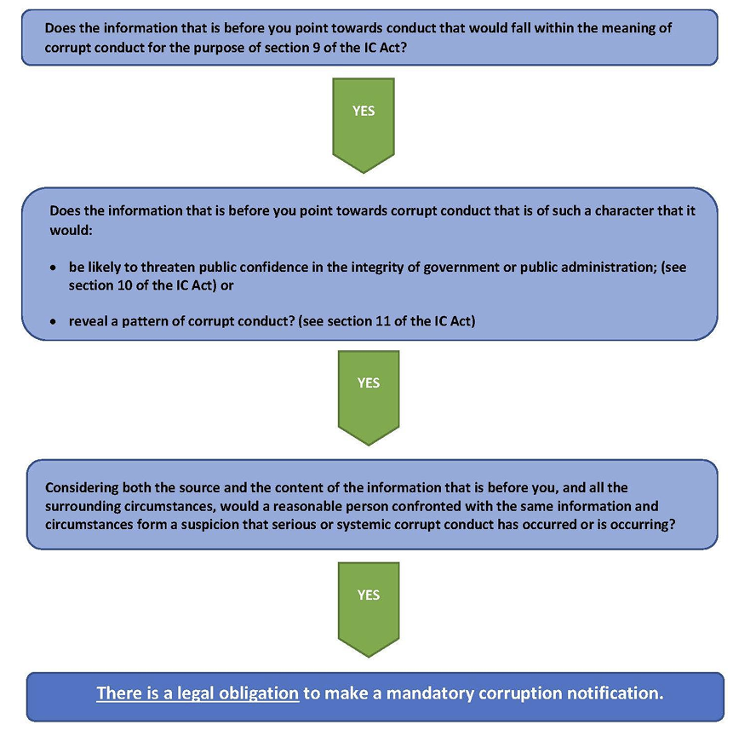
  - Avenues for process complaints
    - Staff who are not satisfied with the Directorate’s response to a report of possible fraud or corruption may raise their concerns with the ACT Ombudsman or the ACT Integrity Commission. Staff who are aggrieved by the conduct of a misconduct investigation under the relevant Enterprise Agreement may raise their concerns through the appeal mechanism within the Enterprise Agreement or with the Public Sector Standards Commissioner.

Contact
  - The Directorate’s Senior Executive Responsible for Business Integrity Risk (SERBIR) is responsible for this procedure.
  - For support contact the SERBIR at eduserbir@act.gov.au or the Audit and Assurance team on (02) 6207 4386.

Feedback
  - Any feedback about this procedure should be raised with the policy owner. Refer to Contact information above.

References
  - Definitions

Term | Definition
Corruption | A person engages in corrupt conduct if they are a public official and they breach public trust, abuse their office as a public official, misuse information they have gained in their capacity as a public official or do something that could cause a public official to behave dishonestly or in a biased way when they carry out their official duties.
Fraud | An intentional dishonest act or omission done with the knowledge of deceiving.
Serious corrupt conduct | Serious corrupt conduct means corrupt conduct that is likely to threaten public confidence in the integrity of government of public administration.
Senior Executive Responsible for Business Integrity Risk (SERBIR) | A senior executive appointed by the Director-General, in order to manage the integrity requirements under the PSM Standards 2006 (part 2.3).
Systemic corrupt conduct | Systemic corrupt conduct means instances of corrupt conduct that reveal a pattern of corrupt conduct in one or more public sector entities.
  - Related Policies and Information
- ACTPS Integrity Framework
- ACTPS Integrity Governance Policy
- ACTPS Code of Conduct
- Code of Conduct for School Based Staff
- Code of Conduct for Teachers, School Leaders and Principals
- Conflict of Interest Policy

Attachment A Fraud and Corruption Control Flowchart
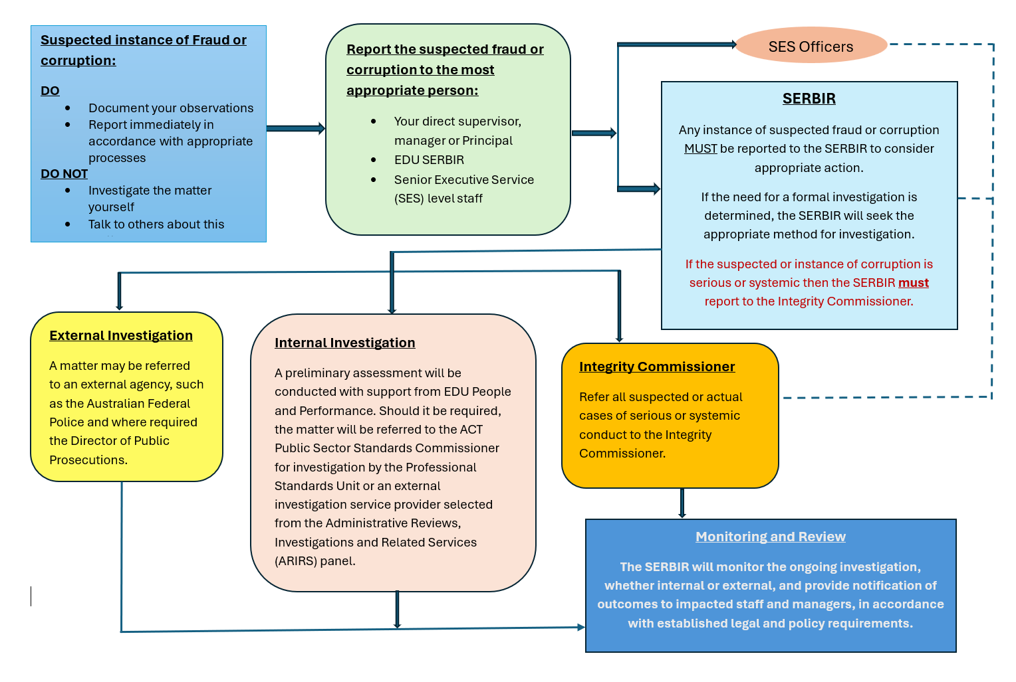

Section 10 Integrity Commission Act 2018
Section 11 Integrity Commission Act 2018

