

ACT POST SCHOOL DESTINATIONS AND PATHWAYS IN 2016

A summary of the 2016 results from the survey of 2015 year 12 graduates and school leavers and the longitudinal survey of 2013 year 12 graduates and school leavers.
Key Findings
- Ninety-two percent of 2015 year 12 graduates were employed and/or studying in 2016, compared with 74 percent of 2015 school leavers.
- Fifty-nine percent of 2015 year 12 graduates were studying in 2016 and a further 31 percent intended to start some study in the next two years.
- Thirty-nine percent of 2015 school leavers were studying in 2016 and a further 34 percent intended to start some study in the next two years.
- Seventy-two percent of 2015 year 12 graduates were employed in 2016, compared with 60 percent of 2015 school leavers.
- The percentage of 2013 year 12 graduates studying increased from 59 percent in 2014 to 74 percent in 2016.
- Eighty-six percent of the 2013 year 12 graduates who deferred university in 2014 were attending university in 2016.
- Sixty-two percent of 2013 year 12 graduates and 30 percent of 2013 school leavers who were not studying in 2014, were studying in 2016

© Australian Capital Territory, Canberra, 2016
This publication has been produced by the ACT Government. Apart from any use permitted under the Copyright Act 1968, no part of this publication may be reproduced by any process without written permission from the ACT Government’s Education Directorate.

Contents

Executive Summary 4
Background 6
Part 1 – 2015 Year 12 Graduates and School Leavers 6
Destination of year 12 graduates 6
Key outcomes 6
Study 8
Labour force status 11
Participation in other post-school activities 13
Destination of school leavers 13
Characteristics of students who left school in 2015 16
Satisfaction with school 17
Reasons for leaving school 18
Part 2 – 2013 Year 12 Graduates and School Leavers 19
Pathways of 2013 year 12 graduates 19
Key outcomes 19
Study 20
Labour force status 24
Pathways of 2013 school leavers 27
Scope and methodology 29
Glossary 30
References 31

Executive Summary
The ACT Government believes every student in the ACT should have access to the opportunities provided through quality education. The Education Directorate 2014-17 Strategic Plan sets out an ambitious agenda to ensure progress for all students and an increase in the qualification levels of the ACT, with every Canberran set for life through access to quality further education and training.

In its commitment to an educated and skilled workforce to meet the present and future needs of the ACT, the Education Directorate has prioritised learning pathways designed to meet the needs of young people through flexible training options and engagement with industry and employers.

In May 2016 the Education Directorate conducted two post school destination surveys.
- The annual survey of 2015 ACT year 12 graduates (those who completed an ACT Senior Secondary Certificate in 2015) and year 9 to 12 school leavers (those who were in year 9 to 12 when they left school in 2015 prior to completing an ACT Senior Secondary Certificate). A total of 2,649 graduates and 393 school leavers completed the survey.
- A longitudinal survey of 2013 ACT year 12 graduates and school leavers (approximately 2.5 years after leaving school). This longitudinal survey was the third, and final, wave of the three-year longitudinal study of 2013 ACT year 12 graduates and school leavers (2014, 2015 & 2016). A total of 1,325 graduates and 166 school leavers completed the survey. In the future, longitudinal surveys will be conducted with every second year cohort.

Part 1 of the ACT Post School Destinations and Pathways in 2016 report presents information about the 2016 destinations of 2015 ACT year 12 graduates and school leavers and part 2 presents information about the pathways 2013 year 12 graduates and school leavers have taken from 2014 to 2016.
The vast majority (92%) of 2015 ACT year 12 graduates, were employed and/or studying in 2016, with the report highlighting that females, those who gained an ATAR and/or did not receive a pension, were more likely to be employed and/or studying than their peers.

Survey results for 2015 school leavers, showed that almost three-quarters (74%) were employed and/or studying in 2016. The report highlights that those who remained at school until year 12, participated in work experience, received career counselling and/or did not receive a pension were more likely to be employed and/or studying than their peers.

The report shows that over 30 percent of 2015 year 12 graduates and school leavers were not studying in 2016, but were intending to study in the next two years. A similar trend has been observed in previous years. The results from the longitudinal survey indicated that the majority of 2013 graduates surveyed in 2014 who indicated their intention to study in 2015 or 2016, did start study in either 2015 or 2016. Figure 1 shows the overall increase in the percentage of 2013 year 12 graduates and school leavers commencing study in 2015 and a further smaller increase in 2016 for year 12 graduates. 2013 year 12 graduates who formally deferred university in 2014 were more likely to start study in 2015 or 2016 than those who had an informal intention to study.
Figure 1: 2013 year 12 graduates and school leavers by study status in 2014, 2015 and 2016 (%)
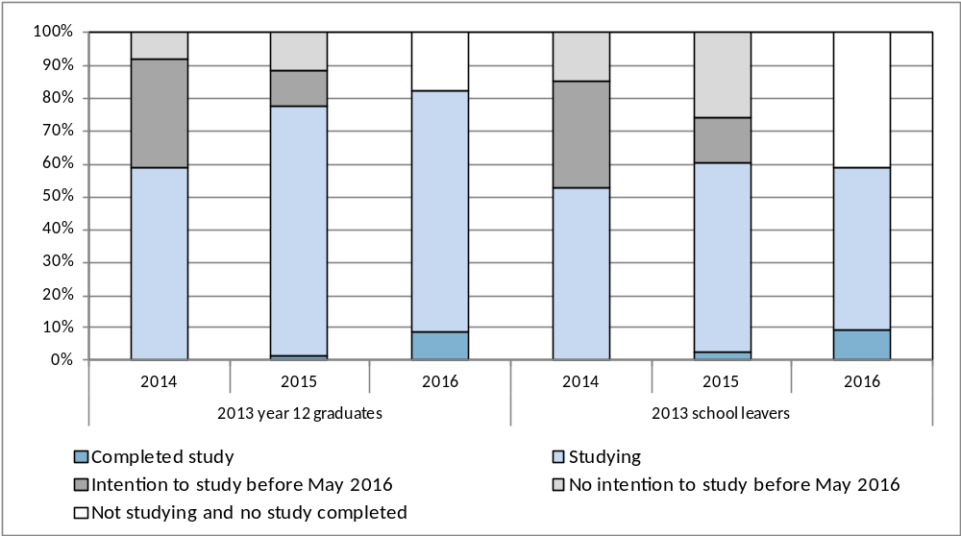

Overall, the report presents a positive picture of the pathways from school to further study and employment for young people both graduating from and leaving ACT schools. However, the report clearly shows that those young people who complete an ACT Senior Secondary Certificate are advantaged both in terms of employment and further study outcomes, six months after leaving school, when compared with their peers who leave school before graduating from year 12 (Figure 2).

Figure 2: 2015 year 12 graduates and school leavers by main destination in 2016 (%)
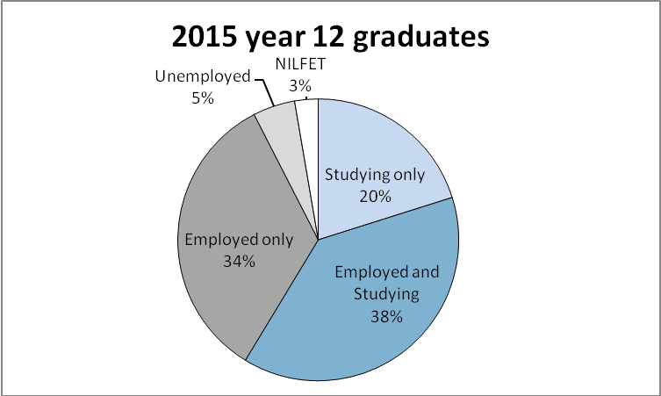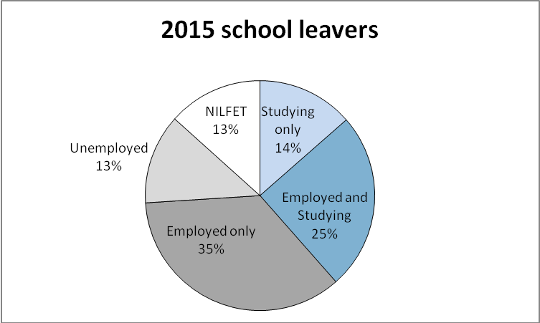
Note: NILFET means ‘not in labour force, education or training’.
The School Leaver Survey results provide important information that informs planning, development and provision of education and training choices for the young people of the ACT. The Directorate works closely with school staff in ACT public and non-government schools to ensure the survey results are disseminated and used for curriculum planning and to assist students with study and career choices at school and beyond.

Background
Australia is in a period of significant education and training reform. The current national reform agenda is impacting on all sectors of education, training and skills development. The ACT is proactive in looking to the future of education and training in our region, building on the strengths of current collaborations, relationships and partnerships within the sector, and promoting opportunities for change.
The ACT is committed to providing learning pathways for students which result in an educated and skilled workforce to meet the present and future needs of the ACT and region. The focus is on ensuring young people’s needs are met, providing flexible and responsive training options, engaging with industry and employers and improving retention rates. Together these strategies empower students to shape their own learning pathways while meeting industry needs.
Results from the School Leaver Surveys provide important information that informs planning, development and provision of education and training choices for the young people of the ACT.
In addition to the annual School Leaver Survey, the Education Directorate recently introduced a longitudinal survey to find out if students continue with their initial and/or intended pathways in subsequent years and to further explore issues identified in the annual survey, such as the trend to defer further study. The longitudinal survey of 2013 year 12 graduates and school leavers was the first longitudinal survey conducted in the ACT. Consenting 2013 year 12 graduates and school leavers were surveyed three times in total; 2014 (Wave 1), 2015 (Wave 2) and 2016 (Wave 3).
In this publication students who completed an ACT Senior Secondary Certificate in 2015 are described as 2015 year 12 graduates. Students who were in year 9 to 12 when they left school in 2015 prior to completing an ACT Senior Secondary Certificate are described as 2015 school leavers. Students who completed an ACT Year 12 Certificate in 2013 are described as 2013 year 12 graduates. Students who were in year 9 to 12 when they left school in 2013 prior to completing an ACT Year 12 Certificate are described as 2013 school leavers.

Part 1 – 2015 Year 12 Graduates and School Leavers

Destination of year 12 graduates
Key outcomes
Ninety-two percent of 2015 year 12 graduates reported that they were employed and/or studying in 2016. This compares favourably with the Australian employed and/or studying rate in 2015 of 88 percent for 15-24 year olds who completed year 12 prior to leaving school in 2014 (Australian Bureau of Statistics, 2015).
Table 1 provides an overview of the percentage of year 12 graduates employed, studying and employed and/or studying in the year following graduation. Data are presented for surveys conducted with 2012, 2013, 2014 and 2015 year 12 graduates. The following points were consistently noted over the four years:
- female students were more likely to be employed and more likely to be employed and/or studying than male graduates. For example, 76 percent of female 2015 year 12 graduates were employed in 2016 compared to 69 percent of male graduates
- graduates who spoke a language other than English at home (LBOTE) were more likely to be studying while graduates who were not LBOTE were more likely to be employed
- graduates who did not obtain an Australian Tertiary Admission Rank (ATAR) were more likely to be employed, less likely to be studying and less likely to be employed and/or studying
- graduates who were receiving a Government pension, allowance or benefit were more likely to be studying, less likely to be employed and less likely to be employed and/or studying.
Table 1: Year 12 graduates employed and/or studying, by selected demographics (%)
 |  | Employed |  |  |  |  | Currently studying |  |  |  |  | Employed and/or studying
Year of graduation |  | 2012 | 2013 | 2014 | 2015 |  | 2012 | 2013 | 2014 | 2015 |  | 2012 | 2013 | 2014 | 2015
Gender
 | Female | 77.2 | 75.2 | 72.8 | 75.7 |  | 60.4 | 61.8 | 61.7 | 59.3 |  | 94.7 | 93.7 | 93.1 | 94.5
 | Male | 71.4 | 70.8 | 66.3 | 68.9 |  | 59.3 | 56.7 | 60.7 | 58.0 |  | 92.1 | 90.1 | 90.7 | 90.4
LBOTE
 | No | 78.2 | 75.9 | 72.9 | 76.2 |  | 55.9 | 55.8 | 58.3 | 54.5 |  | 93.2 | 91.7 | 91.6 | 92.2
 | Yes | 55.1 | 57.0 | 54.3 | 56.4 |  | 79.4 | 78.0 | 75.3 | 76.1 |  | 94.5 | 93.0 | 93.8 | 93.4
Participated in a VET course at school
 | No | 74.4 | 71.5 | 67.9 | 70.5 |  | 57.6 | 57.5 | 60.4 | 57.8 |  | 93.5 | 91.1 | 91.4 | 91.8
 | Yes | 74.0 | 77.3 | 74.7 | 77.7 |  | 65.7 | 64.2 | 63.8 | 61.3 |  | 93.1 | 94.1 | 93.5 | 94.5
ATAR Group
 | No ATAR | 78.8 | 75.6 | 74.3 | 75.7 |  | 48.5 | 49.1 | 45.4 | 45.2 |  | 88.3 | 86.7 | 85.8 | 87.8
 | 1 - 65 | 75.9 | 75.3 | 69.7 | 72.6 |  | 55.5 | 57.4 | 63.3 | 57.0 |  | 93.0 | 92.8 | 93.7 | 91.8
 | 66 - 75 | 74.6 | 79.9 | 75.8 | 74.7 |  | 65.0 | 62.9 | 66.5 | 62.9 |  | 95.7 | 96.5 | 96.7 | 94.8
 | 76 - 85 | 73.1 | 74.8 | 69.8 | 72.9 |  | 66.8 | 64.4 | 68.1 | 68.6 |  | 97.7 | 93.8 | 95.2 | 97.3
 | 86 - 95 | 70.9 | 67.0 | 62.8 | 70.1 |  | 70.9 | 67.3 | 71.5 | 70.6 |  | 97.4 | 95.1 | 93.5 | 96.3
 | 96 - 100 | 59.6 | 52.5 | 51.9 | 52.0 |  | 73.3 | 74.7 | 80.8 | 79.6 |  | 95.9 | 94.9 | 96.8 | 96.1
Received career counselling at school
 | No | 74.6 | 72.5 | 68.8 | 71.0 |  | 59.1 | 60.9 | 61.4 | 57.0 |  | 92.7 | 92.0 | 91.5 | 91.0
 | Yes | 74.6 | 73.8 | 70.7 | 73.5 |  | 61.3 | 58.2 | 61.4 | 60.5 |  | 94.2 | 92.1 | 92.8 | 93.9
 | Don't Know | 62.5 | 63.5 | 57.7 | 58.1 |  | 42.8 | 52.7 | 51.7 | 27.0 |  | 89.1 | 85.5 | 76.7 | 71.4
Participated in work experience at school
 | No | n.a. | 72.7 | 67.6 | 70.4 |  | n.a. | 59.2 | 60.2 | 58.0 |  | n.a. | 92.4 | 91.7 | 92.2
 | Yes | n.a. | 73.2 | 71.3 | 74.0 |  | n.a. | 59.2 | 62.2 | 59.2 |  | n.a. | 91.5 | 92.1 | 92.7
Received a government pension, allowance or benefit in 2015
 | No | n.a. | 75.7 | 72.9 | 75.7 |  | n.a. | 57.7 | 60.0 | 56.8 |  | n.a. | 92.6 | 92.8 | 93.0
 | Yes | n.a. | 46.8 | 43.7 | 43.5 |  | n.a. | 73.9 | 71.1 | 75.9 |  | n.a. | 85.4 | 85.0 | 87.7
All graduates |  | 74.3 | 73.0 | 69.6 | 72.3 |  | 59.8 | 59.2 | 61.2 | 58.7 |  | 93.4 | 91.9 | 91.9 | 92.5
Note: n.a. indicates that results are not available.
Study
Fifty-nine percent of all graduates indicated that they were undertaking some study in 2016, with 49 percent studying full-time (Table 2). This is slightly lower than the Australian study rate in 2015 of 62 percent (and 50% in full-time study) for 15-24 year olds who completed year 12 prior to leaving school in 2014 (Australian Bureau of Statistics, 2015).
2015 year 12 graduates who achieved a higher Australian Tertiary Admission Rank (ATAR) had a greater tendency to undertake further study. Eighty percent of the graduates with an ATAR between 96 and 100 were undertaking study in 2016, compared with 63 percent of the graduates with an ATAR between 66 and 75.
Of the 15 percent of 2015 year 12 graduates who were receiving a government pension, allowance or benefit in May 2016, 76 percent were studying in 2016, compared with 57 percent of those who were not receiving a government pension, allowance or benefit.
Table 2: 2015 year 12 graduates studying in 2016, by selected demographics (%)
 |  | Studying |  |  | Not studying
 |  | Part-time | Full-time | All
Gender
 | Females | 7.9 | 51.1 | 59.3 | 40.7
 | Males | 9.5 | 47.3 | 58.0 | 42.0
LBOTE
 | No | 8.7 | 45.0 | 54.5 | 45.5
 | Yes | 8.4 | 67.2 | 76.1 | 23.9
Participated in a VET course at school
 | No | 8.1 | 48.9 | 57.8 | 42.2
 | Yes | 10.4 | 50.5 | 61.3 | 38.7
ATAR Group
 | No ATAR | 16.3 | 27.5 | 45.2 | 54.8
 | 1 - 65 | 6.5 | 49.9 | 57.0 | 43.0
 | 66 - 75 | 5.4 | 56.6 | 62.9 | 37.1
 | 76 - 85 | 3.5 | 65.1 | 68.6 | 31.4
 | 86 - 95 | 2.7 | 67.9 | 70.6 | 29.4
 | 96 - 100 | 2.6 | 76.4 | 79.6 | 20.4
Received career counselling at school
 | No | 10.6 | 45.3 | 57.0 | 43.0
 | Yes | 7.6 | 52.4 | 60.5 | 39.5
Participated in work experience at school
 | No | 6.8 | 50.8 | 58.0 | 42.0
 | Yes | 10.2 | 48.0 | 59.2 | 40.8
Received a government pension, allowance or benefit in 2015
 | No | 8.5 | 47.5 | 56.8 | 43.2
 | Yes | 10.5 | 65.4 | 75.9 | 24.1
All graduates |  | 7.6 | 49.3 | 58.7 | 41.3
Note: The percentages in this table do not all add to 100 percent due to rounding and a small percentage of ‘don’t know’ responses.
The Australian Standard Classification of Education (ASCED) was used to classify fields of study. The most common fields of study related to:
- society and culture (19%). This included fields such as political science, psychology, law, economics, sport and literature
- management and commerce (12%). This included fields such as accounting, business management, marketing and finance
- health (12%). This included fields such as medical, dental and veterinary studies, nursing, pharmacy, optical and rehabilitation therapies
- natural and physical sciences (12%). This included fields such as mathematics, physics, chemistry, biology and earth sciences.
Fifty-nine percent of 2015 year 12 graduates applied for a university place and 97 percent of these graduates were successful in gaining a place. Of the successful applicants:
- 71 percent accepted the place and enrolled in 2016
- 26 percent of successful applicants deferred
- two percent rejected the offer.
Graduates who were not LBOTE and graduates with a lower (66-75) ATAR were more likely to defer their university studies.
The ASCED was also used to classify level of study. Responses of:
- advanced diploma, associate degree and bachelor degree or higher were more broadly classified as the higher education level
- responses of Certificate I-IV and diploma were classified as the Vocational Education and Training (VET) level in this publication.
Sixty-seven percent of 2015 year 12 graduates studying in 2016 reported that they were studying at the higher education level and 29 percent were studying at the VET level. A greater proportion of females were studying at the higher education level – 70 percent of females compared with 63 percent of males. The proportion of males studying at the VET level was slightly more than the proportion of females studying at that level – 31 percent of males compared with 27 percent of females (Figure 3).
Figure 3: 2015 year 12 graduates studying in 2016, by level of study and gender (%)
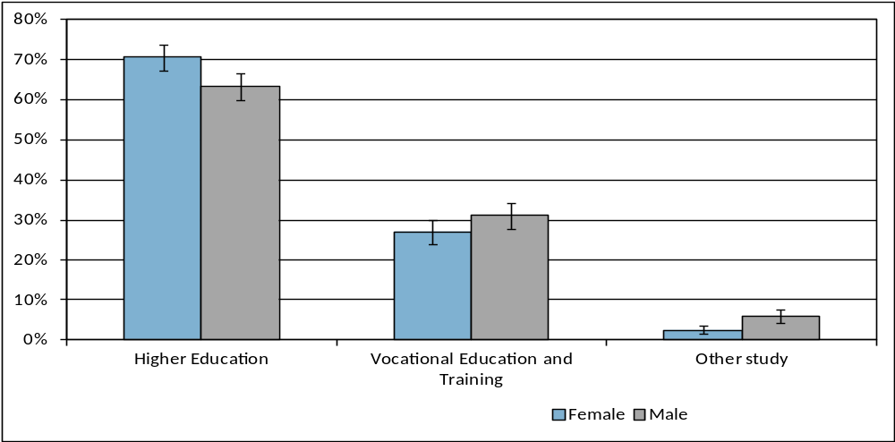
Note: The error bars reflect the 95 percent confidence intervals and no overlap indicates there is a statistical difference between the results.
Of the 2015 year 12 graduates who were studying in 2016, 55 percent reported that they chose their course because it interested them and 30 percent chose the course because they thought it would assist with employment (Table 3).
Forty percent of graduates who were studying in 2016 and did not gain an ATAR reported that they chose the course because it interested them and 37 percent chose the course because they thought it would assist with employment. Graduates with a higher ATAR were more likely to have chosen their course because it interested them, with 68 percent of graduates with an ATAR between 96 and 100 reporting this as their main reason.
Table 3: 2015 year 12 graduates studying in 2016, by main reason for choosing their course and selected demographics (%)
 |  | It's a course that interests me | To get/start/help in a job/business | To help get into another course | To improve my education | Other
Gender
 | Females | 55.3 | 29.9 | 5.4 | 1.2 | 7.7
 | Males | 54.2 | 29.9 | 4.6 | 2.1 | 8.3
Participated in a VET course at school
 | No | 53.2 | 30.7 | 5.7 | 1.6 | 7.9
 | Yes | 59.2 | 27.9 | 3.0 | 1.6 | 8.1
ATAR Group
 | No ATAR | 40.0 | 37.3 | 8.7 | 1.7 | 10.8
 | 1 - 65 | 60.6 | 23.0 | 6.8 | 2.0 | 7.0
 | 66 - 75 | 56.0 | 30.6 | 3.7 | 0.8 | 8.4
 | 76 - 85 | 58.0 | 31.1 | 1.3 | 2.2 | 7.0
 | 86 - 95 | 62.7 | 25.9 | 3.4 | 1.2 | 6.9
 | 96 - 100 | 67.8 | 22.6 | 2.8 | 1.4 | 4.0
All graduates |  | 54.8 | 29.9 | 5.0 | 1.6 | 7.3
Note: The percentages in this table do not all add to 100 percent due to rounding and a small percentage of ‘don’t know’ responses.
Figure 4: 2015 year 12 graduates undertaking an apprenticeship or traineeship in 2016, by selected demographics (%)
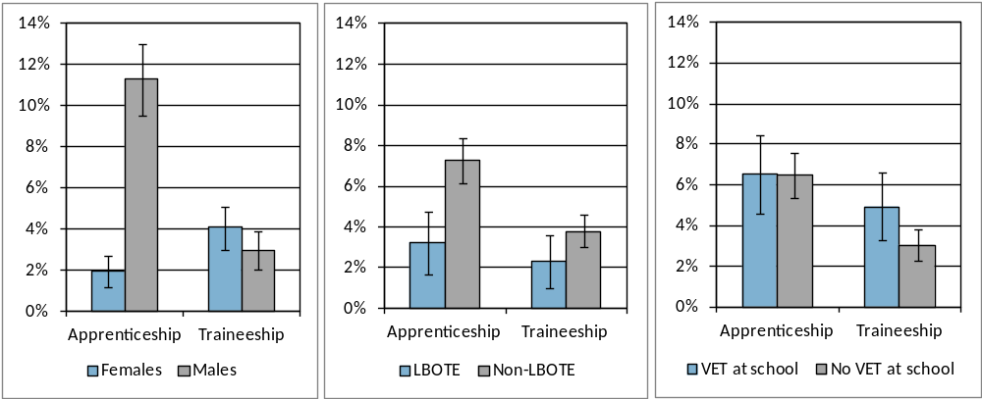
Note: The error bars reflect the 95 percent confidence intervals and no overlap indicates there is a statistical difference between the results.
Overall, seven percent of year 12 graduates indicated they were undertaking an apprenticeship in 2016 and four percent were doing a traineeship. The percentage of graduates undertaking an apprenticeship varied significantly for selected demographics (Figure 4):
- male graduates were much more likely to be undertaking an apprenticeship than females
- graduates who were not LBOTE were more likely to be undertaking an apprenticeship than graduates who were LBOTE.

Twenty-nine percent of 2015 year 12 graduates who were not studying in 2016 reported their main reason for not studying was to “take a gap year”, 12 percent “wanted to earn money”, 11 percent indicated that they had “got a job” and 10 percent were “not sure what to study” (Table 4). Sixteen percent of graduates who were not studying and did not get an ATAR reported their main reason for not studying was because they were “taking a gap year” and 15 percent said they “got a job”.
Table 4: 2015 year 12 graduates not studying in 2016, by main reason for not studying and selected demographics (%)
 |  | Taking a gap year | Wanted to earn money | Got a job | Not sure what to study | Not ready for study | Travelling | Other
Gender
 | Females | 33.6 | 11.5 | 9.7 | 11.5 | 7.3 | 8.5 | 29.2
 | Males | 25.2 | 12.2 | 12.9 | 7.8 | 7.4 | 5.7 | 39.0
Participated in a VET course at school
 | No | 30.4 | 11.8 | 10.5 | 8.4 | 7.4 | 6.1 | 35.8
 | Yes | 26.3 | 11.9 | 14.0 | 13.7 | 7.2 | 10.3 | 28.5
ATAR Group
 | No ATAR | 16.1 | 13.0 | 14.7 | 12.4 | 9.2 | 2.9 | 42.7
 | 1 - 65 | 25.2 | 13.6 | 9.3 | 10.3 | 10.6 | 8.0 | 35.5
 | 66 - 75 | 42.8 | 8.4 | 10.6 | 4.6 | 3.9 | 10.3 | 27.7
 | 76 - 85 | 48.0 | 10.2 | 4.1 | 9.8 | 3.3 | 13.2 | 21.5
 | 86 - 95 | 54.1 | 9.2 | 6.7 | 4.1 | 3.6 | 15.4 | 16.1
 | 96 - 100 | 55.5 | 14.0 | 11.4 | 2.4 | 2.6 | 5.6 | 22.6
All graduates |  | 29.4 | 11.9 | 11.3 | 9.6 | 7.4 | 7.1 | 34.1
Note: The percentages in this table do not all add to 100 percent due to rounding and a small percentage of ‘don’t know’ responses.
Of the 41 percent of 2015 year 12 graduates who were not studying in 2016, 76 percent intended to start some study in the next two years. In general, as ATAR increased, so did intention to start some study in the next two years. The most common intended ASCED fields of study related to:
- society and culture (19%)
- health (13%)
- creative arts (11%).
This high rate of deferral in ACT is consistent with the general trend in Australia, with the incidence increasing from 10 percent in 1999-2000 to 24 percent in 2009-10 (Lumsden & Stanwick, 2012).

Labour force status
Seventy-two percent of 2015 year 12 graduates reported having a paid job in 2016 (Table 5). Fourteen percent of graduates reported not currently having a paid job and actively looking for work with the majority looking for part-time work.
Table 5: Number and proportion of 2015 year 12 graduates, by labour force status in 2016
 |  |  | Number | Proportion (%)
 | Employed |  | 3178 | 72.3
 |  | Full-time | 995 | 22.7
 |  | Part-time | 2151 | 49.0
 |  | Don't know/Refused | 31 | 0.7
 | Unemployed |  | 637 | 14.5
 |  | Looking for full-time work | 82 | 1.9
 |  | Looking for part-time work | 478 | 10.9
 |  | Looking for full or part-time work | 75 | 1.7
 |  | Don't know | 2 | 0.0
 | Total in labour force |  | 3815 | 86.8
Not in labour force |  |  | 578 | 13.2
Total |  |  | 4393 | 100.0
Unemployment rate |  |  |  | 16.7

The percentage of 2015 year 12 graduates who were receiving a government pension, allowance or benefit in May 2016 varied depending on their labour force status. Twenty-one percent of graduates who were unemployed and 20 percent of those not in the labour force were receiving a government pension, allowance or benefit in May 2016, compared with six percent of employed graduates.
The Australian and New Zealand Standard Classification of Occupations (ANZSCO) was used to classify occupations. The most common occupations were:
- community and personal service workers (36%)
- sales workers (29%), technicians and trade workers (11%)
- labourers (10%).
Seventy-eight percent of 2015 year 12 graduates studying part-time in 2016 were employed, with 44 percent employed part-time (Table 6). Sixty-three percent of graduates studying full-time were employed, with the majority (53%) employed part-time. Eighty-two percent of graduates who were not studying were employed and 12 percent were unemployed.
Table 6: 2015 year 12 graduates in the labour force in 2016, by study status in 2016 (%)
 |  |  | Studying |  |  | Not studying | All graduates
 |  |  | Part-time | Full-time | Total
 | Employed |  | 78.5 | 63.1 | 65.7 | 81.8 | 72.3
 |  | Full-time | 34.3 | 10.3 | 14.4 | 34.4 | 22.7
 |  | Part-time | 43.7 | 52.6 | 50.9 | 46.2 | 49.0
 | Unemployed |  | 13.0 | 17.2 | 16.5 | 11.7 | 14.5
 |  | Looking for full-time work | 2.6 | 0.2 | 0.5 | 3.8 | 1.9
 |  | Looking for part-time work | 9.5 | 16.6 | 15.3 | 4.6 | 10.9
 |  | Looking for full or part-time work | 0.9 | 0.5 | 0.6 | 3.2 | 1.7
Total in labour force |  |  | 91.5 | 80.4 | 82.2 | 93.5 | 86.8
Not in labour force |  |  | 8.5 | 19.6 | 17.8 | 6.5 | 13.2
Total |  |  | 100.0 | 100.0 | 100.0 | 100.0 | 100.0
Note: The percentages in this table do not all add to 100 percent due to rounding and a small percentage of ‘don’t know’ responses.
Participation in other post-school activities
The percentage of 2012, 2013, 2014 and 2015 year 12 graduates who participated in various activities in the year following leaving school is shown in Table 7. Participation has remained reasonably stable over the four years. At the time of the survey in May 2016:
- 18 percent of 2015 year 12 graduates were travelling.
- 12 percent were undertaking volunteer work.
- 11 percent were pursuing elite sporting interests.
- 11 percent were caring for family members.
Table 7: Year 12 graduates participating in various post school activities (%)
Year of graduation | 2012 | 2013 | 2014 | 2015
Travelling | 19.0 | 21.7 | 18.2 | 18.1
Undertaking volunteer work | 11.4 | 13.4 | 14.2 | 12.3
Pursuing elite sporting interests | 8.5 | 11.0 | 10.0 | 11.1
Caring for family members | 6.9 | 10.1 | 8.1 | 11.0

Destination of school leavers
Seventy-four percent of 2015 school leavers reported they were employed and/or studying in 2016. This compares favourably with the Australian employed and/or studying rate in 2015 of 68 percent for 15-24 year olds who completed year 11 or below prior to leaving school in 2014 (Australian Bureau of Statistics, 2015).
Table 8: School leavers employed and/or studying, by selected demographics (%)
 |  | Employed |  |  |  |  | Currently studying |  |  |  |  | Employed and/or studying
Year left school |  | 2012 | 2013 | 2014 | 2015 |  | 2012 | 2013 | 2014 | 2015 |  | 2012 | 2013 | 2014 | 2015
Gender
 | Females | 58.7 | 57.6 | 53.9 | 63.9 |  | 42.9 | 38.5 | 46.5 | 32.2 |  | 75.2 | 72.3 | 70.5 | 74.3
 | Males | 60.6 | 54.2 | 61.8 | 58.6 |  | 44.7 | 49.5 | 43.3 | 41.9 |  | 75.9 | 75.1 | 77.4 | 73.8
Year level
 | Year 9 to 11 | 59.5 | 58.1 | 57.5 | 65.6 |  | 38.1 | 45.6 | 42.7 | 39.0 |  | 68.8 | 72.7 | 68.7 | 68.8
 | Year 12 | 60.8 | 52.4 | 60.7 | 56.4 |  | 50.8 | 46.0 | 45.6 | 38.2 |  | 84.2 | 75.7 | 80.3 | 78.1
LBOTE
 | No | 60.3 | 55.3 | 61.3 | 62.3 |  | 44.4 | 45.2 | 44.7 | 38.2 |  | 75.7 | 73.5 | 76.5 | 74.1
 | Yes | 56.6 | 54.6 | 44.8 | 39.8 |  | 42.2 | 51.5 | 42.0 | 41.7 |  | 74.4 | 81.9 | 66.3 | 73.4
Received career counselling at school
 | No | 58.8 | 46.0 | 56.4 | 52.4 |  | 38.5 | 42.8 | 37.0 | 29.7 |  | 70.7 | 65.6 | 69.4 | 61.9
 | Yes | 61.2 | 62.1 | 63.8 | 66.8 |  | 50.9 | 49.2 | 51.2 | 45.4 |  | 81.0 | 81.5 | 82.2 | 83.8
Participated in work experience at school¹
 | No | n.a. | 50.3 | 52.7 | 51.0 |  | n.a. | 46.8 | 41.0 | 37.0 |  | n.a. | 73.1 | 70.1 | 67.8
 | Yes | n.a. | 63.7 | 65.3 | 70.6 |  | n.a. | 47.5 | 47.3 | 40.2 |  | n.a. | 79.4 | 79.9 | 80.6
Receiving a government pension, allowance or benefit in 2014¹
 | No | n.a. | 61.2 | 64.4 | 65.9 |  | n.a. | 46.3 | 44.9 | 41.0 |  | n.a. | 78.5 | 78.9 | 79.2
 | Yes | n.a. | 12.7 | 23.7 | 30.5 |  | n.a. | 42.5 | 42.8 | 26.1 |  | n.a. | 42.5 | 49.2 | 46.6
All school leavers |  | 60.0 | 55.3 | 59.3 | 60.5 |  | 44.1 | 45.8 | 44.3 | 38.5 |  | 75.6 | 74.1 | 75.2 | 74.0
Note: n.a. indicates that results are not available. ¹ 2013 school leavers who attended specialist school were not included in this item.

The percentage of school leavers employed and/or studying in the year after leaving school is detailed in Table 8. Data are presented for surveys conducted with 2012, 2013, 2014 and 2015 school leavers. The following points were consistently noted over the four years:
- school leavers who were LBOTE were less likely to be employed than those who were not LBOTE
- school leavers who received career counselling at school were more likely to be employed, studying and employed and/or studying than those that did not receive career counselling
- school leavers who participated in work experience were more likely to be employed, studying and employed and/or studying than those that did not participate in work experience
- school leavers who were receiving a Government pension, allowance or benefit in 2016 were less likely to be employed, studying and employed and/or studying than those not receiving this assistance.
Thirty-nine percent of 2015 school leavers indicated that they were undertaking some study in 2016, with 24 percent studying full-time (Table 9). This is slightly lower than the Australian study rate in 2015 of 44 percent for 15-24 year olds who completed year 11 or below prior to leaving school in 2014 (Australian Bureau of Statistics, 2015).
Table 9: 2015 school leavers studying in 2016, by selected demographics (%)
 |  | Studying |  |  | Not studying
 |  | Part-time | Full-time | All
Gender
 | Females | 18.0 | 14.2 | 32.2 | 67.8
 | Males | 10.0 | 28.6 | 41.9 | 58.1
Year level
 | Year 9 to 11 | 21.3 | 13.2 | 39.0 | 61.0
 | Year 12 | 6.1 | 31.7 | 38.2 | 61.8
LBOTE
 | No | 13.3 | 22.6 | 38.2 | 61.8
 | Yes | 8.0 | 33.7 | 41.7 | 58.3
Received career counselling at school
 | No | 11.7 | 16.4 | 29.7 | 70.3
 | Yes | 12.4 | 31.0 | 45.4 | 54.6
Participated in work experience at school¹
 | No | 9.2 | 25.3 | 37.0 | 63.0
 | Yes | 16.7 | 21.6 | 40.2 | 59.8
Receiving a government pension, allowance or benefit in 2014¹
 | No | 13.1 | 25.3 | 41.0 | 59.0
 | Yes | 10.8 | 15.3 | 26.1 | 73.9
All school leavers |  | 12.8 | 23.5 | 38.5 | 61.5
Note: The percentages in this table do not all add to 100 percent due to rounding and a small percentage of ‘don’t know’ responses.
The main reason why 2015 school leavers chose their course of study in 2016 was because it interested them (37%) and 32 percent chose the course because they thought it would assist with employment.
For 2015 school leavers, the most common ASCED subjects of study related to:
- engineering and related technologies (14%). This includes fields such as panel beating, cabinet making, vehicle mechanics, refrigeration mechanics and welding, as well as engineering.
- architecture and building (14%). This included fields such as landscape architecture, interior design, regional planning, bricklaying, carpentry and plumbing
- mixed field program (13%). This included study aimed at developing basic literacy and numeracy skills and general skills needed for employment and personal wellbeing.
Sixteen percent of 2015 school leavers reported undertaking an apprenticeship or traineeship in 2016. The percentage of year 9 to 11 school leavers undertaking an apprenticeship was significantly greater than the percentage of year 12 leavers undertaking an apprenticeship (Figure 5). Of the school leavers who were undertaking an apprenticeship most were technicians or trade workers (ANZSCO) studying architecture and building, food, hospitality and personal services or engineering and related technologies (ASCED).
Figure 5: 2015 school leavers undertaking an apprenticeship or traineeship in 2016, by selected demographics (%)
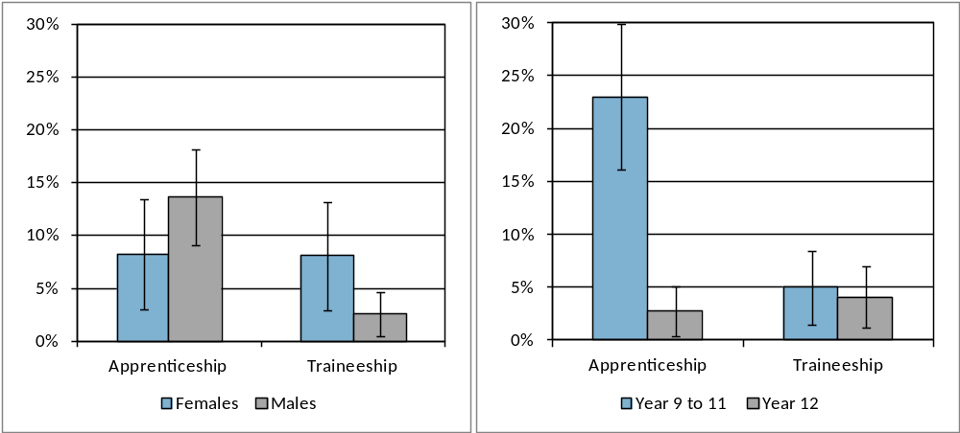
Note: The error bars reflect the 95 percent confidence intervals and no overlap indicates there is a statistical difference between the results.
Fifty-five percent of the 2015 school leavers who were not studying in 2016 intended to start some study in the next two years. Twenty percent of 2015 school leavers who were not studying in 2016 reported their main reason for not studying was because they “got a job”.
Sixty percent of 2015 school leavers reported having a paid job in 2016 (Table 10). Eighteen percent of school leavers said they did not have a paid job but were actively looking for work. Twenty-one percent of 2015 school leavers were not in the labour force in 2016. The unemployment rate was 23 percent for school leavers.
Of the school leavers who had a paid job in 2016, the most common ANZSCO occupations were:
- technicians and trade workers (25%)
- community and personal service workers (23%)
- sales workers (20%)
- labourers (15%).

Table 10: Number and proportion of 2015 school leavers, by labour force status in 2016
 |  |  | Number | Proportion (%)
 | Employed |  | 537 | 60.5
 |  | Full-time | 248 | 28.0
 |  | Part-time | 267 | 30.1
 |  | Don't know/Refused | 22 | 2.5
 | Unemployed |  | 160 | 18.0
 |  | Looking for full-time work | 56 | 6.3
 |  | Looking for part-time work | 59 | 6.6
 |  | Looking for full or part-time work | 46 | 5.1
 |  | Don't know | 0 | 0.0
 | Total in labour force |  | 697 | 78.5
Not in labour force |  |  | 191 | 21.5
Total |  |  | 888 | 100.0
Unemployment rate |  |  |  | 23.0

At the time of the survey in 2016, some 2015 school leavers were participating in other post-school activities, either instead of or as well as study and/or employment:
- 12 percent were caring for family members
- 10 percent were undertaking volunteer work
- nine percent were travelling
- five percent were pursuing elite sporting interests.

Characteristics of students who left school in 2015
Table 11 details the characteristics of 2015 year 12 graduates and school leavers.
An equal proportion of males and female graduates completed the survey; however for school leavers the majority (65%) percent were male. Just over half (56%) of the 2015 school leavers who completed the survey were in year 12 when they left school. Nineteen percent of graduates spoke a language other than English at home, whilst eight percent of school leavers spoke a language other than English at home. School leavers were more likely to have participated in school-based engagement programs.

Table 11: 2015 school leavers and year 12 graduates, by selected demographics (%)
Selected Demographics | School leavers | Year 12 Graduates
Year 9 to 11 | 44.3 | 0.0
Year 12 | 55.7 | 100.0
Females | 35.2 | 51.0
Males | 64.8 | 49.0
LBOTE | 8.0 | 19.3
Participated in a VET course at school | n.a. | 25.1
Received career counselling at school | 53.5 | 61.6
Participated in work experience at school | 48.3 | 54.2
Received a government pension, allowance or benefit in 2014 | 14.5 | 10.0
Participated in engagement programs whilst at school | 15.0 | 7.1
Participated in support programs for students with disability at school | 11.3 | 9.8
Aboriginal and Torres Strait Islanders | 5.0 | 1.5
Note: n.a. indicates that results are not available.
Specific survey results for students with disability and Aboriginal and Torres Strait Islander students have not been included in this publication due to concerns regarding the small number who participated in the survey. The majority of young people who participated in school support programs for students with disability and graduated or left school in 2015 were employed and/or studying in 2016. Although most attended a mainstream school, a small proportion attended a specialist school for students with disability and the majority of these students were participating in community support programs at the time of the survey in 2016. Over 80 percent of Aboriginal and Torres Strait Islander young people who graduated or left school in 2015 were employed and/or studying in 2016.

Satisfaction with school
Parents of 2015 year 9 to 11 school leavers were asked about their level of satisfaction with the school the student most recently attended and 67 percent of parents were satisfied with the school. In contrast, the 2015 School Satisfaction Survey showed that overall 87 percent of parents and carers were satisfied with the school their child attended.
2015 Year 12 school leavers and year 12 graduates were asked about their level of agreement with seven statements regarding their experience in years 11 and 12 in the ACT (Figure 6). Responses of strongly agree or agree were classified as “satisfied”, responses of strongly disagree or disagree as “not satisfied” and responses of neither agree nor disagree as “neutral”. Overall 78 percent of year 12 school leavers and 95 percent of year 12 graduates found year 11 and 12 worthwhile. Year 12 graduates were generally more satisfied than year 12 school leavers.
Figure 6: 2015 year 12 graduates and year 12 school leavers satisfied with various aspects of their year 11 and 12 experience (%)
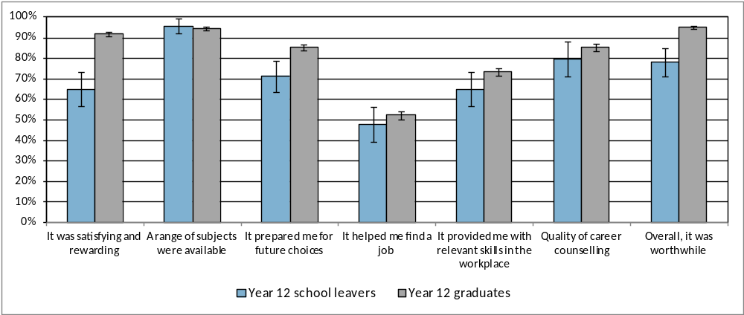
Note: The error bars reflect the 95 percent confidence intervals and no overlap indicates there is a statistical difference between the results.

Reasons for leaving school
Parents of year 9 to 11 students who left school in 2015 were asked the reasons why their child decided to leave school (Table 12). The most common responses were:
- the child was not doing very well at school (68%)
- the child wanted to earn their own money (56%)
- the child wanted to get a job (53%).
Table 12: Most common responses parents gave regarding why their child (who was in year 9, 10 or 11 in 2015) left school
Response Categories | Proportion (%)
Wanted to get a job | 52.7
Wanted to earn his/her own money | 55.6
Not doing very well at school | 67.6
Had a job to go to | 36.5
Didn't get on with the teachers and/or students at school | 34.4
Wanted to do study or training that wasn't available at school | 33.9
Had an illness, disability or caring responsibilities | 29.1
Note: The percentages in this table do not add to 100 percent, as respondents could provide more than one response.

Part 2 – 2013 Year 12 Graduates and School Leavers

Pathways of 2013 year 12 graduates
Key outcomes
Ninety-seven percent of 2013 year 12 graduates reported that they were employed and/or studying in 2016. Eighty-three percent of graduates were employed and 74 percent of all year 12 graduates were studying in 2016. Overall, 2013 year 12 graduate participation in study increased substantially from 2014 to 2016 peaking at 76 percent in 2015. The percentage employed increased slightly in 2015 and then increased more substantially in 2016. There was a slight increase in the percentage employed and/or studying over the three years (Table 13).
This general increase in participation in study is consistent with results reported in similar interstate longitudinal surveys with different year cohorts (Queensland Department of Education, Training and Employment, 2015; Victorian Department of Education and Early Childhood Development, 2010). However, the percentage increase in participation in study over the three years was much larger in the ACT which may be due to the more recent reporting period in this publication and/or the greater percentage of graduates who deferred study in the first year after leaving school and commenced study in the following year in the ACT.
Table 13: 2013 year 12 graduates employed and/or studying in 2014, 2015 and 2016 by selected demographics (%)
 |  | Employed |  |  |  | Currently studying |  |  |  | Employed and/or studying
Year of survey |  | 2014 | 2015 | 2016 |  | 2014 | 2015 | 2016 |  | 2014 | 2015 | 2016
Gender
 | Female | 79.0 | 80.1 | 86.4 |  | 61.2 | 77.8 | 73.3 |  | 94.8 | 97.0 | 97.5
 | Male | 73.0 | 75.5 | 79.3 |  | 56.6 | 75.0 | 74.0 |  | 91.6 | 95.1 | 96.0
Participated in a VET course at school
 | No | 74.0 | 75.4 | 80.3 |  | 56.3 | 76.5 | 73.8 |  | 92.1 | 95.7 | 96.5
 | Yes | 81.2 | 83.9 | 89.5 |  | 65.8 | 76.0 | 73.4 |  | 96.0 | 96.9 | 97.2
Received career counselling at school
 | No | 74.6 | 78.9 | 83.0 |  | 58.1 | 71.8 | 71.7 |  | 92.6 | 94.5 | 96.2
 | Yes | 77.5 | 77.3 | 83.0 |  | 59.6 | 79.8 | 75.8 |  | 94.1 | 97.4 | 97.5
Participated in work experience at school
 | No | 74.7 | 76.8 | 80.7 |  | 58.9 | 79.6 | 76.1 |  | 94.1 | 97.2 | 96.6
 | Yes | 77.0 | 78.6 | 84.7 |  | 58.8 | 73.3 | 71.5 |  | 92.3 | 94.9 | 96.8
All graduates |  | 75.9 | 77.7 | 82.8 |  | 58.8 | 76.3 | 73.7 |  | 93.2 | 96.0 | 96.7

The 2016 main employment and study destinations for 2013 year 12 graduates by employment and study destination in 2014 is shown in Table 14. Ninety-one percent of the graduates who were employed in 2014 were also employed in 2016, 82 percent of those studying in 2014 were also studying in 2016 and 98 percent of those employed and/or studying in 2014 were also employed and/or studying in 2016. Of the 2013 year 12 graduates who were not employed or studying in 2014, 64 percent were employed in 2016 and 51 percent were studying in 2016. Nineteen percent of the 2013 year 12 graduates who were not employed or studying in 2014 were also in this category in 2016.
Table 14: 2013 year 12 graduates employed and/or studying in 2016, by employed and/or studying in 2014 (%)
 | 2016 |  |  | Distribution in 2014
2014 | Employed | Studying | Employed and/or Studying
Employed | 91.0 | 73.5 | 98.7 | 75.9
Studying | 81.4 | 82.0 | 97.8 | 58.8
Employed and/or Studying | 84.1 | 75.3 | 97.9 | 93.2
Not employed or studying | 64.0 | 51.2 | 81.1 | 6.8
Distribution in 2016 | 82.8 | 73.7 | 96.7 | 100.0

Study
Most (82%) of the 2013 year 12 graduates who were studying in 2014 were also studying in 2016. Eighty-nine percent of those studying at a higher education level in 2014 were also studying at this level in 2016 and forty-three percent of those studying at a vocational education and training level were also studying at this level in 2016 (Table 15). Forty percent of the year 12 graduates who were studying at the vocational education and training level in 2014 were not studying in 2016, with the majority (72%) of these graduates completing the qualification prior to the survey in 2016. Over half (62%) of the graduates who were not studying in 2014, were studying in 2016. Forty-seven percent of 2013 year 12 graduates not studying in 2014 were studying at the higher education level in 2016, with the majority (81%) of these students having formally deferred university in 2014.
Table 15: Level of study in 2016 by level of study in 2014 for 2013 Year 12 graduates (%)
 |  | 2016
 |  | Studying |  |  |  | Not studying | Total
2014 |  | Higher education | VET course | Other | Total
Studying |  | 66.0 | 14.3 | 1.6 | 82.0 | 18.0 | 100.0
 | Higher education | 89.0 | 2.5 | 0.0 | 91.5 | 8.5 | 100.0
 | VET course | 16.0 | 43.1 | 0.9 | 60.0 | 40.0 | 100.0
 | Other | 32.7 | 7.1 | 37.0 | 76.8 | 23.2 | 100.0
Not Studying |  | 46.9 | 13.6 | 1.4 | 61.9 | 38.1 | 100.0
Distribution in 2016 |  | 58.1 | 14.0 | 1.6 | 73.7 | 26.3 | 100.0
Note: The percentages in this table do not all add to 100 percent due to rounding and a small percentage of ‘don’t know’ responses. Diploma includes associate degree or diploma.
Forty percent of 2013 year 12 graduates were studying at the higher education level in 2014. Figure 7 provides details of the 2016 main destination for 2013 year 12 graduates studying at the higher education level in 2014. Of those that were studying at the higher education level in 2014:
- the majority (89%) were also studying at the high education level in 2016 with 81 percent of them found to be undertaking the same study over the three years.
- three percent was studying at the VET level in 2016
- eight percent did not continue to study in 2016, with seven percent employed and two percent unemployed or not in the labour force.

Figure 7: 2016 main destination for 2013 Year 12 graduates who were studying at the higher education level in 2014
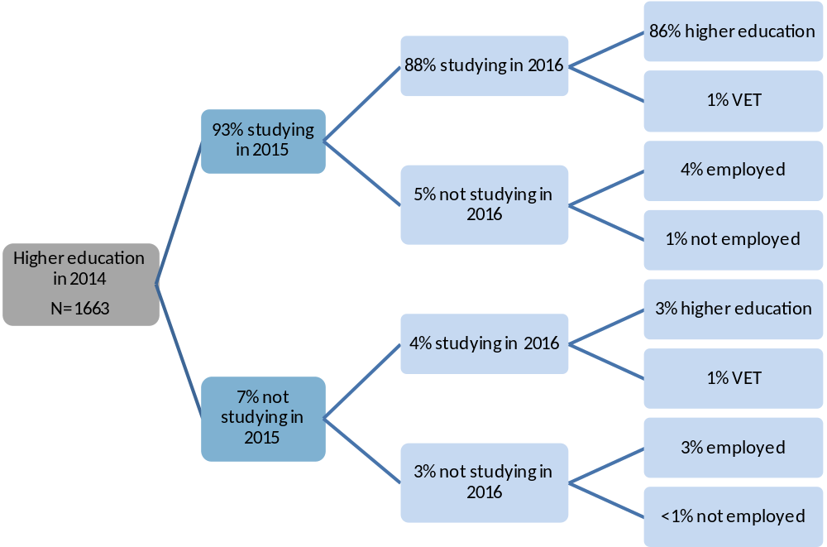
Note: The percentages in this figure do not all add to 100 percent due to rounding and a small percentage of ‘don’t know’ responses.
Seventeen percent of 2013 year 12 graduates were studying at the VET level in 2014. Figure 8 provides details of the 2016 main destination for 2013 year 12 graduates studying at the VET level in 2014. Forty-three percent of the 2013 year 12 graduates who were studying at the VET level in 2014, were also studying at this level in 2016 with 69 percent of them found to be undertaking the same study over the three years. Forty percent were not studying in 2016, with 37 percent employed.
Figure 8: 2016 main destination for 2013 Year 12 graduates who were studying at the VET level in 2014
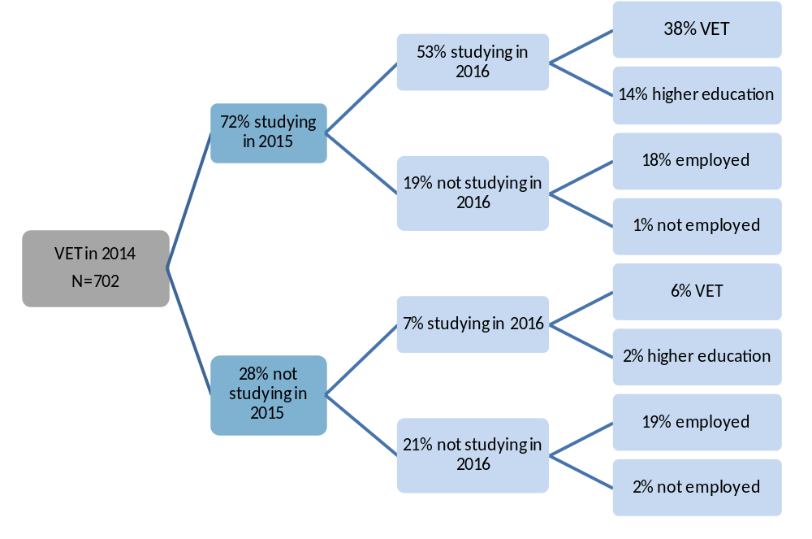
Note: The percentages in this figure do not all add to 100 percent due to rounding and a small percentage of ‘don’t know’ responses.
Seven percent of 2013 year 12 graduates were undertaking an Australian Apprenticeship (had signed a national training contract) in 2014. Figure 9 provides details of the 2016 main destination for 2013 year 12 graduates who were undertaking an Australian Apprenticeship in 2014. Of those who were undertaking an Australian Apprenticeship in 2014:
- over half (57%) were also undertaking an apprenticeship or traineeship in 2016
- 19 percent were studying in 2016 but not as an apprentice or trainee.
- 24 percent were not studying in 2016, with 23 percent employed.
Figure 9: 2016 main destination for 2013 Year 12 graduates who were undertaking an Australian Apprenticeship in 2014
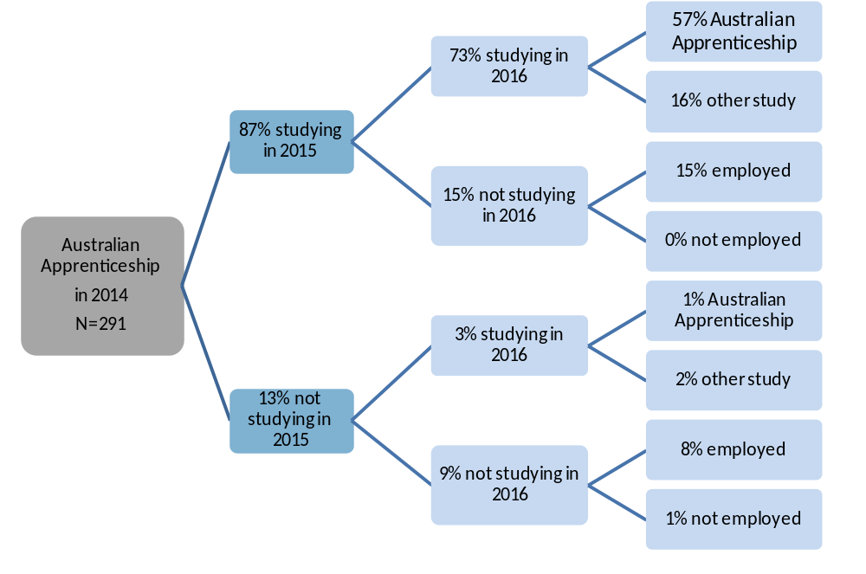
Note: The percentages in this figure do not all add to 100 percent due to rounding and a small percentage of ‘don’t know’ responses.
Eighteen percent of 2013 year 12 graduates were studying in 2014 but not in 2016, and 62 percent of these graduates said they successfully completed the course and/or qualification they were undertaking.
Twelve percent of graduates were not studying in 2014, 2015 or 2016. Sixty-eight percent of these graduates indicated that they were planning to study in 2015 or 2016 at the time of the survey in 2014 or 2015.
Eighteen percent of 2013 year 12 graduates formally deferred a university offer at the time of the survey in 2014. Figure 10 details the 2016 study destination for these graduates. Of those who deferred university in 2014:
- 86 percent were attending university in 2016
- three percent were studying elsewhere
- 10 percent were not studying in 2016.
These results compare favourably with findings from the Longitudinal Surveys of Australian Youth which track young people as they move from school (starting at 15 years of age) into further study, work and other destinations (Lumsden & Stanwick, 2012). Almost three quarters of Australian young people (in the year 2003 cohort) who intended to attend university did so by the age of 23, including about 10 percent who took a break between school and university (Curtis, Mlotkowski & Lumsden, 2012). Of most interest is that there does not appear to be any significant differences, in course outcomes, between those that started university immediately after finishing school and those that had a break (Curtis, Mlotkowski & Lumsden, 2012).
Figure 10: 2016 study destination for 2013 Year 12 graduates who deferred university in 2014
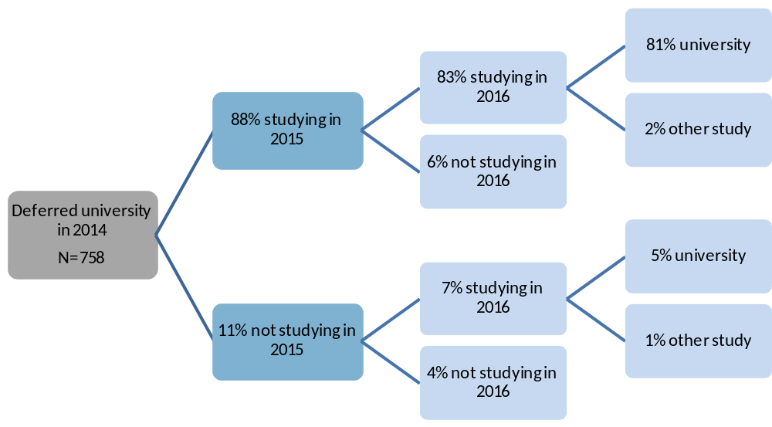
Note: The percentages in this figure do not all add to 100 percent due to rounding and a small percentage of ‘don’t know’ responses.
Figure 11 details the 2016 study destination for graduates who in 2014 had an informal intention to study (intended to study but did not formally defer university) in the next two years. Of these graduates:
- 21 percent were attending university in 2016
- 25 percent were undertaking other study
- 54 percent were not studying in 2016.
Figure 11: 2016 study destination for 2013 Year 12 graduates who in 2014 reported an informal intention to study
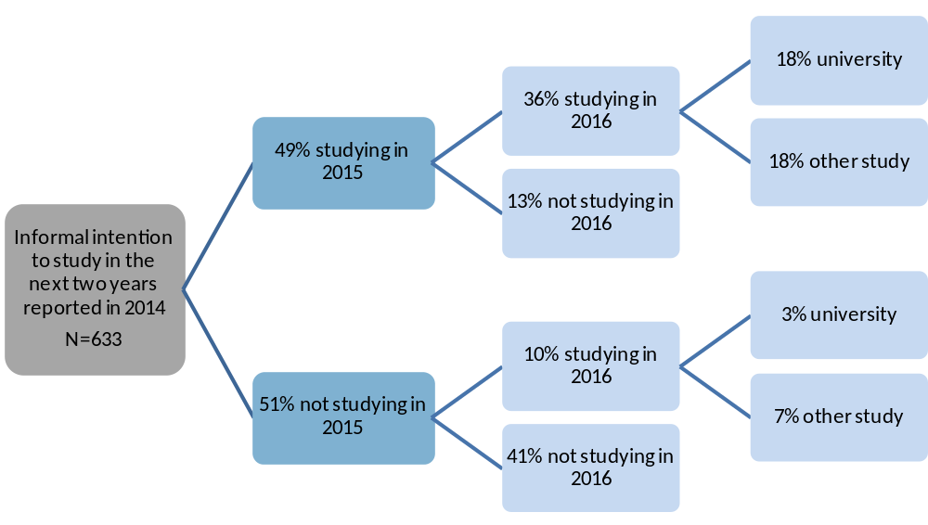
Note: The percentages in this figure do not all add to 100 percent due to rounding and a small percentage of ‘don’t know’ responses.
Overall, 70 percent of 2013 year 12 graduates, who were intending to study in the next two years at the time of the survey in 2014, were studying in 2016. Society and culture was the most common intended and actual field of study for this group of graduates. Table 16 highlights the most common fields of study in 2016 by each of the most common intended fields of study in 2014 for 2013 year 12 graduates studying in 2016, but not in 2014. Sixty-two percent of 2013 year 12 graduates, who intended to study in the field of management and commerce, were studying in this field in 2016. Twenty-nine percent of graduates, who intended to study in the field of management and commerce, were studying in the field of society and culture in 2016.
Table 16: 2016 field of study by 2014 intended field of study for 2013 Year 12 graduates (%) studying in 2016, but not in 2014
 | 2016 field of study
2014 intended field of study | Natural & physical sciences | Health | Management and commerce | Society and culture | Creative arts | Other | Total
Natural & physical sciences | 55.2 | 13.8 | 5.0 | 7.5 | 0.0 | 18.5 | 100.0
Health | 18.3 | 47.0 | 6.0 | 7.2 | 0.0 | 21.6 | 100.0
Management and commerce | 0.0 | 2.6 | 62.5 | 28.8 | 0.0 | 6.1 | 100.0
Society and culture | 11.1 | 1.9 | 6.6 | 58.3 | 7.1 | 15.0 | 100.0
Creative arts | 0.0 | 3.1 | 5.6 | 9.2 | 59.6 | 22.5 | 100.0
Other | 8.9 | 5.4 | 8.3 | 10.6 | 6.6 | 60.2 | 100.0
2014 no intention to study | 8.7 | 7.4 | 14.5 | 19.6 | 5.4 | 44.4 | 100.0
Distribution in 2016 | 14.0 | 10.7 | 12.2 | 24.7 | 9.1 | 29.3 | 100.0
Note: The percentages in this table do not all add to 100 percent due to rounding and a small percentage of ‘don’t know’ responses.
Labour force status
Overall, part-time employment was the most common labour force status for 2013 year 12 graduates in 2014, 2015 and 2016. Most (91%) of the 2013 year 12 graduates who were employed in 2014 were also employed in 2016 (Table 17).
Table 17: Labour force status in 2016 by 2014 labour force status for 2013 Year 12 graduates (%)
 |  |  | 2016
 |  |  | Employed |  |  | Unemployed | Not in labour force | Total
2014 |  |  | Part-time | Full-time | Total |  | Not in labour force | Total
Employed |  |  | 56.6 | 33.5 | 91.0 | 4.2 | 4.8 | 100.0
 | Part-time |  | 71.2 | 18.8 | 90.4 | 4.5 | 5.1 | 100.0
 | Full-time |  | 20.6 | 72.2 | 92.8 | 3.0 | 4.2 | 100.0
Unemployed |  |  | 53.5 | 14.4 | 68.5 | 22.2 | 9.3 | 100.0
Not in labour force |  |  | 38.1 | 6.3 | 45.1 | 12.3 | 42.6 | 100.0
Distribution in 2016 |  |  | 54.0 | 28.0 | 82.8 | 7.4 | 9.9 | 100.0
Note: The percentages in this table do not all add to 100 percent due to rounding and a small percentage of ‘don’t know’ responses.
Of those who were unemployed in 2014, 69 percent were employed in 2016 and 22 percent were unemployed. Over half (57%) of those that were not in the labour force in 2014, were in the labour force in 2016, with 45 percent in employment and 12 percent unemployed.
Seventy-six percent of 2013 year 12 graduates were employed in 2014, and 55 percent of these graduates were studying in 2014. Figure 12 details the 2016 employment status for these graduates and graduates who were employed but not studying in 2014. Of those that were employed in 2014:
- 51 percent were studying in 2014 and employed in 2016
- 40 percent were not studying in 2014 and employed in 2016.
Figure 12: 2016 employment status for 2013 Year 12 graduates employed in 2014, by 2014 study status
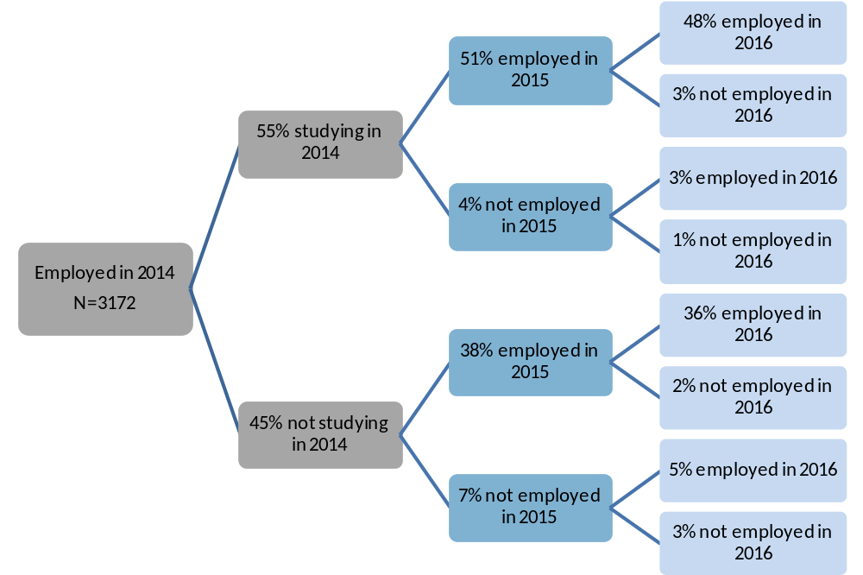
Note: The percentages in this figure do not all add to 100 percent due to rounding and a small percentage of ‘don’t know’ responses.
Twenty-four percent of 2013 year 12 graduates were not employed in 2014, and 72 percent of these graduates were studying in 2014. Figure 13 details the 2016 employment status for these graduates and graduates who were not employed and not studying in 2014. Of the graduates who were not employed in 2014, 39 percent were studying in 2014 and employed in 2016, with the 78% of them found to be also studying in 2016. Of those that were not employed in 2014, 18 percent were not studying in 2014 and employed in 2016, with 46 percent of them found to be studying in 2016.
Figure 13: 2016 employment status for 2013 Year 12 graduates not employed in 2014, by 2014 study status
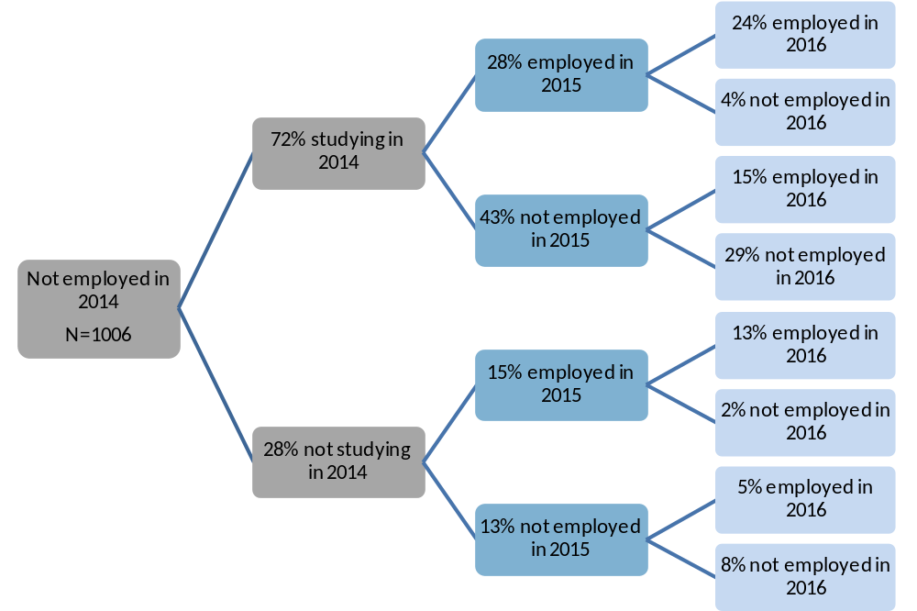
Note: The percentages in this figure do not all add to 100 percent due to rounding and a small percentage of ‘don’t know’ responses.
Fifty-nine percent of the 2013 year 12 graduates were studying in 2014. Part-time employment was the most common labour force status for these graduates in 2014, 2015 and 2016. Most (93%) of the 2013 year 12 graduates studying and employed in 2014 were employed in 2016, with most continuing in either full-time or part-time employment (Table 18). Of those who were studying and unemployed in 2014, 72 percent were employed in 2016 and 19 percent were unemployed. Fifty-one percent of 2013 year 12 graduates that were studying and not in the labour force in 2014, were in the labour force in 2016.

Table 18: 2016 labour force status by 2014 labour force status for 2013 Year 12 graduates studying in 2014 (%)
 |  |  | 2016
 |  |  | Employed |  |  | Unemployed | Not in labour force | Total
2014 |  |  | Part-time | Full-time | Total |  | Not in labour force | Total
Employed |  |  | 61.0 | 31.0 | 92.7 | 2.1 | 5.2 | 100.0
 | Part-time |  | 75.0 | 16.2 | 91.2 | 2.7 | 6.0 | 100.0
 | Full-time |  | 8.8 | 88.9 | 97.7 | 0.0 | 2.3 | 100.0
Unemployed |  |  | 64.7 | 7.4 | 72.1 | 19.1 | 8.7 | 100.0
Not in labour force |  |  | 32.6 | 6.7 | 39.3 | 11.5 | 49.2 | 100.0
Distribution in 2016 |  |  | 56.9 | 23.9 | 81.4 | 5.9 | 12.7 | 100.0
Note: The percentages in this table do not all add to 100 percent due to rounding and a small percentage of ‘don’t know’ responses.

Pathways of 2013 school leavers
Eighty-one percent of 2013 school leavers reported that they were employed and/or studying in 2016. Seventy-two percent of school leavers were employed and 50 percent were studying in 2016. Overall, 2013 school leaver participation in employment increased from 2014 to 2016 (Table 19). Participation in study and employment and/or study increased in 2015 and decreased in 2016.
Table 19: 2013 school leavers employed and/or studying in 2014, 2015 and 2016 by selected demographics (%)
 |  | Employed |  |  |  | Currently studying |  |  |  | Employed and/or studying
Year of survey |  | 2014 | 2015 | 2016 |  | 2014 | 2015 | 2016 |  | 2014 | 2015 | 2016
Gender
 | Female | 54.0 | 60.0 | 67.1 |  | 36.0 | 43.6 | 38.2 |  | 66.9 | 76.8 | 77.5
 | Male | 63.2 | 72.2 | 74.0 |  | 60.6 | 64.1 | 55.0 |  | 83.1 | 88.5 | 82.7
Year level
 | Year 9 to 11 | 60.9 | 70.1 | 73.5 |  | 53.0 | 55.6 | 43.4 |  | 74.6 | 83.3 | 79.9
 | Year 12 | 59.4 | 66.3 | 70.0 |  | 52.3 | 59.6 | 56.3 |  | 81.5 | 86.3 | 82.3
Received career counselling at school
 | No | 58.1 | 69.9 | 72.2 |  | 46.5 | 54.5 | 42.1 |  | 71.4 | 84.7 | 80.3
 | Yes | 65.1 | 67.0 | 69.3 |  | 58.5 | 59.5 | 56.3 |  | 85.9 | 84.6 | 80.1
Participated in work experience at school
 | No | 55.5 | 66.2 | 71.3 |  | 56.4 | 67.1 | 55.5 |  | 79.5 | 88.1 | 85.2
 | Yes | 67.3 | 73.3 | 75.9 |  | 52.3 | 53.5 | 48.4 |  | 80.3 | 86.3 | 82.2
All school leavers |  | 60.2 | 68.3 | 71.8 |  | 52.6 | 57.5 | 49.6 |  | 77.9 | 84.7 | 81.0

The 2016 employment and study destinations for 2013 school leavers by their employment and study destinations in 2014 is detailed in Table 20. Eighty-nine percent of the school leavers who were employed in 2014 were employed in 2016, Sixty-seven percent of those studying in 2014 were also studying in 2016 and 90 percent of those employed and/or studying in 2014 were also employed and/or studying in 2016. Of the 2013 school leavers who were not employed or studying in 2014, 42 percent were employed in 2016 and 27 percent were studying in 2016. Fifty percent of the school leavers who were not employed or studying in 2014 were also in this category in 2016.
Table 20: 2013 school leavers employed and/or studying in 2016, by employed and/or studying in 2014 (%)
 | 2016 |  |  | Distribution in 2014
2014 | Employed | Studying | Employed and/or Studying | Distribution in 2014
Employed | 88.9 | 54.6 | 93.8 | 60.2
Studying | 79.1 | 67.4 | 88.8 | 52.6
Employed and/or Studying | 80.3 | 56.0 | 89.8 | 77.9
Not employed or studying | 41.8 | 26.9 | 50.1 | 22.1
Distribution in 2016 | 71.8 | 49.6 | 81.0 | 100.0

Most (67%) of the 2013 school leavers who were studying in 2014 were also studying in 2016. Fifty-two percent of the 2013 school leavers who were studying at the VET level in 2014 were also studying at this level in 2016. Thirty percent of the school leavers who were not studying in 2014 were studying in 2016.
In relation to the labour force status of 2013 school leavers:
- 89 percent who were employed in 2014 were also employed in 2016.
- 56 percent who were unemployed in 2014 were employed in 2016 and 33 percent were unemployed in 2016.
- 52 percent of those that were not in the labour force in 2014 were in the labour force in 2016, with 39 percent in employment and 13 percent unemployed.
Scope and methodology
The annual School Leaver Survey is a survey of students in years 9 to 12 who left the ACT school system or were awarded an ACT Senior Secondary Certificate in the preceding year. This publication includes a summary of the results of the sixth annual survey, conducted in 2016.
The survey frame was drawn from administrative records held within the Directorate, the Board of Senior Secondary Studies (BSSS) and non-government schools. 2015 year 12 graduates included those that were awarded an ACT Senior Secondary Certificate from an ACT college, school or the Canberra Institute of Technology (CIT) in 2015. 2015 school leavers included year 9 to 12 ACT students who were listed as attending an ACT school in the 2015 February school census but not in the 2016 census (and did not obtain an ACT Senior Secondary Certificate). The survey excluded full fee paying students whose usual residence was overseas, school leavers who experienced a traumatic event, those who returned to school prior to May 2016 or moved interstate or overseas and school leavers from a small number of ACT non-government schools who chose not to participate in the survey.
Prior to the annual School Leaver Survey being undertaken a Primary Approach Letter (PAL) was sent to year 12 graduates and year 12 school leavers and parents of years 9 to 11 school leavers. This provided information about the purpose, importance and content of the survey, the amount of time the interview would take and confidentiality provisions. The survey was undertaken by telephone from 2 to 29 May 2016. Of the 3,887 graduates sent a PAL, 2,649 completed the survey, which provided a response rate of 68 percent. Of the 765 school leavers sent a PAL, 393 completed the survey, which provided a response rate of 51 percent. The figures reported in this publication are estimates based on weighting the survey responses to reflect the total number of 4,393 graduates and 888 school leavers.
The 2016 longitudinal survey of 2013 year 12 graduates and school leavers surveyed young people who participated in the longitudinal school leaver survey in 2015 and agreed to be recontacted in 2016. The vast majority (98%) agreed to be recontacted in 2016 and provided updated contact details when they completed the survey in 2015. This publication includes a summary of the post-school pathways from Wave 1 (conducted in 2014), Wave 2 (conducted in 2015) and Wave 3 (conducted in 2016).
Prior to the survey being undertaken an email was sent to the 2013 year 12 graduates and school leavers that agreed to participate in 2016 and who provided a valid email address when surveyed in 2015. The email provided information about the purpose, importance and content of the survey, the amount of time the interview would take and confidentiality provisions. The 2016 survey of 2013 year 12 graduates, year 10, 11 and 12 school leavers and parents of year 9 school leavers, was undertaken by telephone from 2 to 29 May 2016. Of the 1,720 graduates identified for the survey, 1,325 completed the survey, which provided a response rate of 77 percent. Of the 227 school leavers identified for the survey, 166 completed the survey, which provided a response rate of 73 percent. The figures reported in this publication are estimates based on weighting the survey responses for 2016 (and corresponding 2014 and 2015 responses) to reflect the total number of 4,178 graduates and 824 school leavers. This means that some of the 2014 and 2015 figures may differ slightly from the figures reported in previous reports as the figures in this report are based only on those students who completed all three surveys in 2014, 2015 and 2016.
Glossary
ANZSCO - Australian and New Zealand Standard Classification of Occupations is a standard used in Australia and New Zealand to classify all occupations and jobs and is designed facilitate the organisation and comparability of occupation statistics.
ASCED - Australian Standard Classification of Education is a standard used in Australia to classify all education levels and fields of education. It is designed facilitate the organisation and comparability of education statistics.
ATAR - Australian Tertiary Admission Rank is a percentile ranking used by universities to assist in the selection of school leavers for entry into undergraduate courses. It is used as an indication of a student’s suitability for study at university level, and to allow universities to select appropriate numbers of students for each course.
Career counselling in schools may include one on one or group discussion between students and career advisors, industry experts and representatives from universities and CIT about various aspects of student pathways planning, such as course choices, work experience and developing a resume.
Currently studying refers to respondents who were actively undertaking some study at the time of the survey, including those attending university, technical and further education (TAFE), undertaking an Australian apprenticeship or repeating year 12.
Engagement programs are school based programs, such as Big Picture, Connect 10 and Canberra College Cares.
Labour force status provides data on whether a graduate was employed (full or part-time), unemployed (looking for full or part-time work) or not in the labour force at the time of the survey. Labour force status was derived from responses to a number of questions in the survey.
LBOTE is used in this publication to describe graduates who speak a language other than English at home. Please note, this is slightly different from Language Background other than English (also known as LBOTE) which is used when a language other than English is spoken at home by the individual and/or one or both of their parents.
Government pensions, allowances and benefits include Austudy or ABSTUDY, Carer Allowance or Carer Payment, Disability Support Pension, Newstart Allowance, Parenting Payment, Sickness Allowance, Special Benefit and Youth Allowance.
VET - Vocational Education and Training courses are accredited vocational courses provided by a Registered Training Organisation. Successful completion usually leads to the award of a Vocational Certificate.
References
Australian Bureau of Statistics (2015). Education and Work, Australia, May 2015. Cat. No. 6227.0. Canberra, Australia: Australian Bureau of Statistics.
Curtis, D., Mlotkowski, P. & Lumsden, M. (2012). Bridging the gap: Who takes a gap year and why? Longitudinal Surveys of Australian Youth Research Report. Adelaide, South Australia: National Centre for Vocational Education and Research Ltd.
Queensland Department of Education, Training and Employment (2015). Next step longitudinal study 2013: A report on the post-school transitions of Queensland’s Year 12 completers from 2010. Queensland: State of Queensland.
Lumsden, M. & Stanwick, J. (2012). Who takes a gap year and why? Longitudinal Surveys of Australian Youth Briefing Paper 28. Adelaide, South Australia: National Centre for Vocational Education and Research Ltd.
Victorian Department of Education and Early Childhood Development (2010). The On Track Survey 2010 Longitudinal report: The 2007 cohort 3 years on. Victoria: State of Victoria.

Published by Education Directorate | ACT Government
220 Northbourne Avenue, Canberra City ACT 2602 | GPO Box 158, CANBERRA ACT 2601
Phone: (02) 6207 5111 Web: http://www.det.act.gov.au

