Education Directorate | Transitions and Careers | Version 1.2 | March 2020
Pathways Website Guide for
Pathways Planning Coordinators
and Teachers

https://pathways.act.edu.au

Table of Contents
Document information 3
1.0 Introduction 4
1.1 The purpose of this guide 4
1.2 What is Pathways Planning? 4
1.3 Careers theory and Pathways 5
1.4 Benefits of using the Pathways website 5
2.0 Implementation of Pathways in education settings 6
2.1 A guide for implementation and administration 6
2.2 Pathways implementation support 6
2.3 Supporting young people in Pathways Planning 7
2.4 Engaging parents, carers and families in Pathways 7
3.0 Site administration of Pathways 7
3.1 Management of Pathways 7
3.2 Key users of Pathways 8
3.3 Seeking consent for young people to access the website 9
3.4 Privacy 9
3.5 Getting started on Pathways – checklist 10
3.6 Trouble shooting 10
4.0 Practical guide on how to use Pathways 11
4.1 Registration process 11
4.2 Functionality of Pathways 11
4.3 Content of the 5-6 Plan 12
4.4 Content of the Pathways Plan (7-10) 13
4.5 Content of the 11-12 Plan 13
4.6 Additional functionality of the website 14
The Scope and Sequence of Career Competencies in Pathways Planning 17

Document information
Date approved: 31 October 2014
Approved by: Beth Mitchell, Director, Student Engagement
Review date: 12 months from date of approval
Content owner: Transitions and Careers, Education Directorate
Amendment history:
Version | Date | Comments | Author
1.0 | 31/10/2014 | Initial version released | Shaun Haidon/Rebecca Bray
1.1 | 10/1/2016 | Updated version | Rebecca Bray/Jo Wisdom
1.2 | 24/3/20 | Updated version | Lucia Ciccarone/Jo Wisdom
For more information about this publication please contact:
Assistant Director Pathways and Transitions
Transitions and Careers | Universal School Support
Education Directorate
Email: careers@act.gov.au
Phone: 6205 7044

1.0 Introduction
The ACT Education Directorate’s (the Directorate) Pathways website provides a secure online learning program for young people aged 10 to 17 years in the ACT for career learning and transition planning. The website provides young people with structured and sequential online career development and transition activities and the opportunity to document their plans for the future. Hyperlinks within the website provide easy access to a range of quality online career and transitions websites.
The Pathways website puts students at the centre, enables families as career partners, and supports transition from one education setting to another and onto post school options to ensure a smooth and supported experience for young people.
The Pathways website:
- allows all young people aged 10 to 17 years in the ACT to develop a plan for their future
- ensures that each young person has a Plan that can be easily updated as their interests, goals and aspirations change over time. It will provide young people with access to interactive learning modules which are accessible at any time or place from a range of devices (smart phones, tablets and desktops)
- helps young people to develop their career skills and support them in their transition to their next education setting and/or post-secondary school options including work and/or further education and training
- provides young people the choice to share their Plan with others, in person, hard copy or via email
- ensures a consistent approach to transition planning and career learning across all sectors in the ACT, which is underpinned by careers theory.
The Directorate believes that all students should be provided with the opportunity to complete a Plan and that teachers and parents play a vital role in supporting successful transitions for all students.

1.1 The purpose of this guide
The Pathways website guide for Pathways Planning has been developed to support teachers, career practitioners, school leaders, and parents to effectively implement, administer and manage Pathways in their education setting.

1.2 What is Pathways Planning?
Pathways is a career learning tool that provides young people with an opportunity to think about who they are, what they know, their aspirations about who they’d like to become, how they will get there and who can help them.
Pathways Planning aims to:
- encourage young people to think about and plan their future
- equip young people with the knowledge to successfully manage their career learning and transitions and make informed decisions.
- provide opportunities for young people to learn about themselves and explore their personal strengths, interests, goals and aspirations
- encourage children and young people to plan for their future and share their Plan with others
- provide links to quality career development websites.

1.3 Careers theory and Pathways
Pathways is underpinned by the DOTS Framework developed by Bill Law and Tony Watts.
Pathways has been developed as a tool to assist students develop:
- self-awareness
- recognise opportunities
- education and training knowledge
- decision making skills
- a transition and career action plan
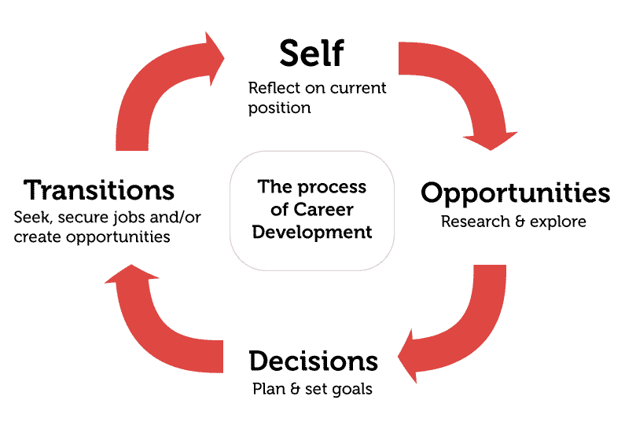
Figure 1 The pyramid of information processing domains in the career decision making process
Pathways has been structured to meet the developmental needs of young people and has been mapped against the following Australian Blueprint for Career Development (the Blueprint) competencies:
- Change and grow throughout life (Career Management Competency 3)
- Participate in life-long learning supportive of career goals (Career Management Competency 4)
- Locate and effectively use career information (Career Management Competency 5)
- Make career enhancing decisions (Career Management Competency 8).

1.4 Benefits of using the Pathways website
Pathways allows young people to access their Plan at any time and their Plan moves with them from one educational setting to the next. A young person’s year 5-6 Plan, Pathways Plan (for year 7-10) and year 11-12 Plan are stored on one Plan. This allows young people to reflect on their career learning over time. The online version allows more efficient use of resources and provides a more accessible option for young people. The Plan is owned by the young person and is their responsibility.
The Pathways website content is regularly updated to meet the ongoing changing needs of young people. Information is current and reviewed regularly by the Transitions and Careers section in the Directorate.

2.0 Implementation of Pathways in education settings

2.1 A guide for implementation and administration
Pathways implementation should be supported by the Principal and implemented as a whole school career learning program. It is envisaged that the Pathways Planning coordinator, often the careers practitioner or wellbeing executive teacher will take responsibility for the implementation of Pathways within their education setting and tailor its delivery to suit the needs of their students.
The Pathways website holds lessons for all the modules. It is recommended that the modules within Pathways are accompanied with quality teaching activities and personalised one-to-one career conversations that centre on the young person’s Plan. Schools are encouraged to revisit Pathways regularly and encourage young people to revisit independently, especially at times of change or transition.
The flexibility of the website allows educational, home environments and youth settings to decide how and when they access and utilise Pathways.
Some suggested implementation strategies include:
- embedding the website into existing curriculum and the general capabilities, and /or career education programs
- establishing it as part of the educational setting’s wellbeing or school-based curriculum
- utilising the website as part of the school’s careers service and career counselling sessions
- requiring parts of the Plan to be completed as part of the transition process
- incorporating Pathways Plans as part of case management for young people and the Individual Learning Plan process
- using Pathways prior to and after key career development and transition milestones such as workplace learning, transitioning to another school or attendance at the ‘CareersXpo’
- using Pathways in career interviews
- accessing the Pathways website as part of the learning journey process, three-way interviews, orientation week activities, transition interviews, college subject selection night, Individual Learning Plan discussions and mid-year transitions to other educational settings
- accompany the vocational learning option (VLO) expression of interest.

2.2 Pathways implementation support
To develop an implementation plan for Pathways at your school, training and support is provided by the Transitions and Careers section within the Directorate to all education settings in the ACT. In addition to this guide, the Transitions and Careers section will provide support to assist with the implementation and administration of online Pathways. Alternatively Transitions and Careers staff are happy to come out to settings and present to staff and young people. Pathways Planning should also be part of each school’s Career and Transitions Services (CaTS) Plan. Please contact Transitions and Careers for Pathways training opportunities and support on 6205 7044 or careers@act.gov.au.

2.3 Supporting young people in Pathways Planning
The Pathways Planning coordinator, career practitioner, teachers and parents/carers are encouraged to engage with young people about their future plans. Pathways should be part of career and transition planning conversations.
If a member of the young person’s support network becomes concerned about the content in a young person’s Pathways Plan, they should follow the educational setting policies and procedures to ensure the safety and well-being of that young person. Referral to a professional career practitioner is recommended.

2.4 Engaging parents, carers and families in Pathways
The website allows a young person to share sections of their Plan with their support network, either in person, by email or they can print modules of their Plan.
Schools and settings are also encouraged to communicate with young people’s support networks through newsletters, social media and school websites so that support networks are aware of the Pathways website.
The ACT Council of Parents and Citizens Association and the Association of Parents and Friends of ACT Schools Inc (APFACTS) are also regularly informed about the Pathways website and they in turn inform the Directorate about how best to communicate with parents and carers.

3.0 Site administration of Pathways

3.1 Management of Pathways
Managing young people’s registrations and their Plans is integral to the effective management of the Pathways website. In order to ensure only young people who are genuine users are provided access to the website, a reconciliation of all registrations should be completed by each educational setting. This will be done by the nominated Pathways Planning coordinator (usually the career practitioner or wellbeing executive teacher) at each educational setting by reviewing the registration emails for students who have nominated the school as their enrolled educational setting.
Once an educational setting is ready to implement Pathways, the Pathways Planning coordinator must contact the Transitions and Careers section (careers@act.gov.au or 6205 7044) and request the establishment of a Pathways email address. It is recommended Pathways Planning coordinators nominate three staff members to have full editor access to this mail box so that it can be monitored at all times, especially in the event of unexpected leave or absence. The Transitions and Careers section will coordinate the establishment of the email address with the help of ICT Shared Services.
The nominated Pathways Planning coordinator is responsible for checking the registration emails received from the website to ensure that each young person is enrolled at their setting. In the event of a young person registering and not being enrolled at the educational setting they have selected, the Transitions and Careers section should be notified immediately (careers@act.gov.au or 6205 7044) so that further investigations can be made into the validity of the registration.
It is also the responsibility of the Pathways Planning coordinator to inform Transitions and Careers about young people leaving the ACT and/or reaching the age of 17 and who no longer require access to their Pathways Plan. This ensures that the young person’s account is disabled and deleted in accordance with the Information Privacy Act 2014, Territory Privacy Principles and the Territory Records Act 2002.
Managing the number of Pathways Plans stored on the server is critical to its speed and once a young person is identified as no longer requiring access, their account must be deleted to avoid Plans taking up unnecessary space on the server.
Before deleting any young person’s Pathways Plan, an email will be sent to them notifying them of the intention to delete the account unless they wish to keep the account active. The young person will be given 30 days to respond. If no response is received the Plan will be deleted.

3.2 Key users of Pathways
For ease of management four key user groups have been identified as follows:
Users | Permissions
Young people (10 to 17 years old) in educational settings in the ACT | - Register and create an online Pathways Plan.  - Enter content into their Pathways Plan and access/edit/review this content at anytime.  - Provide feedback via the feedback form to ensure the continuous improvement of the Pathways website.  - Request additional career help through careers@act.gov.au.
Pathways Planning coordinator (usually the career practitioner or wellbeing executive teacher) | - Manage the inbox for the nominated email account for Pathways registrations.  - Review young people’s registrations and inform Transitions and Careers of any non-enrolled registrations.  - Inform Transitions and Careers if students no longer require access to their Pathways Plan account.  - Develop a Pathways implementation plan for their education setting.  - Implement the effective roll out of online Pathways Planning at their setting.  - Obtain the consent of parents/carers for their young people to access the Pathways website (optional).  - Provide feedback directly or via the feedback form to ensure the continuous improvement of the Pathways website.
Transitions and Careers section (system administrators for the Pathways website) – Education Directorate. | - Update and manage the content of the Pathways website.  - Review users across all educational settings.  - Coordinate the establishment of the mailbox accounts for the educational settings to receive registration emails.  - Investigate and delete any illegitimate users who have registered and who are not enrolled at a recognised setting.  - Seek confirmation from young people leaving the ACT and/or reaching the age of 17 that they no longer require access to their Pathways Plan so their account can be deleted.
Parents/carers, youth workers, career practitioners, wellbeing executive teachers, teachers, community service case managers or other adults who support young people in planning for their future. | - Support young people to develop goals, plans and access reliable career information.  - Provide positive support to young people when they are utilising the website.  - Parents/carers provide consent for young people to access the website.

3.3 Seeking consent for young people to access the website
Schools and settings should inform parents or carers that their child will be accessing the Pathways website.

3.4 Privacy
It is essential that the young person’s right to privacy is maintained. Young people are strongly encouraged to share their Plan with their support network however it is their choice if they wish to do so. Adults supporting young people to develop their Plan need to ensure they understand and adhere to the privacy principles.
The Directorate will not use or disclose a young person’s details for any purpose other than for the effective administration of online Pathways Planning. Collection, use and disclosure of personal information is governed by the Information Privacy Act 2014. Please view the Pathways Privacy Statement at https://pathways.act.edu.au/privacy-statement to learn more about the management of personal information.

3.5 Getting started on Pathways – checklist
Here is a quick checklist of things that need to be done before young people can start registering at your educational setting.
A Pathways Planning coordinator has been nominated who is responsible for managing the effective implementation, roll out and administration of the Pathways website.
A Pathways Planning coordinator has attended a Pathways professional development workshop run by the Transitions and Careers section.
A request has been sent to the Transitions and Careers section to establish a Pathways email address for their educational setting.
Parents/carers have been informed that their child will access the website as part of their school learning.
Staff who will be supporting students to develop a Plan have received information about the purpose and benefits of Pathways Planning and have registered themselves and are familiar with the website.

3.6 Trouble shooting
There are a number of reasons why a user may experience issues. Assuming you are trying to access the site as a registered user, you should check the following:
- Can you view the home page https://pathways.act.edu.au? If not the server or network could be down or the web page has been blocked by a fire wall. Please contact the Transitions and Careers section if this is the case.
- Are you getting an incorrect password error message? This is an indication of one of the following:
  - the user does not exist
  - the user details are incorrect
  - the user has requested to reset their password but hasn’t reset it by accessing the email link.
- If any of these are the case we recommend that you re-register from the beginning. If you would like a username/account to be deleted you should contact the Transitions and Careers section so they can action.
- If more assistance is required please contact the Transitions and Careers section (careers@act.gov.au or 6205 7044).

4.0 Practical guide on how to use Pathways

4.1 Registration process
To access the Pathways website young people can Google ‘Pathways ACT’ or use the web address https://pathways.act.edu.au. Young people can register on Pathways at anytime by completing the registration process. They are requested to provide the following information:
- email address
- password (must be at least 6 characters long, contain at least 2 capital letters (A-Z) and two numbers (0-9) (These stringent settings are a requirement of any secure government website under the Shared Services Information and Communications Technology (SSICT) standards).
- first and second name (we strongly recommend they use their real name for verification purposes)
- educational setting they are enrolled at
- year or year equivalent
- date of birth (month and year only)
- select an avatar image for their Plan.
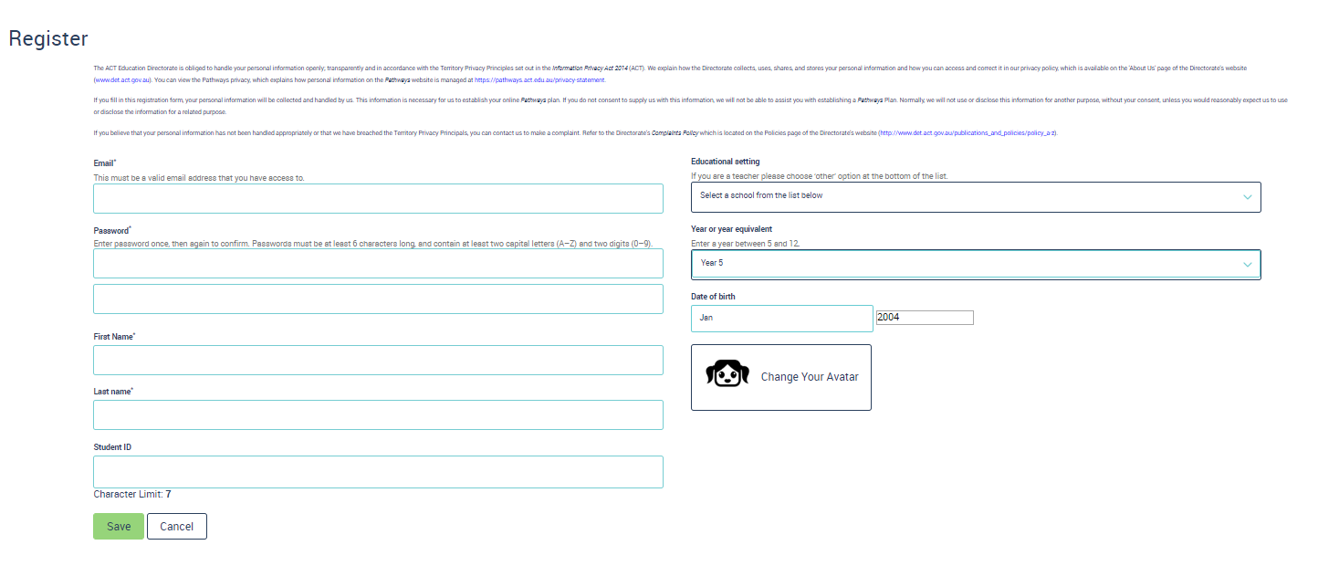

4.2 Functionality of Pathways
The school year the young person has entered on their registration determines which Plan will open and which one they will be able to edit. Young people are only able to make changes in their registered year cohort Plan, however they can go back and view their other Plan/s.
On the landing page students are able to update their details or change their theme (colour combinations). At any stage they can update their email address, password or update the school they are attending. They are also encouraged to use the ‘log out’ button under the switch theme box.
Switch theme allows young people to change the colour combinations used within the website.
Young people should use the log out button when leaving the website

4.3 Content of the 5-6 Plan
The 5-6 Plan encourages students in years 5-6 to learn about who they are and think about who they wish to become. There are seven modules within the 5-6 Plan; the main focus of this Plan is for young people to develop their self-awareness, identify their strengths, set goals and understand the steps to achieving their goals and who can help them. It focuses on assisting young people to make a smooth transition from year 6 to year 7.
At the end of each of these modules the young person is asked to save, and save and continue to the next module.
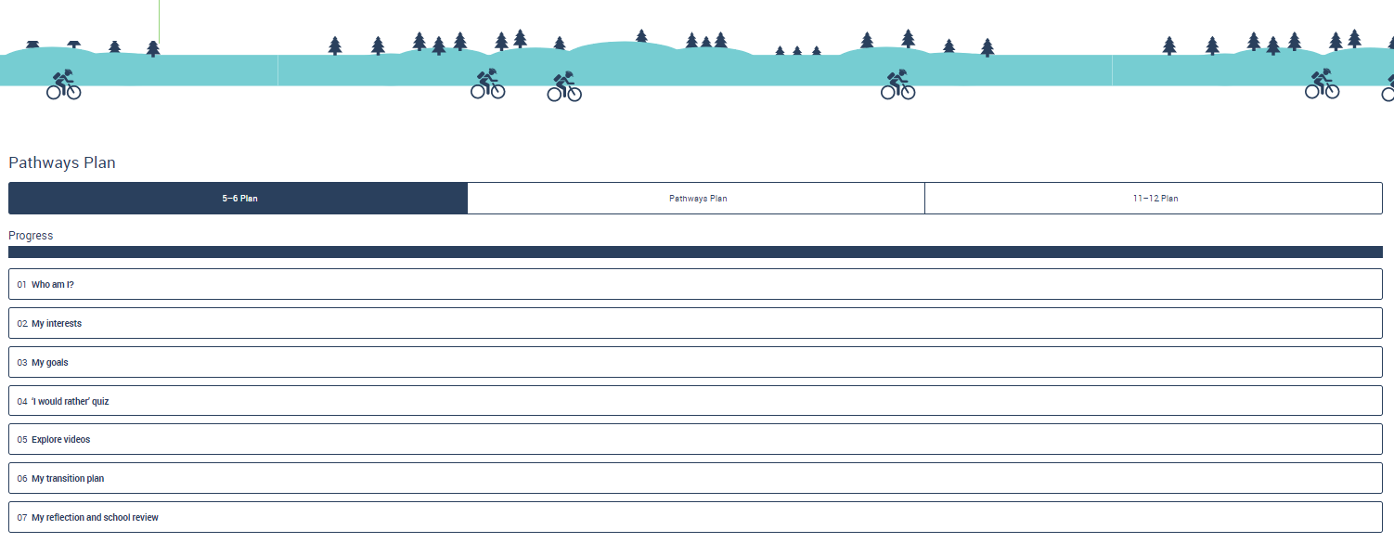

4.4 Content of the Pathways Plan (7-10)
There are 12 modules including the resume builder within the 7-10 Plan. The main focus of this Plan is for young people to identify their strengths and interests and consider their hopes, dreams and aspirations. It helps young people to consider and set SMART goals and identify their achievements, all of which form part of their resume. It allows them to develop a Career Action Plan and a Transition Plan. At the end they are able create a resume that is developed from the information they have entered into module 08 My achievements section of their Plan.
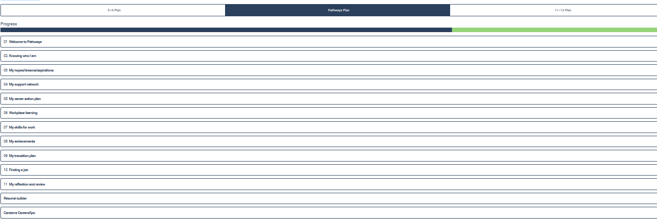

4.5 Content of the 11-12 Plan
There are nine modules including a resume builder within the 11-12 Plan. The main focus of this Plan is for young people to think about what they want to achieve in the future and what they need to do in order to achieve this, as well as their goals and Career Action Plan and post school Transition Plan. It helps a young people to identify the skills required in the workplace, learn about making career enhancing decisions and supports them to become familiar with the terminology used in years 11 and 12. It promotes career building opportunities such as workplace learning and exposure, and provides young people with the opportunity to think about their post year 12 pathway and a checklist of what things they need to consider post year 12.
Students in year 11-12 may receive recognition from the Board of Senior Secondary Studies (BSSS) for the hours spent completing the year 11-12 Plan as a R unit towards their ACT Senior Secondary School Certificate.
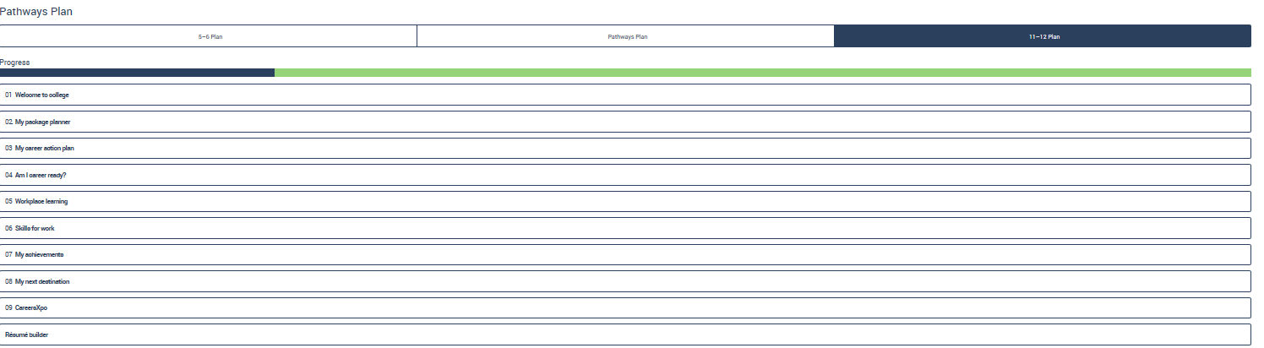

4.6 Additional functionality of the website

4.6.1 Links to additional resources
Throughout the Pathways Plans there are links to other career resources to help develop career knowledge, general capabilities and skills. These resources will be updated on a regular basis to ensure they remain current and relevant to young people. All of the links used within the website meet the Career Industry Council of Australia’s (CICA) guiding principles for career information products.
Some of the links used include:
Myfuture - http://www.myfuture.edu.au
Job Outlook - https://joboutlook.gov.au/
The Job Guide - http://www.jobguide.thegoodguides.com.au
http://www.bsss.act.edu.au/information_for_students/colleges
CIT - http://cit.edu.au/apprenticeships_and_traineeships
AApathways - http://www.aapathways.com.au/Home
College Guide - https://www.education.act.gov.au/public-school-life/starting_school/college-guide
UAC Guide - http://www.uac.edu.au/schoolink/year-10.shtml
The Good Universities Guide - http://www.gooduniversitiesguide.com.au/
UAC - (Universities Admissions Centre) - http://www.uac.edu.au
Study in Australia (for International students) - http://www.studyinaustralia.gov.au
Australian Defence Force - http://www.defencejobs.gov.au

4.6.2 Ability to print or covert sections to pdf
Young people can save and print any or all of the modules.
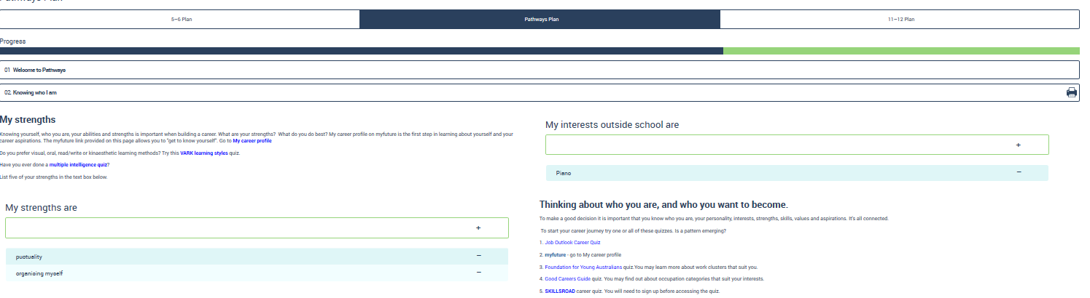
This icon allows the young person to print. This can be done in all modules.

4.6.3 Ability to email sections
Young people can also email all or any of the modules to teachers or members of their support network.

4.6.4 Resume builder
The resume builder provides young people with the essential information required within a resume. The Plan collects information entered by the young person from the “My achievements” section of the 7-10 and 11-12 Plans. This forms the basis of the resume. The resume is in a rich text format (RTF) which means that it can be opened by many different text editors on many different devices. The resume can also be opened by MS Word and saved as a word document.
When young people open the resume in Pathways their device will choose an editor that can read rich text format (RTF). The young person can choose to change the default editor so it is always opened, for example, by Microsoft Word. This is easy to do in Windows and MacOS on a laptop or PC.
Here is a link to instructions on how to change the default programs available in Windows 7:
http://windows.microsoft.com/en-au/windows/change-default-programs#1TC=windows-7
Here is a link to instructions on how to change default applications on Macs: http://www.tech-recipes.com/rx/2573/os_x_how_to_change_default_application_to_open_file_type.

4.6.5 Cyber safety help
A hyperlink to the cyber safety help website has been provided to remind young people of the importance of online safety. It is an Australian Government initiative designed to help keep children and families safe online.

4.6.6 Accessing further career help
The Pathways website reinforces the importance of the young people’s support networks and we encourage them to use these sources of help in the first instance. If they are unable to access a career practitioner or Pathways Planning coordinator, we recommend they seek career help via careers@act.gov.au. The link is located at the bottom of each page.
Career help provides young people with the opportunity to ask for assistance or ask a question through the Transitions and Careers email address (careers@act.gov.au). The Transitions and Careers team will endeavour to respond appropriately to the question.

4.6.7 Providing feedback on the Pathways website
The Pathways website is a constantly evolving tool/resource that will be continuously reviewed and improved. It is important that we receive your feedback to ensure we continue to meet the needs of young people.
If you or young people you work with have feedback we strongly encourage you to complete the feedback form link located on the contact us page.

4.6.8 Teacher lesson plans
The Pathways website provides resources for teachers comprising lesson plans to accompany each module. The lessons support teachers to deliver Pathways learning and assists in the development of the general capabilities, particularly the personal and social capability and critical and creative thinking capability.

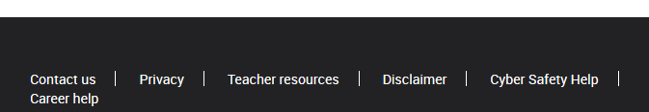

The Scope and Sequence of Career Competencies in Pathways Planning
AREA A: PERSONAL MANAGEMENT
The competencies highlighted in yellow refer to the 5-6 Plan, green refers to the Pathways Plan (7-10) and blue refers to the 11-12 Plan.
CAREER COMPETENCIES | PHASE I 5-6 Plan | PHASE II Pathways Plan | PHASE III 11-12 Plan | PHASE IV
1. Build and maintain a positive self-image | 1.1 Build a positive self-image while discovering its influence on self and others | 1.2 Build a positive self-image and understand its influence on life and work | 1.3 Develop abilities to maintain a positive self-image | 1.4 Improve on abilities to maintain a positive self concept
2. Interact positively and effectively with others | 2.1 Develop abilities for building positive relationships in life | 2.2 Develop additional abilities for building positive relationships in life | 2.3 Develop abilities for building positive relationships in life and work | 2.4 Improve abilities for building positive relationships in life and work
3. Change and grow throughout life | 3.1 Discover that change and growth are part of life | 3.2 Learn to respond to change and growth | 3.3 Learn to respond to change that effects your well being. | 3.4 Develop strategies for responding positively to life and work changes
AREA B: LEARNING AND WORK EXPLORATION
CAREER COMPETENCIES | PHASE I 5-6 Plan | PHASE II Pathways Plan | PHASE III 11-12 Plan | PHASE IV
4. Participate in life-long learning supportive of career goals | 4.1 Discover life-long learning and its contribution to life and work | 4.2 Link life-long learning to personal career aspirations | 4.3 Link life-long learning to the career building process | 4.4 Participate in continuous learning supportive of career goals
5. Locate and effectively use career information | 5.1 Discover the nature of career information | 5.2 Locate and use career information. | 5.3 Locate and evaluate a range of career information | 5.4 Use career information effectively in the management of your career
6. Understand the relationship between work, society and the economy | 6.1 Discover how work contributes to individuals’ lives | 6.2 Understand how work contributes to the community | 6.2 Understand how work contributes to the community  6.3 Understand how societal needs and economic conditions influence the nature and structure of work | 6.4 Understand how societal needs and economic conditions influence the nature and structure of work

AREA C: CAREER BUILDING
CAREER COMPETENCIES | PHASE I 5-6 Plan | PHASE II Pathways Plan | PHASE III 11-12 Plan | PHASE IV
7. Secure/create and maintain work | 7.1 Explore effective ways of working | 7.2 Develop qualities to seek and obtain/create work | 7.3 Develop abilities to seek, obtain/create and maintain work | 7.4 Improve on abilities to seek, obtain/create and maintain work
8. Make career enhancing decisions | 8.1 Explore and improve decision-making | 8.2 Link decision-making to career building | 8.3 Engage in career decision-making | 8.4 Incorporate realism into your career decision-making
9. Maintain balanced life and work roles | 9.1 Explore and understand the interrelationship of life roles | 9.2 Explore and understand the interrelationship of life and work roles | 9.3 Link lifestyles and life stages to career building | 9.4 Incorporate life/work balance into the career building process
10. Understand the changing nature of life and work roles | 10.1 Discover the nature of gendered life and work roles | 10.2 Explore non-traditional life and work options | 10.3 Understand and learn to overcome stereotypes in life and work building | 10.4 Seek to eliminate gender bias and stereotypes in your career building
11. Understand, engage in and manage the career building process | 11.1 Explore the underlying concepts of the career building process | 11.2 Understand and experience the process of career building | 11.3 Take charge of your career building process | 11.4 Manage the career building process

Law, B. & Watts, A. G. (1977) Schools, Careers and Community: A study of some approaches to careers education in schools London, UK: Christchurch Information Office (pp. 8-10).

