Minister’s Student Congress
Friday 26 October 2018
Hedley Beare Centre for Teaching and Learning

EXECUTIVE REPORT

Written on behalf of the Minister’s Student Congress Executive by Laura Mobini-Kesheh, Shaylah McClymont, Lucy Francis and Rose Clarke.

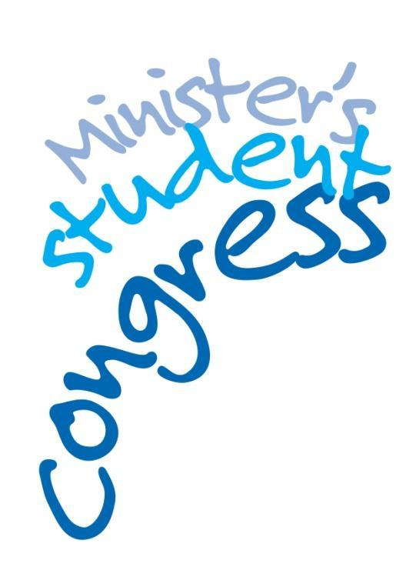

Executive Summary
The Minister’s Student Congress Executive Report provides a concise summary of the discussion held at the 12th Congress, convened at the Hedley Beare Centre for Teaching and Learning on 26 October 2018.
The Executive report will convey the valuable opinions of current students to the ACT Minister for Education.

Student Congress Executive 26 October 2018

Minister’s Student Congress Chairs:
Lucy Francis - Dickson College
Shaylah McClymont - Gungahlin College
Laura Mobini-Kesheh - Dickson College

North Canberra and Gungahlin Network:
Thom Hosie - Lyneham High School

Belconnen Network
Maya Osmond - Canberra High School

Tuggeranong Network:
Daniella Titular - Bonython Primary School
Tobey Krog - Bonython Primary School
Josh Simms - Gowrie Primary School

South Canberra and Weston Network
Rose Clarke - Melrose High School

Terms of Reference
Purpose
The purpose of the Minister’s Student Congress is for ACT Public school student leaders to keep the Minister for Education informed on issues that are important to them and to discuss and give advice on matters raised by the Minister.
The overall aim of the Minister’s Student Congress (hereafter the Congress) is to support student leaders by providing a direct link to the Minister for Education.

Membership
The general membership will consist of:
- student representatives from each ACT Public School;
(representatives should come from student leadership- SRC or other)
- one school leader (staff) from each network;
- a Student Engagement representative.
General members will have a one year term
The Executive membership will consist of:
- three elected student members from each network;
- one school leader (staff) optional;
- a Student Engagement representative.
Executive members will be elected at the last meeting each year, unless special circumstances apply.
Executive members will have a one year term.

Terms of reference
- The Congress will provide advice to the ACT Minister for Education on issues of interest and concern to students in Network groups.
- The Congress will debate matters raised by the Minister for Education and report back to the Minister through an Executive.
- The Congress will act as a reference group for major initiatives affecting ACT Government Schools.
- The Congress may establish an online forum to facilitate communication between meetings. The Executive will mediate the online forum.
- The Executive may form committees as necessary.

Procedures
- The Congress will convene once per semester.
- The Congress will be chaired by a nominated Congress member known as ‘the Chair’.
- The Chair may delegate authority to members to facilitate debate.
- The Executive will meet once per term in addition to Congress times.
- Written records of congress proceedings will be made available to Congress members through their school’s staff representative.
- Supervising teachers may attend the Congress as necessary.

RULES OF THE CONGRESS – THE STANDING ORDERS
The ACT Legislative Assembly has 280 rules, or ‘standing orders’, governing proceedings in the chamber. A modified version of these standing orders is used at the Congress, as follows:
- Members shall refer to the Minister as ‘Minister …’
- Members may only debate matters that are relevant to the question or topic of the congress.
- Members shall show respect to all other members and guests.
- Members shall not use any language which is coarse, disrespectful or discriminatory to another member.
- Members shall not interrupt another member, or make any disturbance while another member or guest is speaking.
- Members shall abide by the requirements of the Code of Practice and Acceptable Use of Information Communication Technology.
- Members shall only interact with the media under the supervision of a teacher and with permission from their parent.

Findings of the Congress

Students engaged in exploring three key concepts: “What is leadership?” “Who are leaders?” and “What qualities and skills do leaders have?” Students identified what is important to them; actions they could take as leaders of change; accessible resources; and potential support networks.
During the initial activity, students viewed a stimulus video of Molly Steer’s journey, a year 4 Queensland student, who has concerns for the environment. Molly starts her journey by taking small personal actions to reduce the number of single use plastic straws littering her local environment. She continues to lead her cause with passion, humility and persistence which has led to several schools and some Queensland councils banning plastic straws and increased debate at a national level. Students were then asked, “What is leadership” and “What qualities or skills do leaders have?”
Students defined leadership as:
- making change in the world to make a difference;
- the ability to take a key role in an area to help and benefit others;
- having influence to fight for a common goal;
- not being afraid to stand out, but also being able to step back;
- believing in a cause; and
- taking a stand for the greater good.

“Leadership is not being afraid to stand out, but also being able to step back”

“Leadership is the ability to take a key role in an area to help and benefit others.”

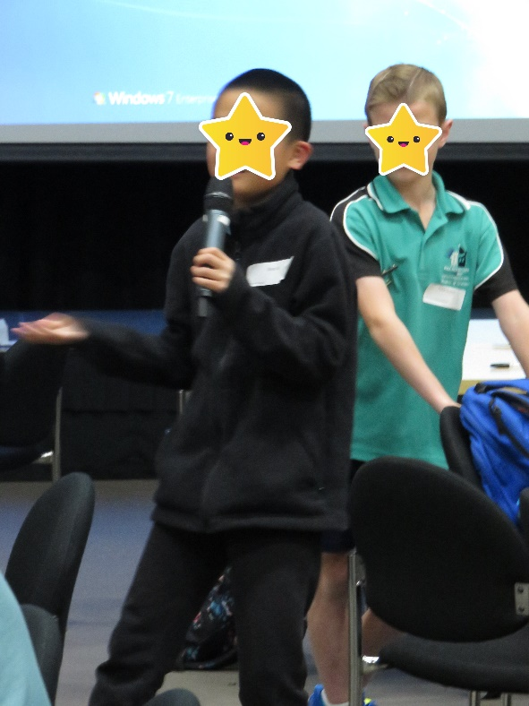
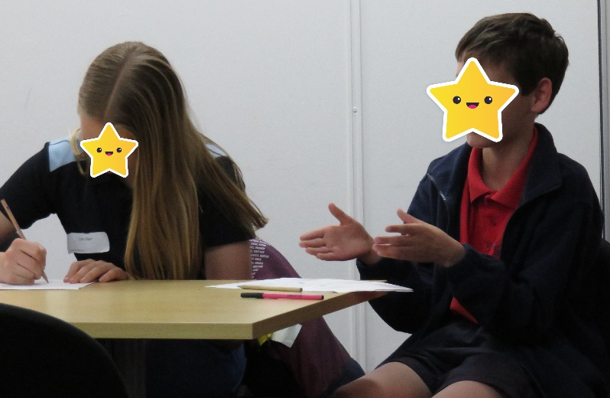

Students identified the qualities and skills of leaders as:
Qualities | Skills
Responsibility | The ability to help and encourage others
Honesty | Supporting others
Keep promises | Giving others tools to lead
To have an open mind for others’ ideas | Listening
Confidence | Independence
Passion | Interpersonal
Resilience | Set an example for others – role model
Considerate
Understanding
Humble
Dedication
Perseverance
Sense of humour
Kind

Students were provided with the opportunity to choose their preferred mode of working and expression for small group activities in sessions two and three. On registration, students selected workshops in either Art, Drama or Idea Building. During these sessions, students engaged in the activities which addressed the same key questions but were provided with tools and opportunities to discuss, share, build ideas and express themselves in their preferred mode.

Session two stimulus questions were, “What is important to you?” “If you could change one thing, what would it be?” Students identified things they are passionate about, and where they also want to create change. Presenters utilised a variety of tools including: digital clips such as Lennon Maher – 7 News in Sydney; and a selection of templates and games.

Of all issues identified, four were shared by all groups: environment, mental health, cyber bullying and equality.

Issues of importance identified by the Art group:
- Environment: pollution (cigarettes, fossil fuels), plastic waste, deforestation, littering, animal cruelty and sustainability
- Mental Health: abuse including domestic violence and abuse of women; cyber bullying; violent video games; addiction
- Social Media: too much screen time and addiction, cyber bullying
- Homelessness
- Student Voice: more opportunities for student voice; some students are less confident than others
- Creativity in schools: the need for a greater emphasis on creativity

Issues of importance identified by the Idea Building group:
- Environment: waste; harm to animals; destruction of habitats and resources
- Fairness and equality: gender equality in sport; wages; disability
- Social media/cyberbullying/mental health

Issues of importance identified by the Drama group:
- Environment: waste in the ocean, destruction of animal habitat through deforestation
- Mental Health: general mental health including anxiety, cyber bullying
- Education
- Equality: equality in sport, pay, racial
- Homelessness & poverty
- LGBTIQ

During session three, students began to develop personal action plans, describing actions they could take to address their selected issue. They identified a goal/s, milestones, support networks and resources.
Art Group
- Avenues most commonly identified by students to spread the word about their projects was through the use of social media platforms including Facebook, Instagram, Twitter and Snapchat. They thought they would need the assistance of family, friends, teachers, school principals, politicians, community members and businesses.

- Frequently represented in the work of the art group, was a people centred approach, beginning with family and friends, moving through local and national contexts to global. The importance of people listening and working together in every stage was apparent.

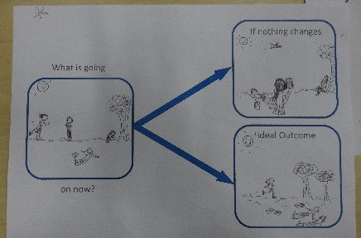
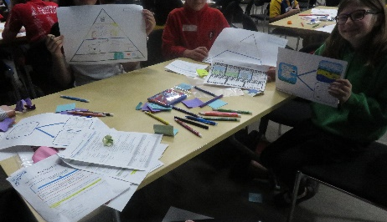
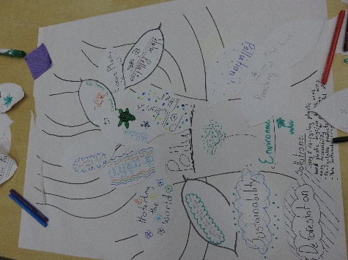
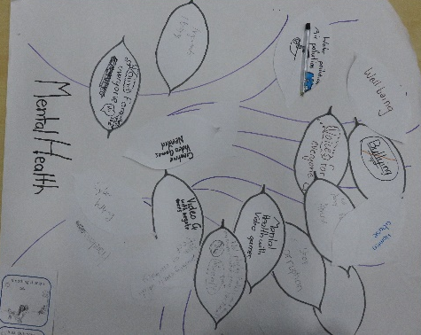
- Common goals were: to inform and educate communities, beginning with their own families, friends, schools and local community and growing to national and international contexts; host tree planting days and improving the lives of others.

Idea Building Group
- The most common avenues students thought they could take to get the word out about their projects were through social media and schools. They thought they would need help from their friends and family, their teachers at school, and local, state and federal governments.

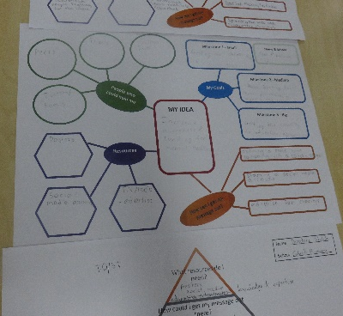
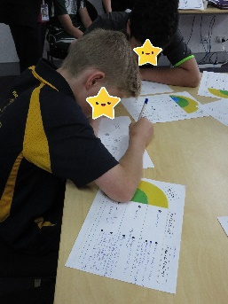
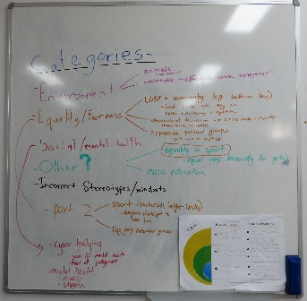
- Common goals were: inform and educate school and community, get people on board, fundraisers, nude food day, extra bins and coloured bins, start club in local school, improved legislation and systems, approach canteen to stop using rubbish.
Drama Building Group
- The most common avenue identified by students to spread the word about their cause was through social media including using hashtags such as #thisisnotok. They thought they would need assistance from politicians, peers, schools, and people of influence such as well known sports players. Students identified actions such as lobbying ministers and other politicians and businesses to create job opportunities.

- Common goals were: to educate and change people’s habits and attitudes; increase investment in clean energy; change TV program content; take action themselves; encourage and/ or lobby people, business and governments to take action, beginning locally and moving to global action.
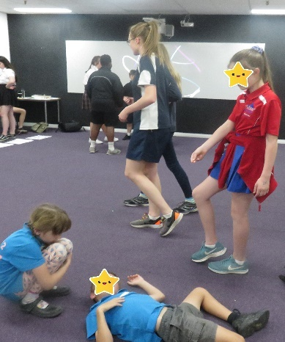
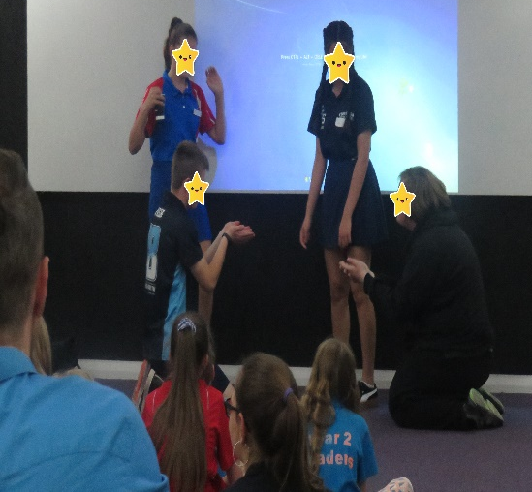
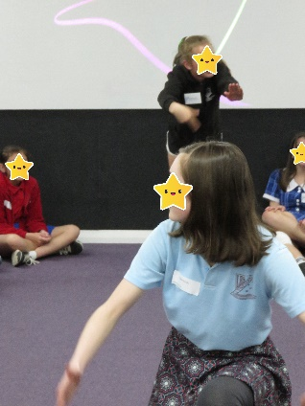

Feedback
At the end of the day, students provided feedback on the Congress, and suggested big ideas that they would like to see addressed in future congresses. Across all sectors, there was a strong emphasis on the environment, mental health/wellbeing and equality. Feedback included sub-groups of these which impact on students’ lives both within and outside of schools including sustainability, bullying, cyberbullying, diversity, technology and homelessness. These topics were reflected in issues identified by students during the Congress, as areas where they would like to impact change.

Technology is the future of jobs, living, communication and just daily life… It is a massive problem as people using social media and technology are vulnerable to cyber bullying which is mentally damaging. [They] can be afraid and paranoid of evaluation and judgement.
We are destroying the earth and its resources, harming ourselves + other life. We’ve caused this problem + we need to fix it.
It is a problem because it doesn’t make sense that a woman who is better at soccer than a man is paid a quarter of what he is paid.

Students took the concept of student voice to the next stage, that of student agency. They expressed a growing sense of empowerment and desire to work within their school communities on interest based, passion projects that would create positive change. A year seven student suggested independent/flexible learning is a way of seeing the diverse ideas of others.
The primary sector consistently reported that ‘thinking about problems and discussing solutions’, being ‘open minded to problems in modern society’ and ‘hearing other ideas’ was helpful and considering ‘different issues in the world and how to fix them is important for the future’. They especially felt that multi-aged groupings were beneficial. Support from older students and student executive members was considered as a key factor in the success of the Congress. Students found the use of digital clips of Australian children as leaders most interesting. This is illustrated by comments such as, ‘that one girl could make a difference’, ‘that little people can make the entire world happy’, ‘young people can change lives’.
Students from the high school sector also stressed the impact of digital clips, ‘videos and speeches were empowering and motivating’ and consistently emphasised the usefulness of ‘seeing other people’s ideas’. They also underscored the value of the structure, planning and comfortable and encouraging environment where ‘stimulating ideas and problem solving techniques were shared’, ‘moving beyond just looking at issues, and looking at making a change’ as being most helpful. High school students generally found the diversity of speakers, networking, meeting like minded people who also want to make a difference and the development of steps to solve big issues the most interesting components of the Congress.

The college sector focussed mainly on equality and sustainability as important issues for further enquiry at future congresses. Both these topics were a focus of student engagement at all small group workshops. College students found ‘moving beyond just looking at issues and looking at making a change’ as the most useful component of the Congress as it relates to their personal passions and issues of concern. Both topics have potential to be explored with application of student agency within school settings. College students reinforced the view that learning about and with different communities was a point of interest for them.

Conclusion
This Congress was designed to build on previous Congresses which explored the topics of ‘The Future of Education’ and ‘Student Voice’. The aim of the Congress was to engage students in questioning the idea that a leader is someone else, someone with power and popularity that does good things. Someone who is perhaps older than they are and are different to the ‘average kid’. Exposure to concepts through real life Australian examples and development of themes over the course of the day, led students to consider themselves as leaders. Valuable insight into what is important to students, and areas in which they would like to impact change contributed to and confirmed potential future topics. Students expressed satisfaction at being able to plan for action which is, in itself, confirmation of the importance of student agency.
A secondary aim was to equip students with the beginnings of knowledge and skills needed to enact change in an area of passion to them. The novel way in which workshops were delivered, providing student choice and based on preferred mode of expression, worked very well for this topic.
Students of all ages showed a high degree of awareness and concern about local and global issues. They demonstrated knowledge of the impact of these issues and acknowledged their complexity. They expressed a real desire to impact change and the sense of empowerment which comes out of student agency.

Recommendations from the Congress
The Student Executive recommends that the Minister’s Student Congress continue to be used as a platform for student voice. It connects the Education Minister to the students in the public education system, who are most greatly impacted by the Minister’s decisions.
To increase transparency and validate the opinions of students, we ask that the Congress have a page on the ACT Directorate Website. This would facilitate communication between the Congress and the public and make each Executive Report accessible to the wider student body, whose views it represents. This particular report contains a variety of ideas regarding student voice, which could be useful to student leaders across the system. The Student Executive therefore believes it would be beneficial for students to be able to access this report.
The topics, areas of interest/passion, where students want to impact change, and the solutions generated by them, demonstrates the capacity of students in years 2-11 to engage with big issues. This, combined with members expressing interest in pursuing independent/flexible learning and increasing student voice, leads the Congress to recommend that student agency be further developed in schools and used as a method of engaging students in meaningful curriculum. This aligns with the Future of Education strategy, in which previous Congresses were involved and the Education Directorate’s Strategic Plan 2018-2021 goal ‘Schools where students love to learn’.
It is also recommended that the principles of student agency be further applied to students informing decisions related to the structure and function of classrooms and schools today and in the future.
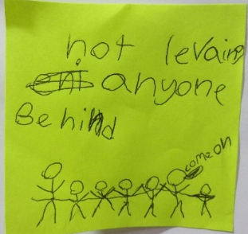
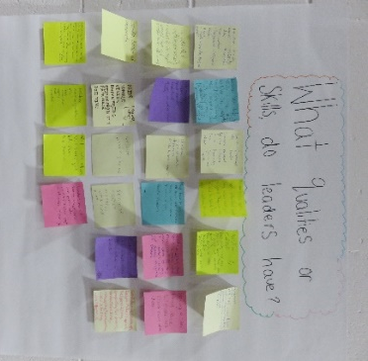
The Congress provided opportunities for students to work in multi-age groups. Feedback indicated this was helpful for some students, provided a leadership opportunity for others and also facilitated exchange of ideas across a diverse group. It is recommended that schools continue to provide opportunities for students to work in multi-aged groups, on meaningful, interest-based projects. This strategy could be applied to projects stemming from student agency.
