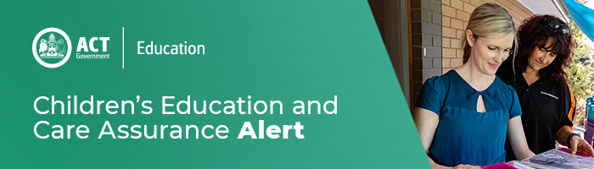
7 August 2020
Child safety and effective supervision

CECA has been notified of two incidents within a week each involving an unknown man. A child at an OSHC service was approached by an unknown man, who was outside the school fence. A long day care service has also notified of an incident, where an unknown man appeared to be acting suspiciously near the boundary of the service. Both matters are under investigation by ACT Policing.

This message is to ask education and care providers, service leaders and educators to be particularly vigilant when supervising children outdoors.

If you become aware of a similar incident or notice anyone acting suspiciously around an education and care service, contact police immediately on 131 444. In the case of an emergency, call 000 and implement the service’s relevant emergency procedures, including lockdown. CECA must be notified as soon as possible and within 24 hours.

All education and care providers, service leaders and educators are reminded to prioritise regular assessment of supervision strategies to ensure that they are taking reasonable precautions to protect children from harm. Supervision strategies should:

- Consider the risk, design, size and arrangement of children’s environments
- Review supervision plans for outdoor areas with particular focus on any areas where
observation may be limited or obstructed
- Reduce or prevent injury
- Include decisions about when children’s play needs to be interrupted or redirected; and
- Ensure there are effective transitions of children between service types and schools

For more information about effective supervision please read ACECQA's Active Supervision Information Sheet

Should families, carers or children feel affected by this incident please encourage them to speak to educators about lockdown procedures at your service. Families can visit ACT Government’s services for Children, Young People and Families at https://www.children.act.gov.au/services-for-children,-young-people-and-families for advice. They can also visit the Child Safety, Safety4Kids and the Constable Kenny websites and take the opportunity to speak to children about personal safety strategies.

For enquires in relation to this notification please call CECA on (02) 6207 1114 or email CECA@act.gov.au
This email has been authorised by the ACT Regulatory Authority (CECA). CECA are responsible for administering the National Quality Framework within the ACT

