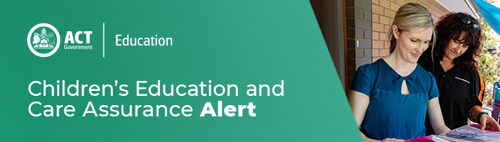
15 April 2021
Work Health and Safety Resources
As WorkSafe ACT’s proactive campaign to audit education and care services (services) continues during 2021, providers and services should take the time to review work, health and safety policies and practices in line with the Work Health and Safety Act 2011.
Worksafe ACT recently identified several non-compliances relevant to electrical, chemical safety and occupational violence in services. This is a timely reminder for providers and services to keep up to date with Worksafe ACT and Safe Work Australia resources, including but not limited to:
- Electrical equipment WorkSafe ACT
- Hazardous chemicals - WorkSafe ACT
- Managing risks of storing chemicals in the workplace | Safe Work Australia
- Work related violence Safe Work Australia
- Work-related violence or aggression WorkSafe ACT
- Guide for preventing workplace violence and aggression Safe Work Australia (attached)
Providers and services are also reminded to familiarise themselves with the notification requirements for serious incidents under the Work Health and Safety Act 2011. In some circumstances providers will need to notify both Children’s Education and Care Assurance (CECA) and WorkSafe ACT when a serious incident involves a child.

For enquires in relation to this notification please call CECA on (02) 6207 1114 or email CECA@act.gov.au
This email has been authorised by the ACT Regulatory Authority (CECA). CECA are responsible for administering the National Quality Framework within the ACT

