WHAT IS RISK MANAGEMENT?
Managing risk means to consider the effect of uncertainty (positive or negative) that arises from internal and external factors which can influence the outcomes of the Directorate, schools, and business areas.
It involves identifying and assessing risks and controls, documenting risks in a risk register, implementing actions and treatments to manage identified risk and monitoring and reporting on risks.
Application of risk management is the combination of culture, systems and processes to improve decision making, be responsive as risks arise, appropriately plan, make financial decisions, and minimise risk compliance.
WHY IS RISK MANAGEMENT IMPORTANT?
AUSTRALIAN STANDARDS RISK MANAGEMENT PRINCIPLES
Proactive management of risks supports staff at all levels to make good decisions and to minimise the risk of things going wrong.
It supports delivery of the best possible outcomes for schools and the community, ensures we meet community and government expectations for accountable and responsible use of public finances and resources, and safeguards student and staff safety and wellbeing.
A consistent process across the Directorate helps us to achieve a balance between realising opportunities for improved service delivery and addressing uncertainty of not achieving our goals

RISK MANAGEMENT PROCESS
FRAMEWORK ELEMENTS
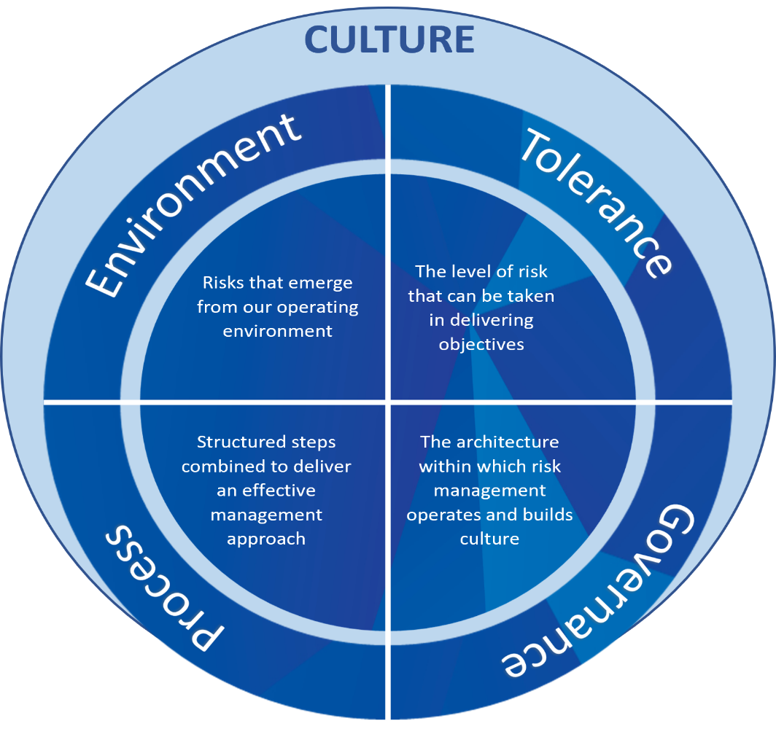
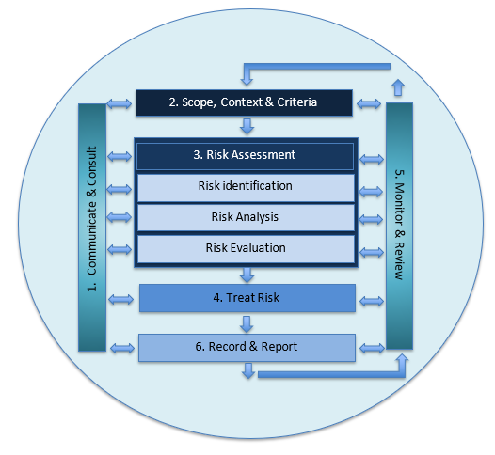

INFORMED BY
Govern rights, responsibilities, protections
Sets the tone and parameters that apply to risk management
Outlines mandatory responsibilities and processes to implement risk management
Guidance material to enable risk management to be applied

SUPPORTING RESOURCES - Internal
SUPPORTING RESOURCES – External

Risk Management Policy
Risk Management Procedure
Risk Management Framework - Guide for Schools & ESO
Supporting materials through ConnectED & Policy Register
Strategic Plan 2022 – 2025
Governance Framework
Compliance Framework
ACT Insurance Authority (ACTIA)
Australian Standard on Risk Management AS ISO 31 000:2018
ACT Government Risk Framework Policy 2021
Audit Committee

ELEMENTS OF THE RISK MANAGEMENT FRAMEWORK

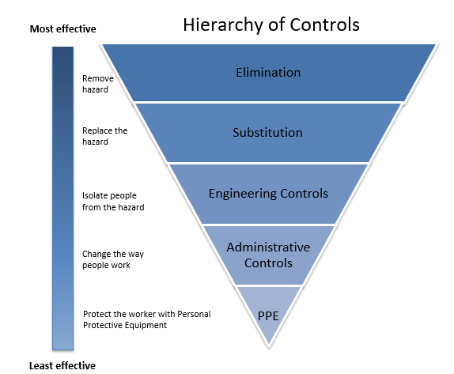
Risk Process
Risk Environment
Complies with the Australian Standard ISO 31000:2018. Consists of six stages to identify risks and hazards and to treat risks with effective controls.
- Communicate and consult
- Scope, context, criteria
- Risk assessment
- Treat risks
- Monitor and review
- Record and report
Hierarchy of Controls is used to minimise or eliminate exposure to hazards as part of the risk assessment process.
Risk Register is used to document the risk process.
The Directorate must manage two types of risks:
Strategic Risks – Directorate Level
These risks can significantly impact on the achievement of the Directorate’s strategic objectives and often affect the wider Directorate. They can be long term and beyond our direct control i.e economic environment, demographic shifts.
These risks are captured in the Directorate’s Strategic Risk Register and are managed and monitored by the Directorate’s Senior Executive.
Risk Categories
The following risk categories, or causes of risk, can result in strategic or operational risks. These include:
- Project /program risks
- ICT
- Workplace Health and Safety (WHS) and wellbeing
- Compliance and legal
- Policy and procedures
- Reputation
- Financial
- Business systems
- Environment.

Operational Risks – Schools and Branches
These risks can significantly impact the achievement of objectives at the school or branch level and are related to the operating environment.
These risks are captured in a School Operational Risk Register or a Branch Risk Register and are management by Principals and Branch Managers respectively.

Risk Tolerance
How much risk we accept in our day-to-day work depends on the amount and type of risk exposure we are willing to accept or avoid (risk appetite) and our understanding of the acceptable levels of risk that can be taken with agreed controls in place (risk tolerance).
Risk appetite and tolerance may change in response to changes in technology, the environment, priorities, strategy, regulations, or stakeholder expectations. Appetite and tolerance site within a minimum and maximum range and are determined by controls and agreed level of responsibility and accountability.
For example: the Directorate accepts a higher level of risk when pursuing innovation and opportunities that further strategic objectives and outcomes. As such, there may be a higher tolerance to policy innovation. However, there is the lowest tolerance and no appetite of risks associated with:
- Safety of children and young people
- Workplace health and safety of its staff, students and the school community
- Site security of confidential and personal information
- Fraud and corruption
- Compliance with legislation

Risk Governance

Governing Body – Executive Governance Committee (EGC)  Based on the “three-line model” the Directorate risk governance provides structure, direction, alignment, and oversight of risk management to ensure that the Framework is applied consistently and with transparency. It outlines the layers of responsibility and accountability for managing risk to the Directorate’s objectives.  Provide integrity, leadership and transparency, support |  | Audit Committee | Independent External Assurance
Direct Service Delivery | Risk Management & Control Functions | Internal Audit & Assurance
1st Line | 2nd Line | 3rd Line
Management of risk within areas of responsibility & decisions made  i.e functions that own and manage risk at a school and ESO level such as the delivery of programs, curriculum and other service delivery activities | Establish risk management & support functions to support teachers & staff  i.e functions that oversee and support the management of risk at a school leadership level and through ESO Business areas | Provides assurance that risk management framework is effective

Responsibility to achieve Directorate objectives

