ACT Government School
Online enrolment Proceedures

Please be advised that enrolment in ACT Government Schools is now a online process and this must be done prior to going to school. The online enrolment should be completed by the Secondary Exchange Organisation.

Below please find the link for the online enrolment and the processes that will assist you in enrolling secondary exhange students.
Application to Enrol in an ACT Public School
At this page Student citizenship/residency status shoulld be None of the above
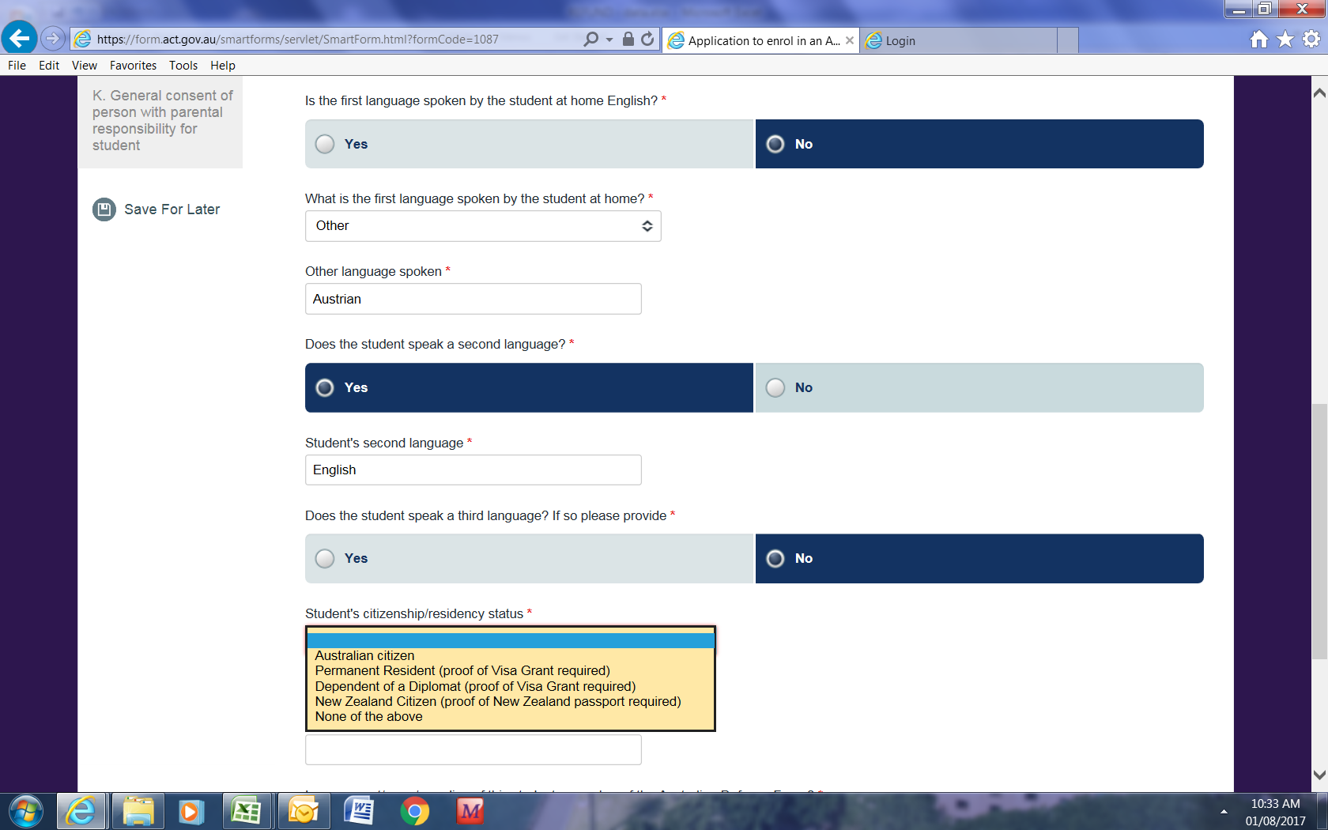
Visa status should be Temporary
Visa number should be 500
It will then bring up ARN Number and this number is – IEARNYYYY001 the red number is the AASES form number and must remain a 3 digit number ie 17/10 would be IEARN2017010.
Please do not hesitate to contact the IEU on 02 620 59176 if you require any further information.

