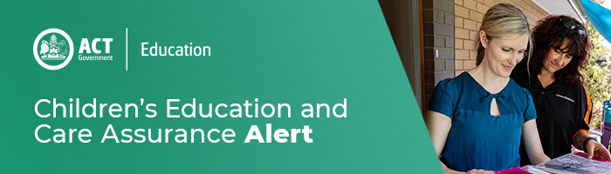
13 March 2020
Commonwealth Department of Education, Skills and Employment COVID-19 resources
Today the Commonwealth Government has released information to support education and care providers and services in response to COVID-19.

This included:
- advice on potential service closures and health directions;

- information on education and care providers can access 42 days of absence payments for children not attending due to COVID19 precaution/quarantine;

- information on Community Child Care Fund (CCCF) special circumstances grant funding will be available for business viability due to hardship; and

- access to the overarching announcement supporting small business cash flow and apprentices/trainees.
Please find this information attached:
- Government Response to COVID-19
- Coronavirus FAQs
- Coronavirus Information Sheet

For enquires in relation to this notification please call CECA on (02) 6207 1114 or email CECA@act.gov.au

For enquires in relation to this notification please call CECA on (02) 6207 1114 or email CECA@act.gov.au
This email has been authorised by the ACT Regulatory Authority (CECA). CECA are responsible for administering the National Quality Framework within the ACT

