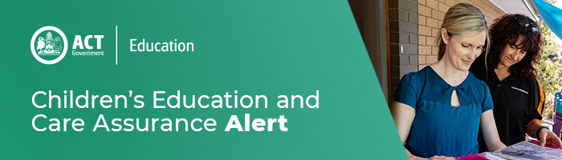
17 December 2020
Update of approved learning frameworks
Education Council has commissioned an update of the two national approved learning frameworks Belonging, Being and Becoming, the early years learning framework and My Time, Our Place the learning framework for school aged care.
As these approved learning frameworks have now been in use for close to a decade, the purpose of this update is to ensure they continue to reflect contemporary developments in practice and knowledge, while supporting all educators to best meet the learning and development needs of each child.
The terms of reference and milestones for the update process are available on the Education Council’s website, with stakeholder feedback and engagement expected to commence from mid-2021.
Work on the update is expected to commence from early 2021, with a stakeholder feedback and engagement process from mid-2021.

For enquires in relation to this notification please call CECA on (02) 6207 1114 or email CECA@act.gov.au
This email has been authorised by the ACT Regulatory Authority (CECA). CECA are responsible for administering the National Quality Framework within the ACT

