ACT POST SCHOOL DESTINATIONS AND PATHWAYS IN 2021

Results from the survey of 2020 year 12 graduates and school leavers and the longitudinal survey of 2019 year 12 graduates and school leavers.

Key Findings
Annual Survey
- Ninety-four percent of 2020 year 12 graduates were employed and/or studying in 2020, compared with 80 percent of 2020 school leavers in the survey.
- Sixty-seven percent of 2020 year 12 graduates were studying in 2021 and of those who were not studying 60 percent intended to start some study in the next two years.
- Fifty-six percent of 2020 school leavers were studying in 2021 and of those who were not studying 49 percent intended to start some study in the next two years.
- Seventy-eight percent of 2020 year 12 graduates were employed in 2021, compared with 70 percent of 2020 school leavers. Both proportions had increased from previous year’s results (65 percent and 53 percent respectively).
- In 2021 there was an additional question on whether school leavers changed their decision to study or work due the pandemic. Thirty-six percent of school leavers changed their decision to work or study in 2021; of these 51 percent of graduates and 25 percent of school leavers reported that they originally planned to take a gap year but were studying or working instead.
Longitudinal Survey
- The percentage of 2019 year 12 graduates studying increased from 58 percent in 2020 to 74 percent in 2021.
- Eighty-eight percent of the 2019 year 12 graduates who deferred university in 2020 were attending university in 2021.
- Fifty-one percent of 2019 year 12 graduates and 30 percent of 2019 school leavers who were not studying in 2020, were studying in 2021.

© Australian Capital Territory, Canberra, 2021
This publication has been produced by the ACT Government. Apart from any use permitted under the Copyright Act 1968, no part of this publication may be reproduced by any process without written permission from the ACT Government’s Education Directorate.
Contents
Key Findings 1
Annual Survey 1
Longitudinal Survey 1
Contents 3
Executive Summary 4
Part 1 – 2020 Year 12 Graduates and School Leavers 6
Destination of 2020 year 12 graduates 6
Key outcomes 6
Study 7
Labour force status 12
Destination of 2020 school leavers 14
Characteristics of all students who left school in 2020 17
COVID-19 specific questions 18
Satisfaction with school 19
Reasons for leaving school 20
Part 2 – 2019 Year 12 Graduates and School Leavers 21
Pathways of 2019 year 12 graduates 21
Key outcomes 21
Study 22
Labour force status 26
Pathways of 2019 school leavers 29
COVID-19 specific questions 30
Satisfaction with life 30
Scope and methodology 32
Glossary 33
References 34

Executive Summary
In May 2021 the Education Directorate conducted two post-school destination surveys.
- The annual survey of 2020 ACT year 12 graduates (those who completed an ACT Senior Secondary Certificate in 2020) and year 9 to 12 school leavers (those who were in year 9 to 12 when they left school in 2020 prior to completing an ACT Senior Secondary Certificate). A total of 2247 graduates and 314 school leavers completed the survey.
- A longitudinal survey of 2019 ACT year 12 graduates and school leavers (approximately 1.5 years after leaving school). This longitudinal survey was the second wave of the three-year longitudinal study of 2019 ACT year 12 graduates and school leavers (conducted in 2020, 2021 & 2021). A total of 758 graduates and 94 school leavers completed the survey.
The survey occurred in the context of the Future of Education Strategy (FoE) which began in 2018-19. This strategy outlines a vision focused on equity of outcomes, wellbeing and high-quality education for all students. The Future of Education strategy articulates priority actions drawn together and coordinated under four foundations as follows:
- Place students at the centre of their learning – ensuring students are engaged in their learning by taking a holistic view of each student’s unique needs and interests, and respecting that students are active participants in their learning who can make informed choices about what and how they learn
- Empower learning professionals – supporting teachers and allied health professionals to meet the needs of students through access to high quality training, mentoring and professional development, and supporting school leaders to build expert teaching teams to deliver on education that places students at the centre;
- Build strong communities for learning – building collaborative partnerships between schools, government and community service providers to support students at the centre through enhanced wellbeing, resilience and connections throughout the community, and ensuring parents and carers are active participants in school life and in the learning of their child/ren
- Strengthen systems that support learning – ensuring the systems that support education enable the flexible delivery approaches that are required to meet diverse needs, including legislation, resourcing and teaching tools, organisational structures and culture, public accountability and reporting, and data and information technology to deliver on education that places students at the centre.
This 2021 ACT post school destinations survey provides important information about the pathways of students who were in ACT schools during Phase One of the FoE strategy. This year additional questions in relation to COVID-19 pandemic were added to the survey.
Part 1 of the ACT Post School Destinations and Pathways in 2021 report presents information about the 2021 destinations of 2020 ACT year 12 graduates and school leavers and Part 2 presents information about the pathways 2019 year 12 graduates and school leavers have taken from 2020 to 2021.
The vast majority (94 percent) of 2020 ACT year 12 graduates were employed and/or studying in 2021, with the report highlighting that females, those who gained an ATAR, or graduates who did not receive a pension at the time of the survey, were more likely to be employed and/or studying than their peers.
Survey results for 2020 school leavers showed that 80 percent were employed and/or studying in 2021. The report highlights that those who received career guidance, participated in workplace learning and/or did not receive a pension were more likely to be employed and/or studying than their peers.
The annual survey found that of those who were not studying in 2021, 60 percent of year 12 graduates and 49 percent of school leavers were intending to study in the next two years. A similar trend has been observed in previous years. The results from the longitudinal survey found that over half of the 2019 graduates who indicated their intention to study in the next two years when surveyed in 2020, did start studying in 2021. Figure 1 shows the overall increase in the percentage of 2019 year 12 graduates and school leavers commencing study in 2020 and a further small increase in 2021. 2019 year 12 graduates who formally deferred university in 2020 were more likely to start study in 2021 than those who had an informal intention to study.
Figure 1: 2020 year 12 graduates and school leavers by study status in 2020 and 2021 (%)
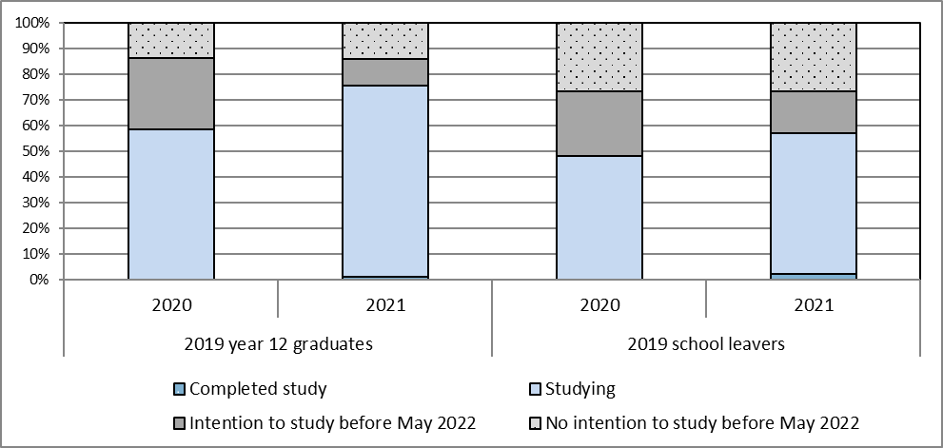
Overall, the report presents a positive picture of the pathways from school to further study and employment for young people graduating from or leaving ACT schools. However, the report clearly shows that those young people who complete an ACT Senior Secondary Certificate are advantaged both in terms of employment and further study outcomes six months after leaving school, compared with their peers who leave school before completing an ACT Senior Secondary Certificate (see Figure 2 below).
Figure 2: 2020 year 12 graduates and school leavers by main destination in 2021 (%)
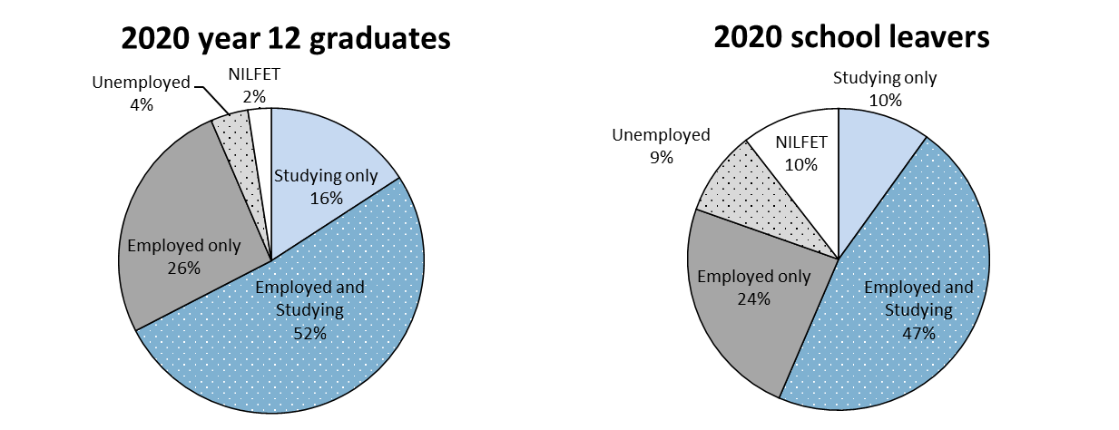
Note: NILFET means ‘not in labour force, education or training’.
The School Leaver Survey results provide important information that informs planning, development and provision of education and training choices for the young people of the ACT. The Directorate works closely with school staff in ACT public and non-government schools to ensure the survey results are disseminated and used for curriculum planning and to assist students with study and career choices at school and beyond.
Background
Australia is in a period of significant education and training reform. The current national reform agenda is impacting on all sectors of education, training and skills development. The ACT is proactive in looking to the future of education and training in our region, building on the strengths of current collaborations, relationships and partnerships within the sector, and promoting opportunities for change.
The ACT is committed to providing learning pathways for students which result in an educated and skilled workforce to meet the present and future needs of the ACT and region. The focus is on ensuring young people’s needs are met, providing flexible and responsive training options, engaging with industry and employers and improving retention rates. Together these strategies empower students to shape their own learning pathways while meeting industry needs.
Results from the School Leaver Surveys provide important information that informs planning, development and provision of education and training choices for the young people of the ACT.
In this publication, students who completed an ACT Senior Secondary Certificate in 2020 are described as 2020 year 12 graduates. Students who were in year 9 to 12 when they left school in 2020 prior to completing an ACT Senior Secondary Certificate are described as 2020 school leavers. Students who completed an ACT Senior Secondary Certificate in 2019 are described as 2019 year 12 graduates. Students who were in year 9 to 12 when they left school in 2019 prior to completing an ACT Senior Secondary Certificate are described as 2019 school leavers.
Part 1 – 2020 Year 12 Graduates and School Leavers

Destination of 2020 year 12 graduates
Key outcomes
Ninety-four percent of 2020 year 12 graduates reported that they were employed and/or studying in 2021. This is higherthe Australian employed and/or studying rate in 2021 of 92 percent for 15-20 year olds who completed year 12 prior to leaving school in 2020 (Australian Bureau of Statistics, 2021).
Table 1 provides an overview of the percentage of year 12 graduates employed, studying and employed and/or studying in the year following graduation. Data are presented for surveys conducted with 2017, 2018, 2019 and 2020 year 12 graduates. The following points were consistently noted over the four years:
- Female students were more likely to be employed and more likely to be employed and/or studying than male graduates. For example, 82 percent of female 2020 year 12 graduates were employed in 2021 compared to 74 percent of male graduates
- Graduates who spoke a language other than English at home (LBOTE) were more likely to be studying and less likely to be employed than graduates who were not LBOTE
- Graduates who did not obtain an Australian Tertiary Admission Rank (ATAR) were less likely to be employed and/or studying
- Graduates who were receiving a Government pension, allowance or benefit were more likely to be studying, less likely to be employed and less likely to be employed and/or studying.
Table 1: Year 12 graduates employed and/or studying, by selected demographics (%)
 |  | Employed |  |  |  |  | Currently studying |  |  |  |  | Employed and/or studying
Year of graduation |  | 2017 | 2018 | 2019 | 2020 |  | 2017 | 2018 | 2019 | 2020 |  | 2017 | 2018 | 2019 | 2020
Gender
 | Female | 79.5 | 76.9 | 65.7 | 81.6 |  | 59.9 | 59.7 | 59.0 | 68.6 |  | 94.8 | 94.0 | 89.4 | 95.9
 | Male | 74.7 | 73.6 | 64.2 | 73.7 |  | 58.7 | 59.5 | 58.2 | 66.3 |  | 91.3 | 91.7 | 85.9 | 91.1
LBOTE
 | No | 79.7 | 78.7 | 68.2 | 79.9 |  | 56.2 | 56.2 | 55.5 | 65.3 |  | 92.7 | 93.0 | 87.2 | 93.4
 | Yes | 67.5 | 62.0 | 51.7 | 69.8 |  | 72.4 | 72.2 | 71.1 | 76.2 |  | 94.8 | 92.3 | 89.9 | 94.5
Participated in a VET course at school
 | No | 76.0 | 73.1 | 62.8 | 77.4 |  | 59.5 | 59.3 | 62.1 | 72.5 |  | 93.2 | 92.0 | 89.3 | 94.6
 | Yes | 81.6 | 82.8 | 68.5 | 78.3 |  | 58.6 | 60.0 | 53.4 | 59.3 |  | 92.9 | 95.7 | 85.6 | 91.9
ATAR Group
 | No ATAR | 78.9 | 75.7 | 68.0 | 79.1 |  | 45.5 | 44.1 | 42.3 | 46.1 |  | 87.6 | 86.3 | 79.8 | 87.7
 | 1 - 65 | 81.3 | 74.7 | 66.9 | 79.6 |  | 50.6 | 57.1 | 53.3 | 69.7 |  | 91.9 | 92.8 | 87.0 | 94.9
 | 66 - 75 | 79.2 | 81.5 | 71.1 | 76.6 |  | 59.9 | 61.1 | 61.4 | 70.7 |  | 95.3 | 97.8 | 91.6 | 95.3
 | 76 - 85 | 76.0 | 78.3 | 61.4 | 73.7 |  | 71.8 | 70.9 | 69.6 | 81.3 |  | 97.6 | 96.8 | 93.5 | 96.6
 | 86 - 95 | 76.0 | 71.0 | 61.1 | 79.9 |  | 74.0 | 67.3 | 73.7 | 86.3 |  | 97.2 | 95.0 | 93.2 | 98.5
 | 96 - 100 | 66.0 | 65.4 | 49.3 | 72.9 |  | 74.5 | 84.0 | 83.2 | 84.5 |  | 97.0 | 97.1 | 94.4 | 97.7
Received career counselling/career guidance at school¹
 | No | 72.6 | 73.2 | 62.7 | 77.0 |  | 54.6 | 54.9 | 56.8 | 64.9 |  | 90.5 | 91.0 | 85.9 | 93.1
 | Yes | 79.5 | 76.6 | 66.7 | 79.1 |  | 61.0 | 62.0 | 59.7 | 69.4 |  | 94.5 | 94.2 | 88.9 | 94.6
 | Don't Know | 54.9 | 57.6 | 41.7 | 45.3 |  | 56.8 | 39.0 | 56.8 | 45.8 |  | 74.9 | 74.0 | 81.0 | 67.6
Participated in work experience/workplace learning whilst at school²
 | No | 76.0 | 72.7 | 63.8 | 75.9 |  | 57.3 | 57.3 | 58.7 | 67.9 |  | 92.1 | 91.8 | 87.8 | 94.0
 | Yes | 78.7 | 78.4 | 66.3 | 81.4 |  | 61.8 | 62.2 | 58.8 | 66.4 |  | 94.4 | 94.0 | 87.7 | 92.5
Received a government pension, allowance or benefit at the time of the survey
 | No | 80.2 | 78.4 | 68.3 | 80.7 |  | 57.3 | 58.2 | 58.1 | 67.0 |  | 93.8 | 93.8 | 89.5 | 94.6
 | Yes | 49.0 | 49.5 | 43.6 | 55.6 |  | 77.6 | 69.9 | 61.8 | 71.2 |  | 85.6 | 85.2 | 76.0 | 85.4
All graduates |  | 77.3 | 75.2 | 64.8 | 77.7 |  | 59.3 | 59.5 | 58.7 | 67.4 |  | 93.2 | 92.8 | 87.7 | 93.5
¹ In 2018 career guidance replaced career counselling. ² In 2018 workplace learning replaced work experience.
Study
Sixty-seven percent of all 2020 year 12 graduates indicated that they were undertaking some study in 2021, with 56 percent studying full-time (see Table 2 below). This is consistent with the Australian study rate in 2020 of 67 percent (and 56 percent in full-time study) for 15-20 year olds who completed year 12 prior to leaving school in 2020 (Australian Bureau of Statistics, 2021).
In general, 2020 year 12 graduates who achieved a higher Australian Tertiary Admission Rank (ATAR) had a greater tendency to be undertaking further study in the year after leaving school. Eighty-six percent of the graduates with an ATAR between 86 and 95 were undertaking study in 2020, compared with 70 percent of the graduates with an ATAR between 1 and 65.
Of the ten percent of 2020 year 12 graduates who were receiving a government pension, allowance or benefit in May 2021, 71 percent were studying in 2021, compared with 67 percent of those who were not receiving a government pension, allowance or benefit.
Table 2: 2020 year 12 graduates studying in 2021, by selected demographics (%)
 |  | Studying |  |  | Not studying
 |  | Part-time | Full-time | All
Gender
 | Females | 9.2 | 58.6 | 68.6 | 31.4
 | Males | 11.3 | 53.6 | 66.3 | 33.7
LBOTE
 | No | 10.7 | 53.5 | 65.3 | 34.7
 | Yes | 8.6 | 66.6 | 76.2 | 23.8
Participated in a VET course at school
 | No | 9.0 | 62.8 | 72.5 | 27.5
 | Yes | 12.3 | 45.4 | 59.3 | 40.7
ATAR Group
 | No ATAR | 17.2 | 27.3 | 46.1 | 53.9
 | 1 - 65 | 7.3 | 60.4 | 69.7 | 30.3
 | 66 - 75 | 6.6 | 63.1 | 70.7 | 29.3
 | 76 - 85 | 7.6 | 73.8 | 81.3 | 18.7
 | 86 - 95 | 6.6 | 79.2 | 86.3 | 13.7
 | 96 - 100 | 4.1 | 80.4 | 84.5 | 15.5
Received career guidance at school¹
 | No | 8.4 | 55.1 | 64.9 | 35.1
 | Yes | 11.1 | 57.5 | 69.4 | 69.4
Participated in workplace learning whilst at school²
 | No | 8.6 | 58.2 | 67.9 | 32.1
 | Yes | 13.6 | 51.9 | 66.4 | 33.6
Received a government pension, allowance or benefit at the time of the survey
 | No | 10.6 | 55.4 | 67.0 | 33.0
 | Yes | 7.5 | 63.0 | 71.2 | 28.8
All graduates |  | 10.3 | 56.1 | 67.4 | 32.6
Note: The percentages in this table do not all add to 100 percent due to rounding and a small percentage of ‘don’t know’ responses. 1 In 2018 career guidance replaced career counselling. 2 In 2018 workplace learning replaced work experience.
The Australian Standard Classification of Education (ASCED) was used to classify fields of study. The most common fields of study related to:
- Health (17%). This included fields such as medical, dental and veterinary studies, nursing, pharmacy, optical and rehabilitation therapies
- Society and culture (14%). This included fields such as political science, psychology, law, economics, sport and literature.
Sixty-one percent of 2020 year 12 graduates applied for a university place and 98 percent of these graduates were successful in gaining a place. Of the successful applicants:
- Eighty-five percent accepted the place and enrolled in 2021
- Twelve percent of successful applicants deferred
- Two percent rejected the offer.
Graduates who were not LBOTE, females and those that received career guidance were more likely to defer their university studies.
The ASCED was also used to classify level of study. Responses of:
- Advanced diploma, associate degree and bachelor degree or higher were more broadly classified as the higher education level
- Certificate I-IV and diploma were classified as the Vocational Education and Training (VET) level in this publication.
Forty-seven percent of 2020 year 12 graduates studying in 2021 reported that they were studying at the higher education level and 19 percent were studying at the VET level. A greater proportion of females were studying at the higher education level –51 percent of females compared with 43 percent of males. The proportion of males studying at the VET level was higher than the proportion of females studying at that level (see Figure 3 below).
Figure 3: 2020 year 12 graduates studying in 2021, by level of study and gender (%)
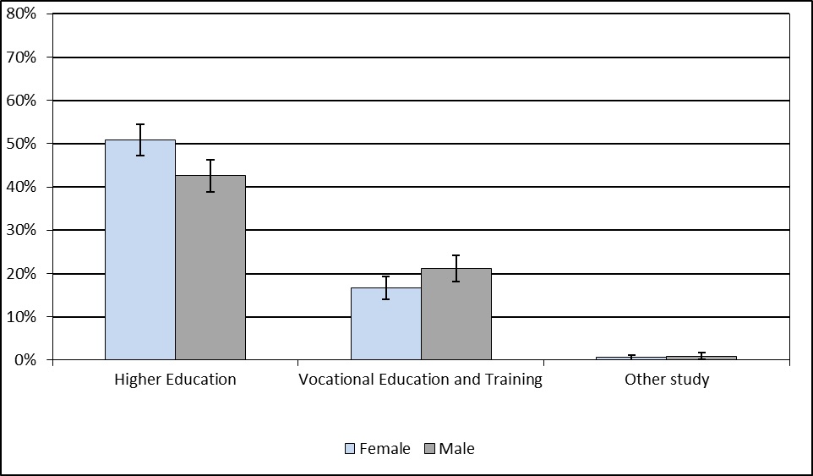
Note: Error bars reflect 95 percent confidence intervals for the population proportion. No overlap of the error bars indicates a statistically significant difference between the proportions.
Of the 2020 year 12 graduates who were studying in 2021, 42 percent reported that they chose their course because it interested them and 32 percent chose the course because they thought it would assist with employment (see Table 3 below).
Forty-four percent of graduates who were studying in 2021 and did not gain an ATAR reported that they chose the course because they thought it would assist with employment and 28 percent chose the course because it interested them. Graduates with a higher ATAR were more likely to have chosen their course because it interested them.
Table 3: 2020 year 12 graduates studying in 2021, by main reason for choosing their course and selected demographics (%)
 |  | It's a course that interests me | To get/start/help in a job/business | To help get into another course | To improve my education | Other
Gender
 | Females | 39.6 | 30.7 | 4.1 | 3.3 | 13.4
 | Males | 44.9 | 32.7 | 1.7 | 2.6 | 9.8
Participated in a VET course at school
 | No | 44.0 | 29.8 | 3.5 | 2.6 | 12.1
 | Yes | 38.2 | 35.5 | 2.0 | 3.7 | 10.8
ATAR Group
 | No ATAR | 27.5 | 44.3 | 2.3 | 4.5 | 10.3
 | 1 - 65 | 39.0 | 30.8 | 3.8 | 3.4 | 15.4
 | 66 - 75 | 41.4 | 26.8 | 4.0 | 2.7 | 15.6
 | 76 - 85 | 48.9 | 28.9 | 2.0 | 2.9 | 10.9
 | 86 - 95 | 47.8 | 28.2 | 4.0 | 1.6 | 9.9
 | 96 - 100 | 56.5 | 22.8 | 1.8 | 2.0 | 8.6
All graduates |  | 42.0 | 31.7 | 3.0 | 3.0 | 11.6
Note: The percentages in this table do not all add to 100 percent due to rounding and a small percentage of ‘don’t know’ responses.
Overall, nine percent of 2020 year 12 graduates indicated they were undertaking an apprenticeship in 2021 and three percent were doing a traineeship. The percentage of graduates undertaking an apprenticeship varied significantly for selected demographics (see Figure 4 above):
- Male graduates were much more likely to be undertaking an apprenticeship than females
- Graduates who participated in a VET course at school were more likely to be undertaking an apprenticeship than graduates who did not.
Figure 4: 2020 year 12 graduates undertaking an apprenticeship or traineeship in 2021, by selected demographics (%)
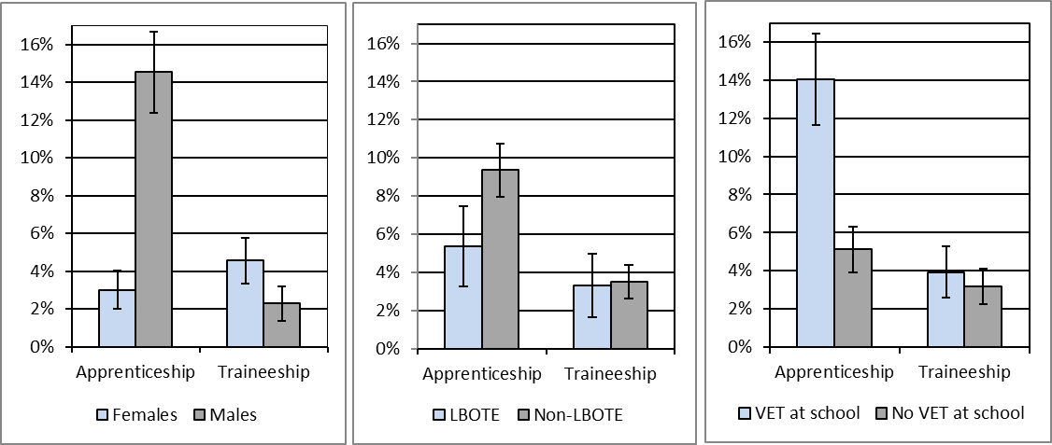
Note: The error bars reflect the 95 percent confidence intervals and no overlap indicates there is a statistical difference between the results.
Twenty percent of 2020 year 12 graduates who were not studying in 2021 reported their main reason for not studying was to “take a gap year”, 19 percent indicated that they had “got a job”, eleven percent were “not sure what to study”, and eight percent were "not ready to study" (see Table 4 below). Forty-seven percent of graduates who were not studying and had an ATAR over 95 reported their main reason for not studying was because they were taking a gap year and 23 percent “got a job”.
Table 4: 2020 year 12 graduates not studying in 2021, by main reason for not studying and selected demographics(%)
 |  | Taking a gap year | Got a job | Not sure what to study | Not ready for study | Family commitment or illness | Never planned/intended to study | Other
Gender
 | Females | 19.9 | 18.7 | 12.5 | 8.5 | 7.1 | 5.8 | 25.0
 | Males | 19.5 | 20.3 | 9.4 | 8.2 | 5.7 | 4.3 | 25.7
Participated in a VET course at school
 | No | 21.8 | 17.0 | 11.8 | 6.0 | 7.6 | 3.3 | 27.2
 | Yes | 17.9 | 22.3 | 10.0 | 11.0 | 5.0 | 6.9 | 23.1
ATAR Group
 | No ATAR | 12.2 | 21.6 | 10.3 | 8.1 | 6.4 | 8.0 | 26.8
 | 1 - 65 | 28.5 | 17.0 | 18.9 | 6.9 | 2.8 | 1.0 | 22.7
 | 66 - 75 | 28.0 | 17.8 | 8.2 | 7.6 | 8.8 | 2.0 | 26.5
 | 76 - 85 | 27.4 | 10.8 | 9.5 | 12.4 | 6.6 | 1.6 | 28.6
 | 86 - 95 | 30.8 | 19.2 | 9.2 | 11.7 | 7.9 | 0.0 | 17.8
 | 96 - 100 | 46.7 | 22.5 | 7.5 | 4.0 | 7.7 | 0.0 | 11.6
All graduates |  | 19.9 | 19.5 | 10.9 | 8.4 | 6.4 | 5.0 | 25.2
Note: The percentages in this table do not all add to 100 percent due to rounding and a small percentage of ‘don’t know’ responses.
Of the 33 percent of 2020 year 12 graduates who were not studying in 2021, 60 percent intended to start some study in the next two years.
In general, as ATAR increased, so did intention to start some study in the next two years. The most common intended ASCED fields of study related to:
- Society and culture (15%)
- Health (14%)
- Creative arts (13%).
Labour force status
Seventy-eight percent of 2020 year 12 graduates reported having a paid job in 2021 (see Table 5 below). Twelve percent reported not currently having a paid job and actively looking for work with the majority looking for part-time work.
Table 5: Number and proportion of 2020 year 12 graduates, by labour force status in 2021
 |  |  | Number | Proportion (%)
 | Employed |  | 3,297 | 77.7
 |  | Full-time | 869 | 20.5
 |  | Part-time | 2,407 | 56.7
 |  | Don't know/Refused | 22 | 0.5
 | Unemployed |  | 508 | 12.0
 |  | Looking for full-time work | 37 | 0.9
 |  | Looking for part-time work | 352 | 8.3
 |  | Looking for full or part-time work | 110 | 2.6
 | Total in labour force |  | 3,805 | 89.7
Not in labour force |  |  | 438 | 10.3
Total |  |  | 4,243 | 100.0
Unemployment rate |  |  |  | 13.3
Note: The percentages in this table may not all add to 100 percent due to rounding and a small percentage of ‘don’t know’ responses.
The percentage of 2020 year 12 graduates who were receiving a government pension, allowance or benefit in May 2021 varied depending on their labour force status. Twenty percent of graduates who were unemployed and 21 percent of those not in the labour force were receiving a government pension, allowance or benefit in May 2021, compared with seven percent of employed graduates.
The Australian and New Zealand Standard Classification of Occupations (ANZSCO) was used to classify occupations. The most common occupations were:
- Sales workers (34%)
- Community and personal service workers (24%).
Eighty-five percent of 2020 year 12 graduates studying part-time in 2021 were employed, with 47 percent employed part-time (see Table 6 below). Seventy-five percent of graduates studying full-time were employed, with almost two third (64%) employed part-time. Eighty percent of graduates who were not studying were employed and 12 percent were unemployed.
Table 6: 2020 year 12 graduates in the labour force in 2021, by study status in 2021 (%)
 |  |  | Studying |  |  | Not studying | All graduates
 |  |  | Part-time | Full-time | Total
 | Employed |  | 84.8 | 74.6 | 76.5 | 80.2 | 77.7
 |  | Full-time | 36.4 | 10.4 | 15.5 | 30.8 | 20.5
 |  | Part-time | 47.5 | 63.8 | 60.5 | 48.9 | 56.7
 | Unemployed |  | 8.5 | 12.7 | 11.8 | 12.2 | 12.0
 |  | Looking for full-time work | 0.0 | 0.3 | 0.3 | 2.2 | 0.9
 |  | Looking for part-time work | 6.8 | 11.2 | 10.3 | 4.1 | 8.3
 |  | Looking for full or part-time work | 1.7 | 1.1 | 1.2 | 5.5 | 2.6
Total in labour force |  |  | 93.3 | 87.3 | 88.3 | 92.4 | 89.7
Not in labour force |  |  | 6.7 | 12.7 | 11.7 | 7.6 | 10.3
Total |  |  | 100.0 | 100.0 | 100.0 | 100.0 | 100.0
Note: The percentages in this table may not all add to 100 percent due to rounding and a small percentage of ‘don’t know’ responses.
Participation in other post-school activities
The percentage of 2017, 2018, 2019 and 2020 year 12 graduates who participated in various activities in the year following leaving school is shown in Table 7. In 2020 and 2021 (that is, graduates from 2019 and 2020) there was reduced participation in all activities. This may be attributed to the COVID-19 restrictions. Participation rates in all activities other than caring for family members increased in 2021, but were still below the 2018 and 2019 rates. At the time of the survey in May and June 2021:
- Thirteen percent of 2020 year 12 graduates were undertaking volunteer work
- Ten percent were pursuing elite sporting interests
- Nine percent were caring for family members
- Eight percent were travelling.
Table 7: Year 12 graduates participating in various post school activities (%)
Activity/ Year left school | 2017 | 2018 | 2019 | 2020
Travelling | 24.2 | 19.7 | 4.6 | 7.6
Undertaking volunteer work | 15.4 | 18.6 | 10.6 | 12.9
Pursuing elite sporting interests | 10.4 | 11.2 | 8.4 | 9.8
Caring for family members | 10.7 | 8.8 | 12.0 | 9.4

Destination of 2020 school leavers
In 2021 school leavers who were in year 9 and agreed to participate in the survey advised they had returned to school. Eighty percent of 2020 school leavers who were in year 10 to year 12 reported they were employed and/or studying in 2021. The percentage of school leavers employed and/or studying in the year after leaving school is detailed in Table 8.
Table 8: School leavers employed and/or studying, by selected demographics (%)
 |  | Employed |  |  |  |  | Currently studying |  |  |  |  | Employed and/or studying
Year left school |  | 2017 | 2018 | 2019 | 2020 |  | 2017 | 2018 | 2019 | 2020 |  | 2017 | 2018 | 2019 | 2020
Gender
 | Females | 62.7 | 52.8 | 43.9 | 63.1 |  | 39.6 | 41.9 | 44.6 | 55.5 |  | 75.5 | 65.8 | 67.6 | 73.8
 | Males | 64.6 | 58.5 | 56.6 | 75.2 |  | 47.1 | 48.1 | 46.9 | 57.0 |  | 78.2 | 73.4 | 72.9 | 84.1
Year level
 | Year 10 to 11 | 68.8 | 65.5 | 55.8 | 78.9 |  | 42.8 | 49.4 | 49.9 | 59.4 |  | 76.1 | 74.0 | 72.3 | 81.3
 | Year 12 | 60.1 | 51.4 | 49.1 | 64.7 |  | 46.2 | 43.4 | 41.9 | 54.1 |  | 78.3 | 69.7 | 69.7 | 79.7
LBOTE
 | No | 65.9 | 60.4 | 52.7 | 73.2 |  | 43.9 | 46.2 | 45.8 | 57.7 |  | 78.4 | 73.2 | 70.3 | 80.6
 | Yes | 46.4 | 31.6 | 51.3 | 57.0 |  | 54.0 | 43.1 | 47.9 | 48.5 |  | 66.9 | 57.3 | 77.5 | 79.2
Received career counselling/career guidance at school¹
 | No | 51.2 | 55.0 | 43.6 | 71.1 |  | 43.4 | 43.8 | 43.2 | 51.6 |  | 65.1 | 66.9 | 65.9 | 79.8
 | Yes | 70.5 | 62.3 | 62.5 | 73.6 |  | 50.4 | 49.7 | 54.3 | 64.0 |  | 85.3 | 79.5 | 81.1 | 84.7
Participated in work experience/workplace learning whilst at school²
 | No | 58.9 | 55.8 | 42.0 | 70.0 |  | 43.3 | 38.5 | 41.3 | 52.7 |  | 72.6 | 71.8 | 64.7 | 80.3
 | Yes | 70.5 | 59.1 | 70.7 | 72.8 |  | 46.8 | 55.8 | 54.0 | 63.8 |  | 83.4 | 70.9 | 81.9 | 80.5
Receiving a government pension, allowance or benefit at the time of the survey
 | No | 72.2 | 62.9 | 55.9 | 76.6 |  | 47.2 | 49.4 | 49.2 | 62.2 |  | 84.5 | 77.5 | 75.0 | 86.6
 | Yes | 12.8 | 22.1 | 29.7 | 36.0 |  | 32.2 | 25.0 | 29.1 | 21.5 |  | 32.6 | 31.0 | 46.1 | 42.8
All school leavers |  | 64.0 | 57.2 | 52.6 | 70.9 |  | 44.8 | 46.1 | 46.0 | 56.4 |  | 77.3 | 71.4 | 71.0 | 80.4
¹ In 2018 career guidance replaced career counselling. ² In 2018 workplace learning replaced work experience.
Data are presented for surveys conducted with 2017, 2018, 2019 and 2020 school leavers. The following points were consistently noted over the four years:
- School leavers who were LBOTE were less likely to be employed than those who were not LBOTE
- School leavers who received career counselling/guidance at school were more likely to be employed than those that did not receive career counselling
- Males were more likely to be studying than females
- School leavers who were receiving a Government pension, allowance or benefit were less likely to be employed and/or studying than those not receiving this assistance.
Fifty-six percent of 2020 school leavers indicated that they were undertaking some study in 2021, with 37 percent studying full-time (see Table 9 below).
Table 9: 2020 school leavers studying in 2021, by selected demographics (%)
 |  | Studying |  |  |  |  | Not studying
 |  | Part-time | Full-time | All*
Gender
 | Females | 9.5 | 44.4 | 55.5 |  |  |  | 44.5
 | Males | 22.6 | 32.7 | 57.0 |  |  |  | 43.0
Year level
 | Year 9 to 11 | 32.3 | 23.1 | 59.4 |  |  |  | 40.6
 | Year 12 | 6.7 | 47.4 | 54.1 |  |  |  | 45.9
LBOTE
 | No | 19.7 | 36.0 | 57.7 |  |  |  | 42.3
 | Yes | 6.6 | 41.9 | 48.5 |  |  |  | 51.5
Received career guidance at school
 | No | 19.0 | 30.5 | 51.6 |  |  |  | 48.4
 | Yes | 17.8 | 45.0 | 64.0 |  |  |  | 36.0
Participated in workplace learning whilst at school
 | No | 12.2 | 38.5 | 52.7 |  |  |  | 47.3
 | Yes | 29.0 | 33.6 | 63.8 |  |  |  | 36.2
Receiving a government pension, allowance or benefit at the time of the survey
 | No | 20.0 | 40.6 | 62.2 |  |  |  | 37.8
 | Yes | 5.7 | 15.8 | 21.5 |  |  |  | 0.8
All school leavers |  | 17.9 | 36.8 | 56.4 |  |  |  | 43.6
Note: The percentages in this table do not all add to 100 percent due to rounding and a small percentage of ‘don’t know’ responses.
¹ In 2018 career guidance replaced career counselling. ² In 2018 workplace learning replaced work experience.
The main reason why 2020 school leavers chose their course of study in 2021 was because 44 percent thought it would assist with employment. and 37 percent indicated it interested them.
For 2020 school leavers, the most common ASCED subjects of study related to:
- Architecture and building (22%).This included fields such as landscape architecture, interior design, regional planning, bricklaying, carpentry and plumbing
- Engineering and related technologies (17%). This included study of design, manufacture, installation, maintenance and functioning of machines, systems and structures; and the composition and processing of metals, ceramics, foodstuffs and other materials
- Society and culture (13%). This included fields such as political science, psychology, law, economics, sport and literature.
Twenty-eight percent of 2020 school leavers reported undertaking an apprenticeship or traineeship in 2021. The percentage of year 9 to 11 school leavers undertaking an apprenticeship was significantly greater than the percentage of year 12 leavers undertaking an apprenticeship (see Figure 5 below). Of the school leavers who were undertaking an apprenticeship or traineeship, almost half (47%) were technicians and trade workers (ANZSCO) studying architecture and building or engineering and related technologies (ASCED).
Figure 5: 2020 school leavers undertaking an apprenticeship or traineeship in 2021, by selected demographics (%)
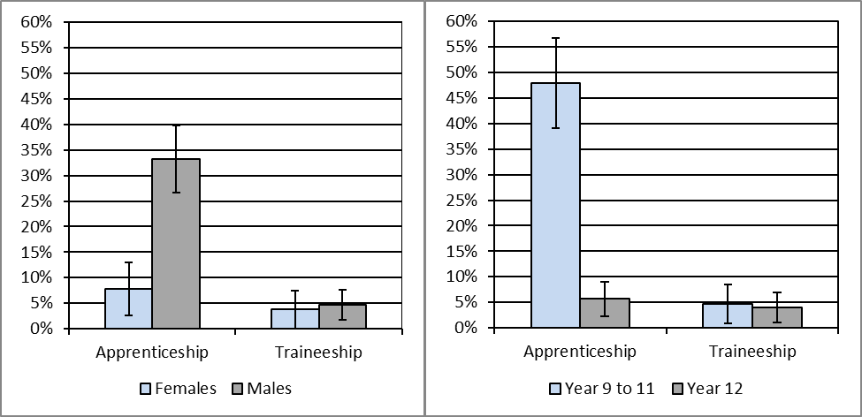
Note: The error bars reflect the 95 percent confidence intervals and no overlap indicates there is a statistical difference between the results.
Forty-four percent of the 2020 school leavers who were not studying in 2021 intended to start some study in the next two years. 20 percent of 2020 school leavers who were not studying in 2021 reported their main reason for not studying was because they got a job, 16 percent of family commitments, illness or disability including 6 percent of respondents who advised this was as a result of COVID-19, and 11 percent were taking a gap year.
Seventy-one percent of 2020 school leavers reported having a paid job in 2021 (see Table 10 below). Fifteen percent of school leavers said they did not have a paid job but were actively looking for work. Fifteen percent of 2020 school leavers were not in the labour force in 2021. The unemployment rate was 18 percent for school leavers.
Of the 2020 school leavers who had a paid job in 2021, the most common ANZSCO occupations were:
- Technicians and trade workers (34%)
- Sales workers (21%)
- Labourers (15%)
- Community and personal service workers labourers (14%).
Table 10: Number and proportion of 2020 school leavers, by labour force status in 2021
 |  |  | Number | Proportion (%)
 | Employed |  | 618 | 70.5
 |  | Full-time | 287 | 32.7
 |  | Part-time | 315 | 35.9
 |  | Don't know/Refused | 16 | 1.8
 | Unemployed |  | 131 | 15.0
 |  | Looking for full-time work | 26 | 2.9
 |  | Looking for part-time work | 64 | 7.2
 |  | Looking for full or part-time work | 42 | 4.8
 |  | Don't know/Refused | 0 | 0.0
 | Total in labour force |  | 749 | 85.4
Not in labour force |  |  | 128 | 14.6
Total |  |  | 876 | 100.0
Unemployment rate |  |  |  | 17.5
At the time of the survey in 2021, some 2020 school leavers were participating in other post-school activities, either instead of or as well as study and/or employment:
- Nine percent were undertaking volunteer work
- Eight percent were pursuing elite sporting interests
- Five percent were travelling.

Characteristics of all students who left school in 2020
Table 11 details the characteristics of all students who left school in 2020; both year 12 graduates and school leavers.
A slightly higher proportion of Year 12 graduates who completed the survey were female (52%); however for school leavers the majority of respondents (64%) were male. Fifty-six percent of the 2020 school leavers who completed the survey were in year 12 when they left school. Twenty percent of graduates spoke a language other than English at home, whilst 14 percent of school leavers spoke a language other than English at home. Graduates were more likely to have received career guidance at school. Thirteen percent of year 12 graduates participated in pathways planning at school compared to 10 percent of school leavers.
Table 11: 2020 school leavers and year 12 graduates, by selected demographics (%)
Selected Demographics | School leavers | Year 12 Graduates
Year 9 to 11 | 43.6 | n.a.
Year 12 | 56.4 | 100.0
Females | 35.7 | 51.7
Males | 64.3 | 48.0
LBOTE | 13.8 | 20.2
Participated in a VET course at school | n.a. | 38.3
Received career guidance at school | 58.4 | 66.4
Participated in workplace learning whilst at school | 34.0 | 33.4
Participated in pathways planning whilst at school | 10.1 | 12.7
Received a government pension, allowance or benefit at the time of the survey | 13.2 | 10.1
Participated in engagement programs whilst at school | 2.9 | 5.0
Participated in support programs for students with disability at school | 11.2 | 6.2
Aboriginal and Torres Strait Islanders | 4.1 | 2.5
Note: n.a. indicates that results are not applicable.
Specific survey results for two key student populations, students with disability and Aboriginal and Torres Strait Islander students, have not been included in this publication due to the small number who participated in the survey. More than half of the young people with disability who graduated or left school in 2020 were employed and/or studying in 2021. Although most attended a mainstream school, a small proportion attended a specialist school for students with disability and majority of these students were participating in community support programs at the time of the survey in 2021. Seventy-Seven percent of Aboriginal and Torres Strait Islander young people who graduated or left school in 2020 were employed and/or studying in 2021.

COVID-19 specific questions
In 2021, there was an additional question on whether students changed their decision to study, work due the pandemic. The survey found 36 percent of students changed their decision to work or study in 2021. Of the students who reported changes in their decision:
- Fifty-one percent of graduates and 25 percent of school leavers reported they planned to take a gap year but were studying or working instead
- Twenty percent of graduates and 36 percent of school leavers reported they planned to study but were working or taking a gap year instead
- Seven percent of graduates and 9 percent of school leavers reported they planned to work but were studying or taking a gap year instead
- Sixteen percent of graduates and 28 percent of school leavers reported they changed their decision to study or work to other decisions.

Satisfaction with school
Parents of 2020 year 9 to 11 school leavers were asked about their level of satisfaction with the school the student most recently attended and 55 percent of parents were satisfied with the school.
Year 12 school leavers and year 12 graduates from 2020 were asked about their level of agreement with seven statements regarding their experience in years 11 and 12 in the ACT (see Figure 6 below). Responses of strongly agree or agree were classified as “satisfied”, responses of strongly disagree or disagree as “not satisfied” and responses of neither agree nor disagree as “neutral”.
Overall 57 percent of year 12 school leavers and 79 percent of year 12 graduates found year 11 and 12 worthwhile. The difference between these two proportions is statistically significant. Year 12 graduates were significantly more satisfied than year 12 school leavers in terms of their responses to the statements “It was satisfying and rewarding” and “It prepared me for future choices”.
2020 year 12 graduates and year 12 school leavers were also asked about their level of satisfaction with their life as a whole at the time of the survey in May 2021. A similar pattern was observed, with sixty-nine percent of graduates and 62 percent of year 12 leavers being satisfied or very satisfied. Of particular interest is that year 12 graduates and year 12 school leavers who received career guidance at school were more satisfied with their life than those who did not receive career guidance at school. 72 percent of 2020 year 12 graduates who received career guidance at school were satisfied with their life compared with 68 percent of those who did not receive career guidance at school. Whilst the level of satisfaction with life was similar for male and female graduates, for year 12 school leavers, males tended to be more satisfied.
Figure 6: 2020 year 12 graduates and year 12 school leavers satisfied with various aspects of their year 11 and 12 experience (%)
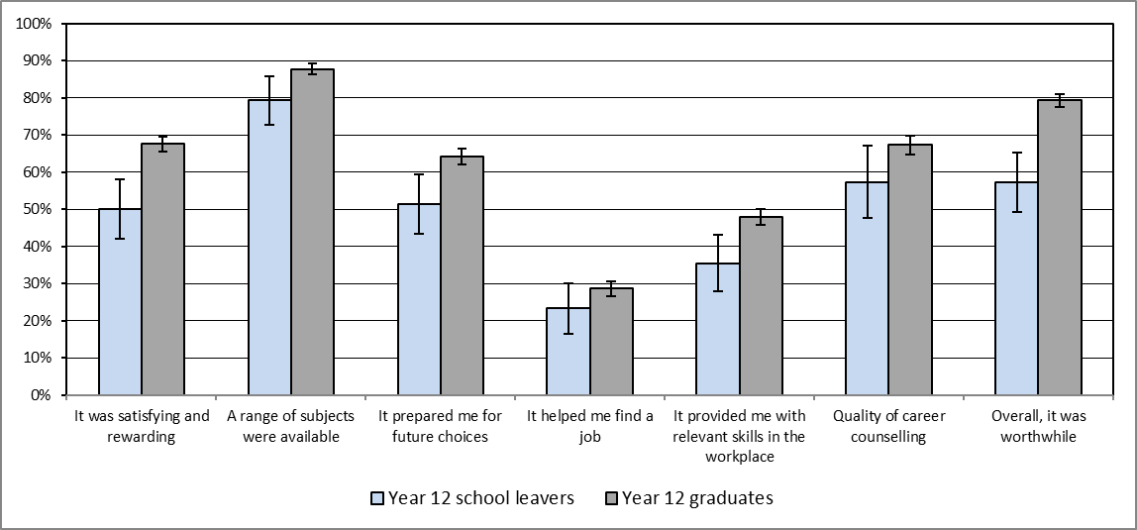
Note: The error bars reflect the 95 percent confidence intervals and no overlap indicates there is a statistical difference between the results.

Reasons for leaving school
Parents of year 9 to 11 students who left school in 2020 were asked the reasons why their child decided to leave school (see Table 12 below). The most common responses were:
- The child wanted to get a job (72%)
- The child had a job to go to (63%)
- The child wanted to earn their own money (62%).
Table 12: Most common responses parents gave regarding why their child (who was in year 9, 10 or 11 in 2020) left school
Response Categories | Proportion (%)
Not doing very well at school | 59.9
Wanted to get a job | 72.1
Wanted to earn his/her own money | 62.1
Had a job to go to | 62.7
Wanted to do study or training that wasn't available at school | 46.3
Didn't get on with the teachers and/or students at school | 24.5
Had an illness, disability or caring responsibilities | 18.2
Note: The percentages in this table do not add to 100 percent, as respondents could provide more than one response.
Part 2 – 2019 Year 12 Graduates and School Leavers

Pathways of 2019 year 12 graduates
Key outcomes
Ninety-five percent of 2019 year 12 graduates reported that they were employed and/or studying in 2021. Eighty percent of graduates were employed and 74 percent were studying in 2021. Participation in both study and employment increased from 2020 to 2021. Overall there was an increase in the percentage employed and/or studying over the same period (see Table 13 below).
Table 13: 2019 year 12 graduates employed and/or studying in 2020 and 2021 by selected demographics(%)
 |  | Employed |  |  | Currently studying |  |  | Employed and/or studying
Year of survey |  | 2020 | 2021 |  | 2020 | 2021 |  | 2020 | 2021
Gender
 | Female | 64.6 | 82.4 |  | 59.2 | 78.5 |  | 88.1 | 97.4
 | Male | 64.5 | 77.7 |  | 57.5 | 69.6 |  | 84.9 | 93.6
Participated in a VET course at school
 | No | 63.2 | 77.9 |  | 63.3 | 81.2 |  | 88.5 | 96.1
 | Yes | 66.5 | 83.2 |  | 50.0 | 64.3 |  | 83.0 | 94.2
Received career counselling at school
 | No | 61.3 | 76.6 |  | 56.2 | 71.0 |  | 83.3 | 91.0
 | Yes | 66.2 | 82.0 |  | 59.5 | 76.3 |  | 88.1 | 97.9
Participated in work experience at school
 | No | 63.5 | 80.3 |  | 58.4 | 75.4 |  | 86.0 | 95.8
 | Yes | 65.4 | 79.6 |  | 58.5 | 72.7 |  | 87.4 | 95.1
All graduates |  | 64.3 | 80.0 |  | 58.4 | 74.3 |  | 86.5 | 95.5
The 2021 main employment and study destinations for 2019 year 12 graduates by employment and study destination in 2020 is shown in Table 14. Ninety-two percent of the graduates who were employed in 2020 were also employed in 2021, 91 percent of those studying in 2020 were also studying in 2021 and 98 percent of those employed and/or studying in 2020 were also employed and/or studying in 2021. Of the 2019 year 12 graduates who were not employed or studying in 2020, 56 percent were employed in 2021 and 46 percent were studying in 2021. Twenty-three percent of the 2019 year 12 graduates who were not employed or studying in 2020 were also in this category in 2021.
Table 14: 2019 year 12 graduates employed and/or studying in 2020, by employed and/or studying in 2021(%)
 | 2021 |  |  | Not employed or studying | Distribution in 2020
2020 | Employed | Studying | Employed and/or Studying | Not employed or studying | Distribution in 2020
Employed | 91.9 | 74.2 | 99.2 | 0.8 | 52.2
Studying | 80.2 | 90.8 | 98.4 | 1.6 | 48.2
Employed and/or studying | 83.8 | 78.7 | 98.4 | 1.6 | 73.6
Not employed or studying | 55.5 | 46.2 | 76.8 | 23.2 | 26.4
Distribution in 2021 | 80.0 | 74.3 | 95.5 | 4.5 | 100.0
Study
Ninety-one percent of the 2019 year 12 graduates who were studying in 2020 were also studying in 2021. Ninety-four percent of those studying at the higher education level were also studying at this level in 2021 and 61 percent of those studying at the VET level were also studying at this level in 2021 (see Table 15 below). Twenty-four percent of the year 12 graduates who were studying at the VET level in 2020 were not studying in 2021, with the majority (63%) of these graduates completing the qualification prior to the survey in 2021. Over half (51%) of the graduates who were not studying in 2020 were studying in 2021. Thirty-four percent of 2019 year 12 graduates not studying in 2020 were studying at the higher education level in 2021, with the majority (62%) of these students having formally deferred university in 2020.
Table 15: Level of study in 2021 by level of study in 2020 for 2019 Year 12 graduates(%)
 |  | 2021
 |  | Studying |  |  |  | Not studying | Total
2020 |  | Higher education | VET course | Other | Total
Studying |  | 72.5 | 17.6 | 0.7 | 90.8 | 9.2 | 100.0
 | Higher education | 94.4 | 2.5 | 0.0 | 96.9 | 3.1 | 100.0
 | VET course | 13.8 | 61.1 | 0.7 | 75.6 | 24.4 | 100.0
 | Other | 48.5 | 14.0 | 6.4 | 69.0 | 31.0 | 100.0
Not Studying |  | 33.7 | 15.2 | 2.2 | 51.1 | 48.9 | 100.0
Distribution in 2021 |  | 56.4 | 16.6 | 1.3 | 74.3 | 25.7 | 100.0
Note: The percentages in this table do not all add to 100 percent due to rounding and a small percentage of ‘don’t know’ responses.
Forty-two percent of 2019 year 12 graduates were studying at the higher education level in 2020. Figure 7 provides details of the 2021 main destination for 2019 year 12 graduates studying at the higher education level in 2020. Of those who were studying at the higher education level in 2020:
- The majority (94%) were also studying at the higher education level in 2021 with 43 percent found to be undertaking the same study in 2021 and 51 percent making a change to their study field, qualification and/or study load in 2021
- Three percent did not continue to study in 2021, with almost all employed .
Figure 7: 2021 main destination for 2019 Year 12 graduates who were studying at the higher education level in 2020
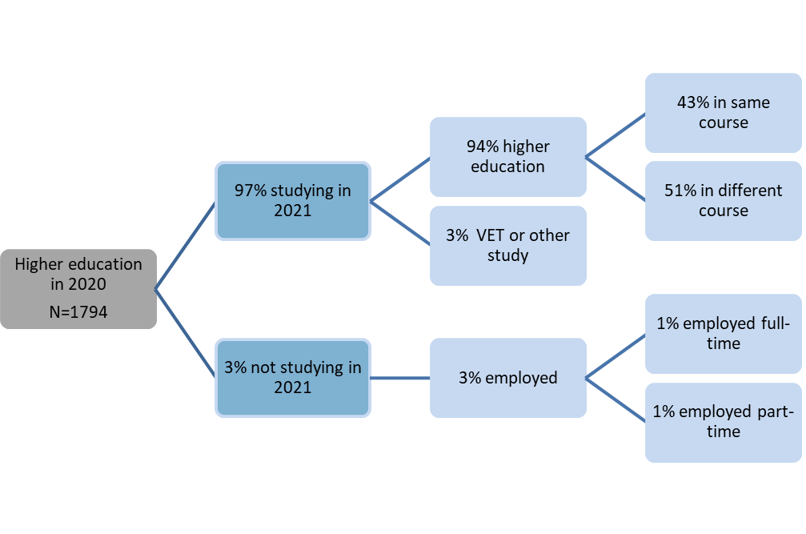
Note: The percentages in this figure do not all add to 100 percent due to rounding and a small percentage of ‘don’t know’ responses.
Fourteen percent of 2019 year 12 graduates were studying at in Vocational Education and Training (VET) in 2020. Figure 8 provides details of the 2021 main destination for 2019 year 12 graduates studying VET in 2020. Of those who were studying VET in 2020, 61 percent were also studying VET in 2021, 28 percent were undertaking the same course in 2021 and thirty-three percent made a change to their study field, qualification and/or study load in 2021.
- Twenty-four percent did not continue to study in 2021, with twenty-one percent employed and four percent unemployed.
Figure 8: 2021 main destination for 2019 Year 12 graduates who were studying at the VET level in 2020
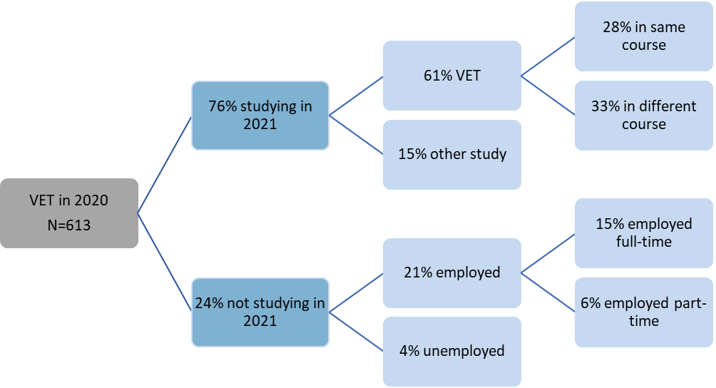
Note: The percentages in this figure do not all add to 100 percent due to rounding and a small percentage of ‘don’t know’ responses.
Six percent of 2019 year 12 graduates were undertaking an Australian Apprenticeship (had signed a national training contract) in 2020. Figure 9 provides details of the 2021 main destination for 2019 year 12 graduates who were undertaking an Australian Apprenticeship in 2020. Of those who were undertaking an Australian Apprenticeship in 2020:
- Seventy-five percent were also undertaking an apprenticeship or traineeship in 2021, with Forty-one percent in the same apprenticeship or traineeship
- Twelve percent were studying in 2021 but not as an apprentice or trainee
- Thirteen percent were not studying in 2021 and employed.
Figure 9: 2021 main destination for 2019 Year 12 graduates who were undertaking an Australian Apprenticeship in 2020
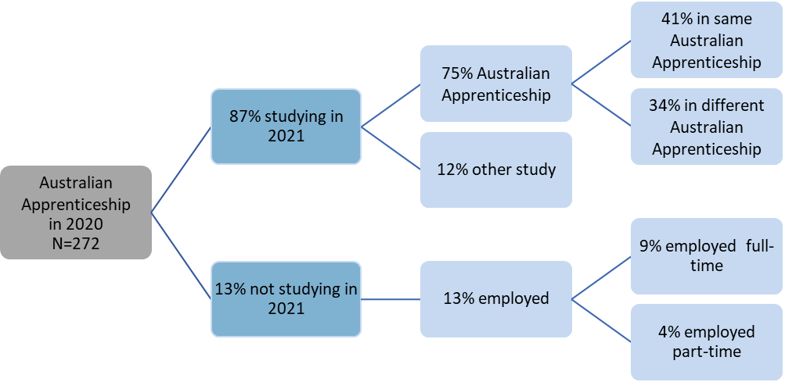
Note: The percentages in this figure may not add to 100 percent due to rounding and a small percentage of ‘don’t know’ responses.
Nine percent of 2019 year 12 graduates were studying in 2020 but not in 2021, and thirteen percent of these graduates said they successfully completed the course and/or qualification they were undertaking.
Forty percent of 2019 Year 12 graduates were not studying in 2020 or 2021 but indicated that they were planning to study in 2021 or 2020 at the time of the survey in 2020. Sixty percent of these graduates said their main reason for not studying was because they got a job.
Twenty-seven percent of 2019 year 12 graduates intended to start some study in the next two years at the time of the survey in 2020, with 39 percent of these graduates formally deferring a university offer. Figure 10 details the 2021 study destination for these graduates and graduates with an informal intention to study (intended to study but did not formally defer university) in the next two years.
Of those who deferred university in 2020:
- Thirty-two percent were attending university
- Two percent were studying elsewhere
- Five percent were not studying in 2021.
Of those with an informal intention to study in 2020:
- Twenty-ninepercent were not studying
- Eighteen percent were attending university
- Fifteen percent were studying elsewhere in 2021.
Figure 10: 2021 study destination for 2019 Year 12 graduates who in 2020 reported an intention to study
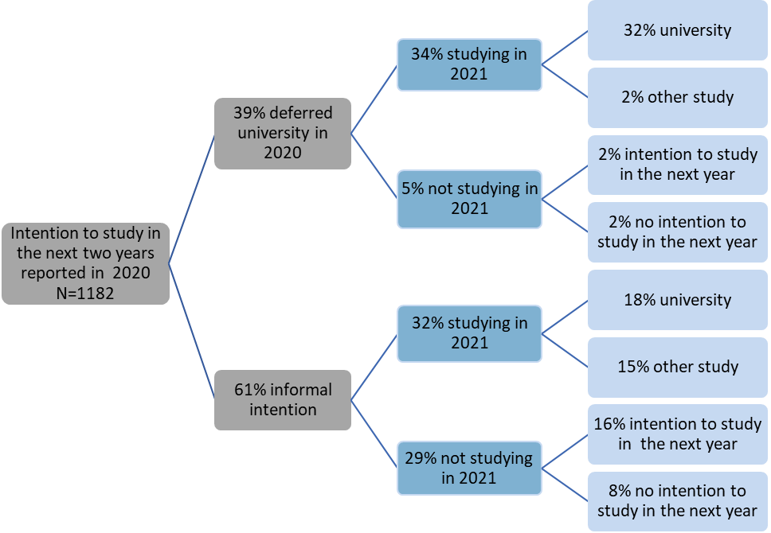
Note: The percentages in this figure may not add to 100 percent due to rounding and a small percentage of ‘don’t know’ responses.
Thirty-two percent of 2019 year 12 graduates were intending to study in the next two years at the time of the survey in 2020 and were studying in 2021, with 57 percent of these graduates studying in their intended ASCED field of study. Table 16 highlights the most common fields of study in 2021 for each of the most common intended fields of study in 2020. fourteen percent of 2019 year 12 graduates who intended to study in the field of creative arts in 2020 commenced study in the field of management and commerce in 2021.
Table 16: 2021 field of study by 2020 intended field of study for 2019 Year 12 graduates(%)
 | Field of study in 2021
Intended field of study in 2020 | Natural and physical sciences | Health | Management and commerce | Society and culture | Creative arts | Other | Total
Natural and physical sciences | 45.2 | 18.3 | 11.3 | 0.0 | 0.0 | 25.1 | 100.0
Health | 11.4 | 71.5 | 6.7 | 2.0 | 0.0 | 8.3 | 100.0
Management and commerce | 3.9 | 0.0 | 49.1 | 25.6 | 0.0 | 21.4 | 100.0
Society and culture | 2.0 | 11.5 | 9.7 | 57.4 | 2.3 | 17.2 | 100.0
Creative arts | 0.0 | 0.0 | 13.9 | 0.0 | 55.0 | 31.0 | 100.0
Other | 0.8 | 6.6 | 6.4 | 11.3 | 4.6 | 70.3 | 100.0
2020 no intention to study | 0.0 | 6.5 | 10.1 | 22.3 | 3.6 | 57.6 | 100.0
Distribution in 2020 | 6.8 | 15.6 | 12.6 | 14.6 | 8.6 | 41.8 | 100.0
Note: The percentages in this table do not all add to 100 percent due to rounding and a small percentage of ‘don’t know’ responses.
Fifty-three percent of 2019 year 12 graduates who in 2020 expressed an intention to study, started studying in 2021, while 29 percent were not engaged in study in 2021. Table 17 details the main reason for starting study in 2021 for each type of study intention in 2020. Of the graduates who deferred university, 49 percent chose a course because it interested them and 32 percent chose the course because they thought it would assist with employment. For graduates who had an informal intention to study, the most common reason for choosing their course was because it interested them (36%) and for graduates with no intention to study, 36 percent indicated that they believed it would assist them with employment.
Table 17: Main reason for starting study in 2021 by study intention in 2020 for 2019 Year 12 graduates (%)
 | Reason for starting study in 2021
Not studying in 2020 | It's a course that interests me | To get/start/help in a job/business | To help get into another course | To improve my education | Other | Total
Deferred University | 48.6 | 32.0 | 3.0 | 1.8 | 14.7 | 100.0
Informal intention to study | 36.2 | 35.2 | 2.4 | 4.6 | 21.6 | 100.0
No intention to study | 34.1 | 36.3 | 2.4 | 11.4 | 15.7 | 100.0
Note: The percentages in this table may not add to 100 percent due to rounding and a small percentage of ‘don’t know’ responses.
Labour force status
Overall, part-time employment was the most common labour force status for 2019 year 12 graduates in 2020 and 2021. Most (92%) of the 2019 year 12 graduates who were employed in 2020 were also employed in 2021, with most continuing in either full-time or part-time employment (see Table 18 below). Of those who were unemployed in 2020, 74 percent were employed in 2021 and 18 percent were unemployed. More than half (64%) of those who were not in the labour force in 2020, joined the labour force in 2021, with 44 percent in employment and 20 percent unemployed.

Table 18: Labour force status in 2021 by labour force status in 2020 for 2019 Year 12 graduates(%)
 |  |  | 2021
 |  |  | Employed |  |  | Unemployed | Not in labour force | Total
2020 |  |  | Part-time | Full-time | Total |  | Not in labour force | Total
Employed |  |  | 57.2 | 34.5 | 91.9 | 3.7 | 4.5 | 100.0
 | Part-time |  | 74.6 | 16.0 | 90.8 | 4.2 | 5.0 | 100.0
 | Full-time |  | 16.7 | 78.8 | 95.5 | 2.0 | 2.5 | 100.0
Unemployed |  |  | 53.1 | 19.7 | 73.9 | 17.6 | 8.4 | 100.0
Not in labour force |  |  | 40.4 | 4.0 | 44.3 | 20.1 | 35.6 | 100.0
Distribution in 2021 |  |  | 53.4 | 26.3 | 80.0 | 9.1 | 10.9 | 100.0
Note: The percentages in this table do not all add to 100 percent due to rounding and a small percentage of ‘don’t know’ responses.
Sixty-four percent of 2019 year 12 graduates were employed in 2020 and, of these, 56 percent were studying in 2020. Figure 11 details the 2021 labour force destination for these graduates and graduates who were employed but not studying in 2020. Of those who were employed in 2020:
- Twenty-seven percent were studying in 2020 and employed in the same job in 2021
- Twenty-four were not studying in 2020 and employed in a different job in 2021.
Figure 11: 2021 labour force status for 2019 Year 12 graduates employed in 2020, by 2020 study status
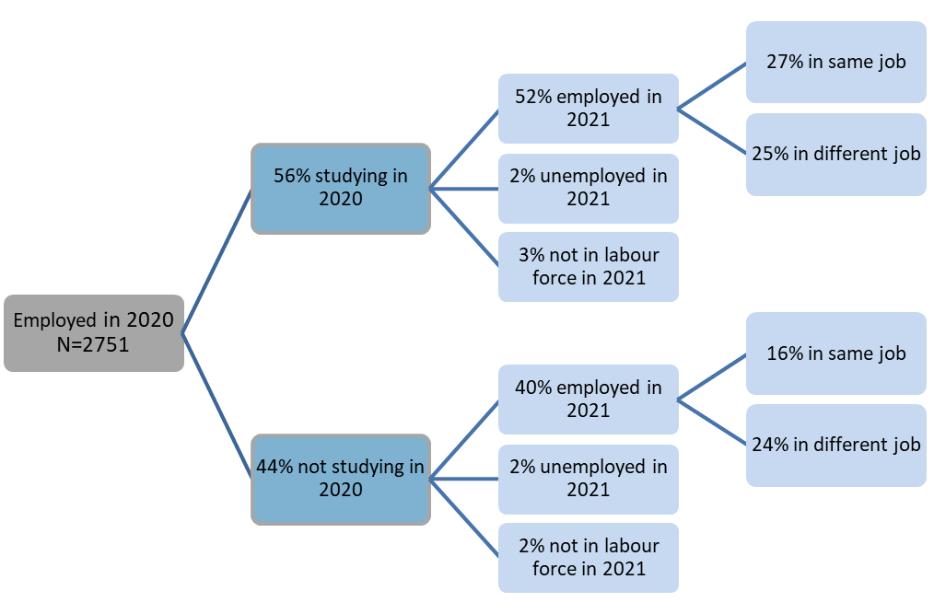
Note: The percentages in this figure do not all add to 100 percent due to rounding and a small percentage of ‘don’t know’ responses.
Seventeen percent of 2019 year 12 graduates were unemployed in 2020 and 55 percent of these graduates were studying in 2020. Figure 12 details the 2021 labour force destination for these graduates and graduates who were unemployed and not studying in 2020. Of those who were unemployed in 2020, 42 percent were studying in 2020 and employed in 2021 and 32 percent were not studying in 2020 and employed in 2021.
Figure 12: 2021 labour force status for 2019 Year 12 graduates unemployed in 2020, by 2020 study status
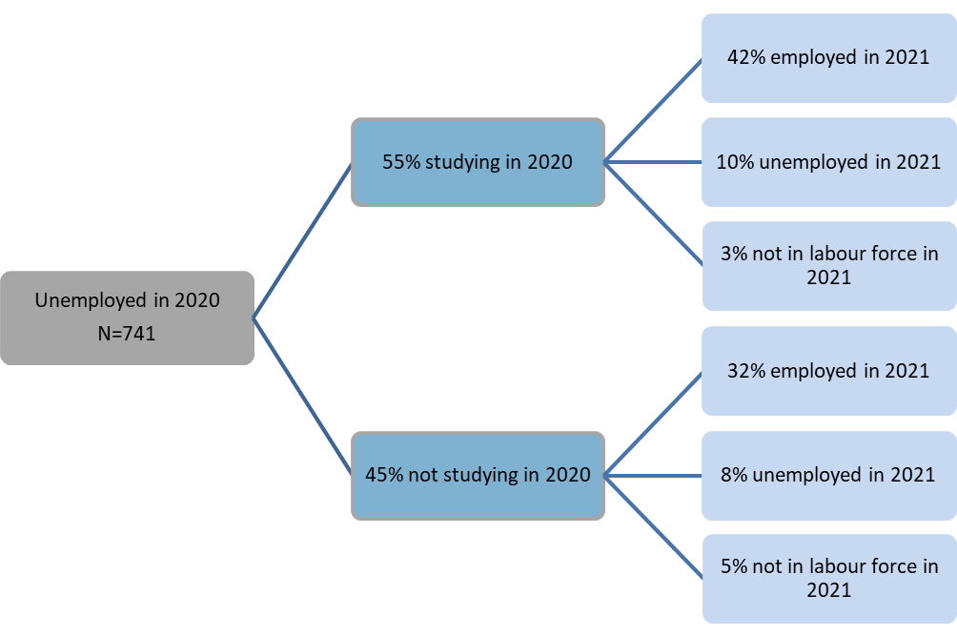
Note: The percentages in this figure do not all add to 100 percent due to rounding and a small percentage of ‘don’t know’ responses.
Eighteen percent of 2019 year 12 graduates were not in the labour force in 2020, and 69 percent of these graduates were studying in 2020. Figure 13 details the 2021 labour force destination for these graduates and graduates who were not in the labour force and not studying in 2020. Of those that were not in the labour force in 2020, 34 percent were studying in 2020 and employed in 2021 and 10 percent were not studying in 2020 and employed in 2021.
Figure 13: 2021 labour force status for 2019 Year 12 graduates not in the labour force in 2020, by 2020 study status
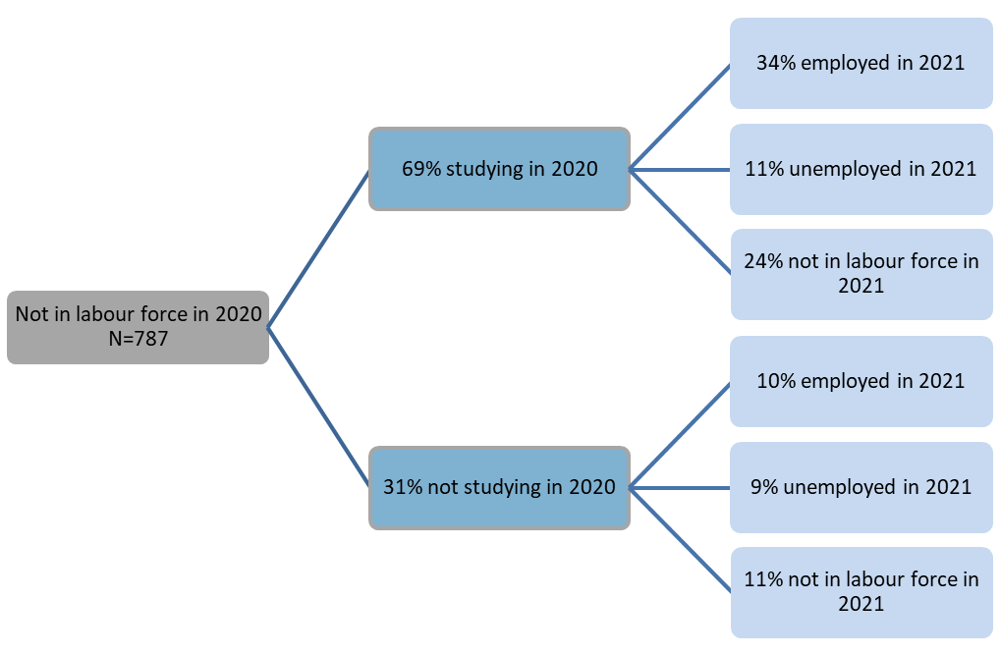
Note: The percentages in this figure do not all add to 100 percent due to rounding and a small percentage of ‘don’t know’ responses.
Sixty-nine percent of the 2019 year 12 graduates were studying in 2020. Part-time employment was the most common labour force status for these graduates in 2020 and 2021. Ninety-two percent of the 2019 year 12 graduates studying and employed in 2020 were also employed in 2021, with most continuing in either full-time or part-time employment (see Table 19 below). Of those who were studying and unemployed in 2020, 76 percent were employed in 2021 and 18 percent were unemployed.
Sixty-five percent of 2019 year 12 graduates who were studying and not in the labour force in 2020 were in the labour force in 2021.
Table 19: 2021 labour force status by 2020 labour force status for 2019 Year 12 graduates studying in 2020(%)
 |  |  | 2021
 |  |  | Employed |  |  | Unemployed | Not in labour force | Total
2020 |  |  | Part-time | Full-time | Total |  | Not in labour force | Total
Employed |  |  | 63.8 | 28.2 | 92.3 | 3.2 | 4.5 | 100.0
 | Part-time |  | 81.0 | 9.3 | 90.7 | 3.4 | 5.9 | 100.0
 | Full-time |  | 7.5 | 90.9 | 98.4 | 1.6 | 0.0 | 100.0
Unemployed |  |  | 64.8 | 10.1 | 76.0 | 18.1 | 5.9 | 100.0
Not in labour force |  |  | 45.6 | 3.6 | 49.1 | 15.7 | 35.2 | 100.0
Distribution in 2021 |  |  | 60.0 | 19.9 | 80.2 | 8.3 | 11.4 | 100.0
Note: The percentages in this table do not all add to 100 percent due to rounding and a small percentage of ‘don’t know’ responses.

Pathways of 2019 school leavers
Eighty-three percent of 2019 school leavers reported that they were employed and/or studying in 2021. Sixty-eight percent of school leavers were employed and 55 percent were studying in 2021. Overall, 2019 school leaver participation in study, employment and employment and/or study increased from 2020 to 2021 (see Table 20 below).
Table 20: 2019 school leavers employed and/or studying in 2020 and 2021 by selected demographics (%)
 |  | Employed |  |  | Currently studying |  |  | Employed and/or studying
Year of survey |  | 2020 | 2021 |  | 2020 | 2021 |  | 2020 | 2021
Gender
 | Female | 44.9 | 54.4 |  | 37.4 | 29.2 |  | 66.9 | 72.6
 | Male | 55.0 | 73.1 |  | 52.3 | 64.8 |  | 76.2 | 87.7
Year level
 | Year 9 to 11 | 44.6 | 68.3 |  | 52.6 | 54.8 |  | 68.3 | 88.8
 | Year 12 | 60.2 | 67.5 |  | 43.5 | 54.9 |  | 79.3 | 77.9
Received career counselling at school
 | No | 41.9 | 61.0 |  | 46.8 | 44.3 |  | 74.0 | 74.1
 | Yes | 64.2 | 77.9 |  | 57.3 | 66.0 |  | 81.4 | 92.0
Participated in work experience at school
 | No | 45.8 | 68.6 |  | 41.0 | 55.1 |  | 70.7 | 88.5
 | Yes | 61.7 | 66.7 |  | 58.9 | 54.5 |  | 78.0 | 75.9
All graduates |  | 52.2 | 67.9 |  | 48.2 | 54.9 |  | 73.6 | 83.5
The 2021 employment and study destinations for 2019 school leavers by their employment and study destinations in 2020 is detailed in Table 21. Eighty-six percent of the school leavers who were employed in 2020 were also employed in 2021, 82 percent of those studying in 2020 were also studying in 2021 and 93 percent of those employed and/or studying in 2020 were also employed and/or studying in 2021. Of the 2019 school leavers who were not employed or studying in 2020, 43 percent were employed in 2021 and 16 percent were studying in 2021. Forty-four percent of the school leavers who were not employed or studying in 2020 were also in this category in 2021.
Table 21: Proportion of 2019 school leavers employed and/or studying in 2021, by employed and/or studying in 2020 (%)
 | 2021 |  |  |  | Distribution in 2020
2020 | Employed | Studying | Employed and/or Studying | Not employed or studying | Distribution in 2020
Employed | 86.0 | 66.2 | 94.3 | 5.7 | 52.2
Studying | 76.3 | 81.9 | 95.9 | 4.1 | 48.2
Employed and/or Studying | 76.7 | 68.7 | 93.3 | 6.7 | 73.6
Not employed or studying | 43.3 | 16.2 | 56.2 | 43.8 | 26.4
Distribution in 2021 | 67.9 | 54.9 | 83.5 | 16.5 | 100.0
Most (82%) of the 2019 school leavers who were studying in 2020 were also studying in 2021. Ninety-six percent of the 2019 school leavers who were studying at the VET level in 2020 were also studying in 2021, with 78 percent studying at the VET level in 2n 2021. Thirty percent of the school leavers who were not studying in 2020 were studying in 2021.
In relation to the labour force status of 2019 school leavers:
- Eighty-six percent who were employed in 2020 were also employed in 2021, with most continuing in either full-time or part-time employment
- Sixty percent who were unemployed in 2020 were employed in 2021 and 35 percent were unemployed in 2021
- Sixty-eight percent of those who were not in the labour force in 2020 were in the labour force in 2021, with 42 percent in employment and 26 percent unemployed..

COVID-19 specific questions
Participants of the longitudinal survey were asked whether the COVID-19 pandemic and subsequent lockdowns had any impact on their decision to study? The majority of respondents indicated that there was no impact. The survey found that
- Sixteen percent of graduates and 24 percent of school leavers reported that they delayed study
- Five percent of graduates and 5 percent of school leavers chose to study when they originally did not intend to
- Four percent of graduates and 5 percent of school leavers commenced studies earlier than they originally intended.
Participants were asked if they were employed prior to COVID-19. Thirty-two percent of graduates and 29 percent of school leavers reported that they were employed prior to covid. Of these graduates:
- Fifty-two percent advised they had less hours than they normally do
- Thirty percent of respondents indicated that they have been stood down until the workplace repoens
- Nine percent reported that they were working more hours than they normally do.
The most common impact for school leavers was working fewer hours than previously (40 percent).
Fourteen percent of graduates and 17 percent of school leavers reported that they did not have a paid job prior to covid. Of these graduates:
- Forty-two percent reported they had fewer hours
- Thirty-seven percent reported it was difficult to find work.
The most common impact reported by school leavers was that it was difficult to find work (30 percent).

Satisfaction with life
In 2021, 2019 school leavers and year 12 graduates were asked about their anticipated satisfaction with life in five years (2024). Overall satisfaction levels were quite high when compared with current satisfaction with life reported by 2020 graduates and school leavers (on page 18 of this report). In addition, graduates reported higher level of satisfaction than school leavers. 2019 year 12 graduates and school leavers who were studying and those who were employed in 2021 were on average more likely to think they would be satisfied with their life in five years. Male school leavers seem to be more optimistic about the future than female school leavers (see Table 22).
Table 22: Proportion of 2019 school leavers and year 12 graduates that think they will be satisfied with their life as a whole in five years (2024) by gender and employment and study status.
 |  | School leavers | Year 12 Graduates
Gender
 | Female | 61.3 | 85.6
 | Male | 76.8 | 83.6
Study Status in 2021
 | Higher education | 91.7 | 86.5
 | VET course | 61.7 | 84.3
 | Not Studying | 67.7 | 80.6
Employed in 2021
 | No | 59.5 | 74.0
 | Yes | 78.3 | 87.2
All |  | 67.7 | 80.6

Scope and methodology
The annual School Leaver Survey is a survey of students in years 9 to 12 who left the ACT school system or were awarded an ACT Senior Secondary Certificate in the preceding year. This publication includes a summary of the results of the annual survey conducted in 2021.
The survey frame was drawn from administrative records held within the Directorate, Catholic Education Archdiocese of Canberra and Goulburn, member schools of the ACT Association of Independent Schools and the Board of Senior Secondary Studies (BSSS). Year 12 graduates of 2020 included those that were awarded an ACT Senior Secondary Certificate from an ACT college, school or the Canberra Institute of Technology (CIT) in 2020. School leavers of 2020 included year 9 to year 12 ACT students who were listed as attending an ACT school in the 2019 February school census but not in the 2020 census (and did not obtain an ACT Senior Secondary Certificate). The survey scope excluded full fee paying students whose usual residence was overseas and school leavers who returned to school or moved interstate or overseas prior to May 2020. The Directorate was unable to approach some school leavers due to insufficient contact details or family circumstances.
Prior to the Surveys being undertaken a primary approach letter was sent to year 12 graduates and year 12 school leavers and parents of years 9 to 11 school leavers. This provided information about its purpose and importance; the broad content of the survey, the amount of time the interview would take and confidentiality provisions. The surveys were undertaken from 21 May to 29 June 2021. Of the 4243 graduates sent a primary approach letter, 2247 completed the survey, providing a response rate of 53 percent. Of the 876 school leavers sent a primary approach letter, 314 completed the survey, providing a response rate of 36 percent.
The 2021 survey of 2019 year 12 graduates, year 10, 11 and 12 school leavers and parents of year 9 school leavers, was undertaken by telephone from 21 May to 26 June 2021. This publication includes a summary of the post-school pathways from wave 1 (conducted in 2020) and wave 2 (conducted in 2021). A total of 1184 responses were received. Of the 1833 graduates sent a primary approach letter, 1071 completed the survey, providing a response rate of 58 percent. Of the 206 school leavers sent a primary approach letter, 113 completed the survey, providing a response rate of 55 percent. The figures reported are estimates based on weighting the survey responses (and corresponding 2020 responses) to reflect the total number of 4279 graduates and 1031 school leavers. Please note, the 2021 figures reported in this publication are in some cases slightly different to the figures reported in previous report as the figures in this report are based on only those students who completed the 2020 and 2021 surveys.
Glossary
ANZSCO - Australian and New Zealand Standard Classification of Occupations is a standard used in Australia and New Zealand to classify all occupations and jobs and is designed to facilitate the organisation and comparability of occupation statistics.
ASCED - Australian Standard Classification of Education is a standard used in Australia to classify all education levels and fields of education. It is designed to facilitate the organisation and comparability of education statistics.
ATAR - Australian Tertiary Admission Rank is a percentile ranking used by universities to assist in the selection of school leavers for entry into undergraduate courses. It is used as an indication of a student’s suitability for study at university level, and to allow universities to select appropriate numbers of students for each course.
Career guidance in schools may include one on one or group discussion between students and career advisors, industry experts and representatives from universities and CIT about various aspects of student pathways planning, such as course choices, work experience and developing a resume. Prior to the 2020 survey, the term ‘career counselling’ was used to describe this set of activities.
Currently studying refers to respondents who were actively undertaking some study at the time of the survey, including those attending university, technical and further education (TAFE), undertaking an Australian apprenticeship or repeating year 12.
Engagement programs are school based programs, such as Big Picture, Connect 10 and Canberra College Cares.
Labour force status provides data on whether a graduate was employed (paid work for one hour or more over a two week period), unemployed (actively looking for paid work) or not in the labour force at the time of the survey. Labour force status was derived from responses to a number of questions in the survey.
LBOTE is used in this publication to describe graduates who speak a language other than English at home. Please note, this is slightly different from Language Background other than English (also known as LBOTE) which is used when a language other than English is spoken at home by the individual and/or one or both of their parents.
Government pensions, allowances and benefits include Austudy or ABSTUDY, Carer Allowance or Carer Payment, Disability Support Pension, Newstart Allowance, Parenting Payment, Sickness Allowance, Special Benefit and Youth Allowance.
VET - Vocational Education and Training courses are accredited vocational courses provided by a Registered Training Organisation. Successful completion usually leads to the award of a Vocational Certificate.

Workplace learning includes work experience, structured workplace learning, Australian School Based Apprenticeships and flexible learning options. Flexible learning options are short term vocational education and training programs that are provided by the Education Directorate and are delivered by a registered training organisation (RTO).
References
Australian Bureau of Statistics (2021). Education and Work, Australia, May 2019. Cat. No. 6227.0. Canberra, Australia: Australian Bureau of Statistics.
Queensland Department of Education, Training and Employment (2016). Next step longitudinal study 2013: A report on the post-school transitions of Queensland’s Year 12 completers from 2010. Queensland: State of Queensland.
Victorian Department of Education and Early Childhood Development (2010). The On Track Survey 2010 Longitudinal report: The 2007 cohort 3 years on. Victoria: State of Victoria.

Published by Education Directorate | ACT Government
220 Northbourne Avenue, Canberra City ACT 2602 | GPO Box 158, CANBERRA ACT 2601
Phone: (02) 6207 5111 Web: http://www.det.act.gov.au

