Three Tiered Approach to Health Care
In ACT Public Schools
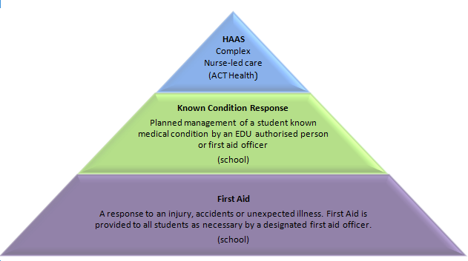

First Aid – as outlined in the Education Directorate (EDU) First Aid Policy – this applies to all students while at school.
- Is undertaken by a designated First Aid Officer
- Includes response to injury, accidents or unexpected illness.
Known Condition Response - planned management as outlined in the EDU First Aid General Procedures and Administration of Student Medication and Complex Health Care Procedures
- Is undertaken by an EDU authorised person/first aid officer.
- Includes First Aid plus following steps in the student’s EDU Known Medical Condition Response Plan. The steps may include giving medication.
- There are specific EDU plans for Diabetes, Epilepsy, Asthma and Anaphylaxis. All other conditions have a generic Known Medical Condition Response Plan.
- Students may also have routine medication requiring a Medication Authorisation and Administration Record.
- School staff/First Aid officers may take the Known Medical Condition Response Plans to the HAAS RN for consideration and advice.
HAAS - Students with complex or invasive health care needs, such as an enteral feed or tracheostomy management, are referred to the ACT Health Healthcare Access At School (HAAS) Program: HAAS@act.gov.au
HAAS will:
- Liaise with the parent and develop an individual HAAS Healthcare Plan
- Determine the level of care that is required to support safe school attendance
- Liaise with the school regarding requirements and training of Learning Support Assistants (LSAs) i.e. HAAS Workers
- Train, assess competency and provide ongoing support to school HAAS Workers
- Provide ongoing support to the school and family.
Frequently Asked Questions
For families and school staff

Why change the current system?
The Education Directorate (EDU) has a commitment to the inclusion of all students in public education. In response to increased requests from parents a new model of care was needed that gives equitable access to education for children with complex health care needs across all public schools in the ACT. This contemporary model developed through collaboration between ACT Health and EDU, is designed to meet the ongoing health care needs of all students and gives flexibility for students with complex health needs to join their peers in activities while supported by familiar trained adults.

What is Healthcare Access At School?
Healthcare Access At School (HAAS) provides nurse-led care to students with complex or invasive health care needs while they are at any ACT public school. The Registered Nurse (RN) completes an initial assessment and develops a Healthcare Plan in partnership with the parents and other health providers as needed. EDU HAAS Workers are then trained in the health tasks that are required in order for the student to safely attend school and are assessed by the RN as competent. The RN provides ongoing support to the student, school and parents and updates the healthcare plan periodically and/or as needed - such as if health requirements change.

What is different?
The Three Tiered Approach to Healthcare in ACT public schools uses a combination of RNs, First Aid Officers and HAAS Workers in a tiered approach to health care. HAAS is now available for all students requiring health support in order to attend school.

What about the Specialist Schools?
Specialist Schools now have more designated First Aid Officers (4 at each school) to respond to first aid ncidents that may arise. Students with complex and/or invasive health care needs at Specialist Schools are included in the HAAS model and an individual health care plan will be developed in consultation with their family.
Specialist Schools will have an RN assigned to their school to support staff in providing health tasks as needed. The RN will continue to be available for all parents and staff at specialist schools to discuss school related student health matters. The RN may not always be on site during the school day.

How much training and support will HAAS Workers receive?
The training provided will depend on the needs of the student receiving the care and the needs and experience of the HAAS Worker. Training is tailored to the individual care plan of the student and while some tasks may require half day training others may need two days or more. The RN will work alongside the HAAS Worker until they feel confident and competent in their new skills. HAAS RN’s will provide extra training, assistance and ongoing support as required by the HAAS Worker; for example, this could include ‘refresher’ training after a period of leave or an update in the event that the student’s requirements change. Furthermore, EDU employees carrying out HAAS functions in schools will engage in a Nationally Accredited Competency training program to support them in the role.

How do I contact HAAS?
Referrals are sent to the HAAS inbox: HAAS@act.gov.au
Parents of students at a Specialist School can contact the school reception desk who will put you through to the RN.
Students who are on the HAAS program have a communication plan developed and the contact process clearly outlined for family and school staff.

