Arts ACT-cover background.jpg



Internal AUDIT

Fact SHEET

**Document No. 00029/02 Published November 2019**

Internal AUDIT

Information AVailable to Assist directorate staff understand the internal audit process and Audit committee reporting requirements.

# An internal audit process - overview

An internal audit is conducted as follows:

* Planning the Internal Audit engagement, including developing and agreeing upon the Audit Scope;
* Submitting the Audit Scope to the Audit Sponsor (i.e., usually the Executive Director responsible for the area to be audited) for approval prior to commencement of the engagement;
* Holding an entry meeting with key stakeholders;
* Conducting the field work including conducting risk assessment and control analysis, performing testing programs, evaluating evidence, and documenting and forming conclusions;
* Conducting an exit meeting with key stakeholders to discuss the preliminary findings of the engagement;
* Preparing a draft report for management comment;
* Submitting the report with management comments to the Audit Sponsor for approval, to the Education Governance Committee for information, and to the Audit Committee for endorsement; and
* Finalisation of the Internal Audit report. 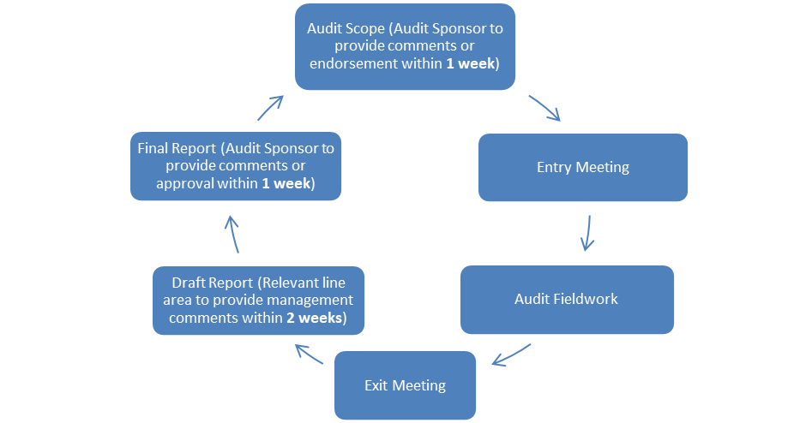

#### Audit Committee Reporting

Audit Committee reporting occurs on a quarterly basis and includes:

* current progress through the Annual Internal Audit Plan, identifying progress made;
* internal audit reports with management comments;
* implementation status of audit recommendations; and
* any other standing agenda items.

The Chief Internal Auditor is required to distribute Audit Committee meeting agenda and papers at least one week before the meeting. The Executive Branch Managers of the relevant areas within the Directorate are required to submit Audit Committee meeting papers (cleared as required by the Executive Group Managers or Deputy Director General) to the Chief Internal Auditor at least two weeks before the meeting.

# Related Policies and Documents

* Audit Committee Charter
* Internal Audit Charter
* Internal Audit Policy
* Internal Audit Procedure

# Information available to Directorate staff

For further information contact Chief Internal Auditor on telephone (02) 6207 4386.