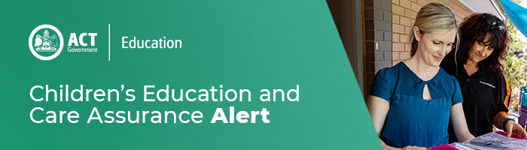
30 October 2020
Gastroenteritis in education and care services

Please see the attached ACT Health letter and resources in relation to reducing gastroenteritis in education and care services.

Education and care providers and services are encouraged to review their obligations of responding to infectious diseases set out Regulation 88 of the Education and Care Services National Regulations requires providers and services to:

- Ensure that reasonable steps are taken to prevent the spread of the infectious disease at the service.
- In an event of an infectious disease at a service the approved provider must ensure that a parent or an authorised emergency contact of each child being educated and cared for is notified of the occurrence as soon as practicable.
- Any infectious disease is notifiable to Children’s Education and Care Assurance (CECA) and ACT Health’s Communicable Disease Control Unit.

Staying Healthy: Preventing infectious diseases in early childhood education and care services (5th Edition) provides educators and all other staff working in education and care services with simple and effective methods for minimising the spread of disease.

For enquires in relation to this notification please call CECA on (02) 6207 1114 or email CECA@act.gov.au
This email has been authorised by the ACT Regulatory Authority (CECA). CECA are responsible for administering the National Quality Framework within the ACT

