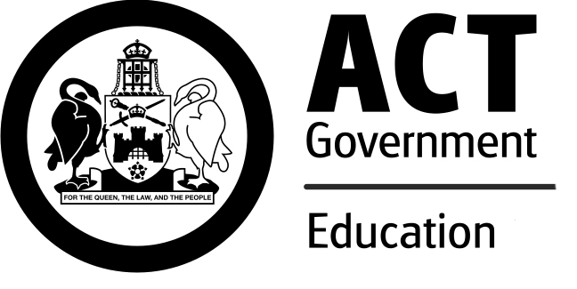
What do people think about

Canberra public schools in 2016?

Each year, the Education Directorate surveys students (years 5 to 12), parents and carers, and school staff to gauge their satisfaction with the education provided across all Canberra public schools. The online surveys ask individuals what they think about their school’s performance. In 2016, students (14,593) from years 5 to 12, parents and carers (9,475), and staff (3,428) across a range of year levels completed the survey.
Overall satisfaction with education in Canberra public schools (Table 1) was positive across all school types. The majority of students, parents and carers, and staff are satisfied their school has high expectations (Table 2).

Table 1: Overall satisfaction with public school education, 2016
 | Colleges | High schools | P - 10 schools | Primary schools | Early childhood schools | Specialist schools | All schools
Students | 83% | 77% | 73% | 85% | na | na | 79%
Parents/carers | 82% | 84% | 79% | 88% | 95% | 94% | 86%
Staff | 92% | 89% | 86% | 95% | 93% | 93% | 92%
na – not applicable

Table 2: Overall satisfaction with the high level of expectations at school, 2016
 | Colleges | High schools | P - 10 schools | Primary schools | Early childhood schools | Specialist schools | All schools
Students | 79% | 73% | 66% | 80% | na | na | 74%
Parents/carers | 81% | 80% | 73% | 83% | 93% | 93% | 82%
Staff | 86% | 86% | 81% | 94% | 90% | 92% | 89%
na – not applicable

How do we use the survey results?
Survey results from all Canberra public schools are collated to provide an indication of system-wide satisfaction levels. Satisfaction is an important measure of our stakeholders’ confidence, engagement and participation. The results inform Directorate decisions and strategies, particularly in relation to school improvement.
The school level results contribute to the school improvement process within each Canberra public school. Overall satisfaction results for each Canberra public school are reported in their annual school board report.

Further Information
Education Directorate
General Enquiries
Telephone: +61 6207 5111
Canberra Connect: 13 22 81
Website: http://www.education.act.gov.au

© Australian Capital Territory, Canberra, November 2016

