ACT Government logoArts ACT-cover background.jpg

**Table of Contents**

**STUDENT RESOURCE ALLOCATION** IN ACT   
PUBLIC SCHOOLS

Table of Contents

1. STUDENT RESOURCE ALLOCATION 3

1.1 Principles 3

1.2 SRA Statements 4

2. COMPONENTS OF SRA 4

2.1 Core Allocation 5

2.2 Loading Allocations 6

2.3 Other Allocations 8

2.4 Preschools 9

2.5 School Operational Allocation 10

### STUDENT RESOURCE ALLOCATION

The Student Resource Allocation (SRA) has been developed to reflect the ACT Government’s commitment to implement a student needs based school funding model for ACT public schools. The Directorate commenced the implementation of the SRA in 2016 to bring improvement in learning outcomes for all students. This document outlines how the elements of the SRA model work together to provide the school’s overall (global) budget.

#### 1.1 Principles

There are seven guiding principles that guide the Canberra public schools reform direction and provide a summary of the key objectives of the SRA Program, including the SRA school funding model.

*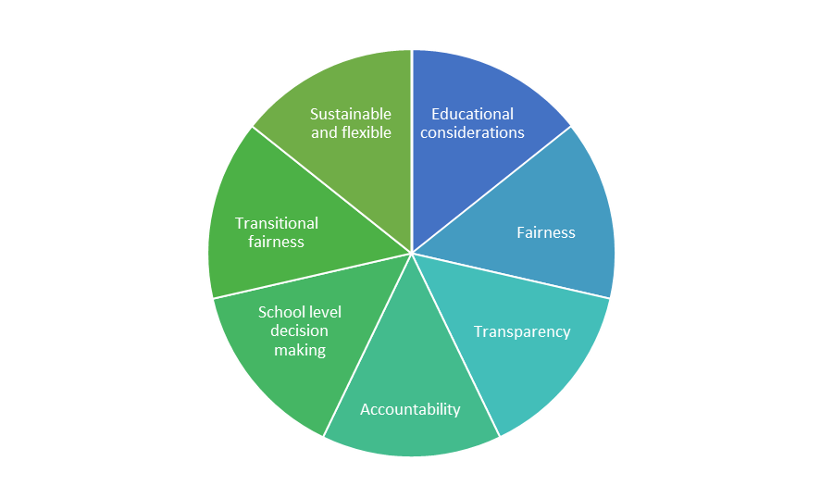Educational Considerations*

Educational considerations, based on the best evidence available, will drive the data sets, weightings, and parameters used in the design and implementation of new arrangements.

*Fairness*

Fairness will result when schools with a similar mix of learning needs receive similar funding.

*Transparency*

Transparency will ensure funding is visible and directed to support the needs of students and schools.

*Accountability*

Accountability for the resources schools receive, including articulation of the responsibilities of schools to support, and report on, student learning.

*School level decision making*

School level decision making will be enabled through clear understanding of what resources will be provided to schools and when it will be provided.

*Transitional fairness*

Transitional fairness will drive progressive implementation over several years so schools, where necessary, can adjust as the ACT moves from the old system to the new model.

*Sustainable and flexible*

Sustainable and flexible design allows for new policy priorities and changing school and student populations over time.

#### 1.2 SRA Statements

Schools receive an SRA Statement twice each year.

* In September, the **projected** allocation is provided to schools for the purposes of planning for the following year.
* In April, the **actual** allocation is provided following confirmation of student enrolments by the February Census.

In addition, schools are provided additional cash payments for professional development, international private students, support for students with disability in January, April, July and October.

### components of the sra

The following key components are reflected in each school’s SRA Statement:

#### Core Allocation

* per student funding
* stages of schooling
* base funding

#### Loading Allocations

* students with a low socio-economic status background
* students with English as an additional language or dialect
* Aboriginal Torres Strait Islander Student Support (Cultural Integrity)
* students with disability

#### Other Allocations

* Continuum of Educational Support
* Transition and career support
* Other (e.g. new school allowance; other specific allocation)

#### Preschool Allocation

* Sessions based staffing allocation

#### School Operational Allocation

* Education and administration
* Physical infrastructure & other
* Pre-school/Early childhood

In addition to the above, some school programs are centrally administered by Education Support Office.

#### 2.1 Core Allocation

The core allocation provides funding for students where minimal levels of disadvantage exist.

The core allocation includes the following funding elements:

* Per Student Funding
* Stages of Schooling weighting
* Base Funding

Schools use this allocation to configure the most effective staffing arrangements to deliver high quality educational services to all students.

#### 2.2 Loading Allocations

In addition to Core Funding, resources are provided to support the identified educational needs of particular students.

##### 2.2.1 Low Socio Economic Status

The low Socio-Economic Status (SES) needs based loading is determined by a Student Family Education and Occupation Index (SFI) specific to individual ACT public schools. The SFI uses parental education and occupation levels to determine school-level need. The low SES loading does not assign funds directly to individual students.

##### 2.2.2 English as an Additional Language or Dialect

The English as an Additional Language or Dialect (EAL/D) loading reflects the diversity of student need in English language proficiency.

The Australian Curriculum, Assessment and Reporting Authority (ACARA) EAL/D Learning Progression Continuum, describing phases of English language acquisition by EAL/D learners, is used to identify student need within the beginning, emerging and developing phases.

ACARA EAL/D Learning Progression Phases

Beginning

Emerging

Developing

Consolidating

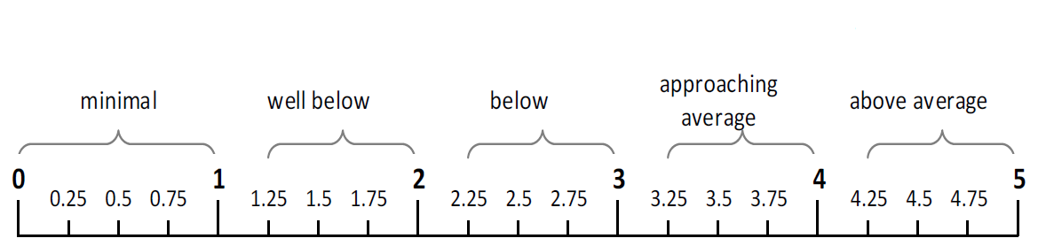

##### Aboriginal and Torres Strait Islander student support (Cultural Integrity)

The Aboriginal and Torres Strait Islander funding is allocated to all schools with the expectation that the needs and aspirations of all Aboriginal and Torres Strait Islander students will be met across the system. Developing Cultural Integrity across the Directorate is a key priority in achieving this intent.

The Directorate has developed a suite of resources to define Cultural Integrity and strengthen cultural practice within each school.

In addition, the Education Support Office will provide advice, guidance and support to schools and students through a range of programs that include:

* Aboriginal and Torres Strait Islander Education Officers (IEOs);
* Scholarships;
* Vocational Learning Options; and
* Professional Learning.

##### Students with Disability

The policy framework and funding allocation for Students with Disability Support is currently under review. Resources allocated to schools will continue under the current process and methodology:

* + Disability Education Programs
  + Schools resourcing based on settings and individual student need as identified by the Student Centered Appraisal of Need (the Appraisal or SCAN).

Information on the Appraisal process is available on the Disability Education webpage ([www.education.act.gov.au/school_education/disability_education](http://www.education.act.gov.au/school_education/disability_education)).

#### 2.3 Other Allocations

##### 2.3.1 Continuum of Educational Support

For the 2018 school year, an allocation is provided to each high school to develop and implement the Continuum of Educational Supports model in the school.

The continuum of support identifies engagement strategies within five key areas:

* transitions
* five core elements
* early interventions
* flexible learning provisions
* outreach and alternative education provision.

##### 2.3.2 Transition and Careers Support

This program provides a career and transition service to meets the need of senior secondary students. The funding is allocated to Colleges to provide high quality, professional transitions and careers support for all students.

This resource provides transitions and careers support to high schools and primary schools through Transition Network Groups.

##### 2.3.3 Other

Further allocations relate to:

* New school allowance: supports the principal to establish a base administration and leadership team in the first three years of a new school’s development
* Student Support and School Equity programs: funding is provided to schools to support disadvantage students and those that experience complex social issues.

#### 2.4 Preschools

Funding is provided to preschools to deliver 15 hours of educational services to four year old students in ACT public schools. The 15 hours include three hours of funding from the Australian Government.

Preschools are funded by session rather than enrolment numbers or other measures. School Improvement branch assists schools in planning optimal numbers of sessions for each school.

#### 2.5 School Operational Allocation

The Schools Operational Allocation (SOA) provides cash funding for school operations – other than staffing. The funding is for educational and school administration costs, including energy, water and sewerage, cleaning and minor maintenance.

**Contact:**

Director: Strategic Finance

Senior Manager: Schools Resourcing & Finance