Early Childhood Strategy
Consultation Sessions: Final Report

Feedback on early childhood education and care in the ACT May 2019

Prepared by Shae Lalor, Director, The Write Path

Table of contents

About the consultations 4
Consultation themes 5
About this report 5
What we heard: a summary 6
Support for the strategy 6
General discussion points 8
Equitable access 8
Child-first 9
Workforce recognition and professionalisation of wages and conditions 9
Engaging the community 10
Transitions 10
Examples of what is working well 11
Theme 1: Improving access, equity and affordability 14
Hours 14
Funding for government versus non-government providers, and the costs to families 14
Locations 15
Enrolment processes and age cut-off 16
How to reach people experiencing the most disadvantage 16
Cultural awareness and inclusivity 17
Barriers to universal access 18
Theme 2: Valuing the workforce and their qualifications 20
Quality and availability of staff 20
Inconsistencies for degree-trained educators 21
Ongoing professional development 22
Community liaison role 23
Promoting the value of early childhood education 24
Theme 3: Supporting transitions to school 25
Face-to-face communication 25
Transition statement 25
Child-first approach 26
Theme 4: Maximising benefits to children 28
What do the children want? 28
Infrastructure and programming 30
Early support opportunities 31
Wraparound care 32
Parental education and community involvement 33
Promoting the value of early years education 34
Integrated and connected support 34
Funding for support 35
Appendix A: Participating organisations 37
Schools, preschools, ELCs, long day care centres, OSHC operators, playschools 37
Peak bodies and advocacy groups 37
Other organisations and groups 38
Appendix B: Consultation methodology 39
Example script for consultation sessions 40

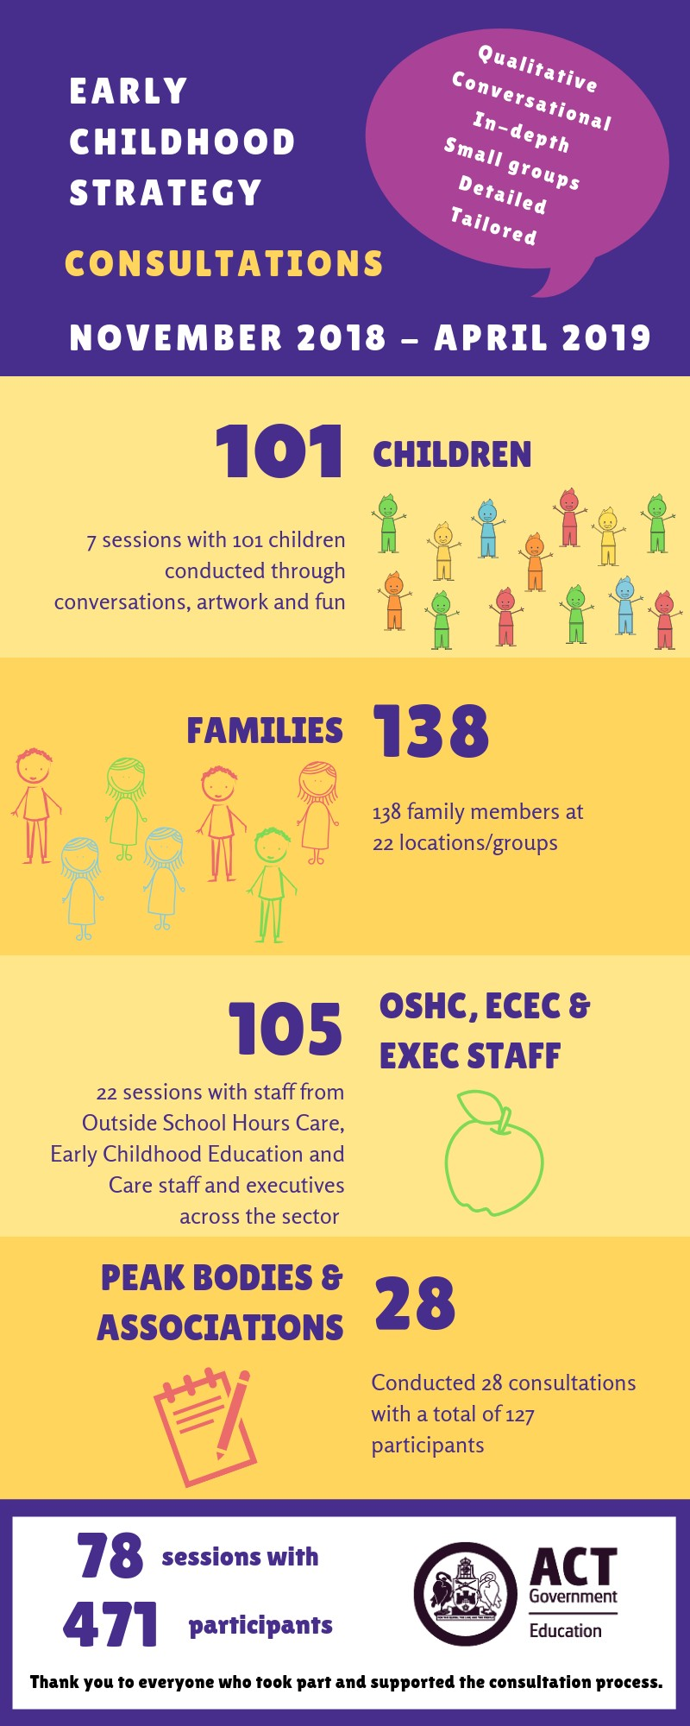
About the consultations
The ACT Government is developing an Early Childhood Strategy for the ACT, which aims to enable every child to participate in quality early childhood education and care prior to them starting formal schooling.
The ACT Education Directorate held targeted consultation sessions to seek input from children, families, educators and the wider community on specific themes related to the ACT Early Childhood Strategy.
Sessions were held during:
- November and December 2018 (phase one)
- January and February 2019 (phase two)
- March and early April 2019 (phase three).
More than 50 organisations participated in the targeted consultations, including:
- government and non-government preschool and other teachers, executives, families and children
- long day care, playschool, early learning centre (ELC) and outside school hours care (OSHC) operators, educators, families and children
- peak body, advocacy group and association representatives
- university staff
- parents participating in playgroups or community groups.
A list of participating organisations is included at Appendix A.
Organisations and individuals were also invited to provide input to the consultation in writing via the YourSay platform and direct email. This option closed on 29 March 2019. Ten written submissions were received.

Consultation themes
The consultations, which focused specifically on early childhood education and care, and the phased- in provision of 600 hours per year of free education for three-year-olds, covered four main themes for the development of the ACT Early Childhood Strategy:
- Increasing access, equity and affordability
- Enhancing workforce and qualifications
- Ensuring seamless transitions from education and care to school
- Maximising benefits to children.
An overview of the consultation methodology is included at Appendix B.

About this report
This report provides an overview of the themes covered by participants during the consultations. It also captures themes from written submissions.
It is a summary of the feedback, with some direct quotes to further explain the theme. No quotes have been attributed to individuals.
It reflects the opinions of individuals, noting that the feedback captured may not be factually correct.
Note, the term ‘educator’ has been used to capture any educator in the sector (including degree- qualified teachers, diploma-qualified or certificate-qualified educators).
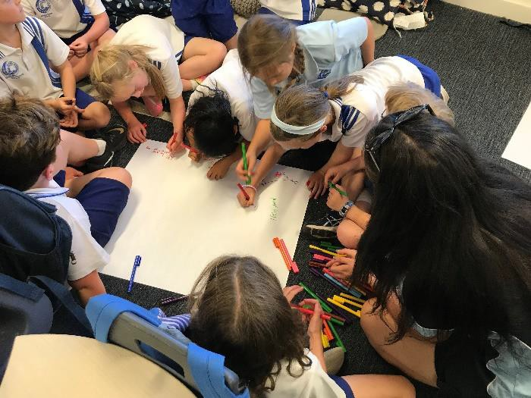
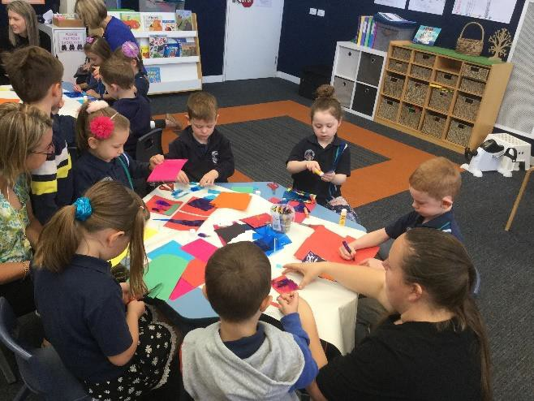
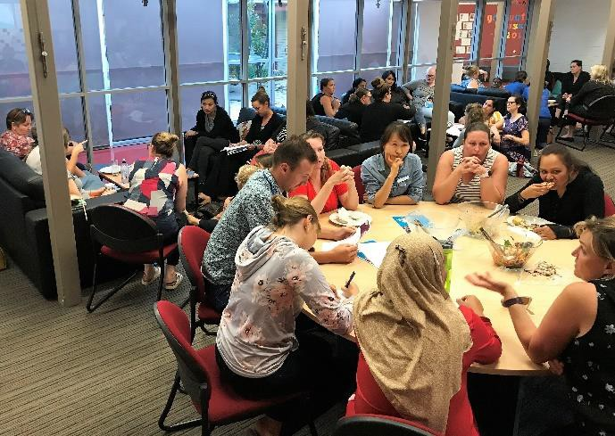

What we heard: a summary
Overwhelmingly, those consulted were supportive of the educational and social benefits of offering children access to free quality early education from the age of three.
Many participants in the consultations also welcomed a longer-term, strategic and collaborative approach to early childhood education and care in the ACT.
Participants noted that when quality early childhood education and care is working well:
- educators are passionate and supported by a strong leader
- the service is proactively engaged with the community
- a community liaison officer (or social worker) is employed to support families and educators
- relationships are built on trust
- people actively communicate and collaborate with each other
- support is given to families when and where they need it.

Support for the strategy
The opportunity to contribute to the development of an ACT Early Childhood Strategy was gratefully acknowledged by many participants. Many commented that a more cohesive and collaborative effort to deliver early childhood education and care in the ACT will benefit children, families and educators. Across various sectors, participants reflected on the importance of offering children in their early years a stable, safe environment to ensure their long-term wellbeing and development.
Many noted that if the strategy can deliver an equitable and affordable approach to early childhood education and care, then this will enhance life outcomes for children, especially those who are experiencing vulnerability or disadvantage. This could result in improved mental health and fewer supports required in the future.
The majority of participants were enthusiastic about a universal access model for three-year-olds, so all children have the opportunity to socialise, connect to their community, feel safe, establish routines, and build their confidence. All those consulted expected the model to be play-based with a focus on the needs of the children.
Participants consistently supported the strategy intent to maximise benefits for children through flexible and cooperative partnerships within communities and appropriate sharing of information – between educators, with families, and with other community service providers already linked to people experiencing disadvantage.
Across consultations with Catholic Education schools, independent schools, and not-for-profit early childhood education and care service providers, the majority were supportive of a collaborative ACT Early Childhood Strategy, with many praising the initiative.
Participants hoped the strategy would encourage society to recognise and value the educational benefits of universal access to a quality program, and therefore, the value the educator workforce contributes in providing this essential education and care to children.
“A free 3-year-old education service is paramount.” (Parent)
“I applaud the government for taking the step.” (Tertiary educator)

“The evidence is really clear that two years of quality education and care does makes a huge difference for kids. There’s a number of longitudinal studies … one in the United States quite a few years ago, the children received two years of quality education and care and now those kids have grown up and they’re in their late 20s early 30s now. So what they’re seeing is people are more likely to go onto further education, less likely to be involved with drugs, less likely to be incarcerated; they’re more likely to own their own home … those people have started to
have their own kids and they’re seeing the families are more likely to eat together and they’re more likely to read to their kids … it effects intergenerational change.” (Educator)
“Respectful relationships start at this young age … it will frame them for life.” (Parent)
“We know we've got quality four-year-old programs. Now that we're going to introduce quality three-year-old programs, to consider that we have a preschool sector. Then we will have a
structure that supports quality programs and leadership.” (Association representative)
“As a concept I’m so pleased to hear we’re going back there. It is hugely positive, not only that these vulnerable families are getting engaged in quality early intervention, but we have families, historically, whose only reason for engaging with services was because they understood there was an option for a 3-year-old program and they really wanted their child in
… that was our way in; we’ve lost that way in.” (Child and Family Centre staff) “I’m all for three-year-old preschool and not-for-profits.” (Tertiary educator)
“We’re helping the parents to shape the children. They’re asking us how we’re doing things and they’re learning how to help with their children’s development.” (Educator)
“Overwhelmingly, people see benefits. We know the research backs up the case that socially, educationally, academically, cognitively … the case is made. It’s more the question of how the implementation will happen within the government preschool system.” (Union representative)
“We’re changing societal attitudes [about things such as sustainability] and it starts at early childhood.” (Education Directorate staff)
“In principle the preschool program for three-year-old initiative is fantastic … it provides another whole different and good option for families and helps children going into an [age] four program. It’s a really positive thing for early childhood education in the ACT to recognise how important it is to have that teacher-qualified education, which I think, despite the problems,
helps with the implementation and later on.” (Tertiary educator)
“We have great respect for the government preschools and the quality of provisions they provide. We think we do something really special and the more we can collaborate in the interest of families and children, the better off the community will be.” (Catholic educator)
“The first five years are so significant in terms of those neurological pathways. Children should being doing activities from when they are babies.” (Association representative)
“We take some assurance from the Minister’s very strong view that there needs to be ethical provision and strong links between these three-year-old facilities and four-year-old government preschools, because that transition is incredibly important.” (Union representative)
“I wish more people would know about early childhood in general; the benefits, the evidence is there now – it’s just getting it out there more.” (Tertiary educator)
“In any dialogue that comes out … is the benefit of early years learning, trying to get the pendulum to swing back to the value and the importance of exposure for young children to learning environments, not the value of getting the parent back into the workforce.” (Association representative)

General discussion points

Improving access, equity and affordability

- Hours
- Funding for government versus non-government providers, and the costs to families
- Locations
- Enrolment processes and age cut-off
- How to reach people experiencing the most disadvantage
- Cultural awareness and inclusivity
- Barriers to universal access

Valuing the workforce and their qualifications
  - Quality and availability of staff
  - Inconsistencies for degree-trained educators
  - Ongoing professional development
  - Community liaison role
  - Promoting the value of early childhood education

Supporting transitions to school

  - Face-to-face communication
  - Transition statement
  - Child-first approach

Maximising benefits to children
    - What do the children want?
    - Infrastructure and programming
    - Early support opportunities
    - Wraparound care
    - Parental education and community involvement
    - Promoting the value of early years education
    - Integrated and connected support
    - Funding for support

Equitable access
Given the range of early childhood education and care offerings across Canberra, including long day care, early learning centres (ELCs), family day care, preschool for four-year-olds (within government, independent and Catholic education schools), playschools and other independently run programs, concerns were raised about how the three-year-old program will be run.
Participants raised specific operational concerns about how the hours would be made available, the locations it would be offered, the quality and availability of staff, the need for parent choice, infrastructure and programming considerations, and enrolment ages.
“It needs to extend to long day care. My children are at a long day care centre that offers a great preschool program. It doesn’t make any sense that I should have to put my children in
two different centres to receive the benefit, when the children would do just as well in the one centre. In fact, children would do better, as they are already comfortable in their centre and

would not need to learn multiple routines for multiple centres, or develop multiple carer relationships, and so on.” (Parent)

The concept of meeting the needs of children experiencing vulnerability or disadvantage through equitable access was supported by many participants. However, many commented that it is vital to minimise any stigma associated with targeting this group, make links to people through existing trusted community relationships, and to support the workforce to manage potential child issues associated with trauma or disability. Many participants also commented on the difficult processes associated with applying for and getting inclusion support for children, which puts extra pressure on educators and families.
“To allow that child to reach their full potential, then we have to expose them to lifestyles different to the family they’re exposed to if that’s all they know and all they see.” (Advocacy group representative)

Child-first
Many participants were concerned about society’s focus on ‘childcare’ rather than ‘child education and care’. Almost every session included a comment that there is still a perception of operators in a long day care setting being seen as babysitters. Many felt the narrative should change to promote the value of quality early childhood education and care in the ACT, and across the nation.
Many of those consulted were adamant that play-based learning was an imperative focus for this age group. Parents and the broader community need continual education about the benefits of this approach. Similarly, educators need to be able to work flexibly to respond to the particular needs of children in their care.
Some expressed that the system is not designed around the needs of children or families, but rather what the system can deliver. To ensure an integrated and connected and effective Early Childhood Strategy, participants strongly advocated for the role of parental education and community engagement. Parents, as a child’s first educator, still require more assistance and guidance in parenting skills and in navigating the range of education and care services and processes available in the ACT.
Participants also commented on the cross-government communication required to reduce siloing, duplication and confusion for families, especially those experiencing vulnerability or disadvantage.
“It’s one element in that whole suite of things that we need to have available for families in order to get the best outcomes for kids.” (Peak body representative)
“We are concerned about the downward pressure that we are experiencing of formalising learning and teaching too early, such as phonics and the teaching of writing.” (Union representative)
“There is a need for a flexible response tailored to the needs and wants of the diverse families within the ACT. For some this looks like structured learning, for others the response should be more informally offered and delivered.” (Peak body written submission)

Workforce recognition and professionalisation of wages and conditions
Those consulted were widely supportive of the important role educators play in a child’s early years. However, the inconsistencies in degrees, diplomas and certificate training, as well as Teacher Quality Institute (TQI) registration, creates a disjointed workforce. Moreover, the huge disparity in pay

between those working in long day care and OSHC settings compared to preschools or ELCs is cause for significant turnover across the sector.
In some consultation sessions, participants noted that ratios still make it difficult to provide the best quality care given the increasing needs of children (for example, due to anxiety, depression, trauma and diagnoses of ADHD) and time-poor parents.
Ongoing professional training and development was also considered a necessity to help manage this crucial opportunity for early support. With the diversity of children, the workforce needs expertise to recognise issues, communicate in culturally appropriate ways with families, and to engage support when needed.
“A big part of what we do is the care factor and quite often it’s what these children need the most: the care factor and that consistency and that nurture that may not be happening at home.” (Educator)
“The diversity of pay and conditions experienced across the sector by not-for-profit providers is considerable. This diversity creates inequity and division across the sector and results in services being unable to attract staff to meet children’s needs. The ACT Government could solve this inequity by linking recurrent funding to the provision of qualified teachers and establishing equitable conditions.” (Catholic Education written submission)

Engaging the community
A strong theme from the consultations was the need to link into existing relationships between families and trusted service providers. It was also suggested that every school employ a community coordinator and potentially a social worker to manage outreach and community service connection. This in turn would allow educators to focus on educating, and on communicating with families in the way that is flexible and responsive.
Many participants suggested outreach activities would help reach vulnerable children and families, if done in consultation with ACT Government directorates such as Health and Community Services, and those already linked with the community, such as Winnunga Nimmityjah Aboriginal Health Service.
“A community hub is much more than just putting a lot of different services in a building – you have to work collaboratively … and to ensure professional learning teams involve everyone.” (Educator)
“You need a role that actually is helping to make those linkages between schools and families and communities … but you also need someone – where a child is exhibiting quite extreme behaviours – who these teachers can consult with. [A community engagement role] can’t do all these things.” (Staff, Child and Family Centre)
“The real solution here is a government and community commitment to supporting parents and families as the key educators in the early years, that works hand-in-hand with enhancements to early childhood care and education.” (Peak body written submission)

Transitions
Participants commented that a good transition between services or year groups involves plenty of time for adjustment, as well as strong communication between educators, parents and children. While many were supportive of a simple transition statement and process across all early childhood education and care operations, most still felt that face-to-face, proactive communication was the best way to support smooth transitions.

In addition, many commented that children should have a voice within their own transition plan.
“The fact that we’re in the same building, I can go and talk to their kindergarten teacher (about behaviours of concern for a handover). We also do transition statements similar to summative assessment which is sent onto the school. We can share that information (and we tell the
parents too).” (Long day care educator)

Examples of what is working well
Almost all participants noted that strong face-to-face communication between educators and families, as well as collaborative relationships between service providers, were at the heart of a positive operation of a service. These approaches were also noted to help with transitions.
Examples given by participants of when this works for the benefit of families and children are:
- Co-located services, offering wraparound services to support families (for example, a maternal and child health (MACH) nurse, community playgroups, long day care service, early childhood school and OSHC all within one location).
- Offering a community hub for families at school – especially families experiencing vulnerability – where leaders and staff have built a sense of community and all families are welcome; where there is no ‘wrong door’ and everyone can get support when they need it.
- Community support workers or coordinators within schools to provide an essential link and support for teachers and families – for referrals to community services, to build partnerships and to meet specific community interests/needs.
- Making links to families through trusted services or existing relationships (such as Winnunga Nimmityjah Aboriginal Health Service).
- Three-year-old playschool or playgroup within a school environment, supported by a preschool teacher, ideally offered more than one morning per week.
“The peer support potential of playgroups can reduce isolation, identify depression, provide parenting role-modelling, give advice on businesses and services and offer referrals to government and community services.” (Peak body written submission)

A well-executed wraparound model is shown at Canberra’s early childhood schools, where the range of services available to the community can include:
- preschool readiness program – includes special visitors (dietitian, speech pathologist, occupational therapist) and discussions about toilet training
- circle of security (for school families first; then open to inner south – co-facilitated with a community service provider)
- community breakfasts
- kitchen (as part of early childhood education and care)
- bush school (to grow resilience and confidence)
- nutrition workshops
- community services available one day a week at the school
- music therapy in the classroom and Move and Groove
- MACH nurses from ACT Health – twice a week appointments
- new parents playgroup (in library)
- outside of hours school care
- onsite early childhood education and care operation
- a dedicated community coordinator.

The Catholic Education system’s strong links between their ELCs and primary schools was evident, particularly given their close physical proximity and shared spaces/staffing for OSHC. The ELCs focus heavily on regular and varied communication with families throughout the year and in preparation for transitions, including:
- Dojo app platform
- newsletter fortnightly (director)
- weekly newsletters (teachers)
- a fortnight in review
- notes in file boxes
- schoolbag app
- information evening
- welcome barbecue
- parent management committee
- events for fundraising
- face-to-face.

Other ACT programs that were noted to work well were:
- Prep for pre trial program, as a good starting point for parents (to allay fears) and children (who may have never been away from their parents).
- Playschool, particularly for children with particular needs (such as anxiety), though both parents and educators noted the importance of parental involvement in this model.
- Koori Preschool, though there are waiting lists and additional transition points as they’re not
typically co-located with a school.
- Early Learning Centres, which are co-located with schools, though these can be expensive for families and have limits on numbers.
- CCCares, offering education for young people who are pregnant or have children with wraparound services and supports, including transport.
- Child and Family Centres, though the most vulnerable may not engage and there are not enough centres across the ACT.
- Online platforms (such as Storypark, Seesaw or Dojo) for sharing information about children with families (particularly where different services are using the same platform).
- whatworksforkids.org.au platform set up by the Australian Research Alliance for Children and Youth (ARACY) – a repository of evidence-based programs for children and youth.
“For those early years, a model like this – a small school, lots of different services – makes transitioning easier.” (Parent)
“There is more freedom in this setting to explore those more alternative options, that’s partly down to leadership, but also down to how an early childhood school embraces play and enquiry, and how even our community looks at what we do [compared to a traditional school].” (Educator)
“The early intervention preschools are a perfect example of what worked.” (Long day care educator)
“The biggest barrier is the fact that we have little to no control over all those other services [for children and families]; wouldn’t it be great if we were a truly integrated model and we were offering that spectrum of services from birth.” (Educator)

“Storypark is a huge timesaver and a really good way of collecting data on our kids, it’s really authentic … it’s not making them fit a diagnostic test and then rewinding it – it’s exactly where they’re at.” (Educator)
“One half of the week we have a preschool, and the other half of the week, we have a playgroup predominantly for three-year-olds who are coming to preschool next year. I’ve found that I’ve handed out a lot of drop-in forms. I’ve also found that it’s built on word of mouth of people knowing other people in the community that might need it for various reasons. And if people are seeking support within the community, they let them know about the playgroup, and the parents stay.” (Educator)

The consultations provided many valuable suggestions for the ACT Early Childhood Strategy. The themes of discussion are explained in more detail in the remainder of the report.

Theme 1: Improving access, equity and affordability
Overwhelmingly, those consulted were supportive of the educational and social benefits of offering children access to free quality early education from the age of three. Many reflected on the importance of offering children this age a stable, safe environment, particularly for those children without stability at home.
Participants were clear that it should be a play-based model, with socialisation, early support and community connections at the core. For migrant and refugee advocates, they felt an earlier start in preschool would offer exposure to the routine within the Australian school environment, and improve child confidence, independence, general knowledge, while also helping the broader family unit adjust.
Families commented that it should be their choice as to where they send their child in the early years, yet everyone should still have access to quality education and care.

Hours
Many parents and educators noted that the current government preschool program hours (for four- year-olds) are difficult to manage within a typical work day or work week. For instance:
- Preschool programs that operate two days one week and three days the next pose an issue for families who pay for early childhood education and care on that alternate week. Some children won’t attend preschool on that extra day given the cost outlay for long day care (and risk of losing a spot).
- Preschool programs that only operate within school hours need co-located OSHC for those parents working full-time.
- Full days for children at the age of three can be exhausting. However, half-day playschool or government preschool (to 1.30pm) is difficult to manage for working families, though some noted these shorter hours would be better for children in general, and would suit families with only one parent working.
- Some long day care operations offer 10+ hour days, so the method for incorporating 15 hours a week of free three-year-old preschool would require some consideration within this setting.
- Many long day care operations are open 51 weeks of the year, while ELCs operate on a school calendar, giving parents the option to keep their younger children home for the school holidays, and therefore save money for those weeks. At long day care, parents would still be paying for the school holiday weeks.
“Even three days for a three-year-old is quite intense … putting four-year-old preschool to three days as opposed to a five day fortnight would be a lot easier for families.” (ELC educator)

Funding for government versus non-government providers, and the costs to families
Participants questioned whether funding for the three-year-old program would only be available to government schools, or if independent and Catholic schools, as well as other operators, would also receive funding. This question also led participants to question if universal funding would logically then be offered for a four-year-old program.
Various participants from the independent school sector, as well as other operators and families within the long day care sector, commented that a ‘sector blind’ approach would help address family choice, by ensuring they can access the 600 hours of universal access, no matter where they choose to send their child.

Cost was noted by many participants as a dissuading factor for getting children into quality early education and care. Some felt that the system for subsidies was more focused on enabling parents to work rather than on enabling children to receive a quality early education. For instance, stay-at-home parents are less likely to be able to access any subsidy.
There were also queries about whether the three-year-old program would be applicable for families applying for subsidies and other government supports.
Some parents attending the Child and Family Centre groups noted cost is prohibitive to having their children attend early education and care, even though they felt their child was ready to attend.
“The opportunity for a sector blind approach of government support for the provision of early years education for three and four year olds, meeting the needs of all students across the ACT should be the priority.” (Association written submission)
“Why create a government-funded initiative such as the three-year-old preschool instead of injecting that money into those support services, into what is already quality care for three- year-olds in existing childcare centres? Why not spend it there where those children are already accessing those services instead of creating something new?” (Educator)

Locations
Participants noted that if preschool programs weren’t co-located with other services, including schools, this could make it difficult for families to manage transport arrangements (particularly for families with multiple children of different ages).
Schools also offer an opportunity for early connection to the education system, though some educators noted space would be an issue.
Some parents from an Early Childhood School (up to Year 2) noted that when older children move to a different school, they also move their younger child/ren for convenience or to manage zoning issues.
For many families, including families experiencing disadvantage or those with disability, it was frequently noted that transport is a significant barrier, particularly if a program is not available at every local school.
“Personally, my concern is that what we do here now would have to change. I worry that the Directorate would say ‘we love your premises and playground so we’ll pop a three-year-old preschool here’.” (Playschool educator)
“There is no Koori Pre available in Weston Creek and the closest one [to that parent’s home] has a Koori Pre which closes at 1.30pm and another one doesn’t have any spaces.” (Parent)
“Early childhood schools should be working really well but you’ll still get people deciding to not
stay to Year 2 because they are worried about whether their child will get into that place in
primary school.” (Association member)
“Because we get children from all over the place and they go to lots of different preschools it makes it a lot harder. If we were partnered with one preschool, that would make it easier for the teachers to come here and spend time with us.” (Playschool educator)

Enrolment processes and age cut-off
Participants noted that the timing for the age of enrolment will need to be considered given some children may only have just turned three, which impacts on their stage of toilet training and ability to independently feed themselves.
This has a significant impact both on infrastructure needs (i.e. nappy changing stations) and staffing (i.e. primary-trained educators may not have experience with the specific needs of younger children).
Toilet training was a significant issue noted across most consultations, mainly because the expectations were different between services, and this created confusion for parents. Some parents were told they could not enrol their child into preschool because the child was not toilet trained.
There were differing levels of support (and willingness to accept un-toilet trained children) offered by services to assist parents.
Other enrolment issues raised included:
- preschool is not identified under the Education Act (for zoning)
- information collected should be shared with relevant parties, with permission (i.e. carer status)
- current long day care or other care arrangements should be captured on the enrolment form to assist with transitions.
Many families (from a range of backgrounds) noted that they felt confused by the process for enrolment in preschool and school, and unsupported in knowing what options were available to them in their local area. There was a sense that they needed to work it out on their own, and this created stress for families. Families and association members noted that some schools and centres were more willing to provide support than others.
“The online enrolment is a significant barrier to those accessing [four-year-old preschool] now. Those people do need to be able to walk in, have support to fill in the paperwork.” (Peak body representative)
“Even for families who live across the road [from the school] … because they got their preschool application in so late, they have to go to another suburb.” (Association member)

How to reach people experiencing the most disadvantage
Participants noted that engaging the most vulnerable families would require a different approach to usual communication tactics. Similarly, engaging families from culturally and linguistically diverse (CALD) backgrounds requires new methods of engagement.
For instance, educators and staff noted that vulnerable families are less likely to respond to a pamphlet, email or referral. They are less likely to proactively enrol their child in a three-year-old
program. Instead, a personal ‘case support’ approach could be considered for vulnerable families, by tapping into existing points of connection (i.e. community services, health).
However, families who were experiencing vulnerability or disadvantage did not want to be singled-out and face the stigma of having their child attend the first three-year-old preschool program. It is important that they and their child are treated the same as everyone else.
Educators in particular raised concerns about bringing all vulnerable children together in one program given:

- children need all sorts of models to learn and grow
- this doesn’t offer diversity
- it risks becoming a deficit model
- there will likely be higher levels of one-on-one support required, putting extra pressure on educators.
Some suggested that equity scholarships could be offered through a partnership arrangement with community early childhood education and care providers, or grants be provided to services to implement innovative programs that improve access to early education for children experiencing disadvantage.
Overall, it was suggested that families be engaged early – and via a range of methods – to ensure they enrol their children in preschool.
The Blue Book (through the Health Directorate) is still important and used, so offers an excellent potential resource to better promote quality early education and care, identify potential issues early, as well as create awareness of available ACT services and support.
“I just can’t see how you would do your targeting in a non-stigmatising way if you were just to offer it to vulnerable families first.” (Peak body representative)
“Soft entry, like through playgroups, supported playgroups and so on, helps people recognise their bad experience doesn’t have to be passed on.” (Association member)
“Unless the MACH nurses bring them to us, we don’t see them. No one sees them until day one of preschool when they turn up unannounced, or day one of kindergarten. It really comes down to a partnership with Health – accessing those vulnerable families in the 18 month, 2-year-old and 3-year-old immunisation stages.” (Staff, Child and Family Centre)
“A lot of settings might hold a meet and greet or a teddy bear’s picnic, but it needs to be a lot more personal than that. Time needs to be given … to meet that family one-on-one.” (Association member)
“Community service members working with young families suggest that families are more likely to fully engage with early childhood education where they feel respected in a warm, welcoming environment, and where they can build authentic relationships with educators and other families.” (Peak body written submission)
“A key population group that we identified as needing to be specifically considered was families who are disengaged or vulnerable to disengagement, and who have had contact with the justice system or are at risk of that. When we go on the Child and Families Centre ACT website, it actually uses the words ‘early intervention’ and ‘psychologists’. For people who have had poor interactions with various government systems, that's very scary, intimidating, unattractive language.” (Peak body representative)

Cultural awareness and inclusivity
Participants from CALD and Aboriginal and Torres Strait Islander backgrounds, as well as community services, noted that educators need to recognise:

- the impact of diverse family setups (such as multigenerational) across cultures
- some families from other cultures provide early childhood education at home or via their own cultural links
- the transient nature of the ACT and the potential lack of family support available to families

- informal education connections need to be made in the community
- there are families living in apartments with limited connections to community
- some parents are concerned about mandatory reporting
- some parents have their own difficult histories associated with schooling.
Some participants mentioned there should be greater co-design of services to engage the relevant communities, and that there should be greater representation in the workforce of CALD and Aboriginal and Torres Strait Islander educators. Cultural inclusion and cultural safety can’t just be tokenistic. It has to be an accurate representation of culture and not just on one week of the year.

“In working with Aboriginal and Torres Strait Islander communities, it's really good for services to actually be seen in the community when they don't have to be; turning up to the Christmas party, being part of the Sorry Day walk, going out to picnics up at Boomanulla Oval.” (Peak body representative)
“Migrants come to Australia for a better life, and they have come from countries where an education is really valued, so if education can be given earlier, that’s better.” (Peak body representative)
“This is where cultural difference often becomes a sticking point. For example, families from south-east Asia and many other countries; it’s a very didactic approach to learning. You ROTE learn and it’s all about memory and reciting back again. We’ve got to really drive home that play-based message, and why.” (Educator)
“Particularly for Aboriginal and/or Torres Strait Islander children, children from culturally and linguistically diverse (CALD) communities, and children with a disability, quality education should recognise and respond to their diverse needs.” (Peak body written submission)

Barriers to universal access
Participants noted there are some broader issues impacting on people’s ability to access the services and supports they need in the current early childhood education and care system, which may also impact the roll-out of the three-year-old program. These barriers include:

- availability of support services when a referral is made (for example, to get speech therapy)
- National Disability Insurance Scheme (NDIS) waiting times and complexity in navigating the system
- early enrolment times for schooling (May is considered too early), a lack of flexibility in how families can enrol (i.e. options other than online are required), and a general lack of knowledge/awareness of the enrolment process
- a lack of childcare benefits/subsidies for stay-at-home parents
- a general lack of trust about dealing with government services
- knowing what Centrelink benefits are applicable, and working through the forms
- being able to provide information once, and have it shared between services (e.g. long day care services and school, health services, Centrelink, NDIS)
- children having to go from inquiry, play-based learning (curious, explorer) to sitting at a desk, with teacher-led work at kindergarten
- the system for applying for an additional childcare subsidy – some parents are getting knocked back or not accessing it for as long because they’re worried about admitting to serious abuse or neglect (stigma)

- significant changes to emergency early childhood education and care (limited to 12 weeks) for vulnerable families
- general lack of awareness in new parents about schooling and care options and arrangements
- the complexities in applying for and receiving inclusion or other education support.
“Parents are not talking directly with the Government. It’s probably a bit of concern that their children might get taken away.” (OSHC educator)
“The people from middle-class backgrounds have no problems with the [enrolment] process … it’s people from vulnerable backgrounds [who find it difficult].” (Staff, Child and Family Centre)
“Not all our families are eligible for the government rebate because we have stay-at-home mums.” (ELC educator)
“It’s a mindset as well – for schools and services. We have to have that societal shift that all children can go to any setting; just because they have some additional needs, you don’t have to go to a specialist school.” (Association member)
“It seems a little bit secret about what ACT Government services are available; it’s not clear to
new parents.” (New parent)

However universal access is implemented, some participants noted that the ACT has a unique opportunity (given the size of our jurisdiction) to carefully evaluate the implementation and allow for adjustments in the years to come. This must also be backed up with regular, clear and targeted communication with the sector, families and community service providers.

Theme 2: Valuing the workforce and their qualifications

Quality and availability of staff
“There's lots of research that identifies that continuity of care is really important for children. The qualifications of staff have a direct impact on the quality of service that’s provided. So, you want to have people with good qualifications, and you want them to stay.” (Director)
“Pay is clearly an issue and always has been … some staff can’t afford to pay their rent or bills.” (Peak body representative)

Overcoming staff turnover within early childhood education and care settings is seen as particularly important for the three-year-old age group. Participants noted this age group is when children are developing new and secure relationships with adults other than their parents, and when some families are entering the education sector for the first time since their own childhoods.
In some settings, qualification differences aren’t addressed in pay. Some educators are earning the same pay whether they’re diploma or bachelor-trained, and there’s a substantial difference in skill and knowledge. Similarly, bachelor-trained teachers receive different pay rates depending on
whether they’re engaged in a traditional school setting or a long day care operation.
Participants noted a range of staffing concerns, including:
- Pay for staff in early childhood education and care is very poor, and inconsistent. Qualified teachers in the long day care setting are few and far between due to pay disparity (noting it can be a $20k–$30k pay difference).
- There is a high turnover of staff, particularly in long day care and OSHC settings.
- Staff are put into positions they’re not qualified for – sometimes the early years are given less credibility than other primary years.
- Access to professional development (especially in emotional and social development) is an issue across all parts of the sector.
- It’s already difficult to find (and retain) quality, well-trained staff. More early childhood trained teachers will be needed to meet ratios.
- There need to be incentives for diploma-trained staff to seek a bachelor degree (i.e. scholarships), and there need to be variations to diplomas to allow for different service models (such as ELCs, which may be recognised as long day care, but don’t offer a baby program).
- Tertiary institutions are not putting out enough teachers to meet demand, so there needs to be new approaches to targeting different cohorts for teaching degrees.
- Very few of those who study an early childhood and primary degree choose to stay in early childhood (most go into the primary sector).
- There should be more flexibility (such as part-time positions) in the long day care sector.
- There should be more permanent positions across the industry.
- Aboriginal and Torres Strait Islander teachers are under-represented.
- LSAs should receive more training, particularly around early support, toileting and autism.
- The changing ratio requirements (in 2020) will make it even more difficult to find qualified educators for the three-year-old program.

While there was concern about the differing levels of qualification of educators in the long day care settings, various participants thought there should be quicker pathways for people to gain an early childhood education qualification, such as:
- people returning to the workforce who have been in other careers
- new parents
- more mature people with a broad life experience.
It was also suggested there could be more promotion of study options available through Skills Canberra.
“In your risk management, that’s number one – not having enough teachers.” (Tertiary
educator)
“We have the best interests at heart for the children but it is not necessarily reflected in the conditions for the people working in that area.” (Association member)
“My passion is early childhood, but it’s a tough decision to make [to stay in lower paid positions].” (Director)
“They’re set up to support flexible workforces but they don’t have one themselves.” (Tertiary educator)
“The affordability for families is massive. If it allowed centres to be able to use some of that funding to ensure all of their workers have qualifications … there’s a bit of a lag in the ACT with qualifications and a lot of people are training on the floor.” (Tertiary educator)

The staffing challenges are particularly pronounced in OSHC settings given:
- the casual hours of the work
- the typically younger, less skilled staff
- the number of children of differing ages and varying needs
- the lack of inclusion support
- the rating/assessment for OSHC services being long day care focused. Some OSHC educators suggested this could be addressed by:
- combining recruitment efforts with the school
- sharing school spaces (so the adults go to the children)
- collaborative approaches to transitions between schools and OSHC operators
- offering staff other roles beyond the OSHC (within the school)
- better training
- longer tenders for providers.
“No diploma-trained worker is going to stay with us for a short shift.” (OSHC educator)
“Trying to pin down kindergarten teachers to get information is a nightmare. And by the time families come to pick them up from us at six o'clock and they've already had two calls from the school and a nightmare of a morning, they don’t want a bar of you either.” (OSHC educator)

Inconsistencies for degree-trained educators
Participants from a variety of sectors commented that early childhood educators should be given the same registration status and professional development as other teachers. As in other states, ACT’s early childhood educators need to be recognised as professionals.

Many commented that TQI does not recognise early childhood teachers who don’t work in the school system, yet high school registered teachers can work in the primary sector. At least one university provider offers an early childhood qualification not recognised by the teaching board.
Similarly, TQI points linked to professional development should apply to early childhood registration. This would also support RTOs to backtrack diploma qualification/training assessments.
Other issues raised were:
- the inconsistencies in degrees offered nationally
- the cost to get the degree qualification (those working in early childhood education and care settings cannot afford the degree)
- the need for incentives to work in the sector (there should be the same incentives across all services and the same conditions for teachers and assistants)
- stop putting wages under the Miscellaneous Award Act for early childhood education and care workers as it’s outdated.
Participants noted there should be easier ways to be recognised for existing education to enable a shorter degree, particularly for those who have a diploma or even an unrelated degree.
“It’s wrong for a teacher regulating body [TQI] to make that divide.” (Tertiary educator)
“Logically it’s up to the Principal to decide where that teacher is best suited. If that person is 0– 5 trained and is a specialist, it’s not for a registering authority to prescribe to a Principal what to do … the absurdity of the situation is allowed to continue because of a semantic about what a degree is.” (Association representative)

Ongoing professional development
Some educators noted that the early childhood education and care profession can be quite isolated in terms of relevant professional development and training. It’s a specialist field, which is supported and recognised in some schools/services, but not others.
To support educators enhance their knowledge and benefit children, participants recommended professional development include:
- networking across sectors (government and non-government; school-based and centre- based)
- a multidisciplinary approach to growing the educator
- mentoring opportunities, including a government-led mentor program for new graduates in both long day care and government settings
- release time (paid)
- links to TQI registration (with courses that are specific to early education and care)
- traineeships offered as part of the funding model
- support to increase qualifications from Cert III into diploma or early childhood teacher
- for all teachers to work in the early childhood setting and meet providers so they have a better understanding of how the whole system works.

Given the expectation that educators may be dealing with young children from families experiencing vulnerability or disadvantage, as well as children with emerging developmental or behavioural issues, at the age of three, there were specific suggestions offered, including:
- all educators need extra support and training to manage early support issues, and deal with the trauma potentially associated with vulnerable family experiences
- educators deal with many emotional needs, huge challenges, and complex families, so need different types of support to cope
- a community engagement worker is required in every school
- more training in the Quality Standards is required
- all educators require inclusivity, equity, disability awareness and social justice training
- training may need to be specific/flexible to the children’s particular needs each year
- invite experts to visit (such as speech therapists) for general education and to assess children.
“One of my students threw a chair and locked themselves in a cupboard. Learning the reactions and attitudes to trauma would be excellent.” (OSHC educator)
“It’s very challenging to be running rooms with educators that are just diploma trained, because the gap between an educator that would be competent to run a room and facilitate a whole education program is not quite that person that walks out of their diploma, whereas if you’re looking at a bachelor [degree] … they’re equipped with so much more skill, knowledge and tools to implement high quality curriculums.” (Long day care and OSHC educator)
“The training cost is a big barrier and then the financial reward or reimbursement of the hard work you do is not there.” (Long day care and OSHC educator)
“We have a lot of people who come to the public or private system – qualified teachers – who leave long day care, and that is really disappointing when you look at the importance of the first five years for children.” (Educator)
“If you're a teacher in a school, you have lots of collegiate arrangements, you're working with a large group of teachers so you've got opportunities to network; lots of supports in place. In early childhood education and care, there are a lot of smaller providers with teachers that don't get that sort of networking and collegiate support. There would be lots of benefits to that.” (Director)

Community liaison role
Many participants suggested that educators should be focused on educating. There is a gap in some services that educators are expected to fill – that of connecting with community service providers and the broader community to assist the family. As educators noted, beyond the usual teaching requirements, they’re expected to be marriage counsellors, identify potential speech issues, and manage a spectrum of challenging child behaviours.
Educators who have worked in a school with a community coordinator said it is the most valuable position to connect to services, understand the systems and navigate the frequent changes.
Participants felt community coordinators were imperative for both educators and families, and some schools choose to fund this position.
Participants suggested administrative staff could also be brought on to assist with general paperwork.

“We need people who understand what is needed with regard to NDIS. Only the strong and resilient get to the end to get approved and then the next battle begins of how to get appropriate providers/services. The now disbanded School Psychologist Early Intervention team once did this.” (Union representative)
“The [community coordinator] role could strengthen not just the three-year-old preschool program but strengthen the whole school and those links between community providers,
private providers, the school, the parents. It’s a pivotal position that could have a great impact in what we’re doing.” (Education Directorate staff)

Promoting the value of early childhood education
Almost all participants commented that the role of educator in our society is undervalued. This perception is perpetuated by the pay disparity, the confusing array of qualifications on offer and the sometimes misunderstood play-based approach to teaching in the early years.
Many participants suggested more could be done to promote the benefits of early childhood education using research, spokespeople and examples of good practice. Similarly, if government provided pay parity for educators across schools and long day care settings, this would enhance public perception and inspire others to study for an early childhood teacher qualification.
Even within a school setting, some participants commented that the value of the early years learning framework could be better understood and respected by primary teachers and executives.
Some commented that the current approach to quality ratings doesn’t always reflect the service provision given it’s a ‘point-in-time’ assessment, which creates confusion for families and stress for educators. It was noted that the increasing focus on investigations within the industry is putting some workers – particularly in long day care settings – under enormous undue stress, which results in them leaving the industry.
“We need to make childcare an ‘education situation’ rather than a ‘workforce situation’ – it’s a profession.” (Tertiary educator)
“If you think OSHC is for parents then you don’t know what OSHC is about because that’s
putting parents first … that’s not what we do it for … we do it for the children.” (OSHC educator)
“Just as year 11 and 12 have their own sector, we're going to have three- and four-year-olds. We need to have support mechanisms concentrating just on early childhood rather than being part of a bigger school. Because we know from experience that not all principals have that same lens on early childhood practice appropriate pedagogies.” (Education Directorate staff)

Theme 3: Supporting transitions to school
“Once they enter our early learning centre, they’re entering a community and so those natural transition points that happen from early learning to junior school then senior school – because they’re part of the language and structure of that community – those transition points are
really smooth.” (ELC educator)

Face-to-face communication
Participants across a range of services commented that positive transitions for children are not necessarily about a program or approach, but about good relationships, understanding, trust and building confidence.
A strong community fabric within schools (between educators), with parents and children, and between service providers enables transitions to happen smoothly.
Importantly, participants thought the best way to ensure a smooth transition is through:
- face-to-face communication, which may be backed up by simple transition statements
- sharing of relevant information
- parental involvement
- child involvement
- time for educators to have conversations
- flexibility in approach to meet the needs of the individuals, especially those with extra needs.
“Get the here and now right and the transition will be fine because we’re honouring the stages and needs of what little people need to navigate that well … the bridge is the relationships between the people across the sites, the familiarity about where they’ve come from, where
they’re going to.” (Principal)
“Not one size is going to fit all for everybody … having people in the workforce with the ability to be flexible and creative in the way they handover information. I’d like to see more focus in our training packages on that ability to actually take initiative to vary. The workforce has to promote that – to give their senior educators time to be able to do that and to approach families in varying ways.” (Tertiary educator)
“Children attending this centre, they’re spread all over Canberra. It makes it hard for this centre to have a coordinated role towards every school.” (Parent)
“The richest information comes from the conversations when [educators] sit down and talk about the kids … you’re not always comfortable putting some things in writing. When you do that cross-service, I’m not sure how you facilitate those conversations.” (Educator)

Transition statement
In general, the introduction of a consistent transition statement was supported. Participants suggested it:
- be kept simple so it’s not an overwhelming administrative task
- is linked to existing systems (such as developmental summaries) so information already collected can be used
- include positives and strategies that work; it shouldn’t only focus on issues or negative
behaviours

- be linked to enrolment (especially for those transitioning from long day care to government preschool)
- be shared, with parental permission
- be on the early years learning framework outcomes and social competence
- could be online, but this would be a barrier for some families.
It was also noted in more than one session that schools need to value what happens in long day care settings; that their professional observations should be accepted and valued as part of the transition process.
There was a view that families be engaged by schools from birth, which requires appropriate sharing of data and resourcing. It was felt this would enhance transitions.
“I think there are opportunities for really good conversations between the EC sector and schools around what schools think they need and what they think the children who are transitioning
need. I think that information sharing is really valuable.” (Director)
“It’s not really extra work because the forms that we had you would send one home to the family; and the other one the centre would fill out in a one-pager and it even had a place for the child to draw a picture of themselves … if services are doing the right thing in terms of summative assessments for the child, if they’re smart enough, they’ll use that as the transition statement.” (Educator)
“It is so vital that we get [transitions] right or at least get better; but we shouldn’t let the desire to see a perfect system get in the way of us getting to a good system.” (Peak body representative)
“They [primary teachers] need to be just as interested as professionals to get to know our children [from long day care sector], so instead of watching movies at the end of the year, perhaps they could be getting to know where their children are coming from next year and better support them to make it more seamless … the information is out there.” (Educator)

Child-first approach
Participants commented on the importance of the transition statement representing the views of the child. The statement offers an opportunity to reflect the language the child might use, and for them to contribute via a drawing or other input.
One participant mentioned that children who move regularly with Department of Defence postings use a ‘passport’ transition book to support their move to different locations. The passport captures the child’s experiences and needs. It was suggested a similar model could work within the ACT.
Participants commented that transitions work well for children when they include:
- visits to the school (including different areas such as the playground, canteen, library and toilets)
- visits from the kindergarten teacher
- a buddy system
- a gradual introduction
- linking groups of children who will be going to the same school
- orientation days
- interviews with parents
- dress ups in school uniforms
- a visual book introducing the school to the child.

There were also comments about the transition from the Early Years Learning Framework to the Australian Curriculum. Educators in particular thought the Early Years Learning Framework was still applicable for the early years of primary school and should still be considered in combination with the Australian Curriculum to support transitions. Sometimes the transition from play-based learning to a more structured classroom (with fewer teachers) in kindergarten was the part of transitions that children found particularly challenging.
“It's not about making sure the child is prepared for the school, but more about making sure the school is prepared for the child.” (Educator)
“It’s not unusual for a four- and five-year-old to have separation anxiety come back. You’re going to have to look at emotional and social milestones to help you realise what that child may need in a transition period.” (Tertiary educator)
“Currently community playgroups can access fewer than six operating preschools. The ACT has now fallen behind the rest of the country in playgroup participation and we have lost an important link in the successful transition to school chain.” (Peak body written submission)
“It would be lovely to have, apart from the blue book, a child profile so that over time it changes as the child changes. Then you could actually go, ‘here's my child profile, which includes their social health and wellbeing information’. Maybe start at three or when the blue book drops off.” (Education Directorate staff)
“[As a child], what do you think is important for your teacher to know about you? What do classmates need to know about you? What things do you want the teacher to help you with? If it is child driven it provides better insight into what’s going to work.” (Peak body representative)

Theme 4: Maximising benefits to children
“In principle the preschool program for three-year-old initiative is fantastic … it provides another whole different and good option for families and helps children going into an [age] four program. It’s a really positive thing for early childhood education in the ACT to recognise how important it is to have that teacher-qualified education, which I think, despite the problems,
helps with the implementation and later on.” (Tertiary educator)

Overwhelmingly, those consulted were supportive of the educational and social benefits of offering children access to free quality early education and care from the age of three.
The key benefits noted by participants included:
- preschool, playschool and early learning centres provide excellent opportunities for young children to interact socially and develop fundamental social skills, especially for those children not exposed to other young children on a regular basis
- enabling early support to address developmental and behavioural issues at this age is vital, and enables educators to link families to relevant services
- there is evidence to support the value of play-based learning at this age
- when children are engaged in free early education, it enables their family and carers to also engage in the community and seek support.
According to educators in the Catholic Education system, they actively encourage two years of preschool (through repeating), especially if the children are too young and not ready to move onto school.
“We’re helping the parents to shape the children. They’re asking us how we’re doing things and they’re learning how to help with their children’s development.” (Playschool educator)
“Children that miss those early years of education don’t catch up.” (Parent)
“When we enrol a child we enrol their entire family. It’s about providing those supports and elements that enable them as a family to succeed so the children can learn and they can feel safe and secure.” (Educator)
“She’s just turned four in July and she’s just learnt so much by being in that three-year-old program.” (Parent)
“Children need to feel safe and secure, more than the nuts and bolts of learning literacy and numeracy, at the three-year-old level.” (Educator)
“With true early intervention, you’ll get your money back [in the long term].” (Staff, Child and Family Centre)
“We have great respect for the government preschools and the quality of provisions they provide. We think we do something really special and the more we can collaborate in the interest of families and children, the better off the community will be.” (Catholic Education representative)

What do the children want?
Children were asked what they enjoy/ed about preschool/playschool. They mainly want:
- a variety of play options
- lots of outside spaces to explore

- excursions
- a relationship with their teacher/carer
- a sense of community and friendships
- a feeling of safety.
“At the ELC my favourite thing to do was play.” (Child)
“I like to be able to see my little brother at school.” (Child)
“My teacher and friends helped me when I was upset; they made me feel better; they made me welcome.” (Child)
“My sister is coming next year – I’ll be in kindy but I’ll be able to visit when I take the bins.” (Child)

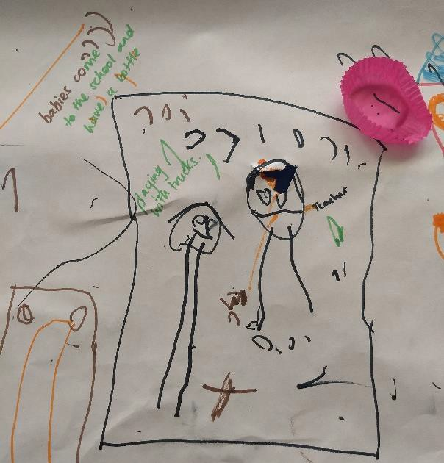 | 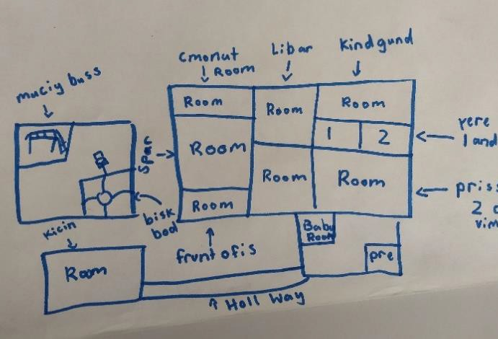
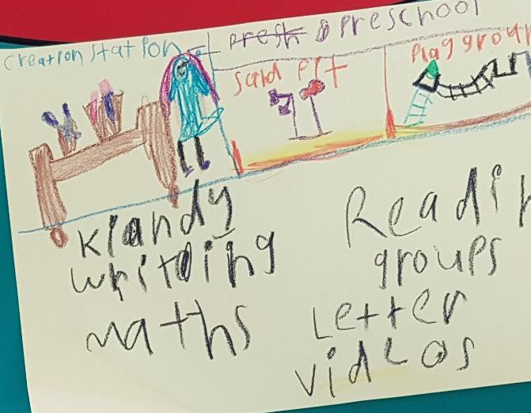 | 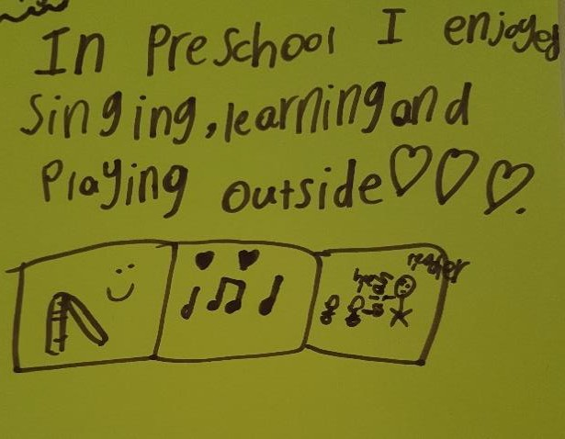

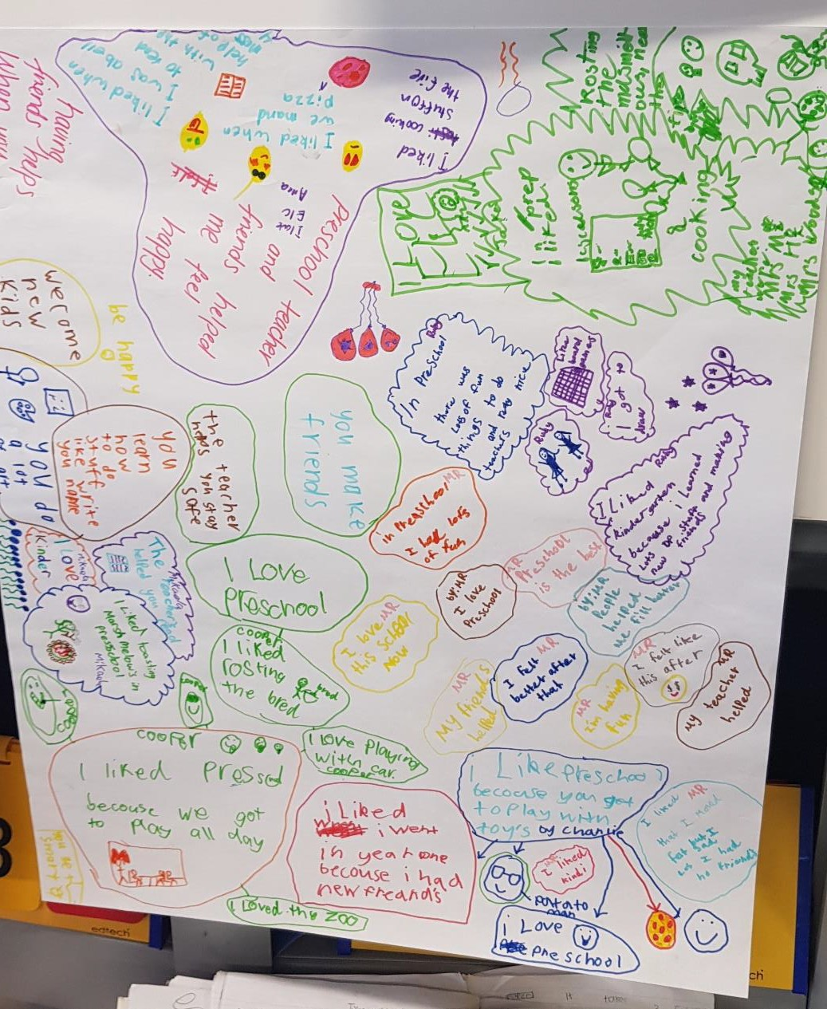

Infrastructure and programming
Many participants noted that a three-year-old program could not be combined with a four-year-old program given the significant differences in the developmental stages and needs of these two age groups. Therefore, additional rooms, toilets, play areas, carparks and outdoor spaces would need to be considered.
Also, existing locations for other early childhood education and care services (such as playschools and long day care centres) would need time to consider infrastructure needs and ‘fit’ with their existing operational approaches. Both the Catholic and government schools commented that there was no extra capacity in many locations.
There are also regulatory considerations. ELCs within the Catholic Education system are deemed as
running ‘long day-care’ in the current regulatory environment, even though they don’t offer places for
babies.

It was noted by both educators and families that a three-year-old preschool program would need to:
- be in a different environment (to four-year-olds) and have capped class sizes
- have a qualified teacher and LSA
- be a rich and engaging program that is structured and resourced
- provide support for educators to offer early support
- avoid the enrolment of only children experiencing vulnerability or disadvantage.
Some parents also noted that the size of the school or service matters. In smaller schools, there is a greater sense of community and ‘being looked after’.
“What we do with our four- and five-year-olds is not going to be appropriate for three-year- olds.” (ELC educator)
“You couldn’t just open up a playschool at a childcare and have it run the same because that wouldn’t have any impact … you have to be strategic about it and put in place all those supports [i.e. early interventions].” (Educator)
“We already have 800 students using this school – you’re looking at carparks, timings – it’s already a really built up area in the mornings with drop-off with Harrison down the road … it’s difficult adding a whole other group of people in.” (ELC educator)
“We take some assurance from the Minister’s very strong view that there needs to be ethical provision and strong links between these three-year-old facilities and four-year-old government preschools, because that transition is incredibly important.” (Union representative)
“We've got some evidence that families are consuming the 15 hours free for four-year-olds at a government preschool and then coming to us and paying for childcare subsidised places. It’d be fantastic, if they really desired to be with us, why can't we give them the 15 hours free?” (Catholic Education representative)
“Currently in the ACT, there is no consistent Licensing Agreement for School Age Care and programs can be discontinued with two weeks’ notice. Continuity of care is important to children who often establish relationships with staff and management. However the importance of this is not acknowledged in the current regulatory environment. The sudden
removal of a service also results in sudden job losses usually at very short notice. This makes it difficult for management to plan for program delivery into the future.” (Association written submission)

Early support opportunities
Across most consultations, participants noted the potential value in recognising, and accessing, early support needs for the three-year-old cohort. Some commented that this should happen before three years of age.
In support of this, appropriate training and support must be available for educators to be able to recognise potential early support needs, and to be able to easily refer families for additional supports. The significant wait times for specialist service providers were noted as a problem across a number of consultations.
It was also noted that there was a lack of understanding by parents that all children develop and learn at different rates.
Interestingly, one advocacy group was not supportive of educators making any kinds of assessments about potential developmental issues given the damaging impact this could have on both the child and their family. In some instances, children are being incorrectly diagnosed. However, the majority

of participants felt that if the educators were appropriately trained and had the right service connections, this would be the ideal time to start an early support diagnosis.
Participants wondered why the kindergarten health check couldn’t be done earlier (in the preschool years) and why external specialists (such as speech pathologists and occupational therapists) couldn’t be brought into classrooms to observe and provide timely advice and support to educators and families.
“When my son was around three, the carer in his childcare room told me she thought he wasn’t speaking properly. To be honest, I didn’t believe her as she wasn’t ‘qualified’. Turned out she was right. If she was a teacher, or the centre had approached it a different way (maybe through their management or if they had a process in place to note development issues) I may have listened and acted sooner.” (Parent)
“You might just say, ‘we’ve noticed they’re not sitting’. Or speech, hearing, physio … we will send the parents off to the drop-in clinic just to be sure and get something checked as it’s a free service. Those services work well.” (Playschool educator)
“Children not identified prior to arriving at school, because their parents did not recognise the problem, did not know what to do about it, or did not have the language skills, literacy skills, cognitive ability or persistence to negotiate the current support system.” (Union representative)

Wraparound care
Given the high rate of parents in the workforce, combined with Canberra’s transient population, many families use long day care or other services for their young children.
To enable families to work beyond the usual school hours (9am to 3pm), many participants noted some type of wraparound before and after school care would be required.
Participants noted:
- many families don’t have access to grandparents
- cost to access OSHC is a huge factor
- continuity of staff is important – it works well where ELC staff also provide OSHC
- given the number of children from different age groups in OSHC, some consideration will need to be given to how the younger children are kept separate from the older children
- ratios and staff qualifications need to be considered
- there are significant challenges facing the OSHC industry in terms of recruiting and retaining quality staff.
“If offering preschool, then you need to offer afters as well, you have a classroom there which isn’t being used, so use it.” (Parent)
“Out of school hours care, for people who have to work, will be a defining thing … I might
decide I won’t send them this year, I’ll send them next year.” (Parent)
“The Catholic Education Archdiocese of Canberra and Goulburn (CECG) ELC model of dividing the day into three parts (before school, preschool and after school care) is designed to cater for the diverse needs of Canberra families. Families are able to choose the level of education and care a child needs on a daily or weekly basis. The ELC staff transition with the children from one program to the next through the day to ensure children are supported through these transitions and their day continues with minimal disruption.” (Catholic Education written submission)

“It would be great to see more purpose-built facilities on school grounds for OSHC. That’s one of the only ways you’re going to get schools to recognise them as part of the school, not just an add-on.” (Community service provider)

Parental education and community involvement
“There seems to be this big competition about when children need to walk and talk and that
sort of thing. If families had the right education, they would understand that those things
naturally come, and the important thing is actually relationships and that’s going to be better off for them in the long run.” (Educator)

Many participants noted that the early years of schooling is when parents can make connections within their communities. When offering a three-year-old program, participants noted that:
- often the parents of the most needy children are disconnected from services/community
- playgroups should be run through preschools (with the help of a preschool educator) to help form communities and educate parents on contemporary education
- it’s a risk to take children away from mothers and fathers without upskilling the parents who have the greatest impact on children.
Examples of positive long day care and ELC arrangements often centred on strong parental involvement through volunteering, a management committee structure, regular communication and ability to pay relevant fees.
Communication with parents needs to be multifaceted to meet the vast variety of needs. For instance, parents with disability, or parents from CALD backgrounds, may require different methods for communication, and this needs to be accommodated for the benefit of the child. At a minimum, plain English communication and reducing jargon will help.
“Parents need to be supported to work with early childhood education and care services to provide a more holistic approach for their children. At its maximum, school or child care make up less than a quarter of a child’s experience – the rest of the time is up to parents and carers.” (Peak body written submission)
“It’s that place thing again. The school becomes a place where the families have a longer period
of time to connect and grow and feel secure.” (Principal)
“We’ve got to start thinking about how we build and think about day care centres to connect the community more.” (ELC educator)
“There’s a need for us to work with the parents and work with them from the point of where
they’re up to and to support the development of courage and confidence.” (Tertiary educator)
“Overall, some families will benefit from accessible, safe and non-judgmental parenting programs.” (Peak body written submission)
“Think about ways to involve the parents. A lot of things have changed in terms of the rate of parents in the workforce, so the voluntary capacity has changed. When my kids were at school it was all about being there to help with reading.” (Association member)
“A lot of people are not going to acknowledge the fact they don’t have the literacy or understanding.” (Peak body representative)
“Some parents have felt that because their disability wasn’t understood that they were cut out of things.” (Peak body representative)

Promoting the value of early years education
Participants noted that the broader community, including some educators, do not understand the benefits of early play-based education for a child’s development. There are misperceptions of the value of early childhood education and care, and that it is much more than ‘just babysitting’. This perception is amplified by the pay and conditions offered to many staff in long day care and OSHC settings.
It was noted that school leaders need to recognise the importance of preschool educators and their value within the primary system.
Similarly, the broader community needs to see the value of early childhood education and care, and to recognise the importance of the first five years. For some stay-at-home parents, there were comments about why they would access this program if the child could stay with them.
“I want to look after my kid, but they get bored and need to do things.” (Parent)
“The first five years are so significant in terms of those neurological pathways. Children should
being doing activities from when they are babies.” (Association member)
“There needs to be recognition for all the work we do – even in our school environment.” (ELC educator)
“If parents are not the first educators of the child, how does that affect what’s happening in that child’s life as they continue? A three-year-old preschool on its own can’t address those issues.” (Association member)
“We were attracted to this place because it’s the people who make the place. Continuity, stability … it’s not about the flashy building, it’s about staff who care.” (Parent)
“This is not a child minding service, it’s a child developmental service. Childcare does not reflect that very clearly.” (Parent)

Integrated and connected support
The challenge of accessing integrated and connected support for families was noted by many participants. This was particularly highlighted by disability and carer advocates. Families with disability, those in foster arrangements or dealing with challenging situations become tired of ‘telling their story’ to numerous service providers.
While a school can become an anchoring place for connection – to help reduce siloing of services and bring the services to the people who need them – it relies on strong communication and collaboration, and a practical approach to managing confidentiality and privacy. Trust is a significant defining factor for Aboriginal and Torres Strait Islander people to engage.
Disability advocates noted that they don’t want children and families to be wrapped around by services, but rather to be wrapped around by community.
Importantly, extra support needs to be considered for parents with disability navigating the early childhood education and care sector.
Many people noted that accessing support for early support or daily disability care was difficult, particularly now that Therapy ACT is no longer operating.

Some suggestions to address a more integrated and connected approach to support were:
- integrate social workers and youth workers in the education system
- bring people with lived experience into the framing of the service model
- offer more training for educators in relevant areas of disability awareness and early support
- better promote the work of supported preschools within the system
- keep families and children at the centre of the support discussion.
“We’re working as a team when we’re working with a family. We don’t want the family to have to tell their story – especially if it’s a really difficult situation they’re being re-traumatised if they have to tell their story all over again.” (Educator)
“The more time the children have in that Integrated inclusive atmosphere is good for them.” (Peak body representative)
“NSET therapy staff – Speech Pathologists and Occupational Therapist numbers – should be boosted in anticipation of increased demand for these services.” (Union representative)
“Schools so far have been very accommodating of allowing service providers into the school. This helps the teachers (if they are interested) in being provided with specific information regarding students and also helps them learn how to manage developmental or learning issues for other students (some who may not have a formal diagnosis). The kids receiving the service are getting the help they need, and others benefit from the teacher learning a new skill.” (Parent)
“There’s got to be a flexibility around approaches. It’s really important that finding a holistic approach doesn’t impose that we have a big case conference with every single person there for every family … for some that will work really well, but for others it will be the worst way to
enable them to access holistic support.” (Peak body representative)
“At three years old it would be a fantastic opportunity to identify/screen … if this is communicated to [Winnunga], then we can iron out those issues, which can be quite subtle. It can become quite overt at age five or six.” (Community service representative)
“Early childhood and centres have got a huge place to play in terms of setting up inclusive worlds that they’re not fully playing yet.” (Advocacy group representative)

Funding for support
Those participants with lived experience of disability were concerned about the complexities in obtaining funding for inclusion support, particularly since the introduction of the NDIS.
There are different funding systems across each sector, meaning inclusion support plans don’t roll over when a child transitions to another service or age group, and the complex application process must begin again – with the child missing out on important support during this time. Educators in the Catholic Education system noted the Include Me paperwork process is highly complex and the available amount of funding is limited. This was reiterated by the OSHC sector and other educators.
One disability advocate suggested the Network Student Engagement Team (NSET) should cover the whole spectrum and work openly in the school, and that it shouldn’t take 12 months for NSET to come in. Participants commented that Supported Preschools are helpful, though they are under-
resourced and don’t fill the gap.
Where possible, a child needs to come into care with support already in place, so assessments should be happening as early as possible.

Participants also noted that there is generally no funding for children who suffer mental health or
trauma; it’s only for a diagnosed disability, which is not enough.
For children with diagnosed disability, participants noted it would be important to ensure children aren’t withdrawn for therapy during their 15 hours of preschool.
“Problems have arisen since the NDIS. This is coming from psychologists as well as teachers. The model we had was so good. It’s disappeared and nothing’s replaced it. The NDIS focuses on one-to-one. The advantage of early intervention that we had is that it was a great integrative
tool for children moving into the mainstream.” (Union representative)
“We’re early childhood workers, so we know a fair bit about children's development, but there's no way we know everything. We need help with that and there doesn't seem to be help. Inclusion support is really hard to get. Therefore, there are children who are slipping through
the cracks.” (Educator)
“It’s one barrier after another. We have only got one child out of 21 services funded. We have on average 15% of children within OSHC with additional needs.” (OSHC provider)
“There has to be appropriate intervention at three so there can be a better transition into
preschool. Because, we’re getting hit with children that haven’t been anywhere near a service, and we’re dealing with it now. Not saying it’s too late, but it’s a gap.” (Union representative)
“We’re really trying to not over-medicalise conditions. There has to be balance struck between early intervention, which is so useful to maximise a child’s development, but by the same token, we don’t want parents sucked into the therapy model; that the more therapy they have, the
better it’s going to be.” (Advocacy group representative)
“I urge you to make three-year-old preschool available at Cranleigh and Malkara for the 2019 school year as the needs of children who qualify to attend these two schools are significantly higher than the needs of the average mainstream three-year-old.” (Former educator)
“When I learnt what providers were able to offer in government settings; they had whole teams dedicated to these children. We are at a real disadvantage in what we can offer. Government schools have OTs, physios and specialised equipment. We rely on families accessing the NDIS.” (Catholic Education representative)
“We need a continuum of support that needs to not stop and start at transition points.”
(Association member)

Appendix A: Participating organisations
We thank the following organisations for contributing to this consultation (face-to-face or via a written submission, or both).

Schools, preschools, ELCs, long day care centres, OSHC operators, playschools
- AIS Caretaker’s Cottage, Australian Institute of Sport, Bruce
- Anglicare OSHC, Scullin (co-located with Southern Cross Early Childhood School)
- Charles Conder preschool playgroup, Conder
- Communities@Work OSHC and long day care, Narrabundah (co-located with Narrabundah Early Childhood School)
- Early Learning Centre, Holy Family Primary School, Gowrie
- Early Learning Centre, Mother Teresa Primary School, Harrison
- Koala Playschool, Cook
- Kids Biz OSHC, Mother Teresa Primary School, Harrison
- Koori Preschool, Kingsford Smith School, Holt
- Koori Preschool, Wanniassa
- Latham Primary School, Latham
- Mother Teresa Primary School, Harrison
- Narrabundah Early Childhood School, Narrabundah
- Orana Steiner School, Weston
- Southern Cross Early Childhood School, Scullin
- University Preschool and Childcare Centre, Australian National University, Acton
- YWCA OSHC at Charles Conder Primary School, Conder
- YMCA Children’s Services, Deakin

Peak bodies and advocacy groups
- A Village for Every Child
- ACT Council of Parents & Citizens Associations
- ACT Council of Social Services (ACTCOSS)
- ACT Disability Reference Group
- ACT Pedagogical Leadership Network
- ACT Playgroups
- ACT Preschool Teachers Professional Association
- ACT Principal’s Association
- ACT Disability, Aged and Carer Advocacy Service (ADACAS)
- Advocacy for Inclusion
- Association of Independent Schools ACT (AISACT)
- Australian Education Union ACT (AEU)
- Australian Research Alliance for Children and Youth (ARACY)
- Carers ACT
- Children First Alliance
- Disability Education Reference Group
- Early Childhood Australia ACT Branch
- Families Australia

- Migrant and Refugee Settlement Services (MARSS)
- United Voice, ACT Branch
- Women with Disabilities

Other organisations and groups
- Australian Catholic University (ACU)
- Beer and Bubs, Civic
- Canberra Institute of Technology (CIT)
- Catholic Education Office
- CCCares at Canberra College, Phillip
- Child and Family Centres (Tuggeranong and Gungahlin)
- Children’s Education and Care Authority (CECA), ACT Education Directorate
- Koori Playgroup, Tuggeranong Child and Family Centre
- MACH new parents’ group, Ngunnawal
- MACH new parents’ group, Gungahlin
- Paint and Play Playgroup, Ainslie
- Paint and Play Playgroup, Franklin
- Poppy playgroup, Tuggeranong Child and Family Centre
- Strategic Policy team, ACT Education Directorate
- Student Engagement team, ACT Education Directorate
- Teaching and Learning team, ACT Education Directorate
- Uniting Care Kippax Playgroup, Kippax
- University of Canberra (UC)
- Wednesday playgroup, Tuggeranong Child and Family Centre
- Winnunga Nimmityjah Aboriginal Health Service

Appendix B: Consultation methodology
The intent of the consultation process was to:
- draw off and build on previous consultation processes conducted recently in the ACT to minimise consultation fatigue within the community
- include consultation with children, families, the early childhood education and care workforce and the sector, including people who may:
  - be Aboriginal and Torres Strait Islander
  - be culturally and linguistically diverse / children and families with English as an additional language or dialect
  - be from refugee background
  - have had exposure to mental health issues
  - have had exposure to domestic or family violence
  - have had exposure to neglect
  - have had exposure to the criminal justice system
- include consultation with the ACT Government’s preschool teacher workforce
- leverage off the partnerships already built with the ACT Early Childhood Advisory Council
- capture stakeholder views on the key elements of the strategy including on the universal access initiative for three-year-old children
- be a focused and targeted process, capturing detailed qualitative feedback from stakeholder groups and identify specific interests and needs within the community
- involve tailored consultation sessions that target each stakeholder group, meaning each conversation would have a different emphasis and be structured around their specific needs.
The consultation sessions were facilitated by ACT Education Directorate staff from the Early Childhood Policy & Regulation section.
Sessions were arranged with:
- children at school, preschool or other education/care settings
- parents, carers or grandparents of children at school, preschool or other education/care settings
- educators at schools, preschools and other education/care settings
- other staff at schools, preschools and other education/care settings
- members of relevant associations, councils or not-for-profit organisations.
Sessions were held in a variety of locations – primarily on-site at local services and schools. In some instances, a staff member of the ACT Education Directorate attended existing meetings or groups to informally gauge views.
The majority of sessions – including those with children – were attended by a contracted scribe to record the key themes from each session. A summary from each session was used to create this overall report.
Note, written submissions were also accepted until end-March 2019 and views from those submissions are also reflected in this report.

Example script for consultation sessions
Acknowledgement of Country
The Education Directorate acknowledges the Ngunnawal Peoples as the Traditional Custodians of the ACT and region upon which we live and work.
We respectfully acknowledge all they have taught us and continue to teach us about children and families and Aboriginal ways of belonging, being and becoming.
We also acknowledge and pay respect to the Wreck Bay peoples as custodians of the land on which Jervis Bay School is located.
Introduction
Minister Berry has asked us to consult with the experts in the field of Early Childhood Education, this includes children, families, educators and our wider community so we can build an Early Childhood Strategy which will help our community into the future.
Today you have <<name consultation team and Shae>> conducting the consultation with you. I would like to thank you all for giving up your time and for <<name of service>> helping us.
It’s important that we can talk openly during this consultation. None of the discussions we have today
will be identifiable to individuals.
Shae will not be providing a report that is not word-for-word but will be outlining the themes discussed. When summarising the discussions we will strip out as much identifying information as possible to ensure your comments are protected and if after today’s session you would like to withdraw your comments let us know and we’ll do what we can to support that. We will also use some quotes, but we never identify who provided the quote.
We have an option for Shae to voice record today’s session, which will be deleted once Shae has used
it to help transcribe. Is this option ok with everyone?
Lastly, please don’t be offended if I limit some of your comments; I want to make sure that everyone gets a chance to share their thoughts. Also, it would be really helpful if we could have only one person talking at a time so we can all follow the conversation.
However, please contact us if you would like to supply further comments after today’s session.
Let’s go around the room, if you could please introduce yourself and let us know your connection to this centre/service? If you could also give me a few words that come to mind when you think about Early Education and Care; these words can be positive, negative or neutral.
Excellent, thank you again to you all for being there today.
Overview of the Early Childhood Strategy
There is a lot of evidence to show that participating in quality early learning programs greatly benefits young children
We are developing an Early Childhood Strategy to coordinate approaches across government. We will be partnering with NGO’s - non-government organisations to deliver an early childhood education and care (ECEC) framework to maximise investment into early childhood services in the ACT

We are guided in the development of the strategy by the Early Childhood Advisory Council, who have been guiding the development of the strategy since their first meeting in August 2017. The Council has representatives from across the early childhood education and care sector
Through the Future of Education conversation we heard a wide range of perspectives on how Education in the ACT should look
There have been other consultations conducted, and we have drawn on these also.
Through the Early Support by Design consultation we heard from a wide range of services and stakeholders about how services can better meet the needs of the ACT community and how support can be provided earlier
Purpose of consultation
Building from the evidence we have, and from what we heard through past consultations, we would like to hear your perspectives on how to make sure early childhood education and care in the ACT best meets the needs of the community
Your experiences, insights and ideas are very valuable to us and will greatly help us develop the Early Childhood Strategy
What is shared here today will be used by staff at the Education Directorate to make sure that the initiatives, goals and direction of the Strategy is working towards meeting your needs
There are four main themes that our consultation will cover:
- Increasing access, equity and affordability
- Enhancing the workforce and their qualifications
- Seamless transitions to school
- Maximising benefits to children
The Early Childhood Strategy covers many aspects of supporting our children from birth in their lifetime learning journey. The Strategy is a 10 year plan, with initial focus on how to support those most vulnerable in our community. However, there has been immediate interest in the ability for our children to have universal access at three years of age to education.
On 31 July 2018, the Minister for Education and Early Childhood Development announced that the ACT Government wants to make phased-in provision of 600 hours per year of free, universal quality early childhood education for three year old children a key part of the ACT Early Childhood Strategy.
Phased introduction of 600 hours per year free, universal quality early childhood education
- What can you see as the benefits to universal quality early childhood education for three year olds?
- What services do you think would work well under this plan?
- What additional support would you need to make this work for you?
- Do you have concerns about this proposal?
Maximising benefits to children
We understand there are gaps and overlaps which lowers the value of money spent, which reduces the possible benefit to children, and that services need to work more effectively together to provide more holistic support to children and families.

- How does the centre/service engage/communicate with families?
- What works well?
- What could be done better?
- When looking at maximising benefits to our children, do you have examples of what works well?
- How could we better connect and share information about our children with relevant others?
- What services and supports do you think our children need?
Workforce and qualifications
We know that a skilled and stable workforce is needed to make sure our children are accessing quality ECEC services. We are also aware that there is a need for wider community recognition of the value of the professionalism, skills and knowledge of our ECEC workforce.
- As a family/employee/service exec what challenges to you think the workforce face?
- How could the workforce be better supported?
- Do you have examples of how the children’s educators helps children and families?
Transitions
Transitions to school – when we talk about transitioning for children we are looking at how a child moves from one service to another. For example, from before school care to school, or from an early education and care setting to pre-school at a school.
We know that transitions to school and between services can be challenging times for our children. There is no consistent approach in the ACT for effective transition strategies between early year’s settings and schools.
- What examples do you have where there have been successful transitions for children?
- What experiences do you have where services have worked together to support children during transitions?
- What has been hard about your child transitioning?
- What has helped when your child has been transitioning?
Closing the session
Thank you to everyone for taking part today.
All of your comments will be used to inform the Early Childhood Strategy, although your input will be de-identified.
Please complete the ‘contact sheet’ if you would like to keep in contact with us, or to have an overview of the consultation sent directly to you.
Thank you gifts.

