Arts ACT-cover background.jpg

**Document No. 00003/1 Published 08/06/2020**

**Swimming Pool and Aquatic Activities procedures**



Swimming Pool and Aquatic Activities Procedures

This procedure must be read in conjunction with Swimming Pool and Aquatic Activities Policy

Table of Contents

Swimming Pool and Aquatic Activities Procedures 2

1. Overview 3

2. Rationale 3

3. Select an approved venue 3

4. Classify planned activities at Swimming Pool and Water Park Based Aquatic Events 3

5. Complete Directorate Swimming Pool and Water Park Based Aquatic Activities Risk Assessment and Management Plan 4

6. Appoint an Aquatic Activity Coordinator and determine appropriate staff supervision ratios and supervision positioning for activities 4

7. Obtain informed consent including medical information for participants 5

8. Induct staff 5

9. Induct students 5

10. Complete Principal’s Checklist 5

11. Ensure correct roll marking procedures are undertaken 5

12. Conduct Royal Life Saving Society ACT Survival Challenge Proficiency Test 6

13. Ensure all students are clearly distinguishable as having passed or not passed the proficiency test if tested 6

14. Ensure Royal Life Saving Society ACT Survival Challenge Proficiency Test result are recorded on MAZE. 6

15. Staff Qualifications 6

16. Equipment 7

17. Planning Flowcharts 8

18. Contact 10

**19.** **Complaints** 10

20. References 10

1. Overview
   1. The Swimming Pool and Water Park Based Aquatic Activities Policy and accompanying Procedures aims to encourage participation of all students in aquatic activities in a safe and supportive environment.
   2. The following document provides a list of mandatory procedures schools are required to follow for planning swimming pool and water park based aquatic activities.
2. Rationale
   1. The ACT Education and Training Directorate recognises the importance of providing students with opportunities to participate in school based aquatic activities, such as swimming carnivals.
   2. These events play an important role in developing students’ confidence in and around water, building capacity to improve health and fitness, and contributing to a positive school culture.
3. Select an approved venue
   1. Schools are required to select an aquatic venue that:

* has been approved by the RLSSACT
* has been approved by the Principal
* meets the needs of the school.
  1. Royal Life Saving Society ACT provides Aquatic Facility Safety Assessments that audit aquatic facilities on an annual basis to ensure they provide the minimum industry safety standards. A list of ‘5 star approved venues’ that are compliant with these industry standards is available from Royal Life Saving Society ACT on (02) 6260 5800 or at: [www.act.royallifesaving.com.au](http://www.act.royallifesaving.com.au)
  2. Prior to booking a venue, schools are required to liaise with the pool operator to ensure the venue can cater to the policy requirements of the school visit. Issues to be discussed with the pool operators include:
* the minimum industry standard of one lifeguard per 100 students is met
* planned activities, including specific unstructured activities
* procedures and risk management around individual activities
* appropriate supervisory ratios and the supervisory positioning for individual activities
* life saving aids required, supplies by the venue, and their location
* Royal Life Saving Society Survival Challenge Proficiency Test procedures if required
* Identification method to distinguish the students who have passed or not passed the Royal Life Saving Society ACT Survival Challenge Proficiency Test (if applicable)
* out-of-bound areas.

1. Classify planned activities at Swimming Pool and Water Park Based Aquatic Events
   1. Determine which, if any, planned activities are unstructured, including activities involving specialised water play equipment   
      *Use of inflatables, such as aqua runs, and other specialised water play equipment*
   2. Consideration for using inflatables, such as aqua runs, or other specialised water play equipment as part of an aquatic activity must be based on general staff supervision considerations coupled with specific issues related to the equipment.
   3. With obstacle courses incorporating the use of inflatables, there should be a minimum of two qualified lifeguards with a suitable number of additional supervisors to adequately supervise inflatable play equipment.
   4. A supervisor should control despatch onto the inflatable at the start of the course, and another should be responsible for the safety of students on the inflatable from the time they enter the water to the time they are clear of the pool.
   5. Supervisors should:

* Liaise with the venue operator to determine supervision points
* Have a clear view of the equipment and the surrounding water
* Make sure they can see underneath the equipment
* Be familiar with and enforce the rules relating to the equipment
* Only allow students of similar age to use the equipment at the same time
  1. The decision to include the use of and risk management around specialised water play equipment must be documented within a risk assessment and management plan.

1. Complete Directorate Swimming Pool and Water Park Based Aquatic Activities Risk Assessment and Management Plan
   1. All schools are required to complete a risk assessment and management plan prior to conducting swimming pool and water park based aquatic activities.
   2. Risk assessment and management plans must include emergency procedures at swimming pool and water park based aquatic activities.
2. Appoint an Aquatic Activity Coordinator and determine appropriate staff supervision ratios and supervision positioning for activities
   1. Appoint an Aquatic Activity Coordinator to oversee the process of organising and conducting the swimming pool or water park based aquatic event.
   2. Activity Leaders may also be appointed to manage individual activities at swimming pool or water park based aquatic events.
   3. Schools are required to arrange for sufficient staff to supervise both dry land and water activities. Planned supervision arrangements should be recorded on a supervision roster and communicated to staff.
   4. Adequate supervision should be provided as follows:

* all students must be supervised at all times during swimming pool and water park based aquatic events
* all teachers at swimming pool and water park based aquatic activities must be aware of their collective and individual responsibilities, including obligations in maintaining Duty of Care
* determining appropriate supervision ratios and supervisor positioning for activities should be based on:
  + activity type
  + assessment of water depth and conditions
  + general conditions at the venue, including weather
  + visibility
  + students’ age and height
  + students’ ability to understand and follow instructions
  + students’ physical ability and swimming proficiency
  + any medical conditions
* a minimum ratio of 1 teacher : 20 students is met.
* Schools are required to ensure that there are sufficient lifeguards supervising the pool area. The minimum lifeguard to patron of 1 lifeguard to 100 swimmers must be met. Lifeguards at the pool must hold a current pool RLSSA lifeguard qualification.

1. Obtain informed consent including medical information for participants
   1. Schools are required to obtain informed parent/carer consent and relevant medical information for all students attending the event. Schools are encouraged to provide additional information to parents outlining the planned event activities.
   2. Sample consent forms are provided in the appendices. The appendices also contain sample consent forms in the seven most commonly spoken languages other than English across Canberra schools.
2. Induct staff
   1. Schools are required to induct staff prior to swimming pool and water park based aquatic activity.
   2. The induction should include:

* venue layout, rules and regulations
* procedures in the event of an emergency
* roles and responsibilities of venue staff, including lifeguards
* roles and responsibilities of school staff, including Aquatic Activity Coordinators and Activity Leaders, where applicable
* Swimming Pool and Water Park Based Aquatic Activities program, identifying any unstructured activities planned,
* obligations for staff in maintaining Duty of Care.

1. Induct students
   1. Schools are required to induct students in the same way as staff are inducted.
   2. The student induction should include:

* Venue layout, rules and regulations
* Procedures in the event of an emergency
* Roles and responsibilities of venue staff, including lifeguards
* Roles and responsibilities of students and school staff, including Aquatic Activity Coordinators and Activity Leaders, where applicable
* Showing the Survival Challenge Proficiency Test DVD and process, if required
* Swimming Pool and Water Park Based Aquatic Activities program, identifying any unstructured activities planned

1. Complete Principal’s Checklist
   1. Complete and sign the Principal’s Checklist included in these procedures.
2. Ensure correct roll marking procedures are undertaken
   1. Schools are required to ensure that attendance is recorded:

* Before the start of the swimming pool or water park based aquatic event
* Before leaving the venue
  1. Schools may record attendance at other times during the day as deemed necessary.

1. Conduct Royal Life Saving Society ACT Survival Challenge Proficiency Test
   1. If the school aquatic event includes unstructured/’free time’, students will be required to complete the Royal Life Saving Society ACT Survival Challenge Proficiency Test to determine the aquatic proficiency of students.
   2. The proficiency test should be completed to or on the day of the swimming pool or water park based aquatic event.
   3. Students must complete the following steps to be identified as having passed the Royal Life Saving Society ACT Survival Challenge Proficiency Test and may participate in unstructured activities in water at or above waist height:
2. Perform a slide-in-entry and walk through 5 metres of water with acceptable stability and coordination
3. Swim continuously for 25 metres using an action an action that resembles a stroke
4. Perform survival scull, float or tread water for 1 minute in deep water. Call for help once within the minute
5. Exit water unassisted, and
6. Perform a voice rescue to a buddy who is pretending to be in trouble. Reassure the victim and encourage them to a point of safety. Call for assistance.
   1. Students who cannot complete all those steps may only participate in structured activities or unstructured activities in water below waist height.
   2. Please note amateur school swimming competitions/races are deemed structured swimming events.
7. Ensure all students are clearly distinguishable as having passed or not passed the proficiency test if tested
   1. Ensure students are provided with identification that clearly distinguishes them having passed or not passed the Royal Life Saving Society ACT Survival Challenge Proficiency Test where unstructured aquatic activities at or above waist depth water are planned.
   2. Schools are responsible for informing the venue operator of the identification method used to distinguish students who have passed or not passed the Royal Life Saving Society ACT Survival Challenge Proficiency Test.
8. Ensure Royal Life Saving Society ACT Survival Challenge Proficiency Test result are recorded on MAZE.
   1. The results of the Royal Life Saving Society ACT Survival Challenge Proficiency Test must be recorded on MAZE following the Swimming Pool or Water Park Based Aquatic Event.
9. Staff Qualifications
   1. At least two of the adults present at swimming pool and water park based aquatic activities (including pool and water park supervisory staff) are required to have the ability to:

* Effect a recovery o a student from the water at the venue
* Perform first aid (hold a current Senior First Aid Certificate), and
* Perform cardio pulmonary resuscitation (hold a current CPR Award).

1. Equipment
   1. Equipment at the venue must include the following:

* Life saving aids readily available within the venue – teachers supervising swimming activities must know their whereabouts and be confident to use them
* First aid kit
* Public address system (if the venue does not have one Aquatic Activity Coordinators can borrow one from School Sport ACT), and
* SPF30+ sunscreen for staff and students.

1. Planning Flowcharts

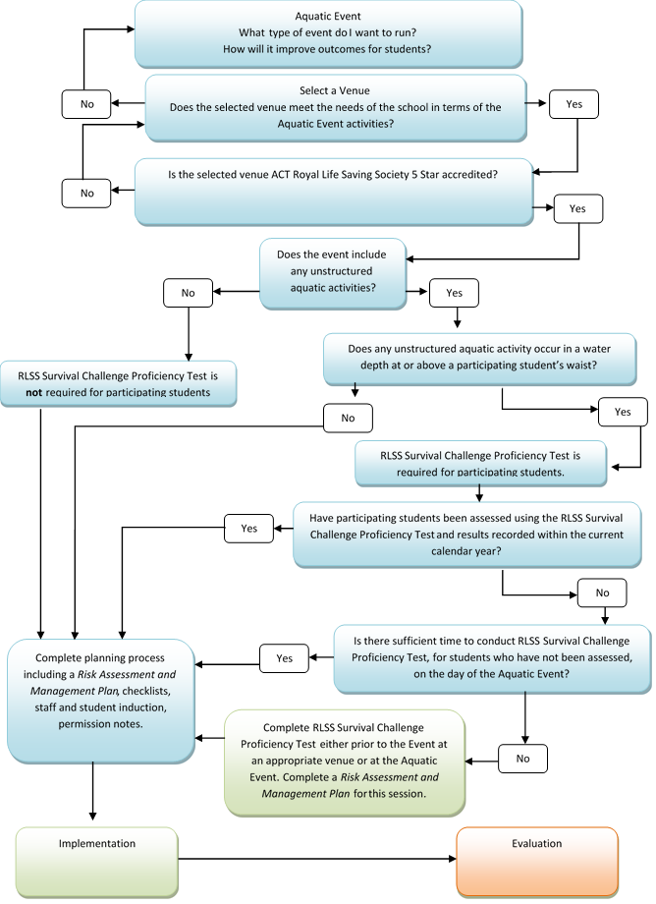

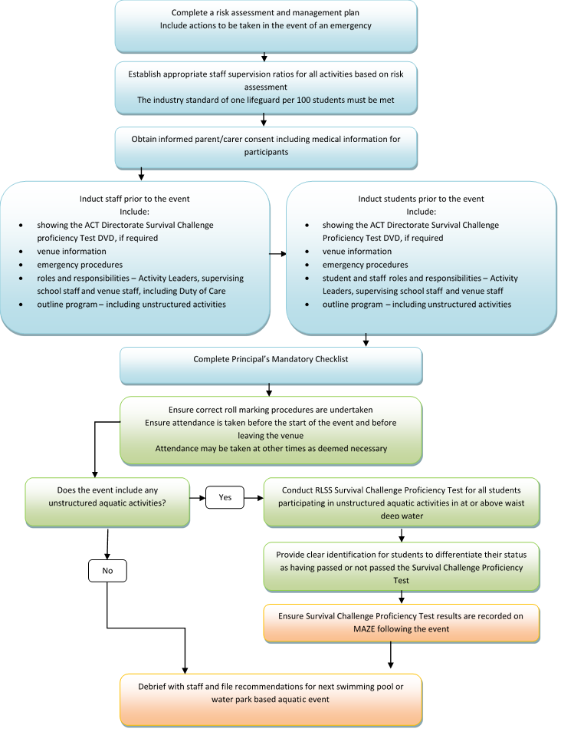

1. Contact
   1. The Executive Branch Manager, Universal School Support is responsible for this procedure.
   2. For support contact Universal School Support on 02 6205 9204.
2. **Complaints**
   1. Any concerns about the application of this policy or the policy itself, should be raised with:

* the school principal in the first instance;
* the Family, Students Complaints and Feedback team on (02) 6205 5429.
* online at <https://www.accesscanberra.act.gov.au/app/forms/etd_liaison_feedback> ;
* See also the Complaints Policy on the Directorate’s website: <https://www.education.act.gov.auReferences>

1. References
   1. **Definitions**

* Example: set out relevant definitions here in alphabetical listing.
  1. **Related Policies and Documents**
* *Swimming Pool and Water Park Based Aquatic Activities* policy
* *Excursions Policy*
* *First Aid Policy*
* *Physical Education and Sport Policy*
* *Risk Assessment and Management Plan*
* *Risk Management Framework*
* *Safety and Emergency Contingency Plan*

### Swimming and Water Park Aquatic Activities Principals Checklist

**To be completed for Swimming Pool and Water Park Aquatic Activities events only.**

Swimming and Water Park Aquatic Activities principal’s checklist is completed during the online application.

***Principal must complete and sign***

|  |  |  |
| --- | --- | --- |
| **Action** | **Date achieved** | **Initials** |
| 1. Type of activity/event to be run has been identified |  |  |
| 1. Selected venue is appropriate for the event and meets the needs of the school |  |  |
| 1. An appropriately qualified person will lead the activity |  |  |
| 1. An appropriately qualified first aid officer, with first aid equipment will be present for the event |  |  |
| 1. Appropriate staff supervision ratios for all planned activities determined and planned for |  |  |
| 1. Risk assessment and safety and emergency contingency plan completed |  |  |
| 1. Informed consent from parents and relevant medical information obtained for students attending the event including *Management and Emergency Treatment Plans* |  |  |
| 1. Movement requisition completed (if interstate travel is involved) |  |  |
| 1. Excursion cost planning sheet completed |  |  |
| 1. Participating staff and students have been prepared for the event |  |  |
| 1. Student and staff induction completed |  |  |
| 1. Evaluation will occur post event |  |  |
| 1. Financial acquittal completed immediately after excursion |  |  |
| 1. Records of planning and implementation of the event are captured on file |  |  |

Principal’s Signature: Date: ___/___/_______



Insert School Logo Here

**Swimming Pool and Water Park Based Aquatic Activities Student Permission Form**

Click here to enter a date

Dear Parents and Carers

The following details relate to an educational excursion to click here to enter venue.

The teacher in charge of this event will be Click here to enter teacher in charge name.

***IMPORTANT INFORMATION*:**

**Event:** Click here to enter event title

**Venue:** Click here to enter venue details

**Date:** Click here to enter a date

**Time:** Click here to enter departure and arrival times

**Transport:** Click here to enter mode of transport

**Cost:** Click here to enter total cost of excursion

**Food:** Click here to enter food requirements including canteen details

**Clothing:** Click here to enter clothing and sunscreen requirements

**Safety/Emergency procedures**

If needed, the school can be contacted at Click here to enter pool venue. In an emergency the school has access to all pool facilities and the appropriate emergency services.

It is important that staff are aware of your child’s swimming ability prior to the event. Please ensure you carefully complete the attached permission note indicating your child’s swimming ability.

Kind Regards

Click here to enter Principal’s name

*School Principal*

Click here to enter school name **Swimming Pool or Water Park Based Aquatic Event**

|  |
| --- |
| **Permission for Aquatic Activities**  As a part of this assessment and to help ensure the safety of your child, please provide the following information:   1. **Name of Child: __________________________________________** 2. **School Year: ____________________________________________** 3. **My child can swim:** No   Yes   1. **Distance my child can confidently swim:**   10m  25m  50m  100m   1. **I agree to my child taking part in swimming / aquatic activities associated with this excursion.**   Name of Parent / Carer: (*please print*) ______________________________  Signature: _______________________________________________________________  Date: ___________________________________________________________________ |

Click here to enter school name **Swimming Pool or Water Park Based Aquatic Event**

**Permission Note Ledger Code:** Click here to enter ledger code

I give permission for my child __________________________ in class ________________________ to attend the Enter school name here swimming pool or water park based aquatic event at Enter venue name here on Click here to enter a date travelling by Enter mode of transport here.

I enclose Nominate amount of $

***Code of Conduct and Parental Agreements*:**

*Staff accompanying students on excursions will take all reasonable care while the students are in their charge to protect them from injury and to control and supervise their behaviour and activities. Unacceptable behaviour will be treated as it is normally treated at school, (reminders, time out in a designated spot, and exclusion from an activity) but with the additional factor that the student may be returned to school should the behaviour be extreme or overly persistent.*

*Parents should be aware that staff members are not responsible for injuries or damage to property which may occur on an excursion where, in all circumstances, staff have not been negligent. Parents should warn children of the risk to themselves, to others and to property, of impulsive, wilful or disobedient behaviour.*

*I agree to my child participating in the swimming/aquatic activities mentioned previously. I have discussed with my child the need for sensible behaviour on this excursion. I authorise the school to make arrangements for the welfare of my child (including medical or surgical treatment) in an emergency and I agree to meet the associated costs. I have provided to the school all medical information relevant to my child’s attending this event.*

*I agree that my child will be under the authority of the school for the duration of the excursion and that the school is authorised to return my child to school or home at my expense if the school considers that circumstances warrant such action. I give permission for my child to travel by private car, driven by a staff member or parent, in an emergency. I agree to provide any relevant medical information to the school to the excursion.*

Name of Parent / Carer: (*please print*) ________________________________

Signature: ________________________________________________________________

Date: ____________________________________________________________________

**This form requests information about students which will be held by the school. This information may be disclosed to government or private medical or para-medical staff and other relevant officers in the event of an accident or emergency. The information is collected as a lawful administrative function of the ACT Education and Training Directorate.**

# Translations of letter for permission for swimming and aquatic activities

## ARABIC

## CHINESE

|  |
| --- |
| 许可通知:自由水上活动 |
| **自由水上活动是在庆祝日或发奖日和学校竞赛日进行的自由游泳活动。** |
| 自由–水上活动 –回答 |
| **在以下两项中，请用画圈方式明确选择其中一项回答:**  **我**允许**我的孩子下水**  **我**不允许**我的孩子下水**  **如果您允许您的孩子下水 (请画圈选择下面一项回答):**  **我的孩子**会游泳*  **我的孩子**不会游泳*  **……………………………………… 父母/监护人签名**  (*请注意: **不会游泳的孩子只允许在浅水(齐腰)区内活动。会游泳的孩 子允许进入深水区) 。** |

|  |
| --- |
| 许可通知: 有组织的水上活动 |
| **有关提议中的有组织的水上活动(请画圈选择下面一项回答):**  **我**允许**我的孩子下水**  **我**不允许**我的孩子下水**  **……………………………………… 父母/监护人签名**  **. . . . . . . . . . . . . . . . . . . . . . . . . . . . . . . . . . . . . . . . . . . . . . . . . . . . . . . . . . . . . . . . . .**  **我允许我的孩子下水(请画圈选择下面回答):**  完全不会游泳: **我的孩子完全不会游泳**  不大会游泳: **我的孩子可以在浅水区活动，但不大会游泳**  一般游泳水平: **我的孩子游泳水平一般，但在深水区游泳能力不强或信心 不足**  游泳水平高: **我孩子具备高水平游泳能力而且在深水区游泳的信心十足。**  **………………………………………… 父母/监护人签名** |

## HINDI

**तैराकी और जलीय गतिविधियों के लिए अनुमति**

शिक्षकों को हर बच्चे की तैराकी की क्षमता का आकलन करना आवश्यक हैंI वे एक भ्रमण जहां तैराकी या जलीय गतिविधियों के लिए पानी है, पर बच्चे को ले जाएगाI

तैराकी का मूल्यांकन और अपने बच्चे की सुरक्षा को सुनिश्चित करने के लिए, कृपया निम्नलिखित जानकारी दे:

1. बच्चे का नाम: ________________________________

2. स्कूल वर्ष: __________________________________

3. मेरे बच्चे तैर कर सकते हैं?

🞎नहीं

🞎 हां

4. मेरे बच्चे विश्वास के साथ तैर कर सकते हैं:

🞎 10 मीटर

🞎 20 मीटर

🞎 30 मीटर

🞎 40 मीटर

5. मैं सहमत हूँ कि मेरे बच्चे स्विमिंग / जलीय इस कार्यक्रम / भ्रमण के साथ जुड़े गतिविधियों में भाग ले सकते हैं.

पिता / माता / अभिभावक/ अभिरक्षक के नाम: _______________________

हस्ताक्षर: _____________________

दिनांक: __________________________

## KOREAN

**허가 확인서 : 수영장내 비계획적 활동**

-----------------------------------------------------------------------------------------------------------------------------------

비계획적 수영이란 기념일 혹은 상급으로 받는 날 등에 하는 자유로운 감독 받지 않는 수영 활동입니다.

-----------------------------------------------------------------------------------------------------------------------------------

**비계획적 - 수영장내활동 – 아래 사항에 응답하십시요.**

-----------------------------------------------------------------------------------------------------------------------------------

정확하게 동그라미 표기 하십시요.

내 아이가 물에 들어 가는 것을 **허가합니다.**

내 아이가 물에 들어 가는 것을 **허가하지 않습니다.**

내 아이가 물에 들어 가는 것을 허가한다면 (아래 중 한가지에동그라미 표기 하십시요)

내 아이는 **수영 능력이 있습니다**.

내 아이는 **수영 능력이 없습니다.**

……………………………………………………………………….. 부모 / 대리인 서명

(**인지사항** : 수영 능력이 없는 아이들은 얕은 물에만 들어 갈 수 있습니다 (허리 정도 수위).

수영 능력이있는 아이들은 깊은 물에 들어 가도록 허락됩니다.

**허가 확인서 : 수영장내 계획적 활동**

--------------------------------------------------------------------------------------------------------------------------------------

계획되고 감독받는 수영장내 활동에 관련하여(아래 중 한가지에동그라미 표기 하십시요) :

내 아이가 물에 들어 가는 것을 **허가합니다.**

내 아이가 물에 들어 가는 것을 **허가하지 않습니다.**

……………………………………………………………………….. 부모 / 대리인 서명

내 아이가 물에 들어 가는 것을 허가한다면 (아래 중 한가지에동그라미 표기 하십시요)

**수영 능력이 없음** : 내 아이는전혀 수영할 수 없습니다.

**약간의 수영이 가능함** : 내 아이는 얕은 물에서는 잘 놀지만 수영 능력이 별로 없습니다.

**보통 수영이 가능함** : 내 아이는 어느 정도 수영할 수 있지만 깊은 물에서는 자신있게 수영할 수

없습니다.

**수영 능력이 강함** : 내 아이는 수영 능력이 강하고 깊은 물에서도 잘 할 수 있습니다.

……………………………………………………………………….. 부모/ 대리인 서명

## SINHALESE

**පිහිනුම් සහ** ජලාශ්‍රිත ක්‍රීඩා **සදහා අවසර**

පිහිනුම් සහ ජලාශ්‍රිත ක්‍රීඩා ඇතුලත් වැඩසටහන්වලට සහභාගීවන හැම දරුවකුගේම පිහිනීමට ඇති හැකියාව ගුරුවරුන් දැන ගත යුතුයි.

මෙම වාර්තාවේ කොටසක් ලෙස සහ ඔබේ දරුවාගේ ආරක්ෂාව තහවරු කිරීමට කරුණාකර පහත සදහන් විස්තර සපයන්න

1. දරුවාගේ නම:________________________________

2. පාසලේ වසර:__________________________________

3. මගේ දරුවාට පිහිනීමට 🞎 නොහැකිය

🞎 හැකිය

4. මගේ දරුවාට පහසුවෙන් පිහිනීමට හැකි දුර:

🞎 10m

🞎 25m

🞎 50m

🞎 100m

5. මෙම වැඩසටහනට ඇතුලත් පිහිනුම් සහ ජලාශ්‍රිත ක්‍රීඩා වලට සහභාගීවීමට මගේ දරුවාට අවසර දෙමි.

දෙමව්පිය/භාරකරු නම (පැහැදිලි අකුරෙන්) _____________________

අත්සන: _____________________

දිනය: _____________________

## SUDANESE (Dinka)

**Päl në kuaŋ ku kä ye ke looi në pïu yiic**

Dupiööc aakɔɔr bik kë them bik kä ke kuaŋ yenne meth kuaŋ lööm në piɔ̈c kɔɔr ben piöc ke kuany ke den de piɔ̈c cök të wen nɔŋ pïu yenneke kuaŋ/ka kä yenneke kuaŋ.

Në biäk de ye themë ku kuɔny ku tïit në ke bë meth yök, ku yïn thiëëc ba kee ka ciëën ke bɛ̈i.

1. Rink e meth---------------------------
2. Ruɔ̈nde thukul------------------------
3. Mehndië e kuaŋ □ Acïi lëu □ Alëu
4. Kaam lëu bïnnë mehndië kuaŋ.

□ 10 m

□ 25 m

□ 50 m

□ 100 m

1. Aya gam ke mehndië bï baŋde looi ne kuaŋic në ke thiääk kennë yee ajuiɛɛrë.

Rink ke kɔcdït ke meth/Dugël/Raan tiɛ̈t nyin

Rinku-----------------------------------

Thäänydu-----------------------------

Pɛɛi nïn--------------------------------

## VIETNAMESE

|  |
| --- |
| Thư Cho Phép: Những Hoạt Động Dưới Nước Không Hoạch Định |
| **Việc bơi lội không hoạch định là việc tổ chức bơi lội tự do hay vào những ngày ban thưởng và liên hoan của trường.** |
| Không Hoạch Định - Những hoạt động dưới nước - Câu Trả Lời |
| **Xin khoanh rõ câu trả lời:**  **Con tôi** được phép **xuống nước**  **Con tôi** không được phép **xuống nước**  **Nếu con quí vị được phép xuống nước (xin khoanh rõ câu trả lời):**  **Con tôi là** người biết bơi *  **Con tôi là** người không biết bơi *  **……………………………… Cha Mẹ/Người chăm sóc ký tên**  **(**\*Xin chú ý: **Người không biết bơi sẽ chỉ được xuống chỗ nước cạn (sâu đến thắt lưng). Người biết bơi sẽ được xuống chỗ nước sâu).** |

|  |
| --- |
| Thư Cho Phép: Những Hoạt Động Dưới Nước Được Hoạch Định |
| **Liên quan đến những hoạt động dưới nước được hoạch định trong đề án (xin khoanh vào câu trả lời):**  **Con tôi** được phép **xuống nước**  **Con tôi** không được phép **xuống nước**  **………………………………… Cha Mẹ/Người chăm sóc ký tên**  **. . . . . . . . . . . . . . . . . . . . . . . . . . . . . . . . . . . . . . . . . . . . . . . . . . . . . . . . . . . . . . . . . . . .**  **Con tôi được phép xuống nước (xin khoanh vào câu trả lời):**  Người không biết bơi: **Con tôi không bơi được**  Người bơi kém: **Con tôi đủ sức và tự tin chỗ nước cạn nhưng không bơi giỏi lắm**  Người bơi trung bình: **Con tôi là người biết bơi vừa phải nhưng không vững hoặc tự tin lắm chỗ nước sâu**  Người bơi vững vàng: **Con tôi là người bơi vững và rất tự tin chỗ nước sâu**  **………………………………… Cha Mẹ/Người chăm sóc ký tên** |