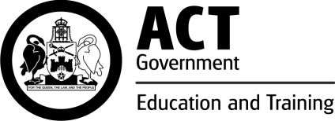
What do people think about ACT public schools in 2015?

Each year, the Education and Training Directorate surveys parents, carers, staff and students from years 5 to 12 to gauge their satisfaction with the education provided across all ACT public schools. The online surveys ask individuals what they think about their school’s performance.

Results from the 2015 Satisfaction Survey
In 2015, parents and carers (8,262), students (14,326) from years 5 to 12 and staff (3,281) across a range of year levels completed the survey.
The results for overall satisfaction with education in ACT public schools (Table 1) were positive across all school sectors. The majority of parents and carers, students and staff are satisfied their school has high expectations (Table 2).

Table 1: Overall satisfaction with public school education, 2015
 | Colleges | High schools | P -10 schools | Primary schools | Early childhood schools | Specialist schools | All schools
Parents/carers | 83% | 85% | 83% | 88% | 93% | 93% | 87%
Students | 83% | 74% | 69% | 85% | na | na | 78%
Staff | 94% | 91% | 88% | 96% | 96% | 91% | 93%
na – not applicable

Table 2: Overall satisfaction with the high level of expectations at school, 2015
 | Colleges | High schools | P -10 schools | Primary schools | Early childhood schools | Specialist schools | All schools
Parents/carers | 81% | 83% | 77% | 85% | 90% | 89% | 84%
Students | 78% | 68% | 63% | 82% | na | na | 73%
Staff | 90% | 87% | 83% | 93% | 92% | 89% | 90%
na – not applicable

How do we use the survey results?
Each year, survey results from all ACT public schools are collated to provide an indication of system-wide satisfaction levels. Satisfaction is an important measure of our stakeholders’ confidence, engagement and participation.
The school level results contribute to the school improvement process within each ACT public school. Overall satisfaction results for each ACT public school are reported in their annual school board report.

Further Information
Education and Training Directorate
General Enquiries
Telephone: +61 6207 5111
Canberra Connect: 13 22 81
Website: http://www.det.act.gov.au

© Australian Capital Territory, Canberra, November 2015

