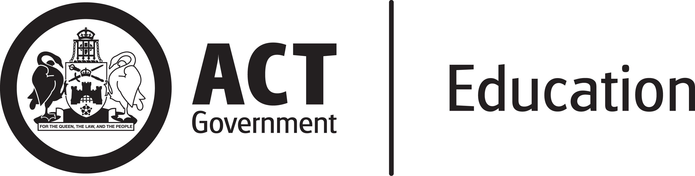

Internal Audit Policy

Policy Identifier. 00029 November 2019

Internal Audit Policy
Policy Identifier: 00029 Published: November 2019
- What is this policy about?
  - This policy defines how the internal audit function operates within the Directorate and should be read in conjunction with the Audit Committee Charter, Internal Audit Charter and the Internal Audit Procedures.
- Policy Statement
  - Internal audit activities will be conducted in accordance with:
- relevant professional standards including International Standards for the Professional Practice of Internal Auditing issued by the Institute of Internal Auditors (IIA) and standards issued by the Australian Auditing and Assurance Standards Board (AASB);
- the Internal Audit Charter; and
- the Audit Committee Charter where applicable.
- Who does this policy apply to?
  - This policy applies to all Education Directorate staff and outsourced internal audit service providers.
- Context
  - Under Standard 2040 – Policies and Procedures of the International Standards for the Professional Practice of Internal Auditing, policies and procedures must be established to guide the internal audit activity.
- Responsibilities
  - The internal audit function is undertaken by Chief Internal Auditor, internal auditors within the Internal Audit section and outsourced internal audit service providers. The Audit Committee provides oversight of the internal audit function.
- The roles and responsibilities of the Audit Committee are outlined in the Audit Committee Charter.
- The roles and responsibilities of Chief Internal Auditor, Internal Auditors and Outsourced Internal Audit Service Providers are outlined in the Internal Audit Charter.
- The Management of the Audited Area is responsible for implementing this policy and its implementation documents, providing access to information, data, facilities and staff as reasonably required to enable the successful completion of the audit, within specified timeframes and within the agreed allocated resources; providing management comments on the draft internal audit report within specified timeframes; ensuring recommendations from audits are implemented in a timely manner and providing regular implementation status update through the Chief Internal Auditor to the Audit Committee; and assisting the Chief Internal Auditor in providing relevant meeting papers to the Audit Committee and attending meetings as required.
- All staff must provide all reasonable assistance to the internal auditors in carrying out its functions.
  - The Chief Internal Auditor is the Policy Owner and responsible for this policy.
- Monitoring and review
  - The Policy Owner monitors the policy. This includes an annual scan of operation and review. A full review of the policy will be conducted within a three-year period. Any substantive changes will be formally approved by the Director-General and endorsed by the Audit Committee.
- Contact

  - For support contact A/g Chief Internal Auditor on (02) 6207 4386
- Complaints

  - Any concerns about the application of this policy or the policy itself, should be raised with:
- the A/g Chief Internal Auditor on (02) 6207 4386;
- the Directorate’s Governance & Community Liaison Unit on (02) 6205 5429;
- online at www.education.act.gov.au/about-us/contact_us;
- see also the Complaints Policy on the Directorate’s website.
- References

  - Definitions
- Internal Audit: an independent, objective assurance activity designed to add value and improve an organisation’s operations. It helps an organisation accomplish its objectives by bringing a systematic, disciplined approach to evaluate and improve the effectiveness of risk management, control and governance processes.
  - Legislation
- International Standards for the Professional Practice of Internal Auditing
  - Implementation Documents
- Internal Audit Procedure, Policy Identifier 00029/1
  - Related Policies and Information
- Audit Committee Charter, Policy Identifier 00029/3
- Internal Audit Fact Sheet, Policy Identifier 00029/2
- Internal Audit Charter, Policy Identifier 00029/4
- ACT Government Internal Audit: Committee and Function Framework (Draft)

