**ACT POST SCHOOL DESTINATIONS AND PATHWAYS IN 2019**

Results from the survey of 2018 year 12 graduates and school leavers and the longitudinal survey of 2017 year 12 graduates and school leavers.

Key Findings

* Ninety-three percent of 2018 year 12 graduates were employed and/or studying in 2019, compared with 71 percent of 2018 school leavers in the survey.
* Fifty-nine percent of 2018 year 12 graduates were studying in 2019 and a further 29 percent intended to start some study in the next two years.
* Forty-four percent of 2018 school leavers were studying in 2019 and a further 26 percent intended to start some study in the next two years.
* Seventy-five percent of 2018 year 12 graduates were employed in 2019, compared with   
  57 percent of 2018 school leavers.
* The percentage of 2017 year 12 graduates studying increased from 58 percent in 2018 to 73 percent in 2019.
* Seventy-seven percent of the 2017 year 12 graduates who deferred university in 2018 were attending university in 2019.
* Fifty-four percent of 2017 year 12 graduates and 30 percent of 2017 school leavers who were not studying in 2018, were studying in 2019

© Australian Capital Territory, Canberra, 2019

This publication has been produced by the ACT Government. Apart from any use permitted under the *Copyright Act 1968*, no part of this publication may be reproduced by any process without written permission from the ACT Government’s Education Directorate.

Contents

Key Findings 1

Contents 3

Executive Summary 4

Background 6

Part 1 – 2018 Year 12 Graduates and School Leavers 6

Destination of 2018 year 12 graduates 6

Key outcomes 6

Study 8

Labour force status 12

Participation in other post-school activities 13

Destination of 2018 school leavers 13

Characteristics of students who left school in 2018 17

Satisfaction with school 18

Reasons for leaving school 19

Part 2 – 2017 Year 12 Graduates and School Leavers 20

Pathways of 2017 year 12 graduates 20

Key outcomes 20

Study 21

Labour force status 25

Pathways of 2017 school leavers 28

Satisfaction with life 29

Glossary 30

References 31

Executive Summary

The ACT Government believes every student in the ACT should have access to the opportunities provided through quality education. The Education Directorate *2019-21* *Strategic Plan* sets out a clear agenda for the delivery of educational services that empower each young person in the ACT to learn for life.

In its commitment to an educated and skilled workforce to meet the present and future needs of the ACT, the Education Directorate has prioritised learning pathways designed to meet the needs of young people through flexible training options and engagement with industry and employers.

In May 2019 the Education Directorate conducted two post school destination surveys.

1. The annual survey of 2018 ACT year 12 graduates (those who completed an ACT Senior Secondary Certificate in 2018) and year 9 to 12 school leavers (those who were in year 9 to 12 when they left school in 2018 prior to completing an ACT Senior Secondary Certificate). A total of 2305 graduates and 262 school leavers completed the survey.
2. A longitudinal survey of 2017 ACT year 12 graduates and school leavers (approximately 1.5 years after leaving school). This longitudinal survey was the second wave of the three-year longitudinal study of 2017 ACT year 12 graduates and school leavers (conducted in 2018, 2019 & 2020). A total of 993 graduates and 142 school leavers completed the survey.

Part 1 of the *ACT Post School Destinations and Pathways in 2019* report presents information about the 2019 destinations of 2018 ACT year 12 graduates and school leavers and part 2 presents information about the pathways 2017 year 12 graduates and school leavers have taken from 2018 to 2019.

The vast majority (93%) of 2018 ACT year 12 graduates, were employed and/or studying in 2019, with the report highlighting that females, those who gained an ATAR and/or did not receive a pension at the time of the survey, were more likely to be employed and/or studying than their peers.

Survey results for 2018 school leavers showed that 71 percent were employed and/or studying in 2019. The report highlights that those who received career guidance, participated in workplace learning and/or did not receive a pension were more likely to be employed and/or studying than their peers.

The report shows that 34 percent of 2018 year 12 graduates and 26 percent of 2018 school leavers were not studying in 2019, but were intending to study in the next two years. A similar trend has been observed in previous years. The results from the longitudinal survey found that over half of the 2017 graduates who indicated their intention to study in the next two years when surveyed in 2018, did start studying in 2019. Figure 1 shows the overall increasein the percentage of 2017 year 12 graduates and school leavers commencing study in 2018. 2017 year 12 graduates who formally deferred university in 2018 were more likely to start study in 2019 than those who had an informal intention to study

Figure 1: 2017 year 12 graduates and school leavers by study status in 2018 and 2019 (%)



Overall, the report presents a positive picture of the pathways from school to further study and employment for young people both graduating from and leaving ACT schools. However, the report clearly shows that those young people who complete an ACT Senior Secondary Certificate are advantaged both in terms of employment and further study outcomes, six months after leaving school, when compared with their peers who leave school before completing an ACT Senior Secondary Certificate (see Figure 2 below).

Figure 2: 2018 year 12 graduates and school leavers by main destination in 2019 (%)



Note: NILFET means ‘not in labour force, education or training’.

The School Leaver Survey results provide important information that informs planning, development and provision of education and training choices for the young people of the ACT. The Directorate works closely with school staff in ACT public and non-government schools to ensure the survey results are disseminated and used for curriculum planning and to assist students with study and career choices at school and beyond.

Background

Australia is in a period of significant education and training reform. The current national reform agenda is impacting on all sectors of education, training and skills development. The ACT is proactive in looking to the future of education and training in our region, building on the strengths of current collaborations, relationships and partnerships within the sector, and promoting opportunities for change.

The ACT is committed to providing learning pathways for students which result in an educated and skilled workforce to meet the present and future needs of the ACT and region. The focus is on ensuring young people’s needs are met, providing flexible and responsive training options, engaging with industry and employers and improving retention rates. Together these strategies empower students to shape their own learning pathways while meeting industry needs.

Results from the School Leaver Surveys provide important information that informs planning, development and provision of education and training choices for the young people of the ACT.

In this publication students who completed an ACT Senior Secondary Certificate in 2018 are described as ***2018 year 12 graduates***. Students who were in year 9 to 12 when they left school in 2018 prior to completing an ACT Senior Secondary Certificate are described as ***2018 school leavers***. Students who completed an ACT Senior Secondary Certificate in 2017 are described as   
***2017 year 12 graduates***. Students who were in year 9 to 12 when they left school in 2017 prior to completing an ACT Senior Secondary Certificate are described as ***2017 school leavers***.

Part 1 – 2018 Year 12 Graduates and School Leavers

# Destination of 2018 year 12 graduates

Key outcomes

Ninety-three percent of 2018 year 12 graduates reported that they were employed and/or studying in 2019. This is higher than the Australian employed and/or studying rate in 2019 of 89 percent for 15‑20 year olds who completed year 12 prior to leaving school in 2018 (Australian Bureau of Statistics, 2019).

Table 1 provides an overview of the percentage of year 12 graduates employed, studying and employed and/or studying in the year following graduation. Data are presented for surveys conducted with 2015, 2016, 2017 and 2018 year 12 graduates. The following points were consistently noted over the four years:

* female students were more likely to be employed and more likely to be employed and/or studying than male graduates. For example, 77 percent of female 2018 year 12 graduates were employed in 2019 compared to 74 percent of male graduates
* graduates who spoke a language other than English at home (LBOTE) were more likely to be studying and less likely to be employed than graduates who were not LBOTE
* graduates who did not obtain an Australian Tertiary Admission Rank(ATAR) were less likely to be employed and/or studying
* graduates who were receiving a Government pension, allowance or benefit were more likely to be studying, less likely to be employed and less likely to be employed and/or studying.

Table 1: Year 12 graduates employed and/or studying, by selected demographics (%)

|  |  |  |  |  |  |  |  |  |  |  |  |  |  |  |  |
| --- | --- | --- | --- | --- | --- | --- | --- | --- | --- | --- | --- | --- | --- | --- | --- |
|  |  | **Employed** | | | |  | **Currently studying** | | | |  | **Employed and/or studying** | | | |
| **Year of graduation** | | 2015 | 2016 | 2017 | 2018 |  | 2015 | 2016 | 2017 | 2018 |  | 2015 | 2016 | 2017 | 2018 |
| **Gender** | |  |  |  |  |  |  |  |  |  |  |  |  |  |  |
|  | Female | 75.7 | 77.5 | 79.5 | 76.9 |  | 59.3 | 59.8 | 59.9 | 59.7 |  | 94.5 | 94.8 | 94.8 | 94.0 |
|  | Male | 68.9 | 72.2 | 74.7 | 73.6 |  | 58.0 | 58.5 | 58.7 | 59.5 |  | 90.4 | 92.0 | 91.3 | 91.7 |
| **LBOTE** | |  |  |  |  |  |  |  |  |  |  |  |  |  |  |
|  | No | 76.2 | 78.5 | 79.7 | 78.7 |  | 54.5 | 55.9 | 56.2 | 56.2 |  | 92.2 | 93.5 | 92.7 | 93.0 |
|  | Yes | 56.4 | 58.0 | 67.5 | 62.0 |  | 76.1 | 74.3 | 72.4 | 72.2 |  | 93.4 | 93.0 | 94.8 | 92.3 |
| **Participated in a VET course at school** | | | |  |  |  |  |  |  |  |  |  |  |  |  |
|  | No | 70.5 | 74.6 | 76.0 | 73.1 |  | 57.8 | 58.5 | 59.5 | 59.3 |  | 91.8 | 93.3 | 93.2 | 92.0 |
|  | Yes | 77.7 | 76.0 | 81.6 | 82.8 |  | 61.3 | 61.3 | 58.6 | 60.0 |  | 94.5 | 94.0 | 92.9 | 95.7 |
| **ATAR Group** | |  |  |  |  |  |  |  |  |  |  |  |  |  |  |
|  | No ATAR | 75.7 | 76.7 | 78.9 | 75.7 |  | 45.2 | 44.7 | 45.5 | 44.1 |  | 87.8 | 89.1 | 87.6 | 86.3 |
|  | 1 - 65 | 72.6 | 79.7 | 81.3 | 74.7 |  | 57.0 | 55.6 | 50.6 | 57.1 |  | 91.8 | 93.2 | 91.9 | 92.8 |
|  | 66 - 75 | 74.7 | 77.2 | 79.2 | 81.5 |  | 62.9 | 64.3 | 59.9 | 61.1 |  | 94.8 | 95.8 | 95.3 | 97.8 |
|  | 76 - 85 | 72.9 | 77.8 | 76.0 | 78.3 |  | 68.6 | 66.8 | 71.8 | 70.9 |  | 97.3 | 96.8 | 97.6 | 96.8 |
|  | 86 - 95 | 70.1 | 70.1 | 76.0 | 71.0 |  | 70.6 | 76.0 | 74.0 | 67.3 |  | 96.3 | 97.4 | 97.2 | 95.0 |
|  | 96 - 100 | 52.0 | 53.2 | 66.0 | 65.4 |  | 79.6 | 74.7 | 74.5 | 84.0 |  | 96.1 | 94.2 | 97.0 | 97.1 |
| **Received career counselling/career guidance at school1** | | | | | |  |  |  |  |  |  |  |  |  |  |
|  | No | 71.0 | 71.5 | 72.6 | 73.2 |  | 57.0 | 60.4 | 54.6 | 54.9 |  | 91.0 | 93.4 | 90.5 | 91.0 |
|  | Yes | 73.5 | 76.1 | 79.5 | 76.6 |  | 60.5 | 59.4 | 61.0 | 62.0 |  | 93.9 | 93.9 | 94.5 | 94.2 |
|  | Don't Know | 58.1 | 63.4 | 54.9 | 57.6 |  | 27.0 | 26.9 | 56.8 | 39.0 |  | 71.4 | 70.8 | 74.9 | 74.0 |
| **Participated in work experience/workplace learning whilst at school2** | | | | | | | |  |  |  |  |  |  |  |  |
|  | No | 70.4 | 73.3 | 76.0 | 72.7 |  | 58.0 | 58.0 | 57.3 | 57.3 |  | 92.2 | 93.0 | 92.1 | 91.8 |
|  | Yes | 74.0 | 76.7 | 78.7 | 78.4 |  | 59.2 | 60.4 | 61.8 | 62.2 |  | 92.7 | 93.9 | 94.4 | 94.0 |
| **Received a government pension, allowance or benefit at the time of the survey** | | | | | | | | | |  |  |  |  |  |  |
|  | No | 75.7 | 77.5 | 80.2 | 78.4 |  | 56.8 | 57.3 | 57.3 | 58.2 |  | 93.0 | 93.9 | 93.8 | 93.8 |
|  | Yes | 43.5 | 49.9 | 49.0 | 49.5 |  | 75.9 | 78.9 | 77.6 | 69.9 |  | 87.7 | 90.3 | 85.6 | 85.2 |
| **All graduates** | | **72.3** | **74.9** | **77.3** | **75.2** |  | **58.7** | **59.1** | **59.3** | **59.5** |  | **92.5** | **93.4** | **93.2** | **92.8** |

1 In 2017 career guidance replaced career counselling. 2 In 2017 workplace learning replaced work experience.

Study

Fifty-nine percent of all 2018 year 12 graduates indicated that they were undertaking some study in 2019, with 48 percent studying full-time (see Table 2 below). This is slightly lower than the Australian study rate in 2018 of 64 percent (and 52% in full-time study) for 15-20 year olds who completed year 12 prior to leaving school in 2018 (Australian Bureau of Statistics, 2019).

In general, 2018 year 12 graduates who achieved a higher Australian Tertiary Admission Rank (ATAR) had a greater tendency to be undertaking further study in the year after leaving school. Eighty-four percent of the graduates with an ATAR between 96 and 100 were undertaking study in 2018, compared with 57 percent of the graduates with an ATAR between 1 and 65.

Of the nine percent of 2018 year 12 graduates who were receiving a government pension, allowance or benefit in May 2019, 70 percent were studying in 2019, compared with 58 percent of those who were not receiving a government pension, allowance or benefit.

Table 2: 2018 year 12 graduates studying in 2019, by selected demographics (%)

|  |  |  |  |  |  |  |
| --- | --- | --- | --- | --- | --- | --- |
|  |  | **Studying** | | | | **Not studying** |
|  |  | **Part-time** | **Full-time** | **All** |  | |
| **Gender** |  |  |  |  |  | |
|  | Females | 8.4 | 50.3 | 59.7 | 40.3 | |
|  | Males | 11.8 | 46.7 | 59.5 | 40.5 | |
| **LBOTE** |  |  |  |  |  | |
|  | No | 10.3 | 44.9 | 56.2 | 43.8 | |
|  | Yes | 8.8 | 62.3 | 72.2 | 27.8 | |
| **Participated in a VET course at school** | | | | | | |
|  | No | 9.7 | 48.7 | 59.3 | 40.7 | |
|  | Yes | 11.0 | 47.7 | 60.0 | 40.0 | |
| **ATAR Group** |  |  |  |  |  | |
|  | No ATAR | 20.5 | 22.1 | 44.1 | 55.9 | |
|  | 1 - 65 | 6.8 | 49.2 | 57.1 | 42.9 | |
|  | 66 - 75 | 6.1 | 54.0 | 61.1 | 38.9 | |
|  | 76 - 85 | 6.1 | 64.2 | 70.9 | 29.1 | |
|  | 86 - 95 | 3.2 | 63.3 | 67.3 | 32.7 | |
|  | 96 - 100 | 2.1 | 81.9 | 84.0 | 16.0 | |
| **Received career guidance at school** | | | | | | |
|  | No | 11.0 | 42.6 | 54.9 | 45.1 | |
|  | Yes | 9.7 | 51.5 | 62.0 | 38.0 | |
| **Participated in workplace learning whilst at school** | | | | | | |
|  | No | 8.0 | 48.9 | 57.3 | 42.7 | |
|  | Yes | 12.6 | 48.0 | 62.2 | 37.8 | |
| **Received a government pension, allowance or benefit at the time of the survey** | | | | | | |
|  | No | 10.0 | 47.2 | 58.2 | 41.8 | |
|  | Yes | 10.6 | 58.0 | 69.9 | 30.1 | |
| **All graduates** |  | **10.0** | **48.5** | **59.5** | **40.5** | |

Note: The percentages in this table do not all add to 100 percent due to rounding and a small percentage of ‘don’t know’ responses. 1 In 2017 career guidance replaced career counselling. 2 In 2017 workplace learning replaced work experience.

The *Australian Standard Classification of Education* (ASCED) was used to classify fields of study. The most common fields of study related to:

* health (17%). This included fields such as medical, dental and veterinary studies, nursing, pharmacy, optical and rehabilitation therapies
* society and culture (15%). This included fields such as political science, psychology, law, economics, sport and literature

Fifty-five percent of 2018 year 12 graduates applied for a university place and 98 percent of these graduates were successful in gaining a place. Of the successful applicants:

* 73 percent accepted the place and enrolled in 2019
* 25 percent of successful applicants deferred
* one percent rejected the offer.

Graduates who were not LBOTE, females and those that received career guidance were more likely to defer their university studies.

The ASCED was also used to classify level of study. Responses of:

* advanced diploma, associate degree and bachelor degree or higher were more broadly classified as the ***higher education level***
* Certificate I-IV and diploma were classified as the ***Vocational Education and Training (VET) level*** in this publication.

Seventy percent of 2018 year 12 graduates studying in 2019 reported that they were studying at the higher education level and 27 percent were studying at the VET level. A greater proportion of females were studying at the higher education level – 75 percent of females compared with 64 percent of males. The proportion of males studying at the VET level was higher than the proportion of females studying at that level (see Figure 3 below).

Figure 3: 2018 year 12 graduates studying in 2019, by level of study and gender (%)

Note: Error bars reflect 95 percent confidence intervals for the population proportion. No overlap of the error bars indicates a statistically significant difference between the proportions.

Of the 2018 year 12 graduates who were studying in 2019, 46 percent reported that they chose their course because it interested them and 34 percent chose the course because they thought it would assist with employment (see Table 3 below).

Forty-five percent of graduates who were studying in 2019 and did not gain an ATAR reported that they chose the course because they thought it would assist with employment and 31 percent chose the course because it interested them. Graduates with a higher ATAR were more likely to have chosen their course because it interested them.

Table 3: 2018 year 12 graduates studying in 2019, by main reason for choosing their course and selected demographics (%)

|  |  |  |  |  |  |  |
| --- | --- | --- | --- | --- | --- | --- |
|  |  | **It's a course that interests me** | **To get/start/help in a job/business** | **To help get into another course** | **To improve my education** | **Other** |
| **Gender** |  |  |  |  |  |  |
|  | Females | 46.4 | 33.2 | 2.6 | 1.3 | 8.6 |
|  | Males | 46.4 | 34.3 | 3.9 | 0.9 | 8.9 |
| **Participated in a VET course at school** | | |  |  |  |  |
|  | No | 48.7 | 32.2 | 3.3 | 1.0 | 8.6 |
|  | Yes | 38.4 | 38.9 | 3.0 | 1.4 | 9.6 |
| **ATAR Group** | |  |  |  |  |  |
|  | No ATAR | 31.0 | 45.4 | 3.6 | 1.6 | 9.8 |
|  | 1 - 65 | 43.3 | 33.0 | 8.9 | 2.3 | 6.9 |
|  | 66 - 75 | 48.0 | 32.1 | 2.4 | 0.0 | 10.5 |
|  | 76 - 85 | 50.8 | 32.4 | 1.3 | 0.4 | 9.2 |
|  | 86 - 95 | 56.9 | 25.7 | 0.4 | 0.7 | 8.5 |
|  | 96 - 100 | 56.1 | 27.4 | 4.5 | 1.5 | 6.4 |
| **All graduates** | | **46.4** | **33.7** | **3.2** | **1.1** | **8.8** |

Note: The percentages in this table do not all add to 100 percent due to rounding and a small percentage of ‘don’t know’ responses.

Figure 4: 2018 year 12 graduates undertaking an apprenticeship or traineeship in 2019, by selected demographics (%)

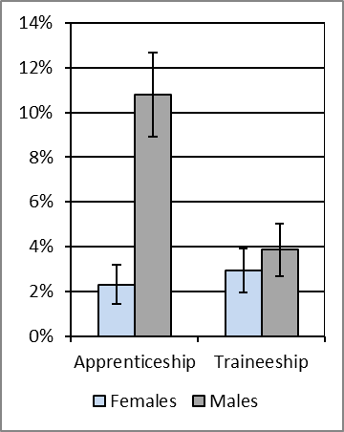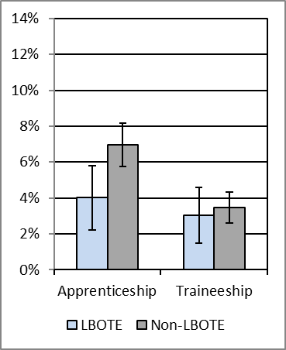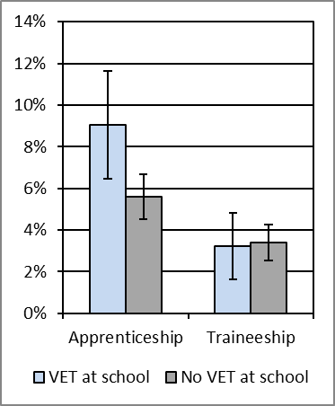

Note: The error bars reflect the 95 percent confidence intervals and no overlap indicates there is a statistical difference between the results.

Overall, six percent of 2018 year 12 graduates indicated they were undertaking an apprenticeship in 2019 and three percent were doing a traineeship. The percentage of graduates undertaking an apprenticeship varied significantly for selected demographics (see Figure 4 above):

* male graduates were much more likely to be undertaking an apprenticeship than females
* graduates who participated in a VET course at school were more likely to be undertaking an apprenticeship than graduates who did not.

Thirty-six percent of 2018 year 12 graduates who were not studying in 2019 reported their main reason for not studying was to “take a gap year”, 14 percent indicated that they had “got a job”, 10 percent were “not sure what to study”, and seven percent “wanted to earn money” (see Table 4 below). Seventy-four percent of graduates who were not studying and had an ATAR over 95 reported their main reason for not studying was because they were “taking a gap year” and 7 percent “got a job”.

Table 4: 2018 year 12 graduates not studying in 2019, by main reason for not studying and selected demographics (%)

|  |  |  |  |  |  |  |  |  |
| --- | --- | --- | --- | --- | --- | --- | --- | --- |
|  |  | **Taking a gap year** | **Not sure what to study** | **Got a job** | **Wanted to earn money** | **Travelling** | **Not ready for study** | **Other** |
| **Gender** | |  |  |  |  |  |  |  |
|  | Females | 38.3 | 11.0 | 13.0 | 6.3 | 5.4 | 4.5 | 16.9 |
|  | Males | 33.6 | 9.4 | 15.9 | 8.0 | 3.1 | 3.6 | 22.1 |
| **Participated in a VET course at school** | | | |  |  |  |  |  |
|  | No | 36.7 | 9.7 | 13.8 | 7.3 | 3.9 | 3.7 | 20.6 |
|  | Yes | 34.1 | 11.7 | 15.9 | 6.6 | 5.6 | 5.1 | 15.3 |
| **ATAR Group** | |  |  |  |  |  |  |  |
|  | No ATAR | 19.4 | 11.0 | 19.6 | 9.2 | 2.7 | 4.3 | 28.2 |
|  | 1 - 65 | 32.6 | 14.6 | 14.2 | 7.9 | 3.9 | 8.5 | 10.1 |
|  | 66 - 75 | 46.9 | 11.6 | 11.8 | 6.7 | 4.3 | 2.6 | 11.5 |
|  | 76 - 85 | 55.7 | 4.7 | 7.5 | 4.6 | 7.7 | 3.5 | 15.0 |
|  | 86 - 95 | 57.2 | 7.7 | 7.0 | 4.1 | 7.5 | 1.4 | 15.0 |
|  | 96 - 100 | 74.2 | 0.0 | 7.4 | 0.0 | 3.0 | 0.0 | 14.7 |
| **All graduates** | | **36.1** | **10.1** | **14.3** | **7.1** | **4.3** | **4.0** | **24.0** |

Note: The percentages in this table do not all add to 100 percent due to rounding and a small percentage of ‘don’t know’ responses.

Of the 41 percent of 2018 year 12 graduates who were not studying in 2019, 67 percent intended to start some study in the next two years. This high rate of deferral in ACT is consistent with previous years and the general trend in Australia, with the incidence increasing from 10 percent in 1999-2000 to 24 percent in 2009-10 (Lumsden & Stanwick, 2012).

In general, as ATAR increased, so did intention to start some study in the next two years. The most common intended ASCED fields of study related to:

* society and culture (16%)
* Creative arts (14%)
* Health (14%).

Labour force status

Seventy-seven percent of 2018 year 12 graduates reported having a paid job in 2019 (see Table 5 below). Twelve percent reported not currently having a paid job and actively looking for work with the majority looking for part-time work.

**Table 5: Number and proportion of 2018 year 12 graduates, by labour force status in 2019**

|  |  |  |  |
| --- | --- | --- | --- |
|  |  |  | **Proportion (%)** |
|  | **Employed** |  | **76.8** |
|  |  | Full-time | 21.5 |
|  |  | Part-time | 54.8 |
|  |  | Don't know/Refused | 0.5 |
|  | **Unemployed** | | **11.9** |
|  |  | Looking for full-time work | 1.0 |
|  |  | Looking for part-time work | 9.4 |
|  |  | Looking for full or part-time work | 2.6 |
|  | **Total in labour force** | | **88.9** |
| **Not in labour force** | | | **11.1** |
| **Total** | |  | **100.0** |
| **Unemployment rate** | | | **13.6** |

Note: The percentages in this table may not all add to 100 percent due to rounding and a small percentage of ‘don’t know’ responses.

The percentage of 2018 year 12 graduates who were receiving a government pension, allowance or benefit in May 2019 varied depending on their labour force status. Nineteen percent of graduates who were unemployed and 19 percent of those not in the labour force were receiving a government pension, allowance or benefit in May 2019, compared with six percent of employed graduates.

The *Australian and New Zealand Standard Classification of Occupations* (ANZSCO) was used to classify occupations. The most common occupations were:

* sales workers (35%)
* community and personal service workers (26%).

Eighty-two percent of 2018 year 12 graduates studying part-time in 2019 were employed, with 43 percent employed part‑time (see Table 6 below). Sixty-eight percent of graduates studying full-time were employed, with the majority (59%) employed part‑time. Eighty-two percent of graduates who were not studying were employed and 11 percent were unemployed.

Table 6: 2018 year 12 graduates in the labour force in 2019, by study status in 2019 (%)

|  |  |  |  |  |  |  |  |
| --- | --- | --- | --- | --- | --- | --- | --- |
|  |  |  | **Studying** | | | **Not studying** | **All graduates** |
|  |  |  | **Part-time** | **Full-time** | **Total** |  |  |
|  | **Employed** | | **82.3** | **68.0** | **70.4** | **82.2** | **75.2** |
|  |  | Full-time | 39.1 | 8.4 | 14.2 | 31.1 | 21.0 |
|  |  | Part-time | 43.2 | 59.2 | 55.9 | 50.3 | 53.6 |
|  | **Unemployed** | | **9.7** | **15.1** | **14.2** | **10.9** | **12.9** |
|  |  | Looking for full-time work | 0.7 | 0.2 | 0.3 | 2.0 | 1.0 |
|  |  | Looking for part-time work | 5.9 | 14.1 | 12.6 | 4.3 | 9.2 |
|  |  | Looking for full or part-time work | 3.0 | 0.7 | 1.2 | 4.4 | 2.5 |
| **Total in labour force** | | | **92.0** | **83.1** | **84.6** | **93.1** | **88.0** |
| **Not in labour force** | | | **8.0** | **16.9** | **15.4** | **6.9** | **12.0** |
| **Total** | | | **100.0** | **100.0** | **100.0** | **100.0** | **100.0** |

Note: The percentages in this table may not all add to 100 percent due to rounding and a small percentage of ‘don’t know’ responses.

Participation in other post-school activities

The percentage of 2015, 2016, 2017 and 2018 year 12 graduates who participated in various activities in the year following leaving school is shown in Table 7. Participation has remained stable over the four years. At the time of the survey in May 2019:

* 20 percent of 2018 year 12 graduates were travelling
* 19 percent were undertaking volunteer work
* 11 percent were pursuing elite sporting interests
* 9 percent were caring for family members.

Table 7: Year 12 graduates participating in various post school activities (%)

|  |  |  |  |  |
| --- | --- | --- | --- | --- |
| **Activity** | **2015** | **2016** | **2017** | **2018** |
| Travelling | 18.1 | 21.8 | 24.2 | 19.7 |
| Undertaking volunteer work | 12.3 | 14.0 | 15.4 | 18.6 |
| Pursuing elite sporting interests | 11.1 | 10.7 | 10.4 | 11.2 |
| Caring for family members | 11.0 | 8.9 | 10.7 | 8.8 |

# Destination of 2018 school leavers

Seventy-one percent of 2018 school leavers reported they were employed and/or studying in 2019. This is higher than the Australian employed and/or studying rate in 2019 of 65 percent for 15-20 year olds who completed year 11 or below prior to leaving school in 2018 (Australian Bureau of Statistics, 2019).

Table 8: School leavers employed and/or studying, by selected demographics (%)

|  |  |  |  |  |  |  |  |  |  |  |  |  |  |  |  |
| --- | --- | --- | --- | --- | --- | --- | --- | --- | --- | --- | --- | --- | --- | --- | --- |
|  |  | **Employed** | | | |  | **Currently studying** | | | |  | **Employed and/or studying** | | | |
| **Year left school** | | **2015** | **2016** | **2017** | **2018** |  | **2015** | **2016** | **2017** | **2018** |  | **2015** | **2016** | **2017** | **2018** |
| **Gender** | |  |  |  |  |  |  |  |  |  |  |  |  |  |  |
|  | Females | 63.9 | 66.0 | 62.7 | 52.8 |  | 32.2 | 39.6 | 41.9 | 38.1 |  | 74.3 | 72.7 | 75.5 | 65.8 |
|  | Males | 58.6 | 66.6 | 64.6 | 58.5 |  | 41.9 | 47.1 | 48.1 | 47.2 |  | 73.8 | 80.4 | 78.2 | 73.4 |
| **Year level** | |  |  |  |  |  |  |  |  |  |  |  |  |  |  |
|  | Year 9 to 11 | 65.6 | 69.8 | 68.8 | 65.5 |  | 39.0 | 42.8 | 49.4 | 51.4 |  | 68.8 | 77.7 | 76.1 | 74.0 |
|  | Year 12 | 56.4 | 64.0 | 60.1 | 51.4 |  | 38.2 | 46.2 | 43.4 | 39.6 |  | 78.1 | 78.2 | 78.3 | 69.7 |
| **LBOTE** | |  |  |  |  |  |  |  |  |  |  |  |  |  |  |
|  | No | 62.3 | 68.2 | 65.9 | 60.4 |  | 38.2 | 43.9 | 46.2 | 44.8 |  | 74.1 | 77.3 | 78.4 | 73.2 |
|  | Yes | 39.8 | 47.6 | 46.4 | 31.6 |  | 41.7 | 54.0 | 43.1 | 41.1 |  | 73.4 | 84.7 | 66.9 | 57.3 |
| **Received career counselling/career guidance at school1** | | | | | |  |  |  |  |  |  |  |  |  |  |
|  | No | 52.4 | 48.5 | 51.2 | 55.0 |  | 29.7 | 43.4 | 43.8 | 49.6 |  | 61.9 | 63.9 | 65.1 | 66.9 |
|  | Yes | 66.8 | 75.5 | 70.5 | 62.3 |  | 45.4 | 50.4 | 49.7 | 45.5 |  | 83.8 | 86.6 | 85.3 | 79.5 |
| **Participated in work experience/workplace learning whilst at school2** | | | | | | | |  |  |  |  |  |  |  |  |
|  | No | 51.0 | 64.7 | 58.9 | 55.8 |  | 37.0 | 43.3 | 38.5 | 41.9 |  | 67.8 | 77.5 | 72.6 | 71.8 |
|  | Yes | 70.6 | 68.7 | 70.5 | 59.1 |  | 40.2 | 46.8 | 55.8 | 48.0 |  | 80.6 | 78.6 | 83.4 | 70.9 |
| **Receiving a government pension, allowance or benefit at the time of the survey** | | | | | | | | |  |  |  |  |  |  |  |
|  | No | 65.9 | 72.8 | 72.2 | 62.9 |  | 41.0 | 47.2 | 49.4 | 48.7 |  | 79.2 | 84.5 | 84.5 | 77.5 |
|  | Yes | 30.5 | 33.3 | 12.8 | 22.1 |  | 26.1 | 32.2 | 25.0 | 15.6 |  | 46.6 | 44.6 | 32.6 | 31.0 |
| **All school leavers** | | **60.5** | **66.5** | **64.0** | **57.2** |  | **38.5** | **44.8** | **46.1** | **44.4** |  | **74.0** | **78.0** | **77.3** | **71.4** |

1 In 2017 career guidance replaced career counselling. 2 In 2017 workplace learning replaced work experience.

The percentage of school leavers employed and/or studying in the year after leaving school is detailed in Table 8. Data are presented for surveys conducted with 2015, 2016, 2017 and 2018 school leavers. The following points were consistently noted over the four years:

* school leavers who were LBOTE were less likely to be employed than those who were not LBOTE
* school leavers who received career counselling/guidance at school were more likely to be employed than those that did not receive career counselling
* males were more likely to be studying than females
* school leavers who were receiving a Government pension, allowance or benefit were less likely to be employed and/or studying than those not receiving this assistance.

Forty-four percent of 2018 school leavers indicated that they were undertaking some study in 2019, with 23 percent studying full-time (see Table 9 below). This is similar to the Australian study rate in 2019 of 38 percent for 15-20 year olds who completed year 11 or below prior to leaving school in 2018 (Australian Bureau of Statistics, 2019).

Table 9: 2018 school leavers studying in 2019, by selected demographics (%)

|  |  |  |  |  |  |
| --- | --- | --- | --- | --- | --- |
|  |  | **Studying** | | | **Not studying** |
|  |  | **Part-time** | **Full-time** | **All** |  |
| **Gender** |  |  |  |  |  |
|  | Females | 18.1 | 15.9 | 38.1 | 61.9 |
|  | Males | 17.4 | 26.2 | 47.2 | 52.8 |
| **Year level** | |  |  |  |  |
|  | Year 9 to 11 | 32.8 | 14.3 | 51.4 | 48.6 |
|  | Year 12 | 6.9 | 29.3 | 39.6 | 60.4 |
| **LBOTE** |  |  |  |  |  |
|  | No | 19.1 | 21.8 | 44.8 | 55.2 |
|  | Yes | 5.1 | 33.5 | 41.1 | 58.9 |
| **Received career guidance at school** | | |  |  |  |
|  | No | 18.3 | 24.2 | 49.6 | 50.4 |
|  | Yes | 17.9 | 25.0 | 45.5 | 54.5 |
| **Participated in workplace learning whilst at school** | | |  |  |  |
|  | No | 15.9 | 23.8 | 41.9 | 58.1 |
|  | Yes | 19.8 | 22.2 | 48.0 | 52.0 |
| **Receiving a government pension, allowance or benefit at the time of the survey** | | | | |  |
|  | No | 19.8 | 24.5 | 48.7 | 52.8 |
|  | Yes | 4.3 | 11.3 | 15.6 | 0.8 |
| **All school leavers** | | **17.5** | **23.1** | **44.4** | **55.6** |

Note: The percentages in this table do not all add to 100 percent due to rounding and a small percentage of ‘don’t know’ responses.   
1 In 2017 career guidance replaced career counselling. 2 In 2017 workplace learning replaced work experience.

The main reason why 2018 school leavers chose their course of study in 2019 was because it interested them (37%) and 33 percent thought it would assist with employment.For 2018 school leavers, the most common ASCED subjects of study related to:

* architecture and building (20%). This included fields such as landscape architecture, interior design, regional planning, bricklaying, carpentry and plumbing
* engineering and related technologies (17%). This included study aimed at developing basic literacy and numeracy skills and general skills needed for employment and personal wellbeing and
* food, hospitality and personal services (11%). This included fields such as hospitality, cookery and hairdressing.

Twenty-five percent of 2018 school leavers reported undertaking an apprenticeship or traineeship in 2019. The percentage of year 9 to 11 school leavers undertaking an apprenticeship was significantly greater than the percentage of year 12 leavers undertaking an apprenticeship (see Figure 5 below). Of the school leavers who were undertaking an apprenticeship or traineeship, the majority (52%) were technicians and trade workers (ANZSCO) studying architecture and building or engineering and related technologies.(ASCED).

Figure 5: 2018 school leavers undertaking an apprenticeship or traineeship in 2019, by selected demographics (%)

Note: The error bars reflect the 95 percent confidence intervals and no overlap indicates there is a statistical difference between the results.

Sixty-seven percent of the 2018 school leavers who were not studying in 2019 intended to start some study in the next two years. Eighteen percent of 2018 school leavers who were not studying in 2019 reported their main reason for not studying as family commitments, illness or disability, 17 percent were employed and 12 percent were taking a gap year.

Fifty-seven percent of 2018 school leavers reported having a paid job in 2019 (see Table 10 below). Twenty percent of school leavers said they did not have a paid job but were actively looking for work. Twenty-three percent of 2018 school leavers were not in the labour force in 2019. The unemployment rate was 26 percent for school leavers.

Of the 2018 school leavers who had a paid job in 2019, the most common ANZSCO occupations were:

* technicians and trade workers (30%)
* sales workers (20%)
* community and personal service workers (19%)
* labourers (18%).

Table 10: Number and proportion of 2018 school leavers, by labour force status in 2019

|  |  |  |  |
| --- | --- | --- | --- |
|  |  |  | **Proportion (%)** |
|  | **Employed** |  | **57.2** |
|  |  | Full-time | 30.4 |
|  |  | Part-time | 26.2 |
|  |  | Don't know/Refused | 0.6 |
|  | **Unemployed** | | **20.0** |
|  |  | Looking for full-time work | 3.3 |
|  |  | Looking for part-time work | 7.3 |
|  |  | Looking for full or part-time work | 9.3 |
|  |  | Don't know/Refused | 0.0 |
|  | **Total in labour force** | | **77.1** |
| **Not in labour force** | |  | **22.9** |
| **Total** |  |  | **100.0** |
| **Unemployment rate** | | | **25.9** |

At the time of the survey in 2019, some 2018 school leavers were participating in other post-school activities, either instead of or as well as study and/or employment:

* 15 percent were travelling
* 11 percent were caring for family members
* eight percent were undertaking volunteer work
* seven percent were pursuing elite sporting interests.

# Characteristics of all students who left school in 2018

Table 11 details the characteristics of all students who left school in 2018; both year 12 graduates and school leavers.

A slightly higher proportion of Year 12 graduates who completed the survey were female (52%); however for school leavers the majority of respondents (71%) were male. Fifty-nine percent of the 2018 school leavers who completed the survey were in year 12 when they left school. Twenty-one percent of graduates spoke a language other than English at home, whilst 11 percent of school leavers spoke a language other than English at home. When compared with graduates, school leavers were twice as likely to have participated in school-based engagement programs. Graduates were more likely to have received career guidance at school. Nineteen percent of year 12 graduates participated in pathways planning at school compared to 12 percent of school leavers.

Table 11: 2018 school leavers and year 12 graduates, by selected demographics (%)

|  |  |  |
| --- | --- | --- |
| **Selected Demographics** | **School leavers** | **Year 12 Graduates** |
| Year 9 to 11 | 40.9 | n.a. |
| Year 12 | 59.1 | 100.0 |
| Females | 28.4 | 51.6 |
| Males | 71.0 | 47.9 |
| LBOTE | 11.3 | 20.6 |
| Participated in a VET course at school | n.a. | 21.4 |
| Received career guidance at school | 59.5 | 69.0 |
| Participated in workplace learning whilst at school | 40.8 | 43.6 |
| Participated in pathways planning whilst at school | 11.7 | 19.1 |
| Received a government pension, allowance or benefit at the time of the survey | 13.5 | 9.3 |
| Participated in engagement programs whilst at school | 10.5 | 5.1 |
| Participated in support programs for students with disability at school | 8.3 | 7.4 |
| Aboriginal and Torres Strait Islanders | 5.1 | 1.7 |

Note: n.a. indicates that results are not applicable.

Specific survey results for two key student populations; students with disability and Aboriginal and Torres Strait Islander students have not been included in this publication due to the small number who participated in the survey. More than half of the young people with disability who graduated or left school in 2018 were employed and/or studying in 2019. Although most attended a mainstream school, a small proportion attended a specialist school for students with disability and just under half of these students were participating in community support programs at the time of the survey in 2019. Eighty-two percent of Aboriginal and Torres Strait Islander young people who graduated or left school in 2018 were employed and/or studying in 2019.

# Satisfaction with school

Parents of 2018 year 9 to 11 school leavers were asked about their level of satisfaction with the school the student most recently attended and 57 percent of parents were satisfied with the school. In contrast, the 2018 School Satisfaction Survey showed that overall 85 percent of parents and carers were satisfied with the school their child attended.

Year 12 school leavers and year 12 graduates from 2018 were asked about their level of agreement with seven statements regarding their experience in years 11 and 12 in the ACT (see Figure 6 below). Responses of strongly agree or agree were classified as “satisfied”, responses of strongly disagree or disagree as “not satisfied” and responses of neither agree nor disagree as “neutral”.

Overall 64 percent of year 12 school leavers and 80 percent of year 12 graduates found year 11 and 12 worthwhile. The difference between these two proportions is statistically significant. Year 12 graduates were significantly more satisfied than year 12 school leavers in terms of their responses to the statements “It was satisfying and rewarding” and “It prepared me for future choices”.

Figure 6: 2018 year 12 graduates and year 12 school leavers satisfied with various aspects of their year 11 and 12 experience (%)



Note: The error bars reflect the 95 percent confidence intervals and no overlap indicates there is a statistical difference between the results.

2018 year 12 graduates and year 12 school leavers were also asked about their level of satisfaction with their life as a whole at the time of the survey in May 2019. A similar pattern was observed with 73 percent of graduates and 60 percent of year 12 leavers being satisfied or very satisfied. Of particular interest is that year 12 graduates and year 12 school leavers who received career guidance at school were more satisfied with their life than those who did not receive career guidance at school. 75 percent of 2018 year 12 graduates who received career guidance at school were satisfied with their life compared with 68 percent of those who did not receive career guidance at school. Whilst the level of satisfaction with life was similar for male and female graduates, for year 12 school leavers, males tended to be more satisfied.

# Reasons for leaving school

Parents of year 9 to 11 students who left school in 2018 were asked the reasons why their child decided to leave school (see Table 12 below). The most common responses were:

* the child wanted to earn their own money (60%)
* the child wanted to get a job (59%)
* the child had a job to go to (58%).

Table 12: Most common responses parents gave regarding why their child (who was in year 9, 10 or 11 in 2018) left school

|  |  |
| --- | --- |
| **Response Categories** | **Proportion (%)** |
| Not doing very well at school | 56.3 |
| Wanted to get a job | 58.9 |
| Wanted to earn his/her own money | 60.5 |
| Had a job to go to | 58.0 |
| Wanted to do study or training that wasn't available at school | 41.2 |
| Didn't get on with the teachers and/or students at school | 32.0 |
| Had an illness, disability or caring responsibilities | 33.7 |

Note: The percentages in this table do not add to 100 percent, as respondents could provide more than one response.

Part 2 – 2017 Year 12 Graduates and School Leavers

# Pathways of 2017 year 12 graduates

Key outcomes

Ninety-eight percent of 2017 year 12 graduates reported that they were employed and/or studying in 2019. Eighty-four percent of graduates were employed and 73 percent were studying in 2019. Participation in both study and employment increased from 2018 to 2019. Overall there was a slight increase in the percentage employed and/or studying over the same period (see Table 13 below).

This general increase in participation in study is consistent with results reported in similar interstate longitudinal surveys with different year cohorts (Queensland Department of Education, Training and Employment, 2013; Victorian Department of Education and Early Childhood Development, 2010). However, the percentage increase in participation in study was larger in ACT. This may be due to the more recent reporting period in this publication and/or the greater percentage of graduates who deferred study in the first year after leaving school and commenced study in the following year in the ACT.

Table 13: 2017 year 12 graduates employed and/or studying in 2018 and 2019 by selected demographics(%)

|  |  |  |  |  |  |  |  |  |  |
| --- | --- | --- | --- | --- | --- | --- | --- | --- | --- |
|  |  | **Employed** | |  | **Currently studying** | |  | **Employed and/or studying** | |
|  | | 2018 | 2019 |  | 2018 | 2019 |  | 2018 | 2019 |
| **Gender** | |  |  |  |  |  |  |  |  |
|  | Female | 79.6 | 86.5 |  | 58.0 | 74.4 |  | 95.9 | 98.4 |
|  | Male | 76.6 | 80.1 |  | 58.8 | 71.2 |  | 92.7 | 96.8 |
| **Participated in a VET course at school** | | |  |  |  |  |  |  |  |
|  | No | 77.6 | 83.1 |  | 58.3 | 73.6 |  | 94.4 | 97.5 |
|  | Yes | 80.9 | 85.4 |  | 58.9 | 70.5 |  | 94.5 | 98.3 |
| **Received career counselling at school** | | |  |  |  |  |  |  |  |
|  | No | 76.5 | 84.5 |  | 54.0 | 65.4 |  | 92.4 | 97.1 |
|  | Yes | 79.3 | 83.7 |  | 59.7 | 75.5 |  | 95.3 | 97.9 |
| **Participated in work experience at school** | | |  |  |  |  |  |  |  |
|  | No | 77.2 | 82.9 |  | 56.0 | 72.6 |  | 93.2 | 97.1 |
|  | Yes | 79.4 | 84.3 |  | 61.1 | 73.4 |  | 95.8 | 98.3 |
| **All graduates** | | **78.3** | **83.6** |  | **58.4** | **72.9** |  | **94.4** | **97.7** |

The 2019 main employment and study destinations for 2017 year 12 graduates by employment and study destination in 2018 is shown in Table 14. Ninety percent of the graduates who were employed in 2018 were also employed in 2019, 86 percent of those studying in 2018 were also studying in 2019 and 98 percent of those employed and/or studying in 2018 were also employed and/or studying in 2019. Of the 2017 year 12 graduates who were not employed or studying in 2018, 69 percent were employed in 2019 and 55 percent were studying in 2019. Ten percent of the 2017 year 12 graduates who were not employed or studying in 2018 were also in this category in 2019.

Table 14: 2017 year 12 graduates employed and/or studying in 2019, by employed and/or studying in 2018 (%)

|  |  |  |  |  |  |
| --- | --- | --- | --- | --- | --- |
| **2018** | **2019** | | | | **Distribution in 2018** |
| Employed | Studying | Employed &/or Studying | Not employed or studying |
| Employed | 90.1 | 71.4 | 98.4 | 1.6 | **60.0** |
| Studying | 81.8 | 86.4 | 99.0 | 1.0 | **44.0** |
| Employed and/or Studying | 84.4 | 74.0 | 98.1 | 1.9 | **74.5** |
| Not employed or studying | 68.8 | 55.0 | 89.9 | 10.1 | **25.5** |
| **Distribution in 2019** | **83.6** | **72.9** | **97.7** | **2.3** | **100.0** |

Study

Most (86%) of the 2017 year 12 graduates who were studying in 2018 were also studying in 2019. Ninety-three percent of those studying at the higher education level were also studying at this level in 2019 and 50 percent of those engaged in VET were also studying VET in 2019 (see Table 15 below). Thirty-four percent of the year 12 graduates who were studying at the VET level in 2018 were not studying in 2019, with the majority (55%) of these graduates completing the qualification prior to the survey in 2019. Over half (54%) of the graduates who were not studying in 2018 were studying in 2019. Thirty-eight percent of 2017 year 12 graduates not studying in 2018 were studying at the higher education level in 2019, with the majority (70%) of these students having formally deferred university in 2018.

Table 15: Level of study in 2019 by level of study in 2018 for 2017 Year 12 graduates(%)

|  |  |  |  |  |  |  |  |  |
| --- | --- | --- | --- | --- | --- | --- | --- | --- |
|  |  | **2019** | | | | | | |
|  |  | **Studying** | | | | **Not studying** | | **Total** |
| **2018** | | **Higher education** | **VET course** | **Other** | **Total** |
| **Studying** | | **70.5** | **14.4** | **1.5** | **86.4** | **13.6** | **100.0** | |
|  | Higher education | 93.0 | 1.7 | 0.0 | 94.7 | 5.3 | 100.0 | |
|  | VET course | 15.8 | 49.5 | 0.5 | 65.8 | 34.2 | 100.0 | |
|  | Other | 28.3 | 6.9 | 39.1 | 74.4 | 25.6 | 100.0 | |
| **Not Studying** | | **37.6** | **14.7** | **1.7** | **54.0** | **46.0** | **100.0** | |
| **Distribution in 2019** | | **56.8** | **14.5** | **1.6** | **72.9** | **27.1** | **100.0** | |

Note: The percentages in this table do not all add to 100 percent due to rounding and a small percentage of ‘don’t know’ responses.

Forty-one percent of 2017 year 12 graduates were studying at the higher education level in 2018. Figure 7 provides details of the 2019 main destination for 2017 year 12 graduates studying at the higher education level in 2018. Of those that were studying at the higher education level in 2018:

* the majority (80%) were also studying at the higher education level in 2019 with 71 percent found to be undertaking the same study in 2019 and 9 percent making a change to their study field, qualification and/or study load in 2019
* nineteen percent did not continue to study in 2019, with eighteen percent employed and one percent unemployed.

Figure 7: 2019 main destination for 2017 Year 12 graduates who were studying at the higher education level in 2018

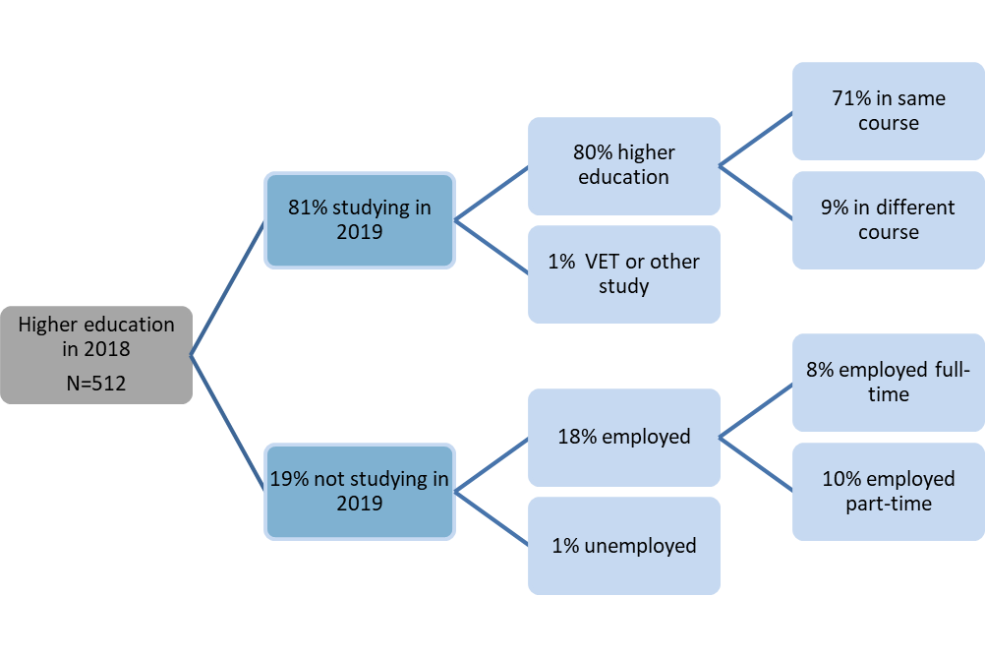

Note: The percentages in this figure do not all add to 100 percent due to rounding and a small percentage of ‘don’t know’ responses.

Fifteen percent of 2017 year 12 graduates were studying at in Vocational Education and Training (VET) in 2018. Figure 8 provides details of the 2019 main destination for 2017 year 12 graduates studying VET in 2018. Of those who were studying VET in 2018, 32 percent were also studying VET in 2019. 28 percent were undertaking the same course in 2019 and 4 percent made a change to their study field, qualification and/or study load in 2019.

* sixty-two percent did not continue to study in 2019, with fifty-six percent employed and six percent unemployed.

Figure 8: 2019 main destination for 2017 Year 12 graduates who were studying at the VET level in 2018

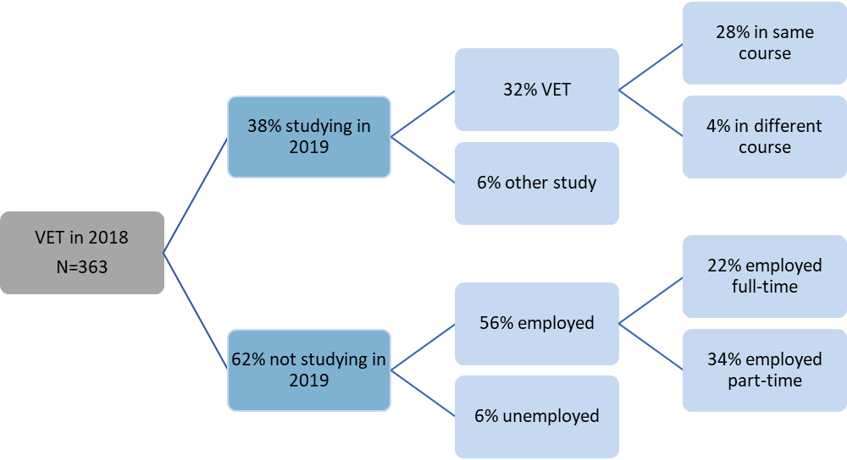

Note: The percentages in this figure do not all add to 100 percent due to rounding and a small percentage of ‘don’t know’ responses.

Five percent of 2017 year 12 graduates were undertaking an Australian Apprenticeship (had signed a national training contract) in 2018. Figure 9 provides details of the 2019 main destination for 2017 year 12 graduates who were undertaking an Australian Apprenticeship in 2018. Of those who were undertaking an Australian Apprenticeship in 2018:

* twenty-nine percent were also undertaking an apprenticeship or traineeship in 2019, with 29 percent in the same apprenticeship or traineeship
* forty-eight percent were studying in 2019 but not as an apprentice or trainee
* twenty-three percent were not studying in 2019 and employed.

Figure 9: 2019 main destination for 2017 Year 12 graduates who were undertaking an Australian Apprenticeship in 2018

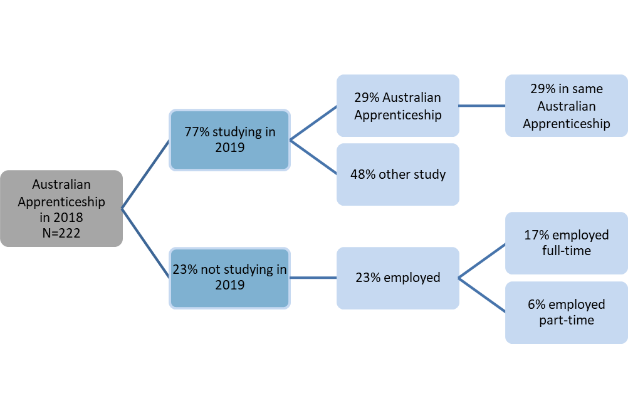

Note: The percentages in this figure may not add to 100 percent due to rounding and a small percentage of ‘don’t know’ responses.

Eight percent of 2017 year 12 graduates were studying in 2018 but not in 2019. Eight percent of 2017 Year 12 graduates were not studying in 2018 or 2019 but indicated that they were planning to study in 2019 or 2020 at the time of the survey in 2018. Thirty two percent of these graduates said their main reason for not studying was because they got a job.

Thirty-one percent of 2017 year 12 graduates intended to start some study in the next two years at the time of the survey in 2018, with 46 percent of these graduates formally deferring a university offer. Figure 10 details the 2019 study destination for these graduates and graduates with an informal intention to study (intended to study but did not formally defer university) in the next two years.

Of those who deferred university in 2018:

* seventy-seven percent were attending university
* five percent were studying elsewhere
* eighteen percent were not studying in 2019.

Of those with an informal intention to study in 2018:

* fifty-three percent were not studying
* twenty-two percent were attending university
* twenty-five percent were studying elsewhere in 2019.

Figure 10: 2019 study destination for 2017 Year 12 graduates who in 2018 reported an intention to study

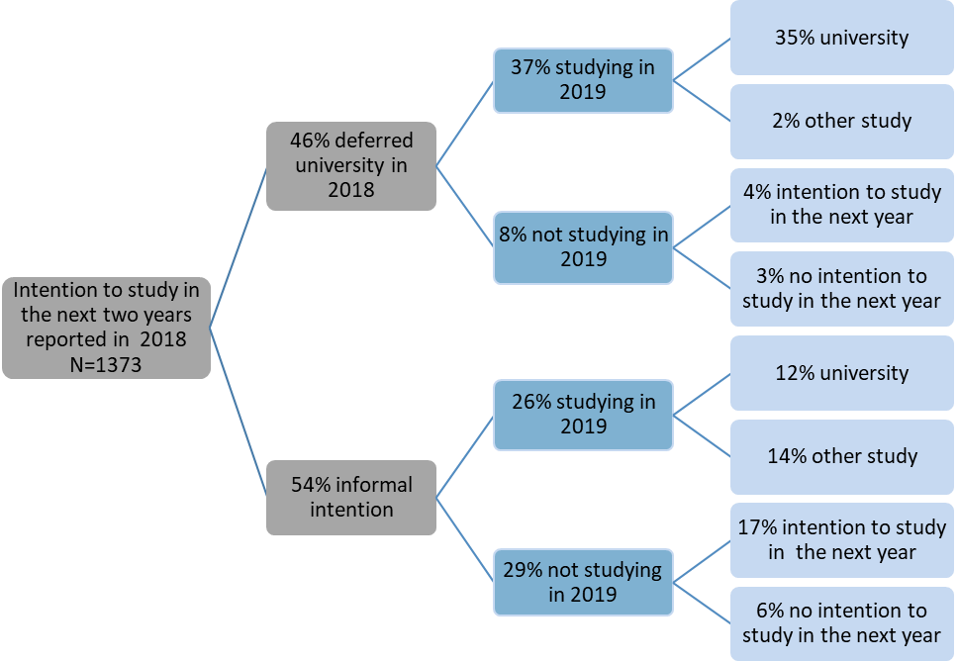

Note: The percentages in this figure may not add to 100 percent due to rounding and a small percentage of ‘don’t know’ responses.

Twenty percent of 2017 year 12 graduates were intending to study in the next two years at the time of the survey in 2018 and were studying in 2019, with 62 percent of these graduates studying in their intended ASCED field of study. Table 16 highlights the most common fields of study in 2019 for each of the most common intended fields of study in 2018. Fifteen percent of 2017 year 12 graduates who intended to study in the field of society and culture in 2018 commenced study in the field of management and commerce in 2019.

Table 16: 2019 field of study by 2018 intended field of study for 2017 Year 12 graduates(%)

|  |  |  |  |  |  |  |  |
| --- | --- | --- | --- | --- | --- | --- | --- |
| **Intended field of study in 2018** | **Field of study in 2019** | | | | | | |
| Natural & physical sciences | Health | Management & commerce | Society and culture | Creative arts | Other | **Total** | |
| Natural & physical sciences | 55.8 | 18.9 | 0.0 | 0.0 | 0.0 | 25.3 | **100.0** | |
| Health | 7.5 | 82.6 | 0.0 | 3.7 | 3.2 | 3.0 | **100.0** | |
| Management & commerce | 0.0 | 0.0 | 70.2 | 3.7 | 0.0 | 26.0 | **100.0** | |
| Society and culture | 7.9 | 4.0 | 15.5 | 47.3 | 2.1 | 23.2 | **100.0** | |
| Creative arts | 0.0 | 9.5 | 9.5 | 3.9 | 62.4 | 14.6 | **100.0** | |
| Other | 1.2 | 3.0 | 9.7 | 3.0 | 4.0 | 77.5 | **98.4** | |
| **2016 no intention to study** | 0.0 | 17.1 | 9.3 | 15.8 | 3.6 | 54.2 | **100.0** | |
| **Distribution in 2019** | 6.2 | 16.8 | 16.2 | 12.5 | 8.4 | 39.9 | **100.0** | |

Note: The percentages in this table do not all add to 100 percent due to rounding and a small percentage of ‘don’t know’ responses.

Sixty-three percent of 2017 year 12 graduates who in 2018 expressed an intention to study, started studying in 2019, while 37 percent were not engaged in study in 2019. Table 17 details the main reason for starting study in 2019 for each type of study intention in 2018. Of the graduates who deferred university, 45 percent chose a course because it interested them and 27 percent chose the course because they thought it would assist with employment.

Assisting with employment was the most common reason 2017 year 12 graduates with an informal intention to study (46%) and those with no intention to study (48%) decided to start study in 2019.

Table 17: Main reason for starting study in 2019 by study intention in 2018 for 2017 Year 12 graduates (%)

|  |  |  |  |  |  |  |
| --- | --- | --- | --- | --- | --- | --- |
|  | **Reason for starting study in 2019** | | | | | |
| **Not studying in 2018** | It's a course that interests me | To get/start/help in a job/business | To help get into another course | To improve my education | Other | **Total** |
| Deferred University | 45.4 | 27.3 | 1.5 | 1.8 | 24.0 | **100.0** |
| Informal intention to study | 36.0 | 46.5 | 1.7 | 0.0 | 15.8 | **100.0** |
| No intention to study | 21.5 | 48.2 | 0.0 | 5.9 | 24.4 | **100.0** |

Note: The percentages in this table may not add to 100 percent due to rounding and a small percentage of ‘don’t know’ responses.

Labour force status

Overall, part-time employment was the most common labour force status for 2017 year 12 graduates in 2018 and 2019. Most (90%) of the 2017 year 12 graduates who were employed in 2018 were also employed in 2019, with most continuing in either full-time or part-time employment (see Table 18 below). Of those who were unemployed in 2018, 71 percent were employed in 2019 and 22 percent were unemployed. More than half (61%) of those who were not in the labour force in 2018, joined the labour force in 2019, with 46 percent in employment and 15 percent unemployed.

Table 18: 2019 labour force status in 2019 by 2018 labour force status for 2017 Year 12 graduates (%)

|  |  |  |  |  |  |  |  |
| --- | --- | --- | --- | --- | --- | --- | --- |
|  | | **2019** | | | | | |
|  | | **Employed** | | | **Unemployed** | **Not in labour force** | **Total** |
| **2018** | | Part-time | Full-time | Total |  |  |  |
| **Employed** | | **61.8** | **27.5** | **90.1** | **6.0** | **3.9** | **100.0** |
|  | Part-time | 76.1 | 12.8 | 89.4 | 6.5 | 4.2 | **100.0** |
|  | Full-time | 21.7 | 69.4 | 91.9 | 4.9 | 3.2 | **100.0** |
| **Unemployed** | | **60.5** | **10.4** | **70.9** | **22.4** | **6.8** | **100.0** |
| **Not in labour force** | | **41.9** | **3.4** | **46.1** | **15.1** | **38.7** | **100.0** |
| **Distribution in 2017** | | **59.8** | **23.1** | **83.6** | **8.9** | **7.6** | **100.0** |

Note: The percentages in this table do not all add to 100 percent due to rounding and a small percentage of ‘don’t know’ responses.

Seventy-eight percent of 2017 year 12 graduates were employed in 2018 and, of these, 51 percent were studying in 2018. Figure 11 details the 2019 labour force destination for these graduates and graduates who were employed but not studying in 2018. Of those who were employed in 2018:

* thirty-seven percent were studying in 2018 and employed in the same job in 2019
* sixteen percent were not studying in 2018 and employed in a different job in 2019.

Figure 11: 2019 labour force status for 2017 Year 12 graduates employed in 2018, by 2018 study status

Note: The percentages in this figure do not all add to 100 percent due to rounding and a small percentage of ‘don’t know’ responses.

Twelve percent of 2017 year 12 graduates were unemployed in 2018, and 66 percent of these graduates were studying in 2018. Figure 12 details the 2019 labour force destination for these graduates and graduates who were unemployed and not studying in 2018. Of those that were unemployed in 2018, 46 percent were studying in 2018 and employed in 2019 and 25 percent were not studying in 2018 and employed in 2019.

Figure 12: 2019 labour force status for 2017 Year 12 graduates unemployed in 2018, by 2018 study status

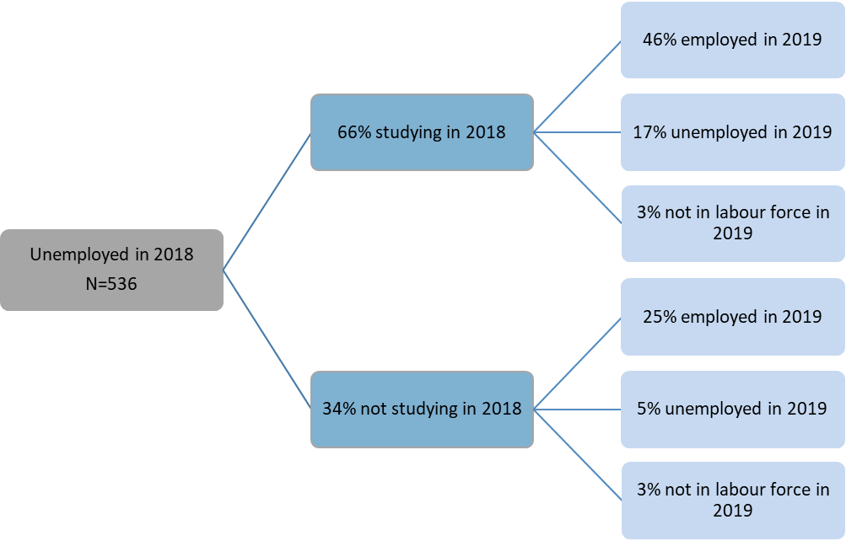

Note: The percentages in this figure do not all add to 100 percent due to rounding and a small percentage of ‘don’t know’ responses.

Ten percent of 2017 year 12 graduates were not in the labour force in 2018, and 84 percent of these graduates were studying in 2018. Figure 13 details the 2019 labour force destination for these graduates who were not in the labour force in 2018. Of those that were not in the labour force in 2018, 38 percent studied in 2018 and were employed in 2019 and 8 percent did not study in 2018 and were employed in 2019.

Figure 13: 2019 labour force status for 2017 Year 12 graduates not in the labour force in 2018, by 2018 study status

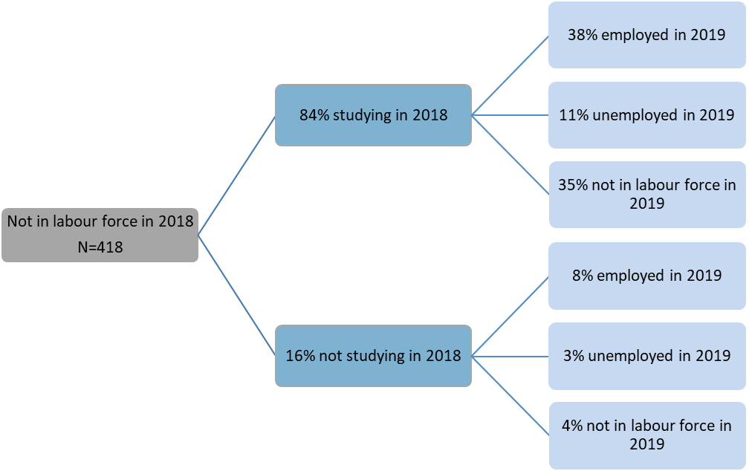

Note: The percentages in this figure do not all add to 100 percent due to rounding and a small percentage of ‘don’t know’ responses.

Fifty-eight percent of the 2017 year 12 graduates were studying in 2018. Part-time employment was the most common labour force status for these graduates in 2018 and 2019. Most (91%) of the 2017 year 12 graduates studying and employed in 2018 were also employed in 2019, with most continuing in either full-time or part-time employment (see Table 19 below). Of those who were studying and unemployed in 2018, 69 percent were employed in 2019 and 26 percent were unemployed.   
Forty-one percent of 2017 year 12 graduates who were studying and not in the labour force in 2018 were in the labour force in 2019.

Table 19: 2019 labour force status by 2018 labour force status for 2017 Year 12 graduates studying in 2018(%)

|  |  |  |  |  |  |  |  |  |
| --- | --- | --- | --- | --- | --- | --- | --- | --- |
|  |  |  | **2019** | | | | | |
|  |  |  | **Employed** | | | **Unemployed** | **Not in labour force** | **Total** |
| **2018** | | | Part-time | Full-time | Total |  |
| **Employed** | | | **70.1** | **20.4** | **91.3** | **4.7** | **4.0** | **100.0** |
|  | Part-time | | 79.8 | 9.6 | 90.0 | 5.6 | 4.4 | **100.0** |
|  | Full-time | | 9.3 | 88.8 | 98.1 | 0.0 | 1.9 | **100.0** |
| **Unemployed** | | | **62.0** | **6.7** | **68.7** | **26.3** | **5.0** | **100.0** |
| **Not in labour force** | | | **41.3** | **3.0** | **45.2** | **13.8** | **41.0** | **100.0** |
| **Distribution in 2019** | | | **65.0** | **16.1** | **81.8** | **9.0** | **9.2** | **100.0** |

Note: The percentages in this table do not all add to 100 percent due to rounding and a small percentage of ‘don’t know’ responses.

# Pathways of 2017 school leavers

Eighty-one percent of 2017 school leavers reported that they were employed and/or studying in 2019. Sixty-three percent of school leavers were employed and 50 percent were studying in 2019. Overall, 2017 school leaver participation in study, employment and employment and/or study increased from 2018 to 2019 (see Table 20 below).

Table 20: 2017 school leavers employed and/or studying in 2018 and 2019 by selected demographics (%)

|  |  |  |  |  |  |  |  |  |  |
| --- | --- | --- | --- | --- | --- | --- | --- | --- | --- |
|  |  | **Employed** | |  | **Currently studying** | |  | **Employed and/or studying** | |
| **Year of survey** | | 2018 | 2019 |  | 2018 | 2019 |  | 2018 | 2019 |
| **Gender** | |  |  |  |  |  |  |  |  |
|  | Female | 61.3 | 67.5 |  | 35.7 | 45.8 |  | 71.1 | 81.1 |
|  | Male | 59.3 | 60.3 |  | 48.1 | 52.3 |  | 76.1 | 81.5 |
| **Year level** | |  |  |  |  |  |  |  |  |
|  | Year 9 to 11 | 70.3 | 73.8 |  | 44.6 | 46.8 |  | 76.4 | 82.6 |
|  | Year 12 | 51.6 | 53.6 |  | 43.5 | 52.9 |  | 72.9 | 80.4 |
| **Received career counselling at school** | | |  |  |  |  |  |  |  |
|  | No | 38.9 | 45.3 |  | 38.4 | 41.3 |  | 56.6 | 64.1 |
|  | Yes | 71.0 | 73.0 |  | 49.1 | 56.0 |  | 84.9 | 91.2 |
| **Participated in work experience at school** | | |  |  |  |  |  |  |  |
|  | No | 59.0 | 58.0 |  | 41.5 | 55.0 |  | 72.4 | 79.3 |
|  | Yes | 61.3 | 68.8 |  | 47.3 | 43.7 |  | 77.3 | 84.1 |
| **All graduates** | | **60.0** | **62.6** |  | **44.0** | **50.2** |  | **74.5** | **81.4** |

The 2019 employment and study destinations for 2017 school leavers by their employment and study destinations in 2018 is detailed in Table 21. Eighty percent of the school leavers who were employed in 2018 were also employed in 2019, 79 percent of those studying in 2018 were also studying in 2019 and 95 percent of those employed and/or studying in 2018 were also employed and/or studying in 2019. Of the 2017 school leavers who were not employed or studying in 2018,   
32 percent were employed in 2019 and 29 percent were studying in 2019. Sixty-one percent of the school leavers who were not employed or studying in 2018 were also in this category in 2019.

Table 21: Proportion of 2017 school leavers employed and/or studying in 2019, by employed and/or studying in 2018 (%)

|  |  |  |  |  |  |
| --- | --- | --- | --- | --- | --- |
| **2018** | **2019** | | | | Distribution in 2018 |
| Employed | Studying | Employed and/or Studying | Not employed or studying |
| Employed | 80.2 | 59.3 | 96.3 | 3.7 | 60.0 |
| Studying | 70.5 | 78.7 | 96.7 | 3.3 | 44.0 |
| Employed and/or Studying | 71.3 | 63.4 | 95.0 | 5.0 | 74.5 |
| Not employed or studying | 31.7 | 29.3 | 39.0 | 61.0 | 25.5 |
| **Distribution in 2019** | **59.9** | **53.5** | **78.9** | **21.1** | **100.0** |

Most (76%) of the 2017 school leavers who were studying in 2018 were also studying in 2019. Seventy-one percent of the 2017 school leavers who were studying at the VET level in 2018 were also studying in 2019, with 65 percent studying at the VET level in 2019. Thirty percent of the school leavers who were not studying in 2018 were studying in 2019.

In relation to the labour force status of 2017 school leavers:

* eighty-one percent who were employed in 2018 were also employed in 2019, with most continuing in either full-time or part-time employment
* forty-seven percent who were unemployed in 2018 were employed in 2019 and 36 percent were unemployed in 2019
* forty-five percent of those who were not in the labour force in 2018 were in the labour force in 2019, with 24 percent in employment and 20 percent unemployed.

# Anticipate satisfaction with life

In 2019, 2017 school leavers and year 12 graduates were asked about their anticipated satisfaction with life in five years (2022). Overall anticipated satisfaction levels were quite high when compared with current satisfaction with life reported by 2018 graduates and school leavers (on page 18 of this report). In addition, graduates reported greater level of satisfaction than school leavers. 2017 year 12 graduates and school leavers who were studying and those who were employed in 2019 were on average more likely to think they would be satisfied with their life in five years. Male school leavers seem to be more optimistic about the future than female school leavers (see Table 22 below).

Table 22: Proportion of 2017 school leavers and year 12 graduates that think they will be satisfied with their life as a whole in five years (2022) by gender and employment and study status.

|  |  |  |  |
| --- | --- | --- | --- |
|  |  | **School leavers** | **Year 12 Graduates** |
| **Gender** | |  |  |
|  | Female | 64.5 | 86.6 |
|  | Male | 82.4 | 84.1 |
| **Study Status in 2019** | |  |  |
|  | Higher education | 100.0 | 88.9 |
|  | VET course | 73.2 | 84.7 |
|  | **Not Studying** | 66.3 | 77.9 |
| **Employed in 2019** | |  |  |
|  | No | 55.3 | 74.3 |
|  | Yes | 87.9 | 87.5 |
| **All** |  | **76.4** | **85.4** |

Glossary

**ANZSCO** - Australian and New Zealand Standard Classification of Occupations is a standard used in Australia and New Zealand to classify all occupations and jobs and is designed to facilitate the organisation and comparability of occupation statistics.

**ASCED** - Australian Standard Classification of Education is a standard used in Australia to classify all education levels and fields of education. It is designed to facilitate the organisation and comparability of education statistics.

**ATAR** - Australian Tertiary Admission Rankis a percentile rankingused by universities to assist in the selection of school leavers for entry into undergraduate courses. It is used as an indication of a student’s suitability for study at university level, and to allow universities to select appropriate numbers of students for each course.

**Career guidance** in schools may include one on one or group discussion between students and career advisors, industry experts and representatives from universities and CIT about various aspects of student pathways planning, such as course choices, work experience and developing a resume. Prior to the 2018 survey, the term ‘career counselling’ was used to describe this set of activities.

**Currently studying** refers to respondents who were actively undertaking some study at the time of the survey, including those attending university, technical and further education (TAFE), undertaking an Australian apprenticeship or repeating year 12.

**Engagement programs** are school based programs, such as Big Picture, Connect 10 and Canberra College Cares.

**Labour force status** provides data on whether a graduate was employed (paid work for one hour or more over a two week period), unemployed (actively looking for paid work) or not in the labour force at the time of the survey. Labour force status was derived from responses to a number of questions in the survey.

**LBOTE** is used in this publication to describe graduates who speak a language other than English at home. Please note, this is slightly different from Language Background other than English (also known as LBOTE) which is used when a language other than English is spoken at home by the individual and/or one or both of their parents.

**Government pensions, allowances and benefits** include Austudy or ABSTUDY, Carer Allowance or Carer Payment, Disability Support Pension, Newstart Allowance, Parenting Payment, Sickness Allowance, Special Benefit and Youth Allowance.

**VET** - Vocational Education and Training courses are accredited vocational courses provided by a Registered Training Organisation. Successful completion usually leads to the award of a Vocational Certificate.

**Workplace learning** includes work experience, structured workplace learning, Australian School Based Apprenticeships and flexible learning options. Flexible learning options are short term vocational education and training programs that are provided by the Education Directorate and are delivered by a registered training organisation (RTO).References

Australian Bureau of Statistics (2019). *Education and Work, Australia, May 2019.* Cat. No. 6227.0. Canberra, Australia: Australian Bureau of Statistics.

Curtis, D., Mlotkowski, P. & Lumsden, M. (2012). *Bridging the gap: Who takes a gap year and why?* Longitudinal Surveys of Australian Youth Research Report. Adelaide, South Australia: National Centre for Vocational Education and Research Ltd.

Queensland Department of Education, Training and Employment (2016). *Next step longitudinal study 2013: A report on the post-school transitions of Queensland’s Year 12 completers from 2010*. Queensland: State of Queensland.

Lumsden, M. & Stanwick, J. (2012). *Who takes a gap year and why?* Longitudinal Surveys of Australian Youth Briefing Paper 28. Adelaide, South Australia: National Centre for Vocational Education and Research Ltd.

Victorian Department of Education and Early Childhood Development (2010). *The On Track Survey 2010 Longitudinal report: The 2007 cohort 3 years on.* Victoria: State of Victoria.

**Published by Education Directorate | ACT Government**

220 Northbourne Avenue, Canberra City ACT 2602 | GPO Box 158, CANBERRA ACT 2601

**Phone**: (02) 6207 5111 **Web**: http://www.det.act.gov.au