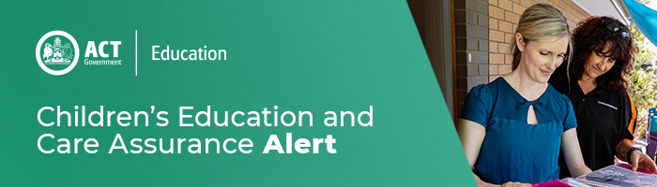
28 July 2020
Maintaining contact details in the National Quality Agenda IT System
The bushfires of 2019–2020 and the advent of COVID-19 has emphasised how critical it is that CECA has up to date emergency contact details for each service as well as each provider. CECA must be able to contact a service or a provider at short notice. These details are also relied upon by the emergency services who may need to communicate critical information and directions.

On 13 March and 27 May 2020 CECA reminded providers and services that contact details for emergencies need to be accurate. The contact details must enable CECA to communicate with a relevant person straight away. A phone number that is unattended or a generic email that is not attended to, are not appropriate contact details. A provider’s email contact or phone number listed in place of a service email contact or phone number also fails to meet the obligation.

All approved providers and services are required to have up to date contact details recorded in National Quality Agenda IT System (NQAITS). It is an offence under Section 174 of the Education and Care Services National Law (ACT) for a provider to fail to notify information in respect of prescribed matters, which include accurate contact details.

It is essential that CECA have the means to directly contact someone responsible for a service or a provider in the event of an emergency.

Providers who have not already reviewed and updated all service and provider level phone numbers, emergency mobile phone numbers and email addresses should do so by close of business on 7 August 2020.

For example, contact details for Persons with Management and Control, provider contacts, service contacts and nominated supervisor contacts should be reviewed and amended to include current information.

As of August 9 August 2020, CECA will take action for approved providers failing to ensure current and appropriate contact details are recorded on NQAITS. So please check and, if necessary, update your contact details now.

For enquires in relation to this notification please call CECA on (02) 6207 1114 or email CECA@act.gov.au
This email has been authorised by the ACT Regulatory Authority (CECA). CECA are responsible for administering the National Quality Framework within the ACT

