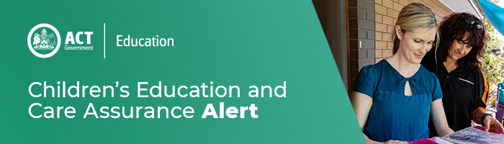
8 December 2020
Avoiding Heat Related Stress in Babies and Young Children
Dear Sector Colleagues

As we enter into the hotter months, it is important to ensure Babies and Young Children stay cool and are well hydrated to avoid heat related stress. The Chief Health Officer has released some information to support education and care providers, this includes:

- Monitoring babies and children for signs of heat related stress;
- Measures that can be used to reduce the risk of heat-related stress to babies and children; and
- Advice on food preparation and storage to prevent growth of pathogens.

Please see letter from the Chief Health Officer for information. If you require additional information on heat-related stress, please visit ACT Health website.

For enquires in relation to this notification please call CECA on (02) 6207 1114 or email CECA@act.gov.au
This email has been authorised by the ACT Regulatory Authority (CECA). CECA are responsible for administering the National Quality Framework within the ACT

