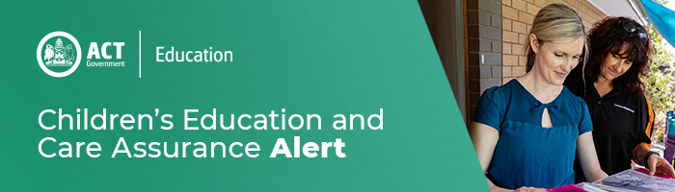
18 December 2020
Thank you for your continued support
This year has been a challenging year, especially for children and young people. Together we have faced bushfires, storms, a global pandemic and economic hardship, but as a Sector you have continued to deliver quality programs to support children and families through this time.
CECA would like to take this opportunity to thank each Educator, Service and Provider for their continued support, resilience and dedication through these unprecedented times. You have done amazing work making sure that early childhood education and care settings are a safe and happy environment where children feel they belong.
CECA would like to wish you and your families a very happy holiday period and for those who are celebrating it, a very Merry Christmas. We hope that you are able to get some respite and spend some time with your loved ones and we look forward to working with you all in 2021.
For enquires in relation to this notification please call CECA on (02) 6207 1114 or email CECA@act.gov.au
This email has been authorised by the ACT Regulatory Authority (CECA). CECA are responsible for administering the National Quality Framework within the ACT

