ABORIGINAL &

TORRES STRAIT ISLANDER EDUCATION 2016-17

REPORT TO THE LEGISLATIVE ASSEMBLY OF THE AUSTRALIAN CAPITAL TERRITORY

CONTENTS

A Message from the Director-General 1
Introduction 2
Aboriginal and Torres Strait Islander
Student Enrolments 2
Quality Learning 3
ACT Early Childhood Strategy 3
Koori Preschool Program 3
Accepting the Challenge Action
Inquiry Program 4
Embedding Aboriginal and Torres Strait Islander
Cultures and Histories in the Curriculum 5
Ngunnawal Plant Use guide pilot program 6
Footprints on Our Land DVD: Aunty Agnes,
Ngunnawal Elder pilot program 6
“Mununja” the butterfly 7
Inspirational teaching and leadership 8
Reconciliation Action Plan –
Keeping It Alive 2016 – 2018 8
Cultural Competency Foundation Program 9
Education Aboriginal and
Torres Strait Islander Staff Network 9
High expectations, high performance 10
Providing a variety of career opportunities
and pathways planning 10
Supporting students at key
transition points 10
Student Aspirations Program 10
Flexible Learning Options 11
Annual Canberra CareersXpo 12
School Apprentices across
ACT Government program 12
Resourcing every ACT Public School to support Aboriginal and Torres Strait Islander students 13
Tutorial Support Scheme 13
Senior Secondary Scholarships Program 13
Tertiary Scholarships Program 14
Mura Achievement Awards 14
NAPLAN Performance 14
NAPLAN Participation Rates 16
Strategies to improve student
engagement and Attendance 17
Retention 18
Year 12 completion rates 19
Connecting with families
and the community 20
Aboriginal and Torres Strait Islander
Elected Body 20
Aboriginal and Torres Strait Islander
Education Consultative Group 20
Community Yarns 20
Business innovation and improvement 22
Future of Education 22
School Administration System (SAS) 22
Ensuring equitable access to technology 22
Google G Suite for Education 22
School Performance 22

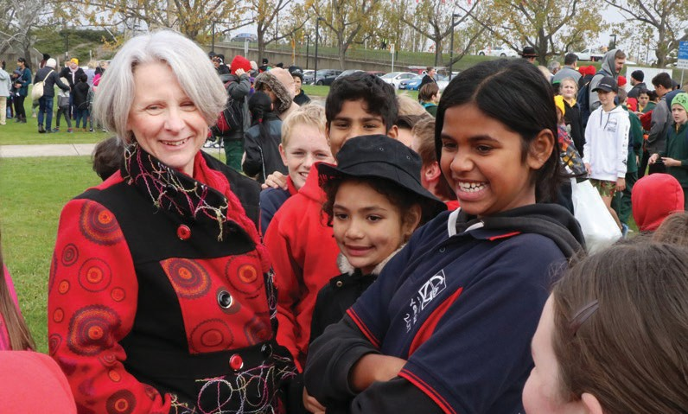

A MESSAGE FROM THE DIRECTOR-GENERAL
On behalf of the ACT Education Directorate, I acknowledge the Ngunnawal and Wreck Bay peoples as the traditional custodians of the lands on which our children live and learn. I pay respect to Ngunnawal Elders past and present.
I am pleased to provide the annual report on Aboriginal and Torres Strait Islander Education in ACT public schools for the period July 2016 to June 2017.
This report reflects the Education Directorate’s commitment to meeting the needs and aspirations for all Aboriginal and Torres Strait Islander students - purposefully moving to strengths-based approaches and a focus on developing cultural integrity in every school and classroom.
The Directorate is very proud of the diverse and innovative programs and opportunities that we provide to support our Aboriginal and Torres Strait Islander students to reach their potential. This includes the following examples of best practice which are occurring across our ACT public schools:
> the commitment of staff to implement the Directorate’s Reconciliation Action Plan;
> providing access for Aboriginal and Torres Strait Islander families to the Koori Preschool Program across five schools;
> various partnerships between schools and the community to embed Aboriginal and Torres Strait Islander perspectives in the curriculum and school activities;

> reviewing and reinvigorating the Directorate’s policy and practice around supporting Aboriginal and Torres Strait Islander students, which will inform a new approach to
school funding;
> the vibrancy of the Directorate’s Aboriginal and Torres Strait Islander Staff Network;
> annual Buroinjin carnivals and the Inner North Aboriginal and Torres Strait Islander Community Cluster carnivals;
> the commitment of our schools to recognise and observe Sorry Day, Reconciliation Week and NAIDOC Week, among other cultural events;
> providing secondary and tertiary scholarships to Aboriginal and Torres Strait Islander students pursuing health and teaching careers;
> development of ACT-specific learning resources;
> the growing number of bush tucker gardens in our schools; and
> the provision of high quality professional learning opportunities for teachers.
This year has been important for celebrating our successes, understanding our strengths and defining how we will address our challenges. I
look forward to continuing to drive innovative and evidence based initiatives to improve outcomes for all Aboriginal and Torres Strait Islander students.

Natalie Howson Director-General
ACT Education Directorate

INTRODUCTION
Reporting to the Legislative Assembly on educational outcomes for Aboriginal and Torres Strait Islander children commenced in 2001. At that time, reporting was six-monthly. Since 2006, reporting has been annual.
This report is the 10th annual report to the ACT Legislative Assembly on Aboriginal and Torres Strait Islander students’ outcomes. This report covers the period July 2016 to June 2017.
Information in this report is presented according to the five priorities outlined in the Education Directorate’s Strategic Plan 2014-17: Education Capital. The five priorities are:
- Quality learning;
- Inspirational teaching and leadership;
- High expectations, high performance;
- Connecting with families and the community; and
- Business innovation and improvement.
Throughout this report there are references to both Ngunnawal and Ngunawal culture. The Directorate acknowledges that members of the local community identify as both Ngunnawal and Ngunawal and has referenced both in this report.

Aboriginal and Torres Strait Islander Student Enrolments
The number of Aboriginal and Torres Strait Islander students has been on the rise over the last five years. In February 2017, there were 1,844 Aboriginal and Torres Strait Islander students enrolled in public schools, which comprised 80 percent of all Aboriginal and Torres Strait Islander school students in the ACT. The 2017 enrolment
figure was an increase of 105 students (6%) on 1,739 enrolments in 2016. The number of Aboriginal and Torres Strait Islander students represented 3.1 percent of total student enrolments in all ACT public and non-government schools.
NUMBER OF ABORIGINAL AND TORRES STRAIT ISLANDER ENROLMENTS IN ACT PUBLIC SCHOOLS, 2012 TO 2017

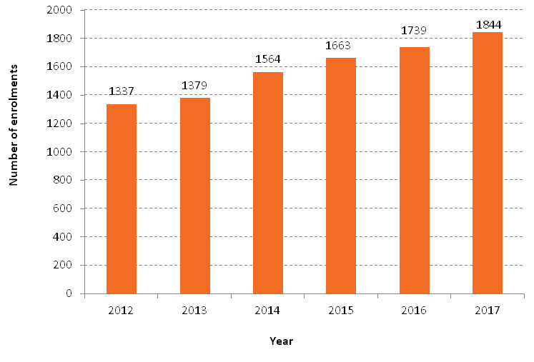

QUALITY LEARNING

We ensure Aboriginal and Torres Strait Islander learners have access to high quality, powerful and relevant learning experiences.

ACT Early Childhood Strategy
The first eight years of life lay the foundations for a child’s health, learning and development.
The ACT Government is currently developing an Early Childhood Strategy, which will look to coordinate approaches across government and strengthen partnership with non-government organisations, to achieve better outcomes for children and their families.
The strategy will consider early childhood services including education, maternal and child health, family support and early intervention, and will be informed by the findings of the Evaluation of Early Childhood Schools and the Koori Preschool Program.

Promoting cultural competence in early childhood education and care services
The ACT’s Regulatory Authority for early childhood education and care services, the Children’s Education and Care Assurance (CECA), promotes and applies cultural competence
as a part of its approach to quality assurance under the National Law for Assessment and Rating. CECA implements three key aspects to achieve this:
- Training of Authorised Officers. Cultural competence training is included in the training course undertaken by CECA’s Authorised Officers before they are able to undertake Assessment and Rating. As a Regulatory Authority, CECA has engaged with recognised presenters in the ACT to conduct training on cultural competence for its staff. Authorised Officers have also completed An Indigenous Cultural Awareness Training Program presented by Tracy Whetnall. CECA aims to promote
a strong understanding of different ways of being and knowing across its work.
- Applying the National Standard to services through Assessment and Rating. Authorised Officers require evidence of a service’s cultural competence across many elements of the National Standard. For example:
> Element 1.1.2 Each child’s current knowledge, ideas, culture, abilities and interests are the foundation of the
program. This requires that children and families’ culture, heritage and ethnicity are considered in the development of the educational program.
> Element 6.3.4 The service builds relationships and engages with the local community. The ACT Regulatory Authority has required
that in order to meet this element services must be raising awareness of Aboriginal and Torres Strait Islander communities, including acknowledging the traditional owners of the land and local elders in a meaningful and respectful manner.
- Sector development. The national curriculum documents are mandated to be used by the National Law. CECA enables the delivery of training opportunities for the Early Childhood Education and Care sector to ensure greater understanding is developed of the principle of Respect for Diversity and practice of Cultural Competence as part of the curriculum documents. CECA facilitates presentations at its ACT Education and Care Sector meetings; co presenting with organisations such
as the Professional Support Coordinator (a Commonwealth funded professional development body) and joining with ACECQA (the national governing body for
the implementation of the National Law) in presenting workshops on Quality Area One Educational program and practice.

Koori Preschool Program
The Directorate’s Koori Preschool Program supports increased participation of Aboriginal and Torres Strait Islander children in preschool through the provision of high quality early childhood education at five sites across Canberra. Children from birth to three years can attend a
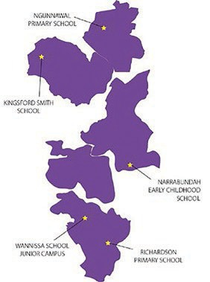
Koori Preschool when accompanied by a parent or guardian, enabling greater family involvement and supporting transition to formal schooling.

Koori Preschools were located at:
> Ngunnawal Primary School;
> Wanniassa School;
> Richardson Primary School;
> Narrabundah Early Childhood School; and
> Kingsford Smith School.
In addition to enrolling in Koori Preschool, children can also attend their local preschool, allowing access of up to 24 hours per week of high quality preschool education in the 18 months prior to starting kindergarten.
In February 2017, there were 85 Aboriginal and Torres Strait Islander children enrolled in Koori Preschools, compared with 78 children in 2016. In 2017, 50 of the 85 children enrolled in Koori
Preschools were also enrolled in a local preschool representing an increase from 44 in 2016.
Several service providers worked in partnership with Koori Preschools to provide a holistic program that focused on engaging with parents and families and readiness for school. Koori Early Years Engagement Officers, employed through the Community Services Directorate, visited weekly to support building strong relationships and family engagement in preschool education.
The Directorate facilitated targeted professional learning in 2016-17 for staff working in the Koori Preschool Program. This professional learning included, among other things, a focus on transitions by Priscilla Reid-Loynes, a Goomeroi and Yularoi woman, teacher and Indigenous Consultant on the Little J and Big Cuz television series. Through a keynote address and interactive workshops, participants developed an understanding of Aboriginal worldviews, knowledge and pedagogies, and how these can be incorporated to support effective transitions for Aboriginal and Torres Strait Islander children.

Accepting the Challenge Action Inquiry Program
The Action Inquiry Program operated across ACT public schools from 2010 until December 2016. The program delivered professional learning and support for teachers and school leaders to conduct school projects to improve the educational outcomes of Aboriginal and Torres Strait Islander children.
During 2016, 226 Aboriginal and Torres Strait Islander students and 30 teachers (from early childhood to college settings) participated in the program. Projects in 2016 included:
> a longitudinal numeracy study;
> oral language initiatives and support;
> supporting transitions into Science, Technology, Engineering and Mathematics (STEM) college subjects; and
> literacy support in upper primary.

Recommendations from the 2016 Action Inquiry program included:
> developing strategies to increase communication between teachers regarding each school’s literacy focus;
> incorporating storytelling as a tool to strengthen oral language within all literacy sessions;
> developing processes and materials to inform Aboriginal and Torres Strait Islander students about STEM courses and career opportunities when they enrol at college; and
> continuing to monitor attendance and introducing methodologies to assist students who have missed significant time for learning.
The recommendations from Action Inquiry projects were shared with principals and school leaders to inform professional practice and planning. The valuable skill sets and knowledge that staff gained as a result of their participation in the program continued to be
drawn upon and incorporated into schools across the public system.

Embedding Aboriginal and Torres Strait Islander cultures and histories in the Curriculum
It is important that Aboriginal and Torres Strait Islander children are able to see themselves and their cultures reflected in all learning areas. Schools continued to work towards
embedding Aboriginal and Torres Strait Islander perspectives across all subject areas.
The Aboriginal and Torres Strait Islander Histories and Cultures cross-curriculum priority of the Australian Curriculum was designed for all students to learn about the histories and cultures of Aboriginal and Torres Strait Islander
people and their contributions to contemporary Australian society. The cross-curriculum priority encouraged all staff and students to engage in reconciliation.
ACT teachers had access to an array of resources including national research and cultural institutions located in Canberra to help all students learn about the world’s oldest living cultures.

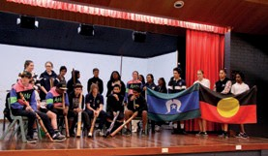Building cultural awareness for a supportive learning environment
Melrose High School used a strengths based approach to support Aboriginal and Torres Strait Islander students. Melrose worked hard to make sure that all students could feel culturally safe and empowered to achieve their dreams and aspirations.
Melrose High School commenced the 2017 school year by holding a smoking ceremony for the whole school building in keeping faith
with their Reconciliation Action Plan. The school regularly invited young Aboriginal and Torres Strait Islander leaders from this Country to conduct Welcome to Country at major events.
Melrose High School was committed to language learning for all school staff. At every staff meeting, new phrases and words were learned and practiced. The primary language used was Wiradjuri, which informed about 50 percent of Gundungurra, the parent language for the Ngambri and Ngunnawal languages.
Another positive step was ensuring that Aboriginal and Torres Strait Islander students and their families were represented in leadership and decision-making roles. The President of the Student Representative Council was a year 10 Torres Strait Islander woman. Melrose High School recently created an identified Aboriginal and Torres Strait Islander position on the school board.
Aboriginal and Torres Strait Islander community engagement initiatives such as embedding local Aboriginal language and culture in the school curriculum and involving students in decision making improved sense of belonging resulting in attendance and academic achievements.

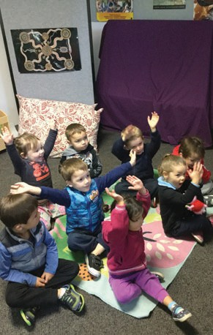

Kingsford Smith Koori Preschool Acknowledgement of Country on Ngunnawal Land
As part of an ongoing conversation about the importance of acknowledging the traditional custodians of the land on which we live, Kingsford Smith students with their Koori preschool assistant adapted an Acknowledgement of Country which is used in preschools around Australia to help young children learn to connect to country and culture, whilst learning valuable motor and verbal skills.
We at Koori Pre,
Would like to say thank you To the Ngunnawal people, Of the Canberra Nation,
For letting us share your land. We promise to look after it, The animals and people too. Hello land (all touch the land) Hello sky (arms up to the sky) Hello me (hug self)
Hello friends (open arms)

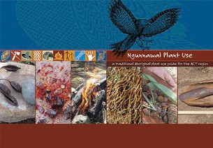
Ngunnawal Plant Use guide pilot program
Nine schools explored ways to incorporate the Ngunnawal Plant Use guide into their teaching and learning programs in 2017. Resources and strategies were shared with other schools.
The book included an introduction to Ngunnawal history and natural resource use, descriptions and photos of 69 plant species, including their use, distribution and method of propagation.
All schools received a copy of the book and associated materials to use in classrooms.

Footprints on Our Land DVD: Aunty Agnes, Ngunnawal Elder pilot program
Six schools participated during 2017 in a pilot program to incorporate Footprints on Our Land in professional learning and classroom activities.
From her life as a girl on Oak Hill and Hollywood missions in Yass to the present day, Footprints on Our Land celebrates the life of Aunty Agnes as a survivor of racism, a caring mother and grandmother and a strong advocate for her community. Footprints on Our Land is a testament to a senior Elder whose tireless service has been a major force of reconciliation in the ACT.

“Mununja” the butterfly
In May 2017, four primary schools commenced a curriculum project exploring ways in which to incorporate the Ngunawal story Mununja the Butterfly into learning activities and programs for upper primary students. It was a beautifully illustrated bilingual text enabling students to experience a little of the Ngunawal language and culture. The story centred around a young girl who was turned into a butterfly to avoid marrying the evil Gunja “the clever one”. The storybook was written by local Ngunawal elder Don Bell, who sadly passed away in 2008.

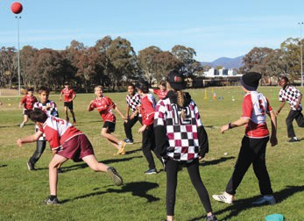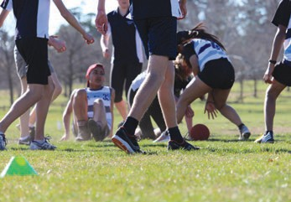Buroinjin carnivals
Buroinjin is a ball game, with variations being played by Aboriginal and
Torres Strait Islander people for many years across New South Wales and southern Queensland. The game played in the ACT was adapted from the Kabi Kabi people of southern Queensland. The game has elements of basketball, handball and touch football. Originally the ball, about the size of a European handball, was made of animal skin. Buroinjin carnivals have proven to be an effective, practical way to celebrate Aboriginal cultures and histories and to incorporate them into the curriculum.
Inter-school Buroinjin carnivals for students in years 5 to 10 have become well known events across ACT public schools. In many schools, Buroinjin has been incorporated into physical activity programs and school
culture with lunchtime games becoming a common occurrence.
The south side primary school Buroinjun carnival on 21 June 2017 saw five schools participate, with
Garran Primary School taking out the competition in a nail biting grand final. Garran will take on the winners of the north side competition, Ainslie School, for the title of the ACT Buroinjin Champions.
The cold winter weather could not keep over 200 students from seven schools from attending the ACT senior school Buroinjin carnival on 22 June 2017.
The carnivals were a huge success and the ACT Education Directorate acknowledges the generous support of Winnunga Nimmityjah Aboriginal Health Service in providing fruit and water for all participants at both carnivals, as well as the kind donation of medals for winning teams.

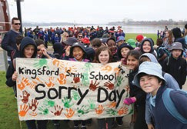INSPIRATIONAL TEACHING AND LEADERSHIP
Sorry Day Bridge Walk – 27 May 2017
Reconciliation is a journey, and one that we can walk together. In the ACT, National Sorry Day was commemorated through the Sorry Day Bridge Walk, organised by the Canberra Aboriginal community health service, Winnunga Nimmityjah. Director-General, Natalie Howson, participated in the Bridge Walk with students from across ACT public schools.
In 2017, all students from kindergarten to year 5 at Kingsford Smith School participated in
the Sorry Day Bridge Walk, demonstrating their school’s HERO values of Harmony, Excellence, Respect and Optimism. The students also designed a banner on the Sorry Day theme to demonstrate what the Sorry Day meant to them and their school community.
Below are some quotes from students on their experiences:
“I liked the speech and it made me feel really sorry for the Aboriginal people”
- Sofia, year 4
“I liked the Sorry Day Walk because there was a smoking ceremony, we got to walk across the bridge and meet a lot of people”
- Declan, year 4
“It made me think about things that happened”
- Chloe, kindergarten

We build the capacities of our teachers and
leaders by design, not by chance.

Reconciliation Action Plan
– Keeping It Alive 2016 – 2018
The theme of the Directorate’s third Reconciliation Action Plan (RAP) was Reconciliation – Keeping it Alive 2016 – 2018.
The RAP was launched on National Sorry Day, 26 May 2016. The purpose of the RAP is to engage all employees in the creation of an organisational culture enriched by the diversity and knowledge of Aboriginal and Torres Strait Islander peoples, strengths and cultures through our common values.

“This RAP is different. Rather than focusing on deficit discourse, it challenges us to consider how we want to be together
as an organisation in order to achieve reconciliation.”
Co-Chair of the Aboriginal and Torres Strait Islander Staff Network
The innovative RAP was communicated through a suite of tools:
> Reconciliation Postcard – a tool to engage all Directorate staff in ongoing conversations, cultural integrity practices in the workplace – asking us ‘What is your next most powerful step?’;
> Reconciliation – Keeping it Alive: double sided poster for internal distribution and prominent display throughout the Directorate; and
> a Reconciliation Australia endorsed corporate booklet which was launched in NAIDOC week from 3 to 10 July, 2016.

Cultural Competency Foundation Program
Pathways to teaching: Jasmin Hunter’s story
In 2015, I started working for the Education Directorate as a casual learning support assistant one day per week at Canberra High School, whilst studying my teaching degree through the University of Sydney via block mode.
Later that year, I attended a community yarn to discuss my pathways and employment opportunities. At this meeting I also made connections to the Education Aboriginal and Torres Strait Islander Staff Network.
In the second semester of 2016, the Directorate employed me as an
Indigenous Education Officer at Gold Creek School, whilst I continued my studies. I have recently completed my final professional work experience at Gungahlin College and aim to begin working as a classroom teacher in late 2017.
During my time in ACT public schools, I ran cultural competency training for school staff and developed lessons on Reconciliation Week and NAIDOC Week, which were delivered across a selection of schools.
Some of the things that helped me along my pathway were:
> the strength and support of the Aboriginal and Torres Strait Islander Staff Network;
> the professional support and mentoring I gained from staff in the Directorate; and
> having a voice and being able to share and learn through engaging with a variety of practitioners.
I really enjoyed working for the Education Directorate and appreciated the support I received.
During 2016, 78 teaching staff completed the Cultural Competency Foundation Program. This was an increase from 69 in 2015. In semester one 2017, 43 teachers from 12 schools participated in the program.
Participants completed online modules and attended a Directorate led workshop which focussed on defining cultural competence and conversations around understanding ourselves as cultural beings.
A second half day workshop at the National Museum of Australia focussed on the Canberra region context and introduced participants to objects in the Museum’s collection to raise questions about the experience
of Aboriginal and Torres Strait Islander peoples after British colonisation in 1770. A third workshop session provided an opportunity for reflection on the course and time to prepare a formal Action Plan.
Feedback from teachers about the online course and the workshops was extremely positive:
“The information in this course is pivotal to understanding the journey of Aboriginal and Torres Strait Islander peoples.”

Education Aboriginal and Torres Strait Islander Staff Network
The Directorate continued to build the Aboriginal and Torres Strait Islander Staff Network (the Network).
Membership was open to all Aboriginal and Torres Strait Islander employees; including permanent,
contract and casual staff.
The Network structure included two co-chairs, elected bi-annually from the teaching and administrative staffing streams. As part of capacity and capability development, past co-chairs mentored newly elected co-chairs and staff interested in these roles in the future were also offered mentoring support. Since 2016, the Network met quarterly with the Senior Executive Team to progress issues raised through members, including culturally responsive recruitment practices, career development and leadership. The meetings provided opportunities
for the Senior Executive Team to update the Network on key initiatives and seek feedback on Directorate activities.

HIGH EXPECTATIONS, HIGH PERFORMANCE

We have high expectations for
Aboriginal and Torres Strait Islander students and will meet the learning needs of every student.

The Directorate delivered a broad range of programs to meet the learning needs, interests and aspirations of all students. Increasing student attendance, the year 12 attainment rates and performance in NAPLAN and other assessments are key performance indicators for the Directorate. Personalised learning and increased transitions and careers support was available to all students. These provided formal and informal pathways into education, employment and self development
for Aboriginal and Torres Strait Islander students.

Providing a variety of career opportunities and pathways planning
All ACT public colleges supported students in their post-school pathways through personalised learning plans and pathways planning for employment, further study or
vocational education and training. Every college had a pastoral care program, a dedicated student support team and provided work experience options.
Aboriginal and Torres Strait Islander students in years 5 to 12 had an opportunity to develop a pathways plan. The Pathways website (https://pathways.act.edu.au/) encouraged students to reflect on who they were and identify their strengths and interests. It helped students practice essential life skills such
as decision-making and goal setting.
Students were encouraged to share their pathways plan with people in their support network.
Students had a plan throughout their time at school which was updated on a regular basis and allowed them to reflect on how they had developed over time as an individual.

Supporting students at key transition points
Four Transitions Network Groups provided a regular forum for cross-school sector collaboration and consultation on all matters relating to
student transitions.
These Network Groups consisted of:
> high school and college transitions/ careers advisors;
> pastoral care and high school year coordinators;
> transitions officers;
> workplace learning coordinators;
> years 5 and 6 primary school teachers;
> school leaders; and
> Directors, School Improvement.
Schools regularly co-planned transition activities, shared ideas and developed strong working relationships to ensure the delivery of best practice programs to support students at key transition points.

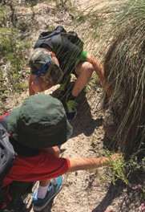
Student Aspirations Program
Aspirations Coordinators work with Aboriginal and Torres Strait Islander students from years 5 to 12 who are engaged in their learning and display strong
leadership potential through successful completion of
secondary school and progression to further education, training and employment options.
Student Aspirations Coordinators have been conducting pathways interviews with students and these interviews will be continuing for the remainder of 2017. During 2016, approximately 140 students participated in the program.
One of the major activities held was an annual student leadership day. In 2016, the leadership day for students in years 5 and 6 was held at Birrigai. Students participated in team building activities, such as the vertical playpen and dangle dup, which required two participants to climb up the structure together, teaching cooperation between the two climbers. Students learned about native plants and their uses and visited significant Aboriginal sites located on Birrigai land.

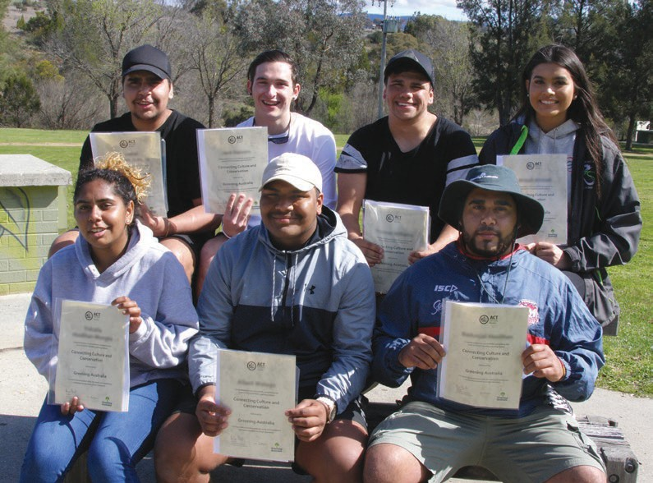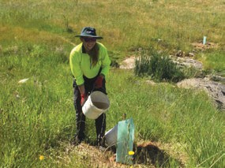Flexible Learning Options
Flexible learning options (FLOs) are curriculum enrichment programs that aim to strengthen students’ learning and career planning. FLOs help students develop a connection between their future study, training and work goals.
Delivered by industry experts in an authentic learning or work environment, FLOs provided an alternative learning experience for students whilst they attended high school and college.
FLOs offered in 2016-17 included beauty therapy, community work, animal care and natural resource management. Nine Aboriginal and Torres Strait Islander students participated in FLOs in semester 2, 2016 and 21 in semester 1, 2017.
The majority of students in semester 1, 2017 participated in the Kick Start my Career through Culture program, which was a partnership between the Education and the Environment, Planning and Sustainable Development Directorates. This program engaged Aboriginal

and Torres Strait Islander students in nationally accredited vocational training in culture and land management.
The ACT Government also partnered with Greening Australia and Canberra Institute of Technology to deliver a program for students in years 7 to 9 to connect with Aboriginal and Torres Strait Islander cultures through conservation
and land management. The students learnt about native plants, bush foods, scar trees and land management practices. The program was conducted on country and at the Greening Australia nursery.
Learning was delivered by Adam Shipp from Greening Australia through narratives and practical hands on activities. Pathways to future career options were discussed in a formal and informal way throughout the course.

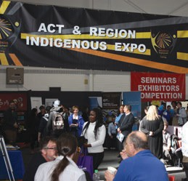
Big Picture Academy in ACT Public Schools: Incorporating Aboriginal and Torres Strait Islander perspectives
To support educational engagement and flexible learning options, high school and college students access a range of work experience, Australian School Based Apprenticeships, traineeships and pathways programs. One such program was Big Picture Australia offered by Melrose High School and Canberra College.
At Melrose High School, the Big Picture Academy was introduced in the Indigenous Studies Centre from the beginning of Semester 2, 2017 for Aboriginal and Torres Strait Islander students in years 9 and 10. The Academy gave students an opportunity to study in a subject area that they were passionate about, and learn what it was like to work in the industry they were interested in through an internship in a professional working environment. The Academy also aimed to connect students to Aboriginal and Torres Strait Islander mentors already working in the local community in the same field.

Students presented their portfolio of work through an exhibition using the ‘8 Aboriginal Ways of Learning1’ model designed by a group of Aboriginal educators from around the country.
The model is an Aboriginal pedagogy framework involving narrative driven learning, visual learning, hands-on/reflective techniques, symbols, metaphors, land-based learning, and connectedness to community.
Melrose High School will further develop this model of learning and achieving positive
outcomes for their Aboriginal and Torres Strait Islander students.
1 ACER (2011) ‘Two Way Teaching and Learning, Toward Culturally Reflective and Relevant Education’

Annual Canberra CareersXpo
The annual Canberra CareersXpo was held in August 2016 and was the largest event of its type in Canberra and the NSW Southern region. It provided a positive opportunity to help young people in the region consider their post-school options. The Xpo was developed as a partnership between the
Canberra City Rotary Club and the Directorate.
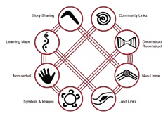Public high schools and colleges organised excursions to the CareersXpo for students in years 9 to 12. The CareersXpo also featured the Indigenous Employment Exhibition which commenced in 2015.

School Apprentices across ACT Government program
The Directorate continued to support the employment of Australian School Based Apprentices (ASBA) in public schools. The School Apprentices across ACT Government program provided school students with the opportunity to work across ACT public schools and ACT Government agencies. Registered Training Organisations provided
the off-the-job learning component of an ASBA through nationally recognised training.
Established as a 2009-10 Budget initiative, the Directorate provided $377,000 annually for this program to offset the costs of ASBA salaries. In 2016-17, six Aboriginal and Torres Strait Islander students undertook the program.

Resourcing every ACT Public School to support Aboriginal and Torres Strait Islander students
During 2016-17, the Directorate undertook a review of the policy and programs in place to support Aboriginal and Torres Strait Islander students.
The outcome of the review was to ensure programs and practices support schools to meet the needs and aspirations of all Aboriginal and Torres Strait Islander students.
Funding allocations are being revised to support this new policy intent.
Schools will support students by building environments of cultural integrity which focus on relationships, celebration, learning and high expectations. This direction is supported by
consultation, data analysis and a review of national and international literature and best practice.
Schools will embed:
> a whole school approach to school cultural integrity development;
> engaging and developing relationships with students, families and the community;
> celebrating and promoting success of Aboriginal and Torres Strait Islander students; and
> curriculum and programs relevant to students so that they can ‘see themselves’ in their learning.

Tutorial Support Scheme
In 2016-17, $230,000 was allocated to implement targeted strategies and programs to meet the individual learning needs of Aboriginal and Torres Strait Islander students. Funding was used for staffing costs in order to deliver one-on-one, small group tuition or study groups to provide more intensive learning support where required.

Senior Secondary Scholarships Program
The Aboriginal and Torres Strait Islander Scholarship Program is a long term strategy to increase the number of Aboriginal and Torres Strait Islander people in the ACT teaching
and health workforce. Scholarships are given to senior secondary students interested in pursuing tertiary or vocational study, as well as tertiary students who are enrolled in a recognised teaching or health degree at a Canberra University.
A total of $75,000 was available annually for the Aboriginal and Torres Strait Islander Secondary Scholarships Program for students pursuing degrees and vocational qualifications in health and teaching. From 2009 to 2017 inclusive, 51 senior secondary students received scholarships: 38 for teaching, 12 for health and one for vocational education. In 2017, one teaching, one vocational education and six health scholarships were awarded.

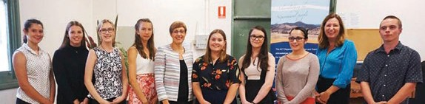

WINNERS OF 2017 SENIOR SECONDARY SCHOLARSHIPS WITH MINISTER BERRY AND MINISTER STEPHEN SMITH.
“I am at Melbourne University now with the Chancellor’s scholarship that I received from my ATAR results… which I could not have gotten without having the financial security of the scholarship in years 11 and 12. The Aspirations team was truly amazing in helping me through year 11 and 12.”
- Previous secondary scholarship recipient
“Winning a scholarship has helped me to continue being heavily involved in the school community through my extra-curricular activities and the Gifted and Talented program. It has also helped me financially so
I have been able to concentrate on my studies rather than having to work as well”
- Jessica, Gungahlin College, year 11 - secondary scholarship recipient

Tertiary Scholarships Program
Each year $80,000 is available for scholarships (worth up to $20,000 per student) to tertiary Aboriginal and Torres Strait Islander students studying teaching or health at the Australian Catholic University (ACU), University of Canberra (UC) or the Australian National University (ANU). From 2009 to 2017 inclusive, 26 tertiary scholarships have been awarded: 22 for students undertaking teaching degrees and four for students studying an approved health degree.
Information gathered from a survey of previous scholarship recipients showed that students had gone on to study in a number of subject areas, including arts, education, science, health, international relations and languages. Other participants had gained employment in after school care and youth work in ACT and NSW schools.
from $180 for year 4 recipients to $600 for year 11 recipients. Bursaries were held at the students’ school and used at parents’ discretion. The bursaries were used to assist with such things as excursion costs, purchasing uniforms, extra-curricular activities and other school related expenses.
The Mura Awards program encouraged schools to celebrate student successes and acknowledge the consistent efforts of Aboriginal and Torres Strait Islander students.

NAPLAN performance
NAPLAN testing measures performance of students in a number of learning domains in order to continuously monitor and further improve learning outcomes. In 2016, the ACT consistently had a higher proportion
of Aboriginal and Torres Strait Islander students achieving at or above the national minimum standard (NMS) for both reading and numeracy compared
with national results. For years 5 and 7 reading, the difference was greater than 10 percentage points.
PROPORTION OF ACT ABORIGINAL AND TORRES STRAIT ISLANDER STUDENTS AT OR ABOVE NMS, 2016
Year Level Type of ACT (%) Australia (%) Reading 84.2 80.6
“This scholarship was the only reason I could study. This scholarship allowed me to begin my studies and get through without the addition of financial stress.”
- Previous tertiary scholarship recipient
Assessment

Year 3
Numeracy 87.6 82.6
Reading 82.5 70.8

Mura Achievement Awards
The Mura Achievement Awards were launched in 2014. Mura is a Ngunnawal term meaning ‘pathways’. Teachers are invited to nominate students in years 4 to 11 for a Mura Award for demonstrating excellence in one or more of the following:
> excellent attendance;
> strong commitment to their learning;
> greatly improved engagement in their learning;
> good academic progress; and
> active involvement in the community and/or extra-curricular activities.
In 2016, 72 Mura Awards were awarded to students at a total cost of $20,780. Successful students received a small bursary to go towards educational costs. Bursaries ranged
Year 5 Numeracy 82.7 76.1
Reading 90.0 77.4
Year 7
Numeracy 87.3 79.4
Reading 81.4 73.6
Year 9 Numeracy 84.3 79.7
Whilst the ACT performed better than the national average in relation to Aboriginal and Torres Strait Islander students, significant disparity still exists between ACT Aboriginal and Torres Strait Islander students and their non-Indigenous peers.
The results published in the 2016 NAPLAN national report showed that in the ACT, and across Australia, the mean scores for Aboriginal and Torres Strait Islander students were significantly lower than the mean scores for non-Indigenous students across all year levels and testing domains.

ACT PERFORMANCE IN NAPLAN READING AND NUMERACY, YEARS 3 TO 5
Year 3 Aboriginal and Torres Strait Islander students | 85.7 | 87.6 | 83.4 | 85.2 | 84.2
Year 3 non-Indigenous students | 96.3 | 96.4 | 95.8 | 95.5 | 96.7
Year 5 Aboriginal and Torres Strait Islander students | 80.4 | 93.7 | 83.1 | 84.9 | 82.5
Year 5 non-Indigenous students | 95.3 | 97.1 | 96.1 | 95.5 | 95.8

Reading Years 3 to 5 AT OR ABOVE NATIONAL MINIMUM STANDARDS (%) 2012 2013 2014 2015 2016

Numeracy Years 3 to 5 AT OR ABOVE NATIONAL MINIMUM STANDARDS (%) 2012 2013 2014 2015 2016

ACT PERFORMANCE IN NAPLAN READING AND NUMERACY, YEARS 7 TO 9
Year 3 Aboriginal and Torres Strait Islander students | 84.0 | 91.4 | 88.1 | 85.4 | 87.6
Year 3 non-Indigenous students | 96.8 | 96.7 | 96.7 | 96.3 | 97.2
Year 5 Aboriginal and Torres Strait Islander students | 81.5 | 87.1 | 84.4 | 87.6 | 82.7
Year 5 non-Indigenous students | 96.2 | 95.2 | 96.3 | 96.8 | 96.6

Year 7 Aboriginal and Torres Strait Islander students | 84.1 | 90.9 | 83.1 | 88.3 | 90.0
Year 7 non-Indigenous students | 96.0 | 96.0 | 96.8 | 97.0 | 96.4
Year 9 Aboriginal and Torres Strait Islander students | 82.4 | 81.0 | 79.4 | 86.6 | 81.4
Year 9 non-Indigenous students | 94.9 | 96.4 | 94.3 | 94.2 | 95.5

Reading Years 7 to 9 AT OR ABOVE NATIONAL MINIMUM STANDARDS (%) 2012 2013 2014 2015 2016

Numeracy Years 7 to 9 AT OR ABOVE NATIONAL MINIMUM STANDARDS (%) 2012 2013 2014 2015 2016

From 2008 to 2016, there was no significant change in the NAPLAN performance of Aboriginal and Torres Strait Islander students in ACT public and non-government schools in either reading or numeracy. Nationally and in the ACT, results for Aboriginal and Torres Strait Islander students were two to three years of schooling behind non-Indigenous students.
Year 7 Aboriginal and Torres Strait Islander students | 81.9 | 90.0 | 85.1 | 86.1 | 87.3
Year 7 non-Indigenous students | 95.4 | 96.0 | 96.6 | 97.0 | 96.9
Year 9 Aboriginal and Torres Strait Islander students | 86.8 | 70.9 | 82.8 | 85.3 | 84.3
Year 9 non-Indigenous students | 95.7 | 93.6 | 95.3 | 95.5 | 96.7

The Directorate is seeking to support all Aboriginal and Torres Strait Islander students in our public schools through the development of learning environments of cultural integrity which support leadership, high expectations and successful pathways for students.
The Directorate launched its Future of Education conversation and invited the community to comment on how we can further improve our education system overall. Through the conversations, the Directorate will plan strategies to:
> provide the best possible outcomes for every child, especially from Aboriginal and Torres Strait Islander, multicultural and disadvantaged backgrounds; and
> invest in our teachers and our learning spaces to foster and enhance learning and support the considerable diversity of need among students in public schools.

The Directorate will continue its focus on student gain across years of schooling through investing in the better use of data by teachers, school leaders and as a system.
During 2017-18, the Directorate will be working to develop indicators to better measure equity and gain in student performance, particularly in NAPLAN. The development of revised indicators will include consultation at the national level. The Future of Education conversation will also play an important role in developing new indicators.

NAPLAN participation rates
The factors impacting on participation rates are varied and complex and ACT Public Schools continued to monitor participation and promoted family and parental awareness of the benefits and uses of NAPLAN testing. The Directorate worked to improve NAPLAN participation rates for Aboriginal and Torres Strait Islander students.
NAPLAN participation rates for Aboriginal and Torres Strait Islander students, locally and nationally, were below the rates for non-Indigenous students. In 2016, 83 percent of Aboriginal and Torres Strait Islander students participated in NAPLAN reading, compared with 93 percent of non-Indigenous students. This was a similar result to 2015, where 80 percent of Aboriginal and Torres Strait Islander students participated compared with 90 percent of non-Indigenous students.
All ACT students in years 3, 5, 7 and 9 are expected to participate in NAPLAN testing. There are three reasons why students may not undertake NAPLAN testing. These are if students are exempt, absent or withdrawn.
Students can be exempted with the family’s consent from one or more NAPLAN tests if they have significant or complex disability or if they are from a non-English-speaking background and arrived in Australia less than one year before the tests. Rates of exemption of ACT Aboriginal and Torres Strait Islander students from NAPLAN 2016 were higher than observed nationally across years 3 to 9.
A family is able to withdraw their child or young person from NAPLAN testing. The ability to withdraw students is intended to address issues such as religious beliefs and philosophical objections to testing and requires an individual parent/carer to make active, explicit decisions and an informed choice.
Withdrawal is generally the highest contributor to non-participation by ACT Aboriginal and Torres Strait Islander students in NAPLAN tests.
Students are recorded as absent if they are not exempt, have not been withdrawn, and did not undertake the test. ACT absent rates for Aboriginal and Torres Strait Islander students were generally lower in NAPLAN 2016 than the rates nationally.
The figures in the table show NAPLAN 2016 participation rates (reading only) for Aboriginal and Torres Strait Islander students and for non-Indigenous students in all ACT schools (public
and non-government). Participation rates were higher in primary school than high school for both Aboriginal and Torres Strait Islander students and non-Indigenous students.
ABORIGINAL AND TORRES STRAIT ISLANDER AND NON-INDIGENOUS STUDENTS’ PARTICIPATION IN NAPLAN, 2016, YEAR LEVEL (READING)

Sector Aboriginal and Torres Strait Islander students

Non-Indigenous students

Number participating
Percentage of all students
Number participating
Percentage of all students

Primary school | 233 | 84.1 | 9,574 | 93.9
High school | 233 | 81.2 | 9,045 | 92.8
All schools | 466 | 82.6 | 18,619 | 93.4

Strategies to improve student engagement and attendance
Programs in ACT public schools such as the Student Aspirations Program, Flexible Learning Options, Tutorial Support and scholarships were instrumental in motivating and engaging Aboriginal and Torres Strait Islander students in school activities. Attendance is intrinsically linked to engagement in school. Staying connected to school is also a positive influence on students’ social and emotional wellbeing. ACT schools took a multi-faceted approach to engaging students.
Attendance measures included:
> principals developing attendance procedures that are communicated to students, families and staff;
> an attendance monitoring and SMS messaging service for families;
> phone calls and meetings with families to discuss barriers to attendance and explore options to address these;
> referring parents and students to appropriate support services; and
> seeking support from the Education Directorate’s multi-disciplinary Network Student Engagement Teams (NSETs).
The table below shows that attendance for both Aboriginal and Torres Strait Islander and
non-Indigenous students increased between 2014 and 2016 for secondary school students (years 7 to 10). The increase for Aboriginal and Torres Strait Islander students in years 7 to 10 was greater than the increase for non-Indigenous students.

ATTENDANCE RATES (%) – ACT PUBLIC SCHOOLS

Sector Students 2014 2015 2016
Primary (years 1 to 6)

Aboriginal and Torres Strait Islander 87.5 88.1 86.8
High (years 7 to 10)

College (years 11 and 12)

Non-Indigenous 93.5 93.6 93.4

Non-Indigenous | 93.5 | 93.6 | 93.4
Aboriginal and Torres Strait Islander | 76.6 | 79.8 | 79.9

Non-Indigenous | 88.6 | 89.6 | 89.5
Aboriginal and Torres Strait Islander | 87.5 | 88.1 | 86.8

When comparing results for ACT students against the national results in 2016, the ACT attendance rate for Aboriginal and Torres Strait Islander students in years 1 to 10 was slightly higher (85.4%) than the national rate (83.4%). There was also a minor increase from 85.2 percent in 2014 to 85.4 percent in 2016.
The COAG Aboriginal and Torres Strait Islander student attendance target is for all schools to achieve 90 percent attendance of Aboriginal and Torres Strait Islander students by 2018. The ACT has a slightly higher local target of 92 percent for all public school students. If similar trends continue, it is unlikely that either target will be reached by 2018.
STUDENT ATTENDANCE RATES (%) YEARS 1 TO 10 COMBINED, 2014 AND 2016, ACT AND AUSTRALIA

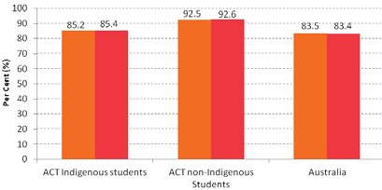Source: Australian Curriculum, Assessment and Reporting Authority
Australian Aboriginal and Torres Strait Islander Students
ACT Aboriginal and ACT non-Indigenous Torres Strait Islander Students Students
Percent (%)

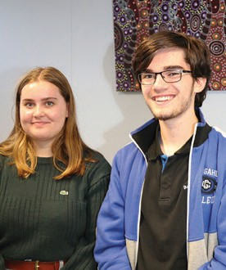ACT Student Voices: 2017 National Indigenous Youth Parliament
In the week of 23 to 29 May 2017, 50 Indigenous youth parliamentarians from around the country were selected to participate in a week long leadership summit to mark the 50th anniversary of Aboriginal Australians getting the right to vote in Federal elections. This democratic engagement program was coordinated by the Australian Electoral Commission.
Six participants from each State and Territory and two from the Torres Strait had the opportunity to debate bills, learn more about the parliamentary process and present on issues they were passionate about in an adjournment speech. Rebecca
Beutel from Dickson College and Alexander Radoll from Gungahlin College (picture above) were the two school-aged students of the six young people who represented the ACT.
Rebecca is a descendant of the Yalanji tribe (Far North Queensland) and is passionate about addressing Indigenous issues. Rebecca was a member of Dickson College’s Aboriginal and Torres Strait Islander group, where she worked with others to foster the values of identity, cultural safety and community participation in her school community. Rebecca’s commitment to education was shown in her receiving an Aspirations Scholarship at Dickson College, which were awarded to eight Aboriginal and Torres Strait Islander students across the ACT.
Alexander is a proud young Aboriginal man from Bungendore, New South Wales. As one of two Indigenous house captains at Gungahlin College, Alexander provided leadership and support, and inspired others to create change. In addition to participating in the Indigenous Youth Parliament, Alexander was also selected for the National Indigenous Youth Leadership Program, where he collaborated with other participants to develop a tool to help reduce Indigenous youth suicide.

Retention
The apparent retention rate provides an indicative measure of the proportion of students who stayed at school, for a designated year and grade of education2.
In ACT public schools in 2016, the apparent retention rate of Aboriginal and Torres Strait Islander students from year 7 to year 12 was 98.8 percent. This was an increase from 89.5 percent in 2015 and
81.0 percent in 2014. The Directorate will continue to maintain and build on this growth in future years by providing school environments which encourage and enable positive pathways for students.

2 It is expressed as a percentage of the cohort group that those students would be expected to have
come from, assuming an expected rate of progression of one grade per year. For example, an apparent retention rate for years 7 to 12 in 2016 would measure the proportion of year 7 students in 2010 that had apparently remained in the schooling system until year 12 in 2016.

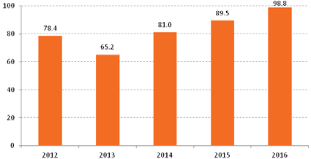
YEAR 7 TO YEAR 12 APPARENT RETENTION RATES FOR ABORIGINAL AND TORRES STRAIT ISLANDER STUDENTS IN ACT PUBLIC SCHOOLS3
Percent (%)
Percent (%)
Note: Caution is advised in the interpretation of this data due to the small number of Aboriginal and Torres Strait Islander students in ACT public schools and cross-border enrolments from students who live in surrounding NSW regions.

Year 12 completion rates
School attendance and retention lead to completion of year 12 which improves employment and entrepreneurial outcomes. At the February 2017 school census there were 116 Aboriginal and Torres Strait Islander students enrolled in a year 12 program in ACT public schools. This was an increase from 88 in 2016; 102 in 2015; and 83 in 2014.
Since 2014, the proportion of Aboriginal and Torres Strait Islander students achieving a Senior Secondary Certificate has trended upwards, suggesting that the programs and initiatives implemented by the Directorate over the last few years have had
a positive effect. In 2016, 64 (of 88) Aboriginal and Torres Strait Islander students achieved an ACT Senior Secondary Certificate, representing a completion rate of 73 percent, compared with 70 percent in 2015 and 59 percent in 2014. Through positive pathways and engagement programs, the Directorate is committed to increasing the proportion of Senior Secondary Certificate recipients.
ABORIGINAL AND TORRES STRAIT ISLANDER STUDENTS IN ACT PUBLIC SCHOOLS ATTAINING A SENIOR SECONDARY CERTIFICATE, 2013 TO 2016, PROPORTION

100
71
70
73
59

80

60

40

20

0
2013 2014 2015 2016
Year

3 Schools Australia (2016) Australian Bureau of Statistics, table 64A Capped
Apparent Retention Rates

CONNECTING WITH FAMILIES AND THE COMMUNITY

We partner with families and engage with the community
to build meaningful relationships.

Strengthening school capacity to engage with families and the community is a priority for the Directorate. There are a number of mechanisms and strategies in place to build and sustain meaningful partnerships with representatives from the local Aboriginal and Torres Strait Islander community.

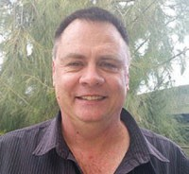
Aboriginal and Torres Strait Islander Elected Body
The Director-General and other senior executive met regularly with the ACT Aboriginal and Torres Strait Islander Elected Body representative for Education, Mr Tony McCulloch (pictured left). Tony is a member of Indigenous Allied Health Australia. Tony has a passion to see all Aboriginal and Torres Strait Islander students reach their potential.
The Directorate’s regular meetings with Mr McCulloch during 2016-17 provided a valuable forum for discussion
and resolution of key issues in education, such as needs based funding, student attendance, Aboriginal and Torres Strait Islander employment targets, Ngunnawal language and culture in schools, and how to improve student performance and outcomes.

Aboriginal and Torres Strait Islander Education Consultative Group
The Directorate continued to support the operation of the ACT Aboriginal and Torres Strait Islander Education Consultative Group. It is envisaged that by the end of 2017 a new Aboriginal and Torres Strait Islander Education Advisory Group will be in operation. The Directorate greatly appreciated the commitment of the group’s members and their contributions to education in our local community and to the national conversation.

Community Yarns
The Community Yarns project was developed as part of the Directorate’s Connection Collaboration Careers Leadership: Aboriginal and Torres Strait Islander Employment Action Plan 2014-2017. The aim was to engage members of the Aboriginal and Torres Strait Islander community for employment opportunities with the Directorate.
In 2016, a Community Yarn at Narrabundah Early Childhood School attracted interest from casual employees interested in career development and gaining permanent employment. Follow up conversations with employees created opportunities to gain experience in other school settings, develop productive and strong connections, and establish networks within the Directorate.
A review of the Community Yarn process was undertaken in late 2016. In consultation with the Aboriginal and Torres Strait Islander Staff Network, the focus during 2017 was to engage with Aboriginal and Torres Strait Islander students enrolled in ACT universities. The first Community Yarn in 2017 was held during National Reconciliation Week at the end of May 2017 to engage with community members and provide information regarding career opportunities.

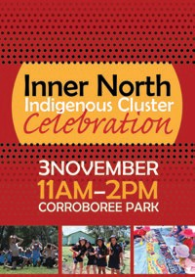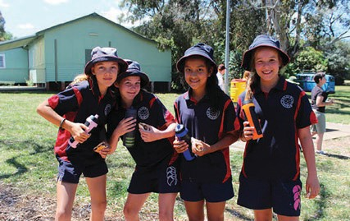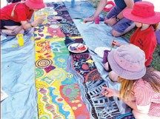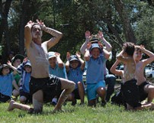
Inner North Indigenous Cluster Celebration
Each year, Aboriginal and Torres Strait Islander students who attend schools in the inner north of Canberra attend the Inner North Indigenous Cluster Celebration held at Corroboree
Park, Ainslie.
The North Canberra cluster consists of Dickson College, Campbell High School, Lyneham Primary and High Schools, Ainslie School, Campbell Primary School, North Ainslie Primary School, O’Connor Cooperative School and Turner School. In 2009, the cluster in partnership with their school
communities invited Indigenous elders and families to collaboratively develop an Aboriginal and Torres Strait Islander Community Partnership Agreement. The Agreement promotes positive relationships, Aboriginal and Torres Strait Islander culture and history, quality teaching and social justice.
Aboriginal and Torres Strait Islander students, their friends and families gathered to celebrate the Aboriginal and Torres Strait Islander Partnerships Agreement and to share good news stories. There was a barbeque, craft and painting activities, musical and singing performances and games. It was a happy and enjoyable day for all involved.

BUSINESS INNOVATION AND IMPROVEMENT

We support innovation, improve our business systems and be open and accountable for our decisions.

Future of Education
In February 2017, the Minister for Education and Early Childhood Development, Ms Yvette Berry MLA, launched the Future of Education, an innovative project canvassing a wide range of views and ideas from a variety of stakeholders including students, parents and carers, community members, teachers and educators.
Since February 2017, the Education Directorate has been consulting broadly to answer the central questions “what do we want and expect from our school and early childhood education system?
Is the system providing this and what might need to change?” This consultation process will result
in a clear vision for the future of the ACT Education system, and will be developed into a strategy that focuses on enhancing equity and access to quality early childhood education and care for all students.

School Administration System (SAS)
The ACT Government has invested $10 million over three years to design and implement a modern, fully integrated school administration system. The new system will transform the administration of ACT public schools and provide enhanced digital communications between home and school.
The system will provide for improved monitoring of achievement, progress and outcomes for Aboriginal and Torres Strait Islander students.
The system will be progressively implemented across all ACT public schools from the start of the 2018 school year.

Ensuring equitable access to technology
In September 2016, the ACT Government made an election commitment to supply every public high school and college student in the ACT with a high quality, up-to-date device. These devices will provide opportunities to Aboriginal and Torres Strait Islander students to develop digital technology skills and improve their learning outcomes.

Google G Suite for Education
Google G Suite for Education is a modern and cloud based online learning platform for students and teachers. The G Suite is available on any modern connected device. G Suite provides
the ability to create and share documents and presentations. G Suite aggregates class tasks and assignments, online collaboration and provides communication tools such as email, instant messaging and web conferencing. G Suite also comes with unlimited online storage for teachers and students. As of June 2017, there were over 49,913 active public school users including Aboriginal and Torres Strait Islander students.

School Performance
The People, Practice and Performance: School Improvement in Canberra Public Schools: A Framework for Performance and Accountability outlines how all ACT public schools are required to undergo an external school review every five years. After the finalisation of each school review, advice is provided to schools to assist them in
developing their new School Strategic Plans, which include actions to improve learning outcomes
for Aboriginal and Torres Strait Islander students. Directors, School Improvement and school leaders are responsible for monitoring progress throughout the year and principals report on progress through their school’s Annual Action Plan and Annual School Board Report.

